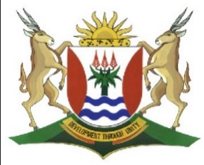
Province of the
EASTERN CAPE
EDUCATION

DIRECTORATE SENIOR CURRICULUM MANAGEMENT (SEN-FET)
HOME SCHOOLING SELF-STUDY MARKING GUIDELINES
SUBJECT | ACCOUNTING | GRADE | 10 | DATE | 11 May 2020
TOPIC | Term 2 Content

The following information was taken from the books of Hlophe Traders.
REQUIRED:
  - Prepare the Trading Account
  - Prepare the Profit and Loss Account
Information
HLOPHE TRADERS
PRE-ADJUSTMENT TRIAL BALANCE ON 28 FEBRUARY 2020
 | Debit | Credit
Balance Sheet Accounts Section
Capital (1 March 2019) |  | 900 000
Drawings | 72 000
Loan: Ace Bank |  | 280 000
Land and Buildings | 610 000
Vehicles | 320 000
Equipment | 170 000
Trading Inventory | 90 000
Debtors Control | 33 000
Creditors Control |  | 60 000
Bank | 78 800
Nominal Account Section
Sales |  | 648 000
Cost of Sales | 360 000
Debtors Allowances | 5 000
Rent Income |  | 66 000
Commission Income |  | 25 600
Interest Income |  | 2 100
Salaries and Wages | 160 000
Vehicle Expenses | 17 000
Advertising | 6 500
Stationery | 4 100
Water and Electricity | 4 800
Interest Expense | 39 200
Sundry Expenses | 11 300
 | 1 981 700 | 1 981 700

ACCOUNTING GRADE 10 FINAL ACCOUNTS ACTIVITY 1 – ANSWER BOOK
QUESTION 1
1.1 GENERAL LEDGER OF HLOPHE TRADERS
TRADING ACCOUNT

1.2 PROFIT AND LOSS ACCOUNT

