SUBJECT and GRADE | Civil Technology (Civil Services) Grade 10
TERM | TERM 2 (Weeks 5-6)
TOPIC | Graphics as a means of Communication (Specific)
AIMS OF THE LESSON | To develop the drawing skills of learners by doing scale drawings of the following Pattern development:  Parallel line method  Basic geometrical constructions relevant to pattern development  Square shaped (square pipe, square elbow)  Round shaped (cylindrical pipe, cylindrical pipe elbow)
RESOURCES | Paper based resources: | Digital resources:
 | In your textbook on page 98 – 109 of Chapter 4 | VIDEO
INTRODUCTION | In Grades 8, 9 and 10 you were introduced to Graphic and Communication, which included:  Pattern development, parallel line method, basic geometrical constructions relevant to pattern development, square shapes (square pipe), round shapes (cylindrical pipe)  Pattern development are used to make adjustments to pipes, bends and T-pieces to make the flow of liquids in different directions.  The methods used for pattern development can be divided into the following three groups: The parallel-line method  The radial-line method  Development by triangulation.  The methods and topics to be covered in Grade 11 include: the parallel-line method; square shapes (square pipe elbow); and round shapes (cylindrical pipe and cylindrical pipe elbow).
CONCEPTS AND SKILLS | Key concepts/definitions:  Scale drawings of the following pattern developments:  Parallel line method  Square shaped (square pipe, square elbow

Round shaped (cylindrical pipe, cylindrical pipe elbow)

The parallel-line method
This method is already covered in grade 10 and it will be very useful for the learners to revise the method to refresh their memory.

How to draw a square-shaped development.
Square pipe:
Draw an orthographic (plan) view of a square pipe and number the corners A, B, C and D, as indicated below.
Draw the baseline. As the square pipe has to be joined, add an allowance on both sides for the joint (seam). The seam will be in the middle of one of the sides, usually the back of the pipe so that the seam can be hidden.
Divide the back into two equal parts and add an allowance for the joint on each side. Mark A1 to A on the baseline, working from left to right. This will be half of the back dimension to which an allowance for the joint must be added. Now measure dimension A to B, B to C, C to D and D to D1, D to D1 is calculated in the same way as A1 to A (half of AD plus the joint (seam) allowance).
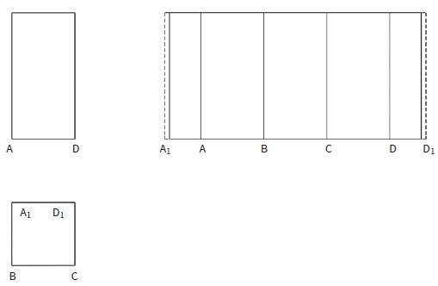

Square pipe development

How to draw square pipe elbow (90°) development.
Draw the top view (plan view) and side elevation, and label the elevation as shown below.
Draw a line to join letters C and D.
Draw the baseline that is equal to the perimeter of the square pipe.
Add the allowance for the seam. Divide the baseline, as shown in Figure 4.37. Distance B1-B equals half the distance of B-B on the plan view. The distances B-A, A-A and A-B on the plan view are equal. B-B1 is the same length as B1-B.
Draw perpendicular lines on the points as indicated.
Use a compass to make distances B1-D1 and B-D on the pattern the same length as B-D on the elevation. A-C is equal to A-C on the elevation. Join points D1-D-C-C-D-D1. This will complete the first half of the pattern.
To complete the other half, set the compass the same distance as C-E on the elevation. Extend lines A-C.

With the compass set to the length of C-E, mark off E on the extended line A-C.
On the pattern, draw a line parallel to the baseline to intersect E-E.
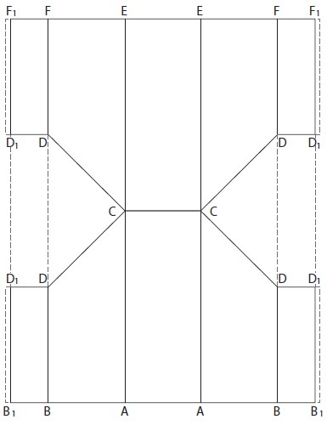
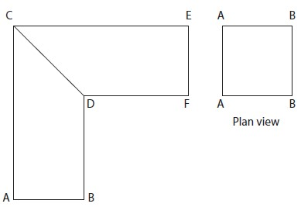
Extend lines B1-D1, B-D, B-D and B1-D1. Where they intersect the parallel line from left to right, mark points F1, F, E, E, F and F1, as shown below. Complete as for the first half of the pattern.

Square pipe elbow

How to draw a cylindrical pipe development.
Draw the front elevation of the cylindrical pipe, as shown below.
Draw a circle to represent the top view at the bottom of the page and divide it into equal distances along the circumference.
Draw the baseline and mark off the distances 0 to 1, 1 to 2, 2 to 3, 3 to 4, etc., according to the distances on the circumference of the top view.
Continue up to 12 and draw perpendicular lines on these points, as indicated below. The cylindrical pipe must be joined.
An allowance has to be added on the left and right side to accommodate the joint. Make the height of the pattern the same height as in the front elevation.
This will give you the unfolded view of the cylindrical pipe.

Development of a cylindrical pipe

How to draw a cylindrical pipe elbow development.
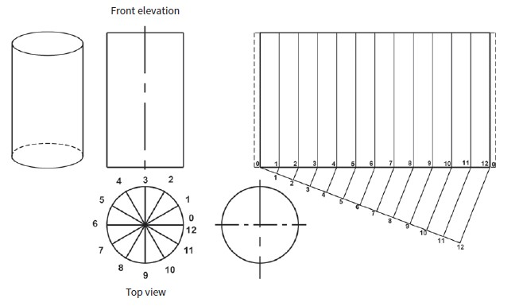
Make the height of the pattern the same height as in the front elevation. This will give you the unfolded view of the cylindrical pipe.
Development of a cylindrical pipe

How to draw a cylindrical pipe elbow development.

Draw the side elevation of the elbow and the top view of the opening (circle), as shown below.
The pattern (elbow) consists of two sections. Divide the circle forming the top view (plan view) into 12 equal parts.

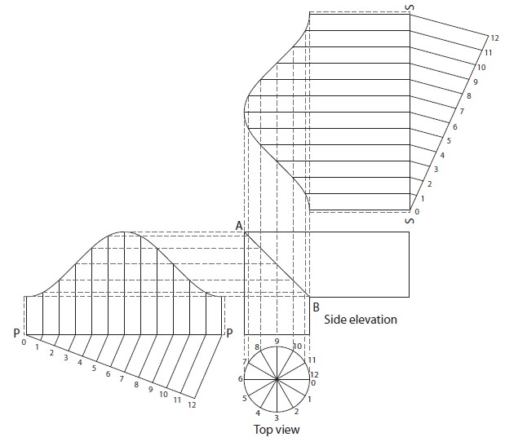
Draw perpendicular dashed lines upwards through these points to meet joint A-B.

Pattern development of a cylindrical pipe elbow
Draw the baseline P-P, as shown in Figure 4.41, equal to the circumference of the pipe. Add half the width of the seam on both sides of the baseline.

Having made the allowance for the seam, note the numbering on the top view.
The cylindrical pipe is divided into 12 parts.
The rest of the baseline is now divided into 12 equal parts according to the distances on the circumference of the top view. All these points represent perpendicular lines upwards. From all these points of intersection on joint line A-B of the side elevation, as well as from points A and B, draw horizontal lines to intersect all the vertical lines on the layout of the pattern.
Join these points of intersection and the true unfolded shape of the joint at A-B will develop. For the second part of the pattern, draw the baseline S-S as shown above equal to the circumference of the pipe. Complete the pattern according to the same process.

ACTIVITIES/ASSESSMENT | COMPLETE the Cylindrical pipe offset development on page 105 and 106 own your own.  After completion of the Cylindrical pipe offset on page 105 complete pattern development of the Shoe of a square gutter pipe on page 109 on your own.
CONSOLIDATION | Mathematics and Mathematical skills will be very helpful to understand this content. Measuring skills (difference between millimeters, centimeters and meters).
VALUES | You will learn cleanliness and pride.  Presentation is a reflection of your personality.  An attribute of an engineer is to clearly present his work.  Accuracy will result in the actual product being produced and avoid wasting time and money.

