SUBJECT and GRADE | Civil Technology (Construction / Woodworking / Civil Services) Grade 10
TERM | TERM 2 (Week 1 – Week 3)
TOPIC | Graphics as a means of Communication (Generic)
AIMS OF THE LESSON | To develop drawing skills:  - By applying various scales.  - Orthographic drawings  - Isometric drawings  - Floor plans  - To introduce CAD drawings
RESOURCES | Paper based resources: | Digital resources:
 | In your textbook on page 77 – 93 of Chapter 4
INTRODUCTION | - In Grade 8 and 9, you were introduced to Graphic and Communication, which includes all the plans, sketches and designs used in Civil Technology by the designer, architect or engineer to allow the builder, contractor or craftsman to create the final product in wood, plastic, metal, concrete and cement  - Learners prior knowledge of communication in Technology.  - Drawing skills as in grade 9 and in the first term.
CONCEPTS AND SKILLS | Key concepts/definitions:  - Basic drawings by applying various scales  - Orthographic projection  - Isometric views  - Instruments and instrument drawings  - Floor plan only of a two-room rectangular building  - Introduction to computer-aided drawings  Make basic drawings by applying various scales:  Before you start drawing an object, you must understand the various scales that can be used. There are three options when objects are drawn to scale, and this depends on the proportion indicated.  - Full scale: the actual dimensions of the object will be used in the drawing, e.g. 1 cm = 1 cm; or scale 1 : 1

- Reducing scale: the dimensions on the drawing have been reduced proportionally to be smaller than the actual dimensions of the object so that it can fit onto a drawing sheet, e.g. 1 cm = 100 cm; or scale 1 : 2, which means that the drawing is half the size of the actual object.
- Enlarging scale: a drawing must sometimes be enlarged so that the dimensions of parts are bigger than the actual dimensions to provide more detail and clarity, e.g. 10 cm = 1 cm; or scale 2 : 1, which means that the drawing is twice the size of the actual object.
The metric scale will be used for all the drawings in Civil Technology. The metric scale uses the millimetre as its base measurement. Full size on this scale will be shown as 1 : 1; reducing scale will be indicated as 1 : 2 (it is helpful to think that 1 unit on the drawing equals 2 units on the object); and an enlarging scale will be indicated as 2 : 1. Common metric scales are, for example, 1 : 10; 1 : 20; 1 : 50; 1 : 100. The following scales will be used in this course.
Full size: Scale 1 : 1
 | Reducing scales : | Scale 1 : 2  Scale 1 : 5  Scale 1 : 10  Scale 1 : 50  Scale 1 : 100
 | Enlarging scales | Scale 2 : 1

A square drawn to a scale of 1 : 1 (10 mm x 10 mm)
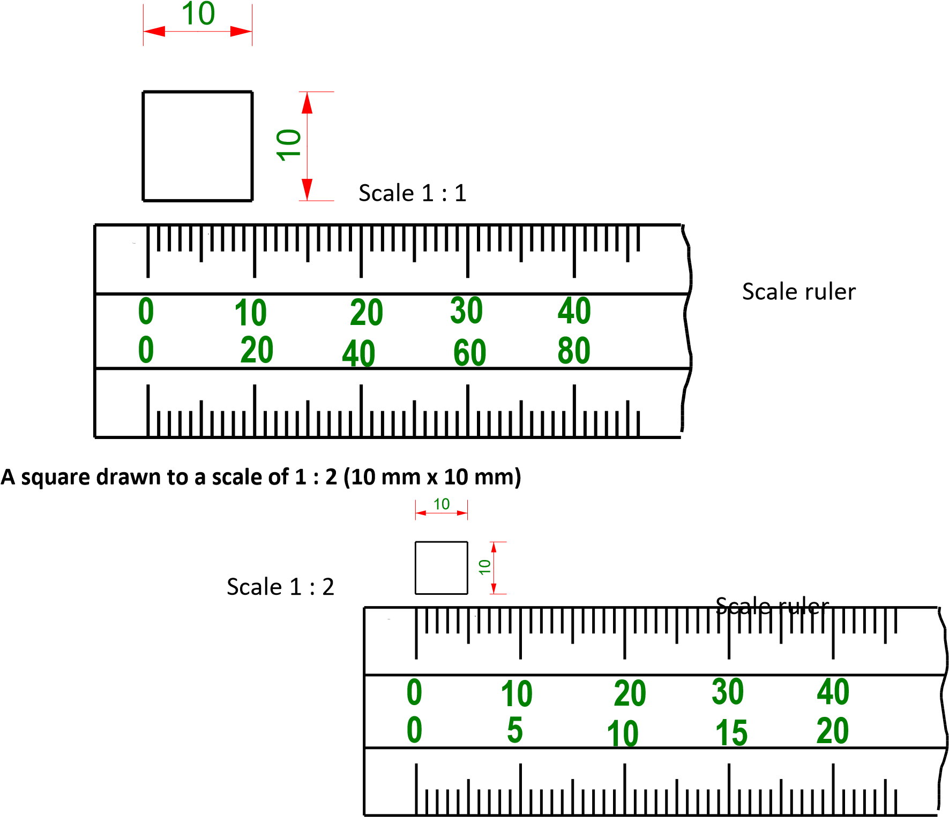

A square drawn to a scale of 2 : 1 (10 mm x 10 mm)
10

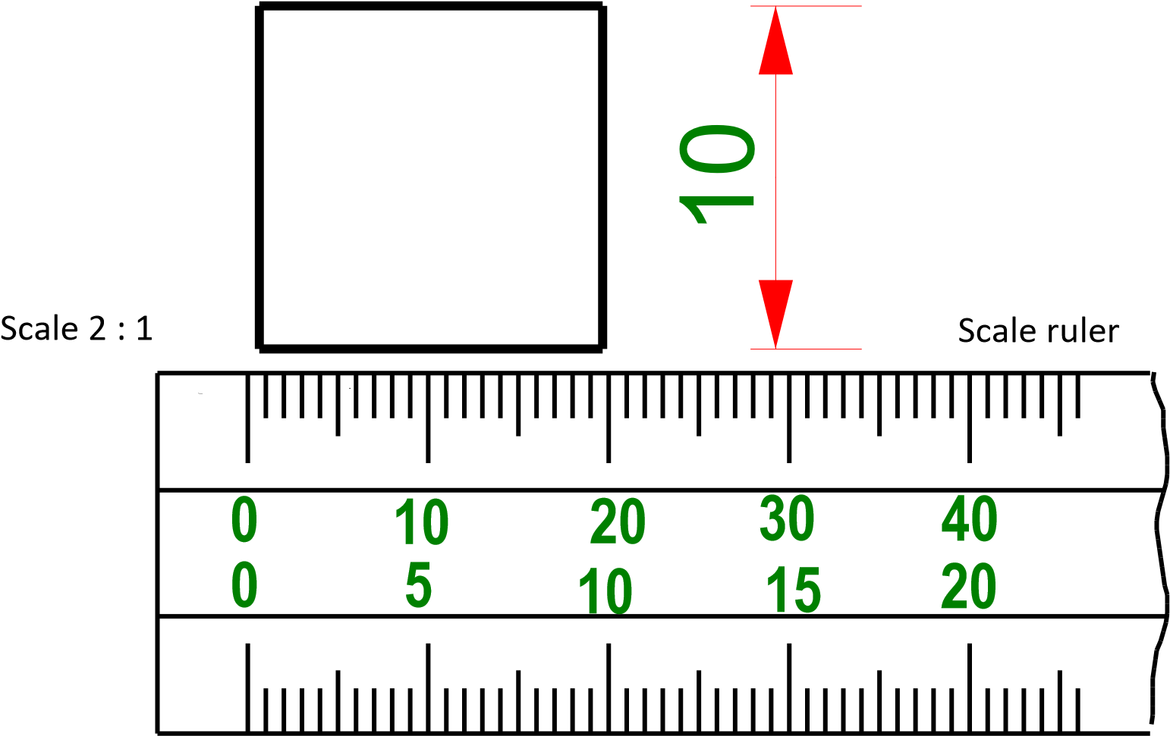

A square drawn to a scale of 1 : 5 (10 mm x 10 mm)

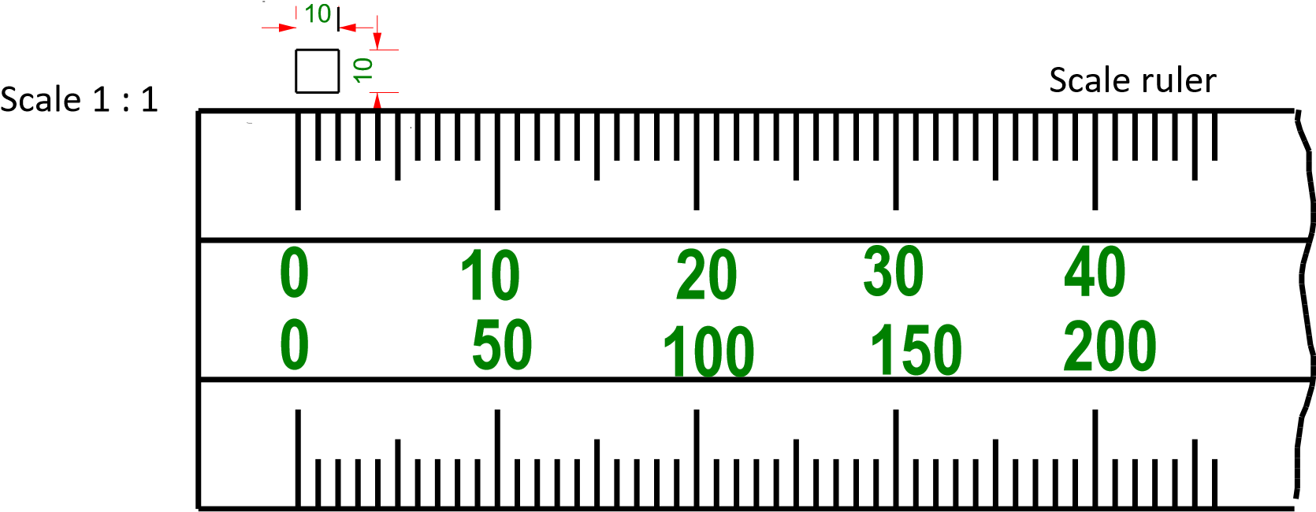

A square drawn to a scale of 5 : 1 (10 mm x 10 mm)
10

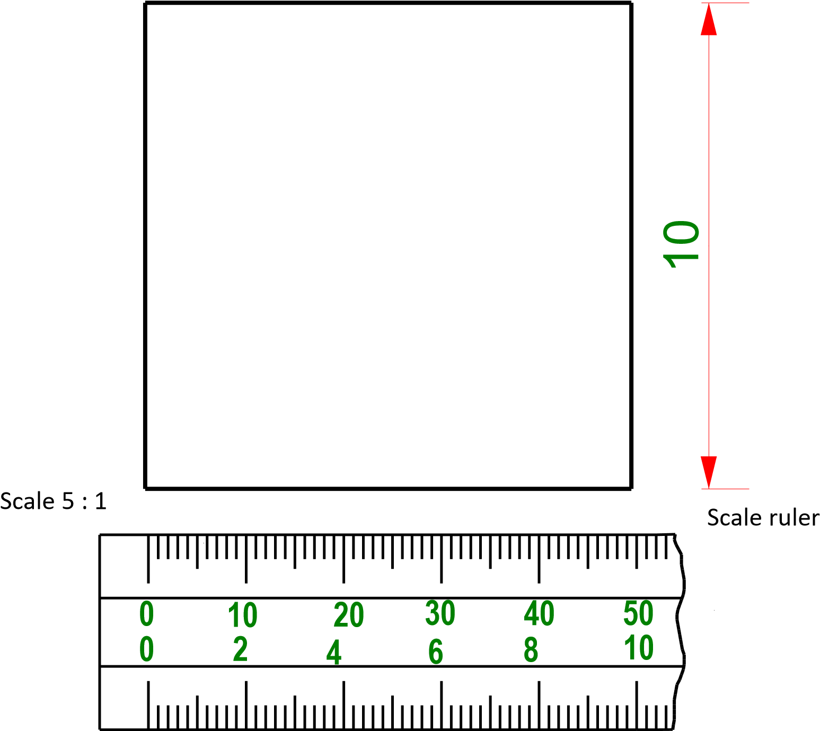

Orthographic projection
First angle orthographic projection.
- We will only be looking at first-angle orthographic drawing.
- The planes you will deal with here are the vertical plane (VP) and the horizontal plane (HP).
- The VP is the one you face when it is standing up in front of you – the window you look at is vertical. The HP is the flat level, such as the floor on which you stand.
- When you place a simple cube in the orthographic space, you will see the aspects (elevations) against various planes.
- As your viewpoint shifts around the cube, this determines against which plane you can draw the cube.
- From the front you will draw the projection against the back wall (VP).
- From the left you will draw the projection against the side wall (VP) and from the top you will draw it on the floor (HP).
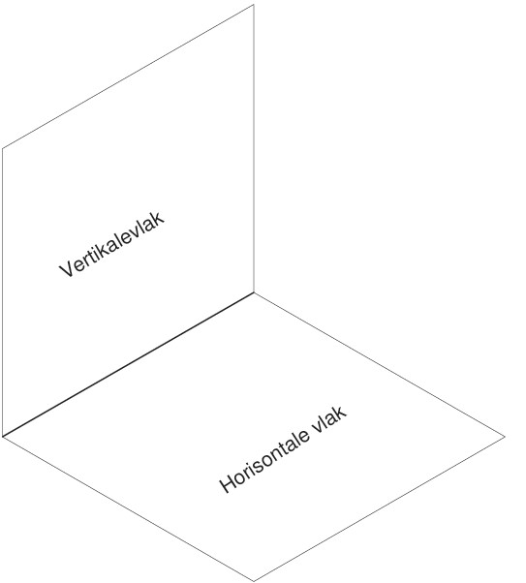

Orthographic projection
Every aspect has two dimensions:
- In the front aspect we have height and width.
- In the top aspect we have width and depth.
- In the left aspect we have height and depth.

When the sheet of paper is subdivided, we refer to the three angles as follows:
- The top left-hand angle – FRONT VIEW
- The top right-hand angle – LEFT VIEW, and
- The bottom left-hand angle – TOP VIEW

Top left-hand angle  Front view | Top right-hand angle  Left view
Bottom left-hand angle
Top view

- Projections for finding the different views are done from the front view.
- Draw a line that forms a 45-degree angle with the bottom square. Measurements
- must take from the given sketch drawing if the depth of the left aspect is to be determined.
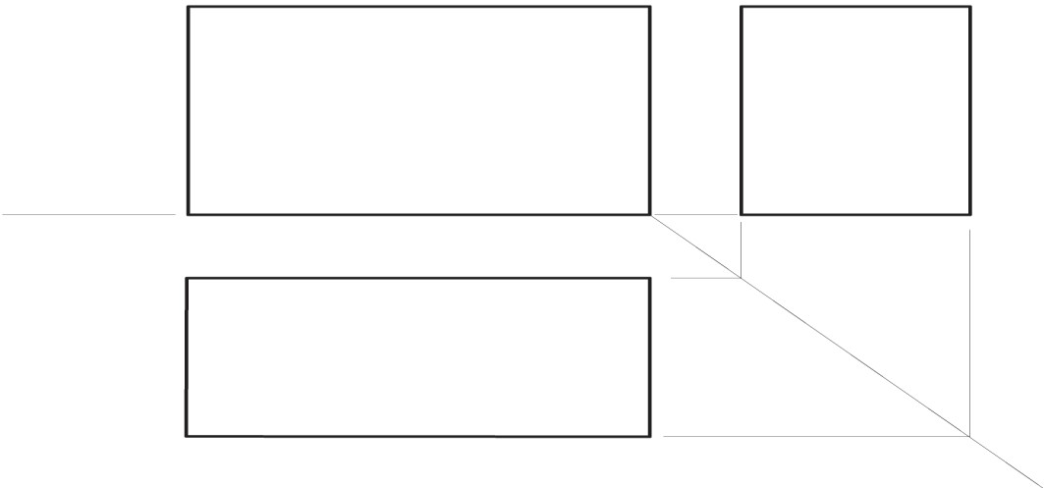
Front view

Top

vie
w

Left

view

Isometric views
- An isometric view gives you a “picture view” of the object you are drawing.
- It indicates three different views at the same time.
- It is based on three lines called axes.
- These axes give you the height, width, and corner points.
- Isometric axes refer to the vertical axis and the two other axes that are each at a 30 degree angle from the horizontal, known as construction lines.

Step 1: Start your isometric drawing by drawing a vertical line to meet the horizontal line.

Step 2: Draw two lines at 30 degrees to the horizontal line.

Step 3: Measure the horizontal dimensions of the brick along the two axes, as well as the height of the vertical line: 80 mm to the left, 35 mm to the right, and a height of 40 mm.

40

Step 4: Now draw the parallel lines to the existing lines, maintaining the angle. Measure 40 mm along the top horizontal plane, as indicated in the diagram below, and draw a line parallel to the 40-mm mark.

Step 5. Measure 20 mm on the opposite vertical plane, using the 80 mm line as point of departure.

20

Step 6: Complete the line block and draw the outlines in bold lines.

Floor plan only of a two-room rectangular building
A floor plan shows the relationships between rooms, spaces and other physical features at one level of a structure. The following features are normally included in a floor plan:
• Floor level, e.g. ground, first floor, etc.
 | • | Room names and their internal sizes.
 | • | Width of openings and thickness of walls.
 | • | Overall dimensions of the building, cupboards and spaces.
 | • | Position of fixtures, e.g. the baths, toilets and cupboards.
 | 8 010 | 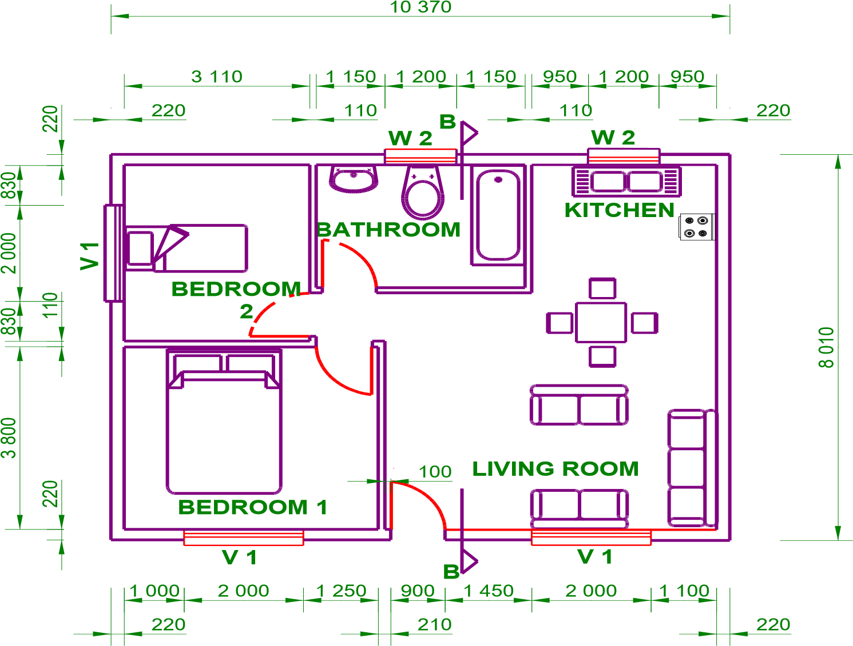

CAD – Computer-aided design
- CAD (computer-aided design) software is used by architects, engineers, draftsmen, artists, and other professionals to create precision drawings or technical illustrations. CAD software can be used to create two-dimensional (2D) drawings or three-dimensional (3D) models. In short, CAD software replaces manual drafting with an automated process.
- A CAD program uses software that allows the designer to draw on his computer screen, instead of on paper. To understand how a CAD program works, you have to think a little differently. You no longer have a piece of paper in front you. A computer screen displays a virtual (imaginary) piece of paper. Instead of using a pencil, you will use a mouse and keyboard.
- CAD allows the designer/draftsman to view the design from any angle, to zoom in or out, at the push of a button. What is more, the computer keeps track of design dependencies so that when one value is changed, other values that depend on it are automatically changed accordingly, thus saving the draftsman time. Keep as edited

Advantages of CAD
- Drawings can easily be modified; the entire design does not have to be redrawn if a mistake has been made.
- Objects can be moved or erased with the click of a mouse.
- It reduces the time required to draw new designs.
- It reduces storage space, as all the design data can be stored on computer rather than on scrolls of paper.
- Designers can zoom in, for a detailed view of specific sections, or out, to get an overall view of the entire design.
- Designs can be copied and paste many times.
- Drawings may be neater than hand-drawn ones, depending on the skill of the designer.
- Products can be produced more quickly, since mistakes can be identified and corrected in the early design stages; thus, costly mistakes in design or production can be avoided.
- Design data can be stored safely, and backups can be made.
- The computer keeps track of design dependencies and can check/adjust measurement.
- Identical products can be mass produced.
- Templates can be developed to make drawing easier.
- Regardless the size of the drawing, CAD systems will produce it accurately.
- Recurring data can be saved as part of a drawing library and imported as needed
Disadvantages
- If there is a problem with the computer and no backup of data has been made, all data may be lost.
- If not checked properly, the object created may be defective.
- The computer and software required can be expensive, so start-up cost may be high (hardware, software).
- Staff needs to be trained, thus adding to costs.
- As computer systems can be used to produce drawings more quickly, fewer people will be employed.
- It will take a long time to make CAD drawings of all the existing designs the company may have

ACTIVITIES/ASSESSMENT | Use the steps in your textbook on page 87 and 88 and draw to a scale of 1:1 the isometric drawing as indicated  below .  D  raw first angle orthographic views of the  drawing  above.  Use A as your front view.  A  After finishing the above activity complete the activity on page 94 in your text book.
CONSOLIDATION | Mathematics and Mathematical skills will be very helpful to understand this content. Measuring skills (difference between millimeters, centimeters and meters). Correct diverting of scales  Development of computer skills
VALUES | Learners will be able to do scale drawings.  Learners will be able to develop the skill to do orthographic and isometric drawings.  Learners will also be introduced to CAD drawings.  Learners will be able to do architecture drawings which can develop in his/her profession.

