Province of the
EASTERN CAPE

DEPARTMENT OF EDUCATION

CONSUMER STUDIES GRADE 10 TERM 2 WEEK 1

FOOD AND NUTRITION
FOOD SPOILAGE
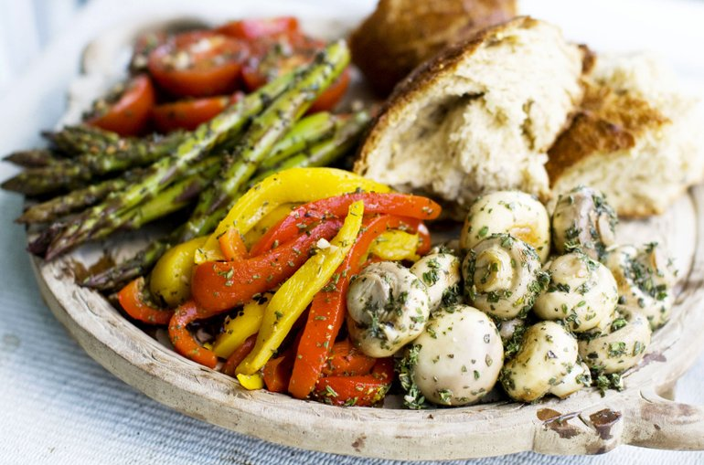

Micro organisms
Natural decay

Moulds

Bacteria

Enzymes
Natural toxicants
Yeast
Oxidation
Pathogenic micro organisms

Occurs when the original nutritional value, texture, flavour or appearance of the food is damaged or changed
WHAT IS FOOD SPOILAGE?

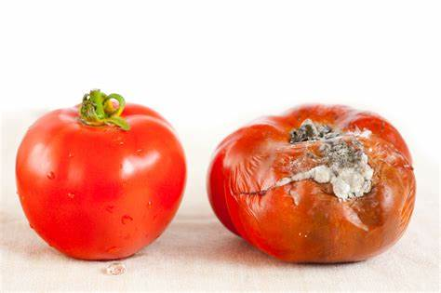\\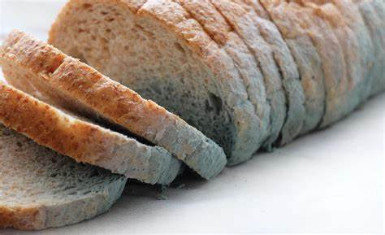

CAUSES OF FOOD SPOILAGE
MICRO ORGANISMS
BACTERIA  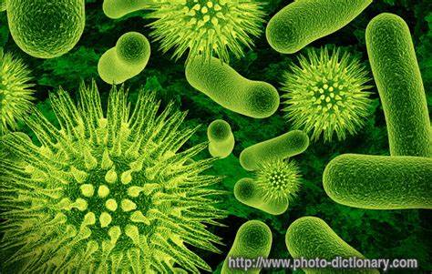 | MOULD  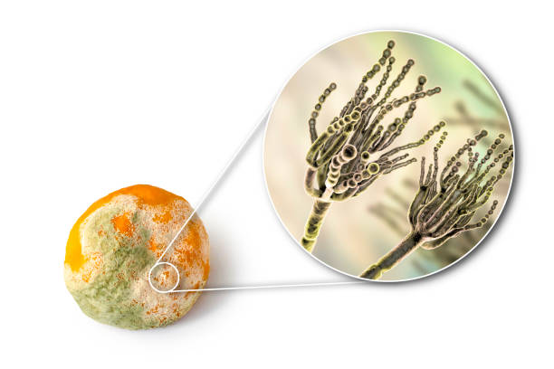
YEAST
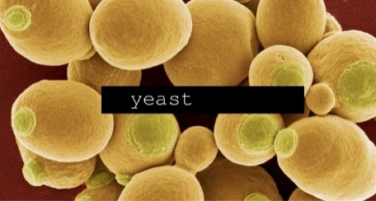
PATHOGENIC MICRO ORGANISMS
STAPHYLLOCACCUS  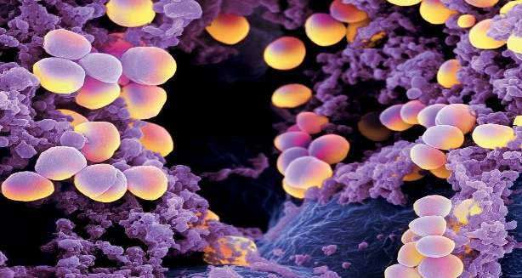 | SALMONELLA  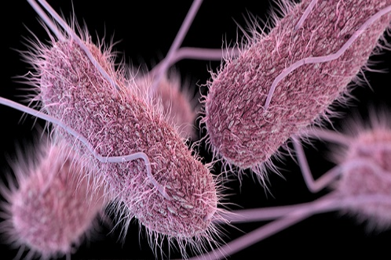
AFLATOXINS
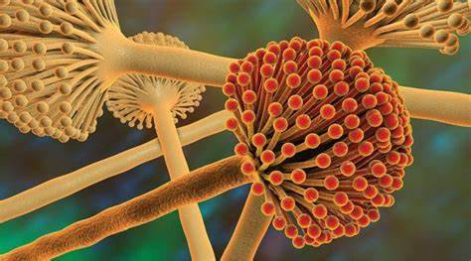

FACTORS THAT INFLUENCE THE GROWTH OF MICROORGANISMS

Food
- Bacteria grow best in protein- rich food while moulds and yeast grow best on carbohydrates.
- Meat, poultry, seafood, milk and milk products, rice and eggs are called potentially hazardous foods because they are most likely to carry pathogenic organisms. This is because of their high protein and liquid content, and their neutral pH.
Acidity (pH)
- pH is the measure of the acidity or alkalinity of a food.
- Most bacteria grow best in an environment that is neutral or slightly acidic.
- Fresh foods tend to have a neutral pH.
Temperature
- Microorganism grows fast and produce toxins between the temperatures of 5⁰C and 60 ⁰ C. This is danger zone.
Time
- Microorganisms need time to grow.
- When potentially hazardous food is placed in the danger zone for longer than two hours, pathogens multiply rapidly.
Oxygen
- Micro organism need oxygen to grow-Aerobic organism.
- Anaerobic micro-organisms only grow in the absence of oxygen.
Moisture
- Microorganism need water to grow and multiply
- Some microorganism can survive when there is little water, but they are not able to grow very well

Preventing the growth of microorganisms.
Microorganisms will not grow under the following circumstances:
- Low temperatures
- High temperatures
- Lack of moisture
- Lack of air
- Very acidic conditions.

NATURAL DECAY
Enzyme action
What are enzymes?
- Chemicals that occur naturally in food and cause chemical changes, e.g. apples and potatoes react with oxygen and become brown after peeling (Oxidation)
- Enzymes cause fruit and vegetables to ripen.
How to prevent enzyme action?
- Enzymes are destroyed by heat e.g. blanching or cooking.
- Fruit and vegetables should be cut just before use to minimize their exposure to air.
- The surface of fruit can be covered with lemon juice to stop oxidation.
Moisture loss
- Fruit and vegetables loose water after harvesting
- Cheese, meat and fish lose moisture through evaporation- store food correctly
How to prevent loss of moisture:
- Fruit and vegetables should be stored in a fridge, in a cool, dry place or in airtight container or plastic bag.
- Cheese, meat and fish should be wrapped and store in a cool place.

Moisture absorption
- Biscuits, rusks and chips -store dry foods in an airtight container

Insects and rodents
Food spoilage by insects and rodents can be prevented by:
- Keeping storage areas clean.
- Keeping food covered.
- Using flour before the ‘best- before’ date

CONTAMINATION BY MICROORGANISMS

 | DEVELOPMENT | TYPES OF FOODS
Bacteria | - Reproduce by dividing onto two.  - Most bacteria are harmless but pathogenic bacteria may cause illness. | - Meat, poultry, fish, eggs and milk and milk products
Yeast | - Need sugar to reproduce by budding and produce carbon dioxide and alcohol  (Fermentation) | - Raising agent in bread making, making wine and beer
Moulds | - Reproduce through spores that are carried through air.  - The toxins of moulds are called mycotoxins. | - Breads, biltong and pickled food  - Cheese (Blue cheese and Brie cheese)

TERMINOLOGY

TERM | EXPLANATION
- Blanching | - Is the cooking process in which a food, usually vegetables and fruit are scalded in boiling water.
- Fermentation | - A chemical process whereby organisms like yeast or bacteria are used to break carbohydrates into acids or alcohol.
- Oxidation | - Is a chemical reaction that take place between food and oxygen in the air.
- Scalding | - Heating of milk just below boiling point.

