Province of the
EASTERN CAPE
EDUCATION

DIRECTORATE SENIOR CURRICULUM MANAGEMENT (SEN-FET)
HOME SCHOOLING SELF- STUDY ANSWER SHEET
SUBJECT | ECONOMICS | GRADE | 11 | DATE | 22/04/2020
TOPIC | MACROECONOMICS MARKS: 30 | TERM 1  REVISION |  | TERM 2 CONTENT | X

QUESTION 1
1.1 | Answer the following questions
 | 1.1.1. | List any TWO examples of complementary goods  - Car and petrol  - Tea and sugar  (accept any other relevant correct answer) (2x1) |  | (2)
 | 1.1.2 | What would encourage a producer to continue increasing its production?  - Business will want to produce where additional income received from a unit is equal to the additional cost of producing the unit / where it is maximising its profits. |  | (2)
1.2 | Study the graph below and answer the questions that follow:
 | 1.2.1 | What does the shift from S to S1 show?  - An increase in supply |  | (1)
 | 1.2.2 | What is the impact on price of the shift in supply from S to S1?  - Increase in price of petrol |  | (1)
 | 1.2.3 | Briefly describe the term quantity supplied  - Quantity supplied is the quantity that sellers are willing and able to offer for sale at a given price over a specific period of time. |  | (2)
 | 1.2.4 | Explain the cause of a shift in supply from SS to S1S1  - Global Recession  - Increase in the price of coal  - Depreciation of the currency  - Accept any correct relevant response) (any 1x2) |  | (2)
 | 1.2.5 | Draw the graph of the complement product of petrol and indicate what the reaction would be.  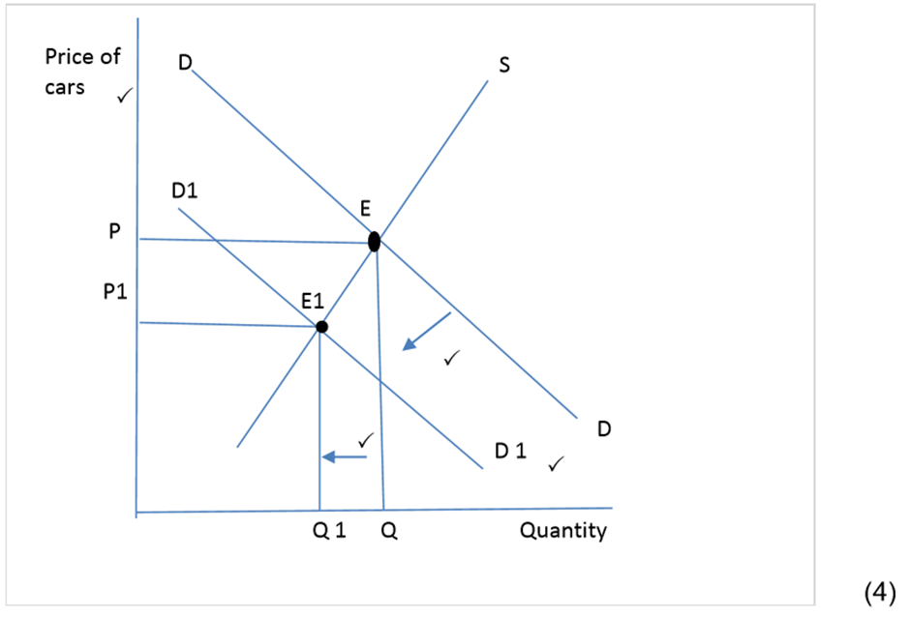 |  | (4)
1.3 | Differentiate between product and factor markets.  - Factor market is a market where factors of production can be bought and sold.  - The factor market is divided into the following:  - Capital market – for long term savings and borrowing  - Labour market  - Natural resource market  - Each factor of production receives a different income or remuneration, as follows:  - Capital – interest  - Labour – wages and salaries  - Natural resources/ land – rent  - Entrepreneurship - profit (Max 4)  PRODUCT MARKETS  - Product markets are markets where goods and services can be bought.  - The product market is subdivided into the following:  - Capital goods markets  - Consumer goods market for durable, semi – durable and non – durable goods  - Services market (Max 4) |  |  | (8)
1.4 | With the aid of graphs, explain how an increase in demand of a product affects the factor market.  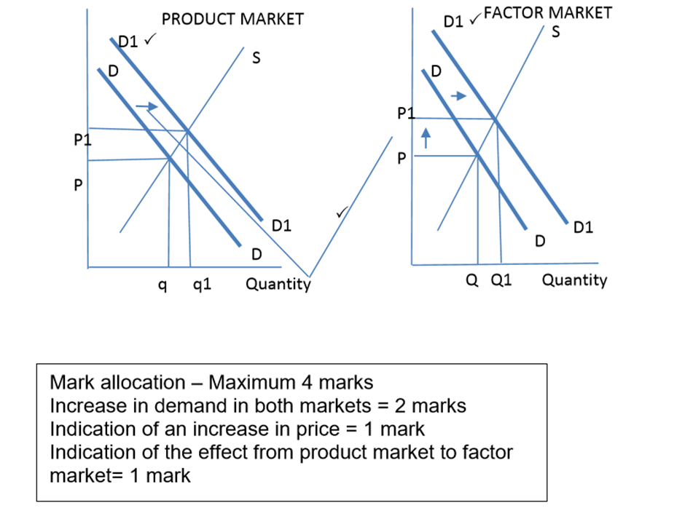  - When the demand for a certain product in the product market increases, this affects the demand for a natural resource producing the product.  - The demand for the product increases from DD to D1 D1. This will lead to an increase in demand in the factor market from DD to D1 D1.  - This results in the increase in price.  - For example, the increase in demand for clothing will result in an increase in demand for either cotton or silk, which are natural resources for the production of clothing. (Accept any relevant correct interpretation) Max. 4 |  |  | (8)
TOTAL |  |  |  | [30]

