Province of the
EASTERN CAPE
EDUCATION

DIRECTORATE SENIOR CURRICULUM MANAGEMENT (SEN-FET)
HOME SCHOOLING SELF- STUDY WORKSHEET
SUBJECT | ECONOMICS | GRADE | 11 | DATE | 21/04/2020
TOPIC | MACROECONOMICS | TERM 1  REVISION | X | TERM 2 CONTENT
TIME ALLOCATION | 40 MINUTES MARKS: 40 | TIPS TO KEEP HEALTHY  1. WASH YOUR HANDS thoroughly with soap and water for at least 20 seconds. Alternatively, use hand sanitizer with an alcohol content of at least 60%.  2. PRACTICE SOCIAL DISTANCING – keep a distance of 1m away from other people.  3. PRACTISE GOOD RESPIRATORY HYGIENE: cough or sneeze into your elbow or tissue and dispose of the tissue immediately after use.  4. TRY NOT TO TOUCH YOUR FACE. The virus can be transferred from your hands to your nose, mouth and eyes. It can then enter your body and make you sick.  5. STAY AT HOME.
INSTRUCTIONS | INSTRUCTIONS AND INFORMATION  - Answer ALL questions in the ANSWER BOOK  - Number the answers correctly according to the numbering system used in this question paper.  - Write the question number above each answer.  - Leave 2–3 lines between subsections of questions  - Write neatly and legibly.

QUESTION 1
1.1 |  |  | Answer the following questions:
 |  |  | 1.1.1 |  | List two methods of determining GDP. | (2x1) | (2)
 |  |  | 1.1.2 |  | Why are intermediate goods and services excluded when calculating the value of GDP? | (1x2) | (2)
 | 1.2 | Study the picture below and answer the questions that follow:
 | 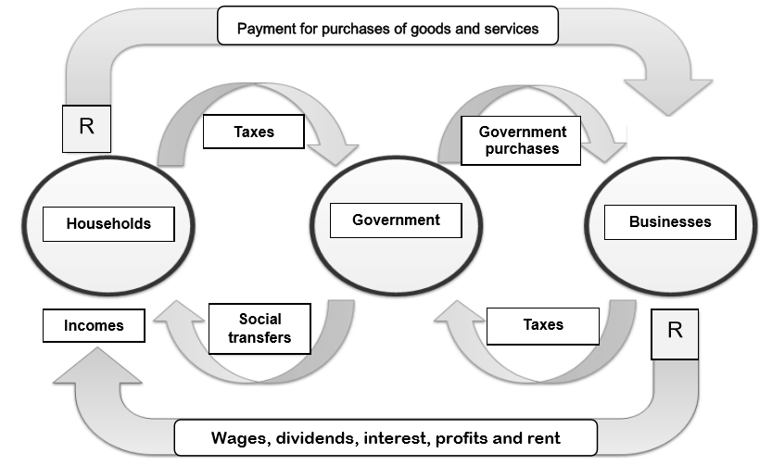 Adapted from google images
 |  | 1.2.1 |  | Identify ONE injection in the diagram above |  |  | (1)
 |  | 1.2.2 |  | Name the type of economy portrayed by the above diagram. |  |  | (1)
 |  | 1.2.3 |  | Briefly describe the term circular flow. |  |  | (2)
 |  | 1.2.4 |  | What is the main objective of social transfers? |  |  | (2)
 |  | 1.2.5 |  | Of what importance is the factor market in the circular flow? |  |  | (4)

1.3 | Study the table given below and answer the questions that follow
EXTRACT FROM NATIONAL ACCOUNTS OF SOUTH AFRICA AT CURRENT PRICES
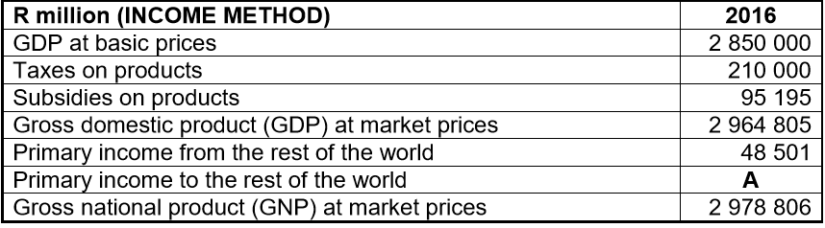
Source: SARB QB March 2016
 | 1.3.1 | Give an example of a primary income from the rest of the world. | (1)
 | 1.3.2 | What is the main function of GDP? | (1)
 | 1.3.3 | Briefly describe the concept market prices | (2)
 | 1.3.4 | Explain the difference between current prices and constant prices. | (2)
 | 1.3.5 | Calculate the value of primary income to the rest of the world (A) in the table. Show all calculations | (4)
1.4 | Explain the importance of final consumption expenditure by households. |  | (8)
1.5 | What is the main purpose of subsidies on production? |  | (8)
 |  |  | [40]

