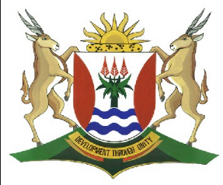
(a)
Province of the
EASTERN CAPE
EDUCATION

DIRECTORATE SENIOR CURRICULUM MANAGEMENT (SEN-FET)
HOME SCHOOLING SELF-STUDY WORKSHEET ANSWER SHEET
SUBJECT | GEOGRAPHY | GRADE | 11 | DATE | 18/5/20
TOPIC | Geomorphology  Topography Associated – Inclined strata | TERM 2  REVISION | √√ | TERM 2 CONTENT | √√

- Answer Sheets on Topography associated with inclined Strata
- Please revise all concepts before going through your worksheet.
- Revise at least 1 hour per day.
- Please revise question papers from 2014 to 2019 on the ECEXAMS website

Answer sheet to Topography associated with inclined strata
1.1.
 | 1.1.1 | A (1)
 | 1.1.2 | A (1)
 | 1.1.3 | B(1)
 | 1.1.4 | A (1)
 | 1.1.5 | B (1)
 | 1.1.6 | A (1)
 | 1.1.7 | B (1)
 | 1.1.8 | A (1) | (8x1) | 8
1.2.
 | 1.2.1 | Homoclinal ridge has a dip slope angle of 25°– 45° (1)  Cuesta has a dip slope angle of 10°– 25° (1) | (2x1) | (2)
 | 1.2.2 | Sedimentary rocks(1) | (1x1) | (1)
 | 1.2.3 | Faulting (1)  Folding (1)  (Any ONE) | (1x1) | (1)
 | 1.2.4 | (a) The dip slope is gentler than the scarp slope (2)  (b) There is more undercutting as softer material  is underneath the resistant layer (2)  The dip slope is on the resistant layer and is therefore difficult to erode (2) | (1x2)  (2x2) | (2)  (4)
 | 1.2.5 | The scarp slope is too steep for agricultural activities (2)  Soil is too thin on the dip slope (2)  Infrastructure like roads and railway lines are very costly to construct (2)  (Any TWO) | (2x2) | (4)
 |  |  | [14]

