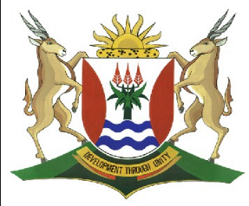
Province of the
EASTERN CAPE
EDUCATION

DIRECTORATE SENIOR CURRICULUM MANAGEMENT (SEN-FET)
HOME SCHOOLING SELF-STUDY WORKSHEET ANSWER SHEET
SUBJECT | GEOGRAPHY | GRADE | 11 | DATE | 18/5/20
TOPIC | SLOPES | TERM 2  REVISION | √√ | TERM 2 CONTENT | √√

- Answer Sheets on Slope
- Please revise all concepts before going through your worksheet.
- Revise at least 1 hour per day.
- Please revise question papers from 2014 to 2019 on the ECEXAMS website

Answer sheet to Slopes

1.1.
 | 1.1.1 | Crest
 | 1.1.2 | Talus
 | 1.1.3 | Pediment
 | 1.1.4 | Knickpoint
 | 1.1.5 | Escarp
 | 1.1.6 | Escarp
 | 1.1.7 | Crest
 | 1.1.8 | Escarp | (8x1) | 8
1.2.
 | 1.2.1 | A
 | 1.2.2 | B
 | 1.2.3 | C
 | 1.2.4 | B
 | 1.2.5 | D
 | 1.2.6 | D
 | 1.2.7 | C | (7x1) | (7)
 |  |  |  | [15]

