Province of the
EASTERN CAPE
EDUCATION

DIRECTORATE SENIOR CURRICULUM MANAGEMENT (SEN-FET)
HOME SCHOOLING SELF-STUDY ANSWER SHEET
SUBJECT | ECONOMICS | GRADE | 12 | DATE | 21/04/2020
TOPIC | MICROECONOMICS MARKS: 40 | TERM 2  REVISION |  | TERM 2 CONTENT | X

QUESTION 1:
DBE Nov 2018

- Discuss, with the aid of graphs, the consequences of market failure under the following headings: −.
- Producer subsidies (8 marks)
- Maximum prices (8 marks)
- Minimum wages (10 marks) (26)

- With reference to the graph below, analyse how a negative externality can result in the misallocation of resources. (10) [40]
INTRODUCTION
- Market failure is when the market fails to produce sufficient (optimum) quantities that people want.  Accept any other relevant introduction (Max 2) | (2)
BODY
MAIN PART
Producer Subsidies
- A subsidy is a form of financial grant to support the production of a good or service by the government by lowering the cost of production
- Subsidies can be direct (e.g. cash grants) or indirection (e.g. depreciation write-off).
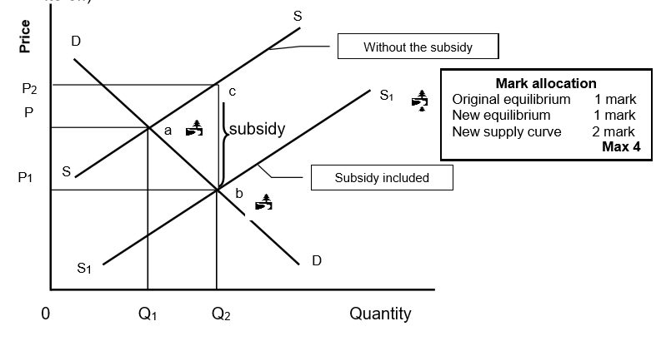
- The market price decrease from P to P2, and the quantity consumed will increase from Q to Q1 due to the subsidy paid by government
- The producer benefits from a subsidy/producer's profit increases (the difference between P and P2)
- The consumer benefits from a subsidy by paying less (price decreased from P to P1)
- Producer subsidies are often given to suppliers of agricultural products such as milk, wheat and maize
(Max 6)
Maximum Prices
- Sometimes the government will set the price of a good or service at a maximum price that is below the market price/The government intervenes and passes a law that suppliers may not charge more than the maximum price

- Maximum price are usually set on basic goods, such as food and transport so that citizens have access to certain goods and services and achieve a certain minimum standard of living

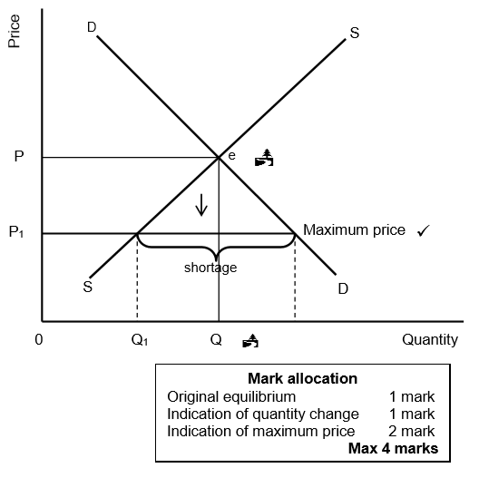
- In the figure above, the maximum price is set at P1, while the market price is at P
- The immediate effect would be that the quantity supplied will drop from Q to Q1
- The shortage caused by the price ceiling creates a problem of how to allocate the good since the demand will exceed the supply
- Black markets often develop where illegal goods are bought or sold (Max 6)
Minimum Wages
- When the government enforces a minimum wage, it means workers have to be paid a certain minimum remuneration that will lead to a higher standard of living / increased satisfaction of wants.  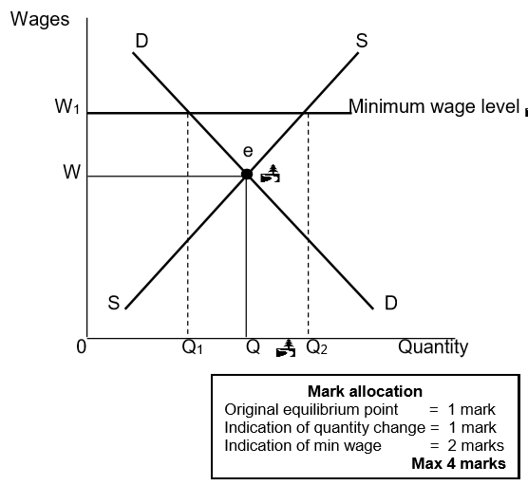  - The graph shows that if the wage rate is set at W, the corresponding demand and supply of labour will be Q  - If a minimum wage of W1 is set, the demand for labour will decrease from Q to Q1. Some people may become unemployed  - However, the supply of labour will increase from Q to Q2. As more people will offer their labour because of a higher income  - Minimum wages will lead to more bargaining power of workers (Max 8)  (Accept any other correct relevant response) (Allocate a maximum of 8 marks for the mere listing of facts/examples). (Max. 26) | (26)
ADDITIONAL PART
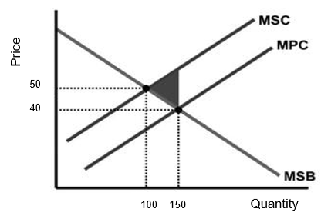  A negative externality results in the misallocation of resources:  - Because external costs are not included in the price when the market produces 150 units  - If external costs are included the supply will decrease and market will produce at 100 units at a higher price of R50, that is socially desirable  - Since the market does not take external cost into account it over-produces thus more resources than it socially desirable is used  - harming other producers or consumers through the behaviour of certain producers that impact negatively on the cost structure of other participants  - charging a price of R40 for quantity 150 sold, that represents only private cost (MPC)  - reaching the socially optimal point of production if social cost is taken into account, that will lead to a price increase to 50 and the quantity reducing to 100  - producing too much of a good which has a negative externality (welfare loss) indicated by the shaded area on the graph  - at R40 if the market is left to its own devices, a quantity of 150 will be produced (socially insufficient) (Max 10) | (10)
CONCLUSION
- Government involves itself directly in the market when the market does not act in the interest of society  (Accept any other correct relevant conclusion.) (Max 2) | (2)
 | [40]

