Province of the
EASTERN CAPE
EDUCATION

DIRECTORATE SENIOR CURRICULUM MANAGEMENT (SEN-FET)
HOME SCHOOLING SELF- STUDY ANSWERSHEET
SUBJECT | ECONOMICS | GRADE | 12 | DATE | 12/05/2020
TOPIC | MICROECONOMICS & CONTEMPORARY ECONOMIC ISSUES MARKS: 40 | TERM 1  REVISION |  | TERM 2 & 3 CONTENT | X

QUESTION 1: MICROECONOMICS AND CONTEMPORARY ECONOMIC ISSUES 40 MARKS – 30 MINUTES
1.1 | Answer the following questions.
 | 1.1.1 | State any TWO benefits for the government of levying taxes on tourists.  - To recover external costs √  - To earn revenue (to create jobs / to reduce poverty) √  - To improve infrastructure √  (Accept any other correct relevant responses)  (2 x 1). | (2)
 | 1.1.2 | What impact do maximum prices have on the market?  - Maximum prices create a shortage of goods in the market √√  - Producers can divert their products to the informal market (black market) √√  - Lower income earners can afford the product √√  (Accept any other correct relevant responses) (1 x 2). | (2)
1.2 | DATA RESPONSE √√
 | 1.2.1 | Identify the number of houses the market will provide if all resources were spent on houses.  10 000 √ | (1)
 | 1.2.2 | How many schools should the government provide to reach the social optimum allocation?  6 000 √ | (1)
 | 1.2.3 | Briefly describe the term market failure.  When the free market is unable to allocate resources efficiently / the best production outcome has not been achieved √√ | (2)
 | 1.2.4 | Why are markets reluctant to produce public goods such as roads?  - It requires a huge capital outlay which is challenging for the private sector √√  - It is difficult to charge higher prices and therefore profits are compromised √√  - The nature of the goods is non-rival (consumption by one does not reduce the amount available for somebody else) √√  - Some of the goods are non-excludable (difficult to prevent people from using the good) √√ (Accept any other correct relevant response) | (2)
 | 1.2.5 | How can the government ensure macroeconomic stability through their involvement in production?  Government can ensure macroeconomic stability in production by:  - using the monetary and fiscal policy through interest rates and corporate taxes √√  - using the supply-side approach by applying policy to increase the flexibility of factors of production and infrastructure √√  - producing goods (missing markets) not provided by the market √√  (Accept any other correct relevant response) (2 x 2) | (4)

1.3 | DATA RESPONSES
 | 1.3.1 | Name any ONE other World Heritage Site.  - Mapungubwe √  - Vredefort Dome √  - Sterkfontein Caves (Cradle of Human Kind) √  - Robben island √  - Richtersveld cultural and botanical landscape √  (Accept any other correct relevant response) | (1)
 | 1.3.2 | What type of tourism is indicated in the data above?  Cultural √ | (1)
 | 1.3.3 | Briefly describe the term indigenous knowledge system (IKS).  Knowledge that has practical application for daily survival for local communities/the history and uniqueness of certain destinations in a country/the local knowledge that is unique to a given society or culture √√  (Accept any other correct relevant response) | (2)
 | 1.3.4 | In what way can businesses use the knowledge of indigenous people to benefit tourism?  - They could create a cultural village for tourists to visit √√  - Tours into the area to observe the way of life, for example the hunting methods of the San people √√  - Use of plants and herbs for medicinal purposes √√  (Accept any other correct relevant responses) | (2)
 | 2.3.5 | Why is infrastructure development important in promoting tourism?  - Tourists require basic services such as good roads and a communication network to ensure an enriching experience √√  - Rural communities that have unique lifestyles require good infrastructure to benefit from tourism √√  - Basic infrastructure development could lead to an increase in social infrastructure such as clinics and hospitals that will benefit tourism √√  (Accept any other correct relevant responses) (2 x 2) | (4)
1.4 | Use a graph of total cost (TC) and total revenue (TR) to explain profit maximisation in a perfect market. |  | (8)
 | 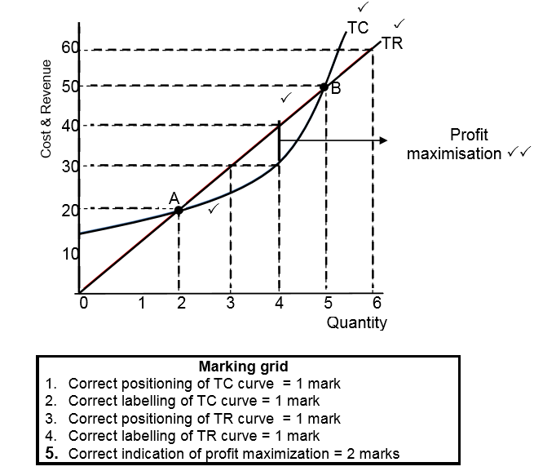
- The firm will make profits between points A and B (TR and TC) where the total revenue exceeds the total cost √√
- Profit is maximised when the gap between TR and TC is the greatest √√
- This occurs at 4 units of production at a cost of R40 √√
- Breakeven points will occur at points A and B √√
(Accept any other correct relevant response).
1.5 | Critically discuss the challenges countries face in reducing the production of hazardous waste.
 | Countries worldwide find it difficult to decrease the production of hazardous waste by:  - producing goods in modern economies which automatically leads to chemical waste as by-product √√ this will mean that hazardous waste could only be reduced if production decreases which would contribute to more unemployment √√  - exporting hazardous waste to developing countries at a price √√ this gives them an opportunity to get rid of excess waste √√ because many African countries like the Ivory Coast allows this activity as it is a source of income √√  - increasing economic activities such as manufacturing and agricultural production that exceed the measures used by government to restrict or dispose of hazardous waste √√ more research should be done on using non-hazardous materials and alteration of product composition to reduce waste √√  - businesses not handling the hazardous waste by following the regulations put in place √√ where handling of chemicals requests precaution to be disposed in designated areas (for the sake of saving money) many firms often dump these chemicals in the environment √√  - generating hazardous waste is also found in households although on a much smaller scale such as left over paints √√ the big challenge remains to change the mind-set of people by educating households to reduce the usage of products that is regarded as hazardous waste like e-waste where computers are sold in developing countries (that should have been hazardous waste in the country of origin) √√  (Accept other correct relevant higher order response)  (Allocate a maximum of 2 marks for mere listing of facts or examples) |  | (8)
 |  |  | [40]

