GRADE 12

REVISION BOOKLET
2020
ECONOMICS PAPER 2

INSTRUCTIONS AND INFORMATION TO LEARNERS

1. | You must know which topics constitute Paper 2  See Annexure A for the distribution

2. | PURPOSE OF THESE QUESTIONS  - This booklet comprises of NSC Questions from previous examinations  - This booklet will help you to revise the topic (s) you have studied to prepare for tests and examination.  - You will get different questions on the same topic as a form of expanding your knowledge.  - Write down your answers before referring to the “Solution Booklet”

3. | HOW TO USE THE REVISION BOOKLET?  - The questions are grouped into Micro econ and Contemporary Econ issues for similar questions.  - Read the questions, then study thereafter attempt to answer the questions.  - You then open your textbook and answer the questions using your book. Refer to the 2017 Examination Guidelines for details of content to be covered in Grade 12  - Compare your answers.  - Submit your final product to the teacher for marking. Peer marking can also be used  - Refer to NSC, SC, EC Question Papers & other Question Papers from other provinces to prepare for Tests and Examination. The Booklet is not inclusive of all the previous NSC examination papers

4. | HOW TO ANSWER QUESTIONS  - MULTIPLE CHOICE  - Cover the options provided, and read the questions then supply the answer from your head thereafter open the given options to look for an answer that is close to your answer. (NB: the options provided may be confusing but if you provide the answer from your head it will be easy)  - SECTION B  - YOU WILL NOTICE THAT IT IS DIVIDED INTO 5 SUBQUESTIONS  - 2.1.1. Easiest question recall knowledge (Name/state/list)  - 2.1.2. It needs application and when you answer it you must write a full  sentence (How, what, explain the effect etc.)  - 2.2. & 2.3. [ DATA RESPONSE QUESTIONS]  - DON’T BE INTIMIDATED BY THE CARTOONS AND DIAGRAMS.  - Most of the time these are just there to remind you about the topic on which the questions are based, mostly the answers do not necessarily come from the extract.  - If intimidated, just cover the data response and read the questions try to answer them then you go to the data response to read it and make some addition where necessary  - 2.4. & 2.5. These require more from you (write full sentences but try  to be brief.  - SECTION C.  - Read and analyse the question so that when you answer you are sure of what is required. (Most often the question starts by stating a point then proceeds to inform you of what you should discuss usually not the stated fact that has been mentioned.  - When you answer, you must structure your response such that you have an Introduction, Main Part, Additional Part and the Conclusion. (Write these as Headings)  - At the beginning of Section C you are guided on how to structure your essay so you have to follow that guideline. It gives you a clue on how to structure your Introduction up to conclusion.

5. | EXAM TIPS  - Go to the exam room prepared  - Revise each topic after it has been completed. For e.g. if Microeconomics is completed in Term 2, collect all previous NSC, Trial & June or February / March papers and revise this topics in totality before Trial / Final Examination  - Study well in advance before the date of writing your exam.  - Draw a study table for all the subjects you are studying

7. | IN THE EXAM ROOM  - Be punctual  - Bring your ID document and exam timetable  - Bring at least TWO pens, a calculator, ruler, lead pencil & eraser.  - Relax  - Read the instructions carefully  - Choose the questions that you are going to answer as follows:-  - SECTION A: COMPULSORY [30]  - SECTION B: CHOOSE TWO QUESTIONS [40x2=80]  - SECTION C: ANSWER ONE QUESTION [40]  NB: IF You answer more than the required number, you will not get marks from the extra questions.  - Start a question on a new page.

ANNEXTURE A
PAPER 1 (1.A &1.B.) |  | PAPER 2
1.A. MACROECONOMICS |  | 2.A. MICROECONOMICS
- Circular flow  - Business cycles  - Public sector  - Foreign exchange markets  - Protectionism and Free Trade |  | - Perfect markets  - Imperfect markets  - Market failures
1.B. ECONOMIC PERSUITS |  | 2.B. CONTEMPORARY ECONOMIC ISSUES
- Growth & Development  - Industrial development policies  - Economic concepts and social performance indicators |  | - Inflation  - Tourism  - Environmental sustainability

 | REVISION BOOKLET
 | MICRO ECONOMICS
 | DYNAMICS OF PERFECT MARKET
1.1.1 | What will the effect be if one firm in a perfect market decides to increase the price of a product? | (2)
1.1.2 | What is the effect on a business if the average cost is more than the average revenue? | (2)
1.1.3 | Why is the demand curve of the individual producer horizontal (flat)? | (2)
1.1.4 | How can consumers benefit from increased competition in the economy? | (4)
1.1.5 | Why will output in the goods market increase when businesses in the perfect market make economic profit? | (2)
1.1.6 | What is the role of the Competition Commission? | (2)
1.1.7 | Distinguish between economic profit and normal profit in the perfect market. | (8)
1.1.8 | Briefly discuss the number of businesses and nature of the product as characteristics of a perfect market structure. | (8)
1.1.9 | Motivate why the government implements minimum wages in the labour market. | (8)
1.1.10 | What are the objectives of the Competition Act, 1988 (Act of 1998) in South Africa? | (8)
1.1.11 | With the aid of a graph, explain why marginal cost must be equal to marginal revenue for profits to be maximised | (8)
1.1.12 | Explain the long-term equilibrium of a firm under perfect competition | (8)
1.1.13 | Explain by means of a neatly labelled graph the relationship between the shut-down point and the supply curve (MC) of the individual business in the perfect market. | (8)
DYNAMICS OF IMPERFECT MARKETS
1.2.1 | What favourable conditions may the monopolist enjoy in comparison to other market structures? | (4)
1.2.2 | Explain how price leadership works in the oligopoly. | (4)
1.2.3 | Why are oligopolists reluctant to compete with each other on price in order to get a greater share of the market? | (2)
1.2.4 | What prevents monopolies from charging excessively high prices? | (2)
1.2.5 | Differentiate between the nature of the product under monopolistic competition and under monopoly. | (8)
1.2.6 | Distinguish between price leadership and cartels as forms of collusion | (8)
1.2.7 | How can firms in an oligopoly increase their market share in the economy? | (8)
1.2.8 | Briefly discuss the demand curve of the monopolist | (8)
1.2.9 | How will a monopolist be more advantaged than a producer in a perfect market?
1.2.10 | Why is Eskom regarded as a natural monopoly?
1.2.11 | Explain why the monopolist will not fix the price lower than centre point of the demand curve.
1.2.12 | Draw a comparison between a perfect market and a monopoly with regard to prices, profit, quantities and cost.
1.2.13 | Distinguish between natural and artificial monopolies
1.2.14 | Explain why it is difficult for the oligopolists to compete with the price.

MARKET FAILURES AND COST BENEFIT ANALYSIS
1.3.1 | Give two reasons for the cost benefit analysis | (2)
1.3.2 | Analyse productive inefficiency with the aid of a production possibility curve. | (8)
1.3.3 | Explain how the immobility of factors of production can cause market failure | (8)
1.3.4 | What are the effects of the implementation of minimum wages in South Africa? | (8)
1.3.5 | Explain the uses of the cost-benefit analysis (CBA). | (8)
1.3.6 | Explain, by means of a neatly labelled graph, how negative externality results in the misallocation of resources | (8)
1.3.7 | Explain two types of inefficiencies. | (8)
1.3.8 | Why do externalities not have a price attached to them?

ECONOMIC CONCEPTS
Give one term for each of the following descriptions.
A wage rate by the government below which no employer may pay his/her workers
The period of production where only the variable factors of production can change
The value of the next best alternative
The additional cost incurred when production increases by one more unit
Businesses working together in an oligopoly market to fix prices
A market that lacks optimum resource allocation and is unable to produce the quantity of goods that people want
An increase in prices of goods due to an increase in input costs
The minimum profit required to prevent an entrepreneur from leaving the industry
The amount by which the total cost increases when an extra unit is produced
The profit that a business makes that is more than the normal profit
The cost that the community incurs
A section of the economy that produces goods and services of the same kind
Prices of goods and services that are set by the government
A group of producers whose goal is to form a collective monopoly
The period where all factors can change
Profit made in addition to normal profit
A price set above the equilibrium price
A situation where one firm fixes a price and the others accept it as the market price
A market structure containing elements of both the perfect- and monopoly markets
The amount a firm earns for every unit sold
Goods that are highly desirable for general welfare.
A situation where it is impossible to increase the welfare of one person without making another one worse off
The costs that remain the same even if the output changes
The point where average revenue (AR) is equal to average variable cost (AVC)
A formal organization of oligopolists formed to control the market
The sum total of private benefits and external benefits
A mechanism that brings together buyers and sellers of goods or services
The positively sloped part of the marginal cost curve in a perfectly competitive firm.
Goods provided by the state
The positively sloped part of the marginal cost curve in a perfectly competitive firm.
The cost or benefit arising from any activity, which does not benefit the person or the organisation carrying on the activity
The price where the quantity demanded is equal to the quantity supplied
An alternative concept for the point where a firm in a perfect market makes a normal profit (33 x 2)

DATA RESPONSE QUESTIONS
 | Study the diagram below and answer the questions that follow.
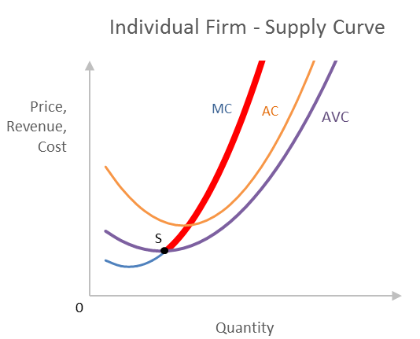
T
 | Explain the term marginal cost. | (2)
 | What is the thicker part of the MC curve called? | (2)
 | Name the point on the MC curve where the firm will shut down production | (2)
 | Why will the firm stop its production at that specific point? | (4)
 | Study the illustration below and answer the questions that follow.
 | To which game is the heading above referring ? | (1)
 | Why is the competition board watching | (2)
 | List the three institutions responsible for promoting fair competition in South Africa | (3)
 | In your opinion how will the economy benefit from fair competition? | (4)
 | Study the illustrations below and answer the questions that follow
 | 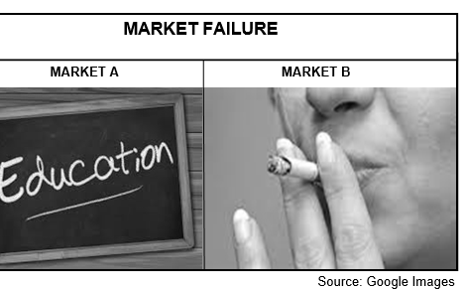
 | Explain the term market failure | (2)
 | What can government do to resolve the failure in the market for good A? | (2)
 | Which ONE of the markets is suffering a shortage? | (2)
 | How can the goods above cause market failure/ | (4)
 | 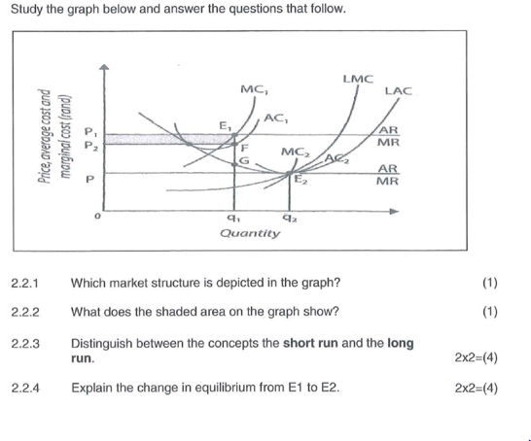
 | 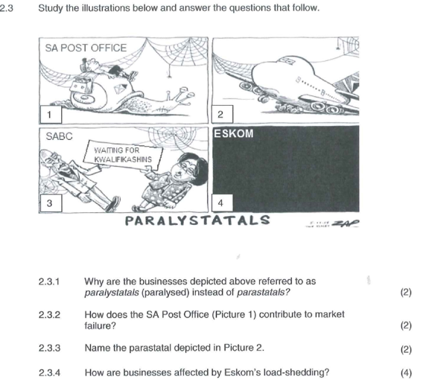
 | Study the diagram below and answer the questions that follow
 | 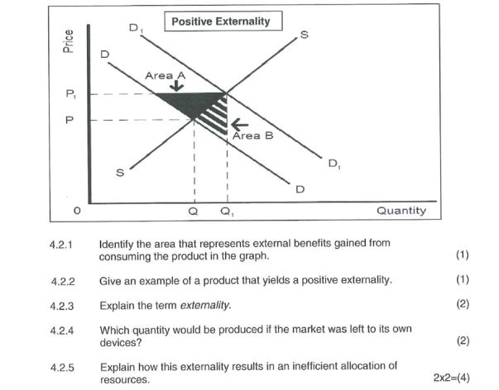
Study the following diagram of a firm’s cost and revenue curves and answer the questions that follow:

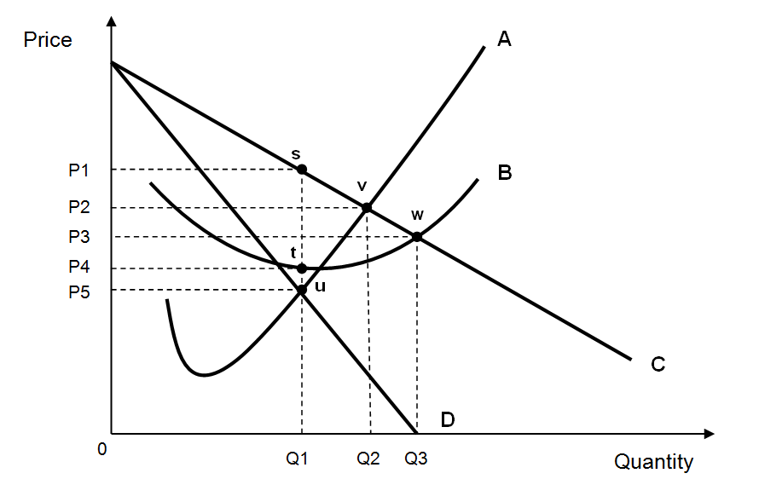

2.2.1 Identify the curves labelled A and D. (2x1) (2)

2.2.2 What type of market structure is this firm operating in? (2)

2.2.3 At what level of output and price will this firm be maximising profits? (2)

2.2.4 Identify the area where total profit is earned by the firm. (4)

Study the article below and answer the questions that follow.

Johannesburg - Fifteen of the construction firms which were fined R1.46bn over a collusion racket will be facing a host of civil damages claims, reported City Press on Sunday.

Last year the Competition Commission fined the major construction firms a collective R1.46bn for anti-competitive behaviour and inclusive tendering relating to projects concluded between 2006 and 2011.

Now, some of the largest construction companies in the country are set to be slammed with civil damages claims.

The hardest hit appears to be WBHO, which has 27 claim certificates issued against it by the competition tribunal.

Source: Fin24.com

2.3.1 What is the role of the Competition Commission? (2)

2.3.2 Mention other two institutions working in relation to competition policy (2)

2.3.3 According to the article, the major construction firms were fined for“anti- competitive behavior and inclusive tendering”. Explain. (2)
2.3.4 Explain who would be claiming “civil damages’ against the construction firm and why they would be doing so. (4)

 | Study the following graph and answer the questions that follow.
 | Name the graph above. | (2)
 | Identify the profit maximisation point in the graph. | (2)
 | How is the price determined in this market? | (2)
 | Calculate the total profit/ loss made by this firm. Show calculations. | (4)

ESSAYS
1 | The existence and survival of any business depends on how they are conducting themselves.  Compare the market structure of a monopoly with that of a perfect competitor. (26 marks)  • Draw a clearly labelled graph indicating the shut-down point for the perfect competitor. Briefly explain why a business will stop producing goods at this point. (10 marks) | [40]
2 | Under perfect market conditions the market price of products is determined through the interaction of supply and demand.  - Discuss perfect competition under the following headings:  - A comparison of the demand curve of the individual producer and industry  - Profit maximisation  Make use of graphs to support your discussion. (26)  - In your opinion, does the Competition Act of South Africa promote fair competition? (10) | [40]
3 | A monopoly is the extreme opposite of a perfect competitive market.  - Examine the monopoly as a market structure.  (26 marks)  - With the aid of a neatly labelled graph, explain long-run equilibrium of the monopolist. (10 marks) | [40]
4 | Market failure is a common feature of free market economies.  • Discuss the causes of market failure in detail. (26 marks)  • With the aid of a graph (PPC) explain how productive efficiency can be achieved in the market. (10 mark) | [40]
5 | Governments uses various instruments at their disposal to correct or limit market failures.  - Draw a clearly labelled graph explaining the consequences of government intervention in the market for each of the following:  - Maximum prices  - Taxation (26 marks)  - In your opinion, how has the implementation of minimum wages advantaged the worker in South Africa? (10 marks) | [40]
6 | Markets are broadly categorised into perfect and imperfect markets. However, in reality very few examples of perfect markets exist.  - Examine the conditions of a perfect market in detail. (26 marks)  - Draw a clearly labelled graph to show economic profit for an individual producer in the market. (10 marks | [40]

CONTEMPORARY ECONOMIC ISSUES
TOURISM
 | How can tourism influence the lives of poor people near tourist destinations?
 | Give TWO examples of World Heritage Sites in South Africa.
 | Discuss the economic benefits of tourism for the government and infrastructure development.
 | Explain the term tourism.
 | Why is South Africa such a popular holiday destination?
 | What is the impact of indigenous knowledge within the South African context on tourism?
 | How can tourism eradicate poverty in South Africa? (2 x 1) | (2)

INFLATION
What is the inflation target range set by the SARB?

What negative influence will inflation have on the balance of payments

Why is core inflation lower than the CPI?

How can the government use fiscal policy to combat inflation?
Why would you exclude food from the CPI basket when calculating core inflation?

Give TWO examples of prices that are controlled by the South African government.

What will happen to employment when the cost of production increases?

Why is inflation regarded as a never-ending process?

What is the current inflation target range?

What is the main purpose of the South Africa's inflation targeting policy?

What is the impact of inflation on investors and savers?

Discuss taxation as a fiscal measure to combat inflation.

Define the concept inflation.

ENVIRONMENTAL SUSTAINABILITY
What are the benefits of using technology in sustaining the environment? (4 x 2)
How can people reduce transport fuel consumption in order to sustain the environment?
In your opinion, why are non-renewable resources referred to as 'dirty'?
•
Why industries are often accused of contributing to land and water pollution?

Give TWO examples of the preservation of the environment.

Explain environmental taxes and marketable permits as intervention strategies to achieve environmental sustainability.

What is the effect of climate change on weather patterns?

In your opinion, how can conservation and preservation contribute to a better environment?

DATA RESPONSE QUESTIONS

 | Study the information below and answer the questions that follow
 | 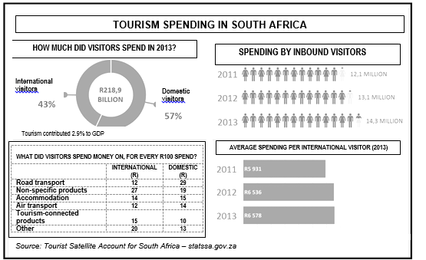
 | Define the term inbound visitors | (2)
 | List TWO examples of tourist connected products | (2)
 | Determine the change in spending by inbound tourists between 2011 and 2013 | (2)
 | How much rand did the domestic visitors spend in 201? | (2)
 | What can local sellers do to encourage international visitors to spend more money during their visit in South Africa? | (2)
 | Study the picture and answer the questions that follow
 | 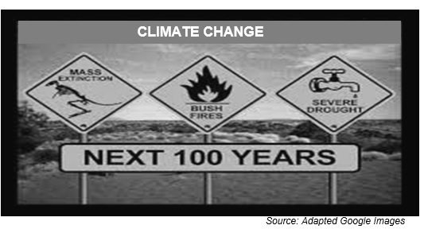
 | Explain climate change | (2)
 | What can be regarded as the main reason of climate change? | (2)
 | What message is depicted in the picture? | (2)
 | In your opinion what can be done to prevent the outcome of climate change as illustrated above? | (4)
 | Study the extract below and answer the questions that follow.
 | 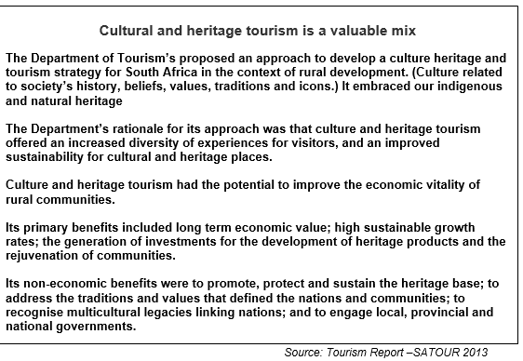
 | What is the meaning of the concept valuable mix? | (2)
 | Define the term indigenous heritage | (2)
 | How can cultural and heritage tourism improve rural communities? | (2)
 | Explain the non-economic benefits derived from cultural and heritage tourism | (4)
ESSAY

 | Tourism is the fastest growing industry in the world.  - Examine in detail the effects of tourism on the South African economy.  (26 marks)  - How can indigenous knowledge systems be used to promote tourism in South Africa? (10 marks) | [40]
 | Inflation is a phenomenon that many countries in the world have to deal with.  • Examine in detail the causes of cost-push inflation. (26)  • Has South Africa's inflation-targeting policy been beneficial to the economy? Motivate your response. (10) | [40]
 | The current levels of pollution and environmental degradation are too high and this affects the ability of the environment to survive its use for economic activities.  • Discuss government's attempts (interventions and control) to ensure the sustainability of our environment. (26 marks)  • In your opinion, how effective is pollution control measures in South Africa? (10 marks) | [40]
 | Tourism is one of the fastest growing industries worldwide.  • Critically discuss the effects of tourism. (26 marks)  • Evaluate how tourism benefits the households in your community by using appropriate examples. (10 marks) | [40]
 | Inflation is a non-excludable reality and has an impact on every citizen.  - Analyse the negative consequences of inflation. (26 marks)  - What measures will you suggest to combat inflation in South Africa?  (Ignore the traditional Monetary and Fiscal measures) (10 marks | [40]

