Province of the
EASTERN CAPE
EDUCATION

DIRECTORATE SENIOR CURRICULUM MANAGEMENT (SEN-FET)
HOME SCHOOLING SELF- STUDY WORKSHEET
SUBJECT | ECONOMICS | GRADE | 12 | DATE | 12/05/2020
TOPIC | MICROECONOMICS & CONTEMPORARY ECONOMIC ISSUES MARKS: 40 | TERM 1  REVISION |  | TERM 2 & 3 CONTENT | X
TIME ALLOCATION | 30 MINUTES MARKS: 40 | TIPS TO KEEP HEALTHY  1. WASH YOUR HANDS thoroughly with soap and water for at least 20 seconds. Alternatively, use hand sanitizer with an alcohol content of at least 60%.  2. PRACTICE SOCIAL DISTANCING – keep a distance of 1m away from other people.  3. PRACTISE GOOD RESPIRATORY HYGIENE: cough or sneeze into your elbow or tissue and dispose of the tissue immediately after use.  4. TRY NOT TO TOUCH YOUR FACE. The virus can be transferred from your hands to your nose, mouth and eyes. It can then enter your body and make you sick.  5. STAY AT HOME.
INSTRUCTIONS | INSTRUCTIONS AND INFORMATION  - Answer ALL questions in the ANSWER BOOK  - Number the answers correctly according to the numbering system used in this question paper.  - Write the question number above each answer.  - Leave 2–3 lines between subsections of questions  - Write neatly and legibly.

QUESTION 1: MICROECONOMICS AND CONTEMPORARY ECONOMIC ISSUES 40 MARKS – 30 MINUTES
1.1 | Answer the following questions.
 | 1.1.1 | State any TWO benefits for the government of levying taxes on tourists. (2 x 1) | (2)
 | 1.1.2 | What impact do maximum prices have on the market? (1 x 2). | (2)
1.2 | Study the graph below and answer the questions that follow.
 |  | 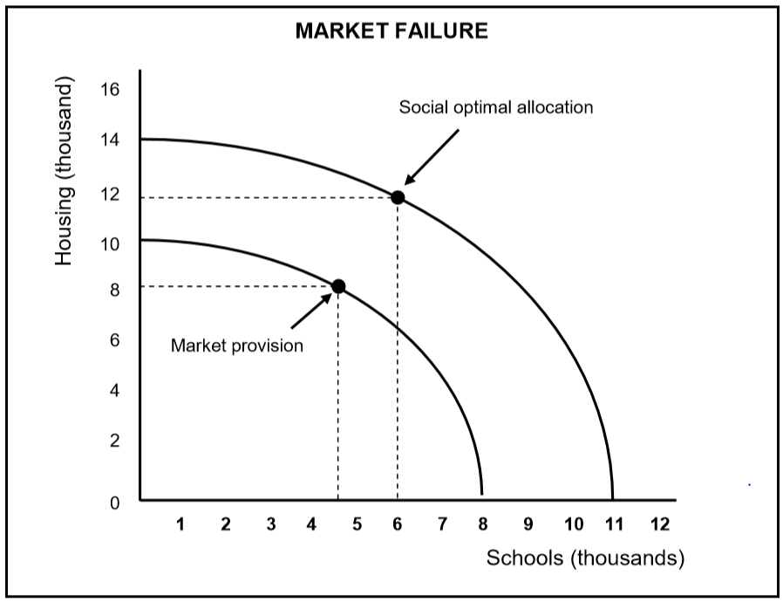
 | 1.2.1 | Identify the number of houses the market will provide if all resources were spent on houses. | (1)
 | 1.2.2 | How many schools should the government provide to reach the social optimum allocation? | (1)
 | 1.2.3 | Briefly describe the term market failure. | (2)
 | 1.2.4 | Why are markets reluctant to produce public goods such as roads? | (2)
 | 1.2.5 | How can the government ensure macroeconomic stability through their involvement in production  (2 x 2) | (4)

1.3 | Study the information below and answer the questions that follow.
SOUTH AFRICA'S NEWEST WORLD HERITAGE SITE
The Khomani Cultural Landscape is South Africa's newest World Heritage Sites according to the United Nations Educational, Scientific and Cultural Organisation (UNESCO) .

This landscape protects what remains of the once nomadic San people. The Khomani San are one of the only groups of San still practising their traditional hunter-gatherer way of life, within the Kgalagadi Transfrontier Park (huge semi-desert wilderness in the north of the country).
[Adapted from Indaba Tourism Guide, 2017]

 | 1.3.1 | Name any ONE other World Heritage Site. | (1)
 | 1.3.2 | What type of tourism is indicated in the data above? | (1)
 | 1.3.3 | Briefly describe the term indigenous knowledge system (IKS) | (2)
 | 1.3.4 | In what way can businesses use the knowledge of indigenous people to benefit tourism? | (2)
 | 2.3.5 | Why is infrastructure development important in promoting tourism? (2 x 2) | (4)
1.4 | Use a graph of total cost (TC) and total revenue (TR) to explain profit maximisation in a perfect market. |  | (8)
1.5 | Critically discuss the challenges countries face in reducing the production of hazardous waste. |  | (8)
 | SC/NSC DBE/2019 |  | [40]

