Province of the
EASTERN CAPE
EDUCATION

DIRECTORATE SENIOR CURRICULUM MANAGEMENT
(SEN-FET)
HOME SCHOOLING SELF-STUDY WORKSHEET
SUBJECT | GEOGRAPHY | GRADE | 12 | DATE | 15/05/20
TOPIC | URBAN SETTLEMENTS | TERM 2  REVISION | ✓ | TERM 2 CONTENT | ✓
TIME ALLOCATION | 1HOUR | TIPS TO KEEP HEALTHY  1. WASH YOUR HANDS thoroughly with soap and water for at least 20 seconds. Alternatively, use hand sanitizer with an alcohol content of at least 60%.  2. PRACTICE SOCIAL DISTANCING – keep a distance of 1m away from other people.  3. PRACTISE GOOD RESPIRATORY HYGIENE: cough or sneeze into your elbow or tissue and dispose of the tissue immediately after use.  4. TRY NOT TO TOUCH YOUR FACE. The virus can be transferred from your hands to your nose, mouth and eyes. It can then enter your body and make you sick.  5. STAY AT HOME.
INSTRUCTIONS

Content Assessed is as follows:
✓Urban injustices (September 2019)
✓Urban Landuse zones
✓Urban sprawl
✓ Urbanisation and urban Growth (June 2019)
✓High and low order services in the CBD
✓Urban Hierarchies (June 2018)
✓Issues related to rapid urbanization

- The mark allocation is as follows: (2 x 1) (2) means that TWO facts are required for ONE mark each.
- (2x 2) (4) means that TWO facts are required for TWO marks each.
- If words/action verbs like Name, Identify, Provide, Classify, are used in a question, ONE-word answers are acceptable. If words/action verbs like Discuss, Define, Explain, Comment, Evaluate, Justify, Suggest, substantiate are used in a question, FULL sentences or phrases are required.
- All paragraph questions must be answered in FULL sentences.

  - Study photographs A and B in FIGURE 1.1 on Urban Injustices (Sept 2019)

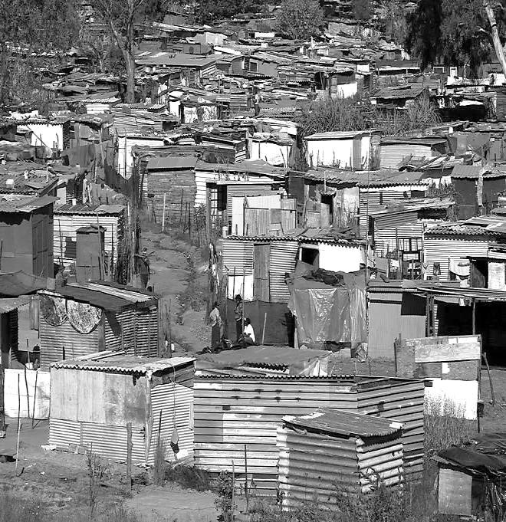
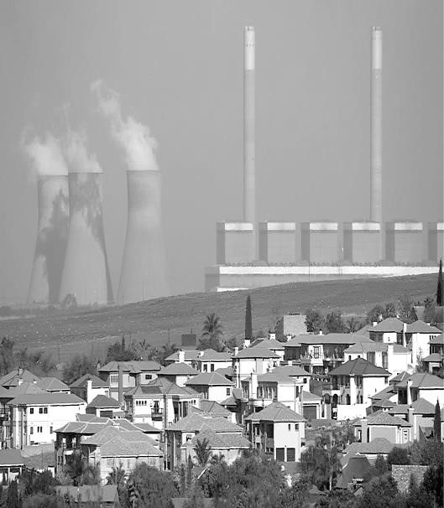
FIGURE
1.1
.
:.1
URBAN INJUSTICES

A

B

[
Source
:

images.the conversation.com
]

[
Source
:

static.independent.co.za
]

 | 1.1.1 | What is social injustice? | (1 x 1) | (1)
 | 1.1.2 | - State the unequal access to services and resources illustrated in photograph A.  - Why are the poor mainly affected by the unequal access to services and resources?  © List TWO negative impacts that  unequal access to services and  resources can have on a country. | (1 x 1)  (1 x 1)  (2 x 1) | (1)  (2)  (2)
 | 1.1.3 | Name the type of pollution causing the environmental injustice in photograph B. | (1 x 1) | (1)
 | 1.1.4 | Discuss TWO negative effects of this type of pollution mentioned in QUESTION 1.1.3 on the health of the community. | (2 x 2) | (4)
 | 1.1.5 | Suggest TWO measures that could be implemented to protect the community against the type of pollution named in QUESTION 1.1.4. | (2 x 2) | (4)
 |  |  |  | (15)
2.1 Refer to FIGURE 2.1 on urban land-use zones. Match the descriptions below
with one of the urban land-use zones. You may use an urban land-use zone more than once. Choose the answer and write only the correct land-use next to the question number (4.1.1–4.1.7) in the ANSWER BOOK. (Sept 2019)
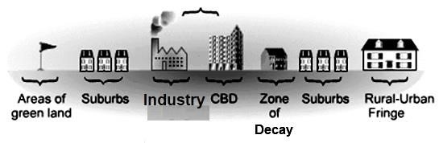
FIGURE 2.1
URBAN LAND
-
USE ZONES

[
Source
:

wwwgeography.co.uk
]

 | 2.1.1 | This land use zone has the highest land-value
 | 2.1.2 | Occupies the most amount of land in an urban settlement
 | 2.1.3 | This land-use zone consists of a large number of immigrants
 | 2.1.4 | A high degree of accessibility is evident in this land-use zone
 | 2.1.5 | This land-use zone is mostly made up of residential areas
 | 2.1.6 | Land is usually cheaper in this land-use zone
 | 2.1.7 | This land-use zone has a number of dilapidated buildings | (7x1) | (7)
3.1 Refer to FIGURE 3.1, a cartoon depicting the concept of urban sprawl.
(Sept 2019)

FIGURE 3.1: URBAN SPRAWL
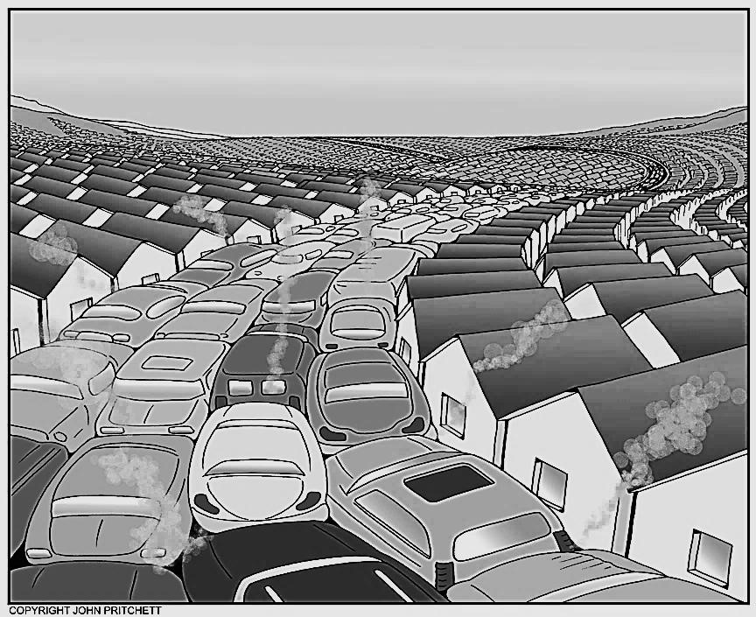

 | 3.1.1 | Define the term urban sprawl. | (1 x 1) | (1)
 | 3.1.2 | State TWO causes of urban sprawl. | (2 x 1) | (2)
 | 3.1.3 | Explain how the cartoon illustrates urban sprawl taking place. | (2 x 2) | (4)
 | 3.1.4 | Discuss TWO ways in which urban sprawl can harm the environment. | (2 x 2) | (4)
 | 3.1.5 | Explain how green belts can be seen as a possible measure to manage urban sprawl. | (2 x 2) | (4)
 |  |  |  | (15)
4.1 Study FIGURE 4.1, showing urbanisation and urban growth in Africa.
Various options are provided as possible answers to the following questions. Choose the answer and write only the letter (A–D) next to the question number (4.1.1.– 4.1.7) in the ANSWER BOOK, for example 4.1.1 - A. (June 2019)
FIGURE 4.1: URBANISATION AND URBAN GROWTH IN AFRICA
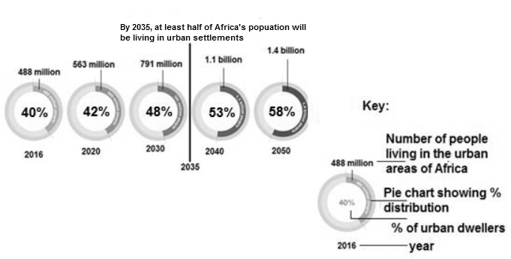

[Adapted by examiner from STATSSA]

 | 4.1.1 | The process by which an increasing percentage of the total population is accommodated in the urban area is referred to as …  - urban growth.  - urban expansion.  - urbanisation.  - urban sprawl.
 | 4.1.2 | The percentage of the total population living in urban settlements at any given time is referred to as the …  - settlement percentile.  - rate of urbanisation.  - rate of depopulation.  - level of urbanisation.
 | 4.1.3 | The predicted increase in percentage of  people living in the urban area between 2016 and  2040 is … %.  - 02  - 40  - 13  - 53
The total number of people living in urban areas in 2016 was … million people.

- 488
- 563
- 732
D 791

The current (2018) predicted population in Africa that are living in urban areas is approximately … million people.

- below 488
- above 563
- between 520 and 530
- 791

A major effect of urban growth that is likely to be experienced in 2050 will be a/an …

- shortage of housing.
- decrease in population.
- increase in food security.
- increase in biodiversity.

 |  | In which year will half of Africa’s population be living in urban areas?  - 2035  - 2020  C 2040  D 2050 | (7 x 1) | (7)
5.1 Study FIGURE 5.1 which illustrates services offered in urban areas.

FIGURE 5.1: THE ORDER OF GOODS AND SERVICES IN THE CBD
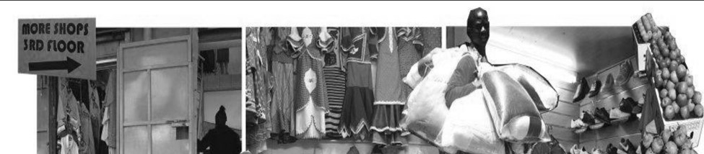
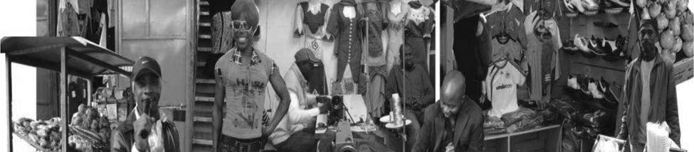
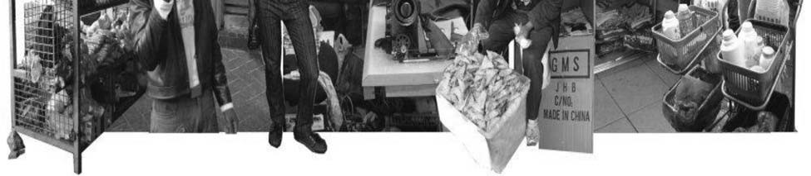

 | 5.1.1 | Using the photograph, name any TWO goods being sold in this market. | (2x1) | (2)
 | 5.1.2 | Determine if the goods being sold by traders are high order goods or low order goods. | (1x1) | (1)
 | 5.1.3 | Give a reason for your answer to QUESTION 5.1.2 | (1 x 2) | (2)
 | 5.1.4 | Why would the cost of goods (ANSWER to QUESTION 5.1.1) be low? | (1x2) | (2)
 | 5.1.5 | Comment on the threshold population for the type of goods being sold. | (1x2) | (2)
 | 5.1.6 | The goods being sold are mostly traded in the CBD. Why would determining a range for the goods be difficult? | (3x2) | (6)
 |  |  |  | (15)
6.1 Refer to FIGURE 6.1 on the hierarchy of settlements.

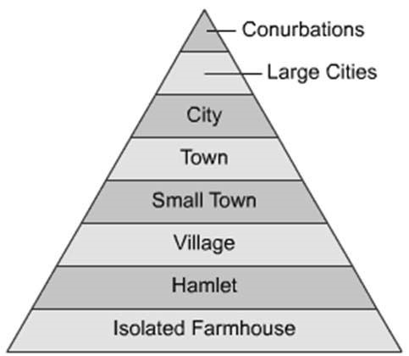

[
Source:
www.google/images
]

 | 6.1.1 | Are higher order services likely to be found near?  the top, or the bottom of the hierarchy?
 | 6.1.2 | Which settlement type offers rural as well as urban functions?
 | 6.1.3 | Will highly specialised functions be found in a village or conurbation?
 | 6.1.4 | Name the urban place that is bigger than a conurbation.
 | 6.1.5 | Is a city or town likely to have a smaller range and more lower-order goods and services?
 | 6.1.6 | State the type of settlement that Durban would fall  under in this hierarchy. | 7x1) | (7)
Study FIGURE 7.1 on an issue related to rapid urbanization. (June 2019)

FIGURE 7.1 ISSUES RELATED TO RAPID URBANISATION

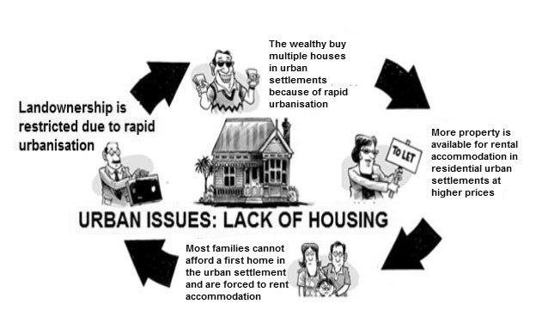

[
Adapted by Examiner from Google, images]

 | 7.1.1 | Identify the issue related to rapid urbanization. | (1x1) | (1)
 | 7.1.2 | What is the relationship between landownership and residential urban settlements and the wealthy? | (1x2) | (2))
 | 7.1.3 | Use the cartoon to suggest TWO probable(most likely) challenges experienced by families in residential urban settlements. | (2x2) | (4)
 | 7.1.4 | Write a paragraph of approximately EIGHT lines to discuss ways in which the Department of Human Settlements can improve the challenges (suggested in QUESTION 7.1.3) of rapid urbanisation in  residential urban settlements. | (4 x 2) | (8)
 |  |  |  | (15)

