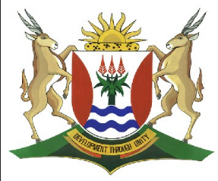
Province of the
EASTERN CAPE
EDUCATION

DIRECTORATE SENIOR CURRICULUM MANAGEMENT (SEN-FET)
HOME SCHOOLING SELF-STUDY WORKSHEET
SUBJECT | INFORMATION TECHNOLOGY PRACTICAL | GRADE | 12 | DATE | 27 April to 1 May 2020
TOPIC | Databases and SQL - Joining tables | TERM 1  REVISION | (Please tick) | TERM 2 CONTENT
TIME ALLOCATION | 1hr | TIPS TO KEEP HEALTHY  1. WASH YOUR HANDS thoroughly with soap and water for at least 20 seconds. Alternatively, use hand sanitizer with an alcohol content of at least 60%.  2. PRACTISE SOCIAL DISTANCING – keep a distance of 1m away from other people.  3. PRACTISE GOOD RESPIRATORY HYGIENE: cough or sneeze into your elbow or tissue and dispose of the tissue immediately after use.  4. TRY NOT TO TOUCH YOUR FACE. The virus can be transferred from your hands to your nose, mouth and eyes. It can then enter your body and make you sick.  5. STAY AT HOME.
INSTRUCTIONS | Resources used // This week’s work is taken from the New DBE Practical book  Study the Chapter 4, Units 1 to 4  Attempt all the examples in the book  Answer the following questions that are extracted from this book  The Datafiles for the activity are in the week’s data folder
Data maintenance
Write down the following queries and run them using the MoviesSQL App. Make sure that all calculated fields have field names.
1 The title, score and movie studio name for all movies.
2 The title, release year and studio city for all movies.
3 All fields from the tblMovies and tblStudios tables.
4 All fields from movies with a score above 90 not made in Hollywood.
5 All superhero movies made by Disney.
6 The average score of all movies, grouped by studio name.
7 Run the CitiesInSA_App.exe, write down queries that will answer the following questions, as well as the answers to these questions.
a. What is the largest city in Mpumalanga?
b. In which province is the city Allemansvlei?
c. What is the longitude and latitude of Kwazulu-Natal’s capital city?
d. In which province is the city Nkwali and what is the province’s population?
e. What are the capital cities and largest cities of all provinces with a population greater than 6 million people?

