PHYSICAL SCIENCES
ECDoE MATERIAL
2020
RATES OF REACTION
Energy and change

Energy changes in reactions related to bond energy changes
- Define heat of reaction (ΔH) as the energy absorbed or released in a chemical reaction.
- Define exothermic reactions as reactions that release energy.
- Define endothermic reactions as reactions that absorb energy
- Classify (with reason) reactions as exothermic or endothermic.

Exothermic and endothermic reactions
- State that ΔH > 0 for endothermic reactions, i.e. reactions in which energy is released.
- State that ΔH < 0 for exothermic reactions, i.e. reactions in which energy is absorbed.

Activation energy
- Define activation energy as the minimum energy needed for a reaction to take place.
- Define an activated complex as the unstable transition state from reactants to products.
- Draw or interpret fully labeled sketch graphs (potential energy versus course of reaction graphs) of catalyzed and uncatalyzed endothermic and exothermic reactions.

Rate and Extent of Reactions

Rates of reactions and factors affecting rate
- Define reaction rate as the change in concentration of reactants or products per unit time.
- Calculate reaction rate from given data.
$Rate= \frac{∆c}{∆t}$ $unit:mol∙{dm}^{-3}∙s^{-1}$
Questions may also include calculations of rate in terms of change in mass/volume/ number of moles per time.
- List the factors that affect the rate of chemical reactions, i.e. nature of reacting substances, surface area, concentration (pressure for gases), temperature and the presence of a catalyst.
- Explain in terms of the collision theory how the various factors affect the rate of chemical reactions. The collision theory is a model that explains reaction rate as the result of particles colliding with a certain minimum energy.

Measuring rates of reaction
- Answer questions and interpret data (tables or graphs) on different experimental techniques for measuring the rate of a given reaction.

Mechanism of reaction and of catalysis
- Define the term positive catalyst as a substance that increases the rate of a chemical reaction without itself undergoing a permanent change.
- Interpret graphs of distribution of molecular energies (number of particles against their kinetic energy or Maxwell-Boltzmann curves) to explain how a catalyst, temperature and concentration affect rate.
- Explain that a catalyst increases the rate of a reaction by providing an alternative path of lower activation energy. It therefore decreases the net/total activation energy.

LEARNING OBJECTIVES
Rate and extent of chemical reactions
- Define the following terms:

- Heat of reaction ΔH | - Exothermic reaction
- Endothermic reaction | - Activation energy
- Activated complex | - Reaction rate
- Positive catalyst

- Draw or interpret fully labeled sketch graphs of potential energy versus course of reaction graphs. With and without a catalyst.
- List the factors which affect the rate of chemical reactions:
  - Surface area (solid)
  - Concentration (solution), pressure (gas)
  - Temperature
  - Addition of catalyst
  - Nature of reacting substances
- Use the collision theory to explain how the various factors affect the rate of chemical reactions
- Calculate reaction rate from given data and using graphs.
- Use the formula: $Rate=\frac{∆c}{∆t}$ or Rate=$\frac{∆V}{∆t}$
- Maxwell-Boltzmann curves:
- Interpret graphs of distribution of molecular energies (number of particles against their kinetic energy or) to explain how a catalyst, temperature and concentration affect rate.
- Draw and interpret graphs of distribution of molecular energies ( number of particles against their kinetic energy

SUMMARY
What is a rate of reaction?
- Define reaction rate as the change in concentration of reactants or products per unit time.
- Calculate reaction rate from given data.
In symbols: OR
Where, ⊗[reactants] : change in concentration of reactants
⊗[products] : change in concentration of products
⊗t : change in time
The mechanism of reactions
The Maxwell-Boltzmann distribution diagram shown below shows the distribution of the kinetic energy of the particles in a reaction system. The distribution of the kinetic energies of the reactant particles is used to explain the reaction rate in the system
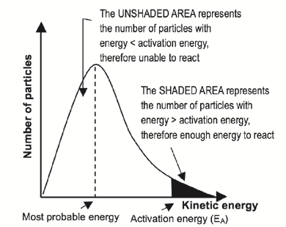
- The curve always passes through the origin — this means that no molecules have zero kinetic energy since all molecules are in motion — unless they reach the temperature of 0 K or –273 ̊C.
- The curve does not touch the x-axis at high kinetic energy i.e. there are always some molecules with very high kinetic energy.
- The energy value that corresponds with the peak of the curve represents the most probable energy.
- The area below the curve is equal to the total number of molecules in the system.
- The shaded area below the curve and to the right of the activation energy, equals the number of reactant particles that have enough energy to collide effectively and therefore can react.
- The area below the curve and to the left of the activation energy, equals the number of reactant particles that can’t collide effectively and therefore can’t react.
- If the shaded area is bigger, there are more particles that can collide effectively, and the reaction rate is higher
Factors which affect reaction rates
- The nature of the reactants
- The concentration of the reactants for aqueous (aq) solutions.
- Pressure for gas (g) reactants
- The surface area (state of division) for solid reactants
- The temperature of the reaction system.
- The presence of a suitable catalyst

The Collision Theory
For a reaction to take place, two reactants must collide with one another. Not all collisions lead to a reaction, those collisions that give rise to products are called effective collisions
- The collision theory is applied to explain how these factors affect the rates of chemical reactions.
- An effective collision between reactant particles takes place if:
- the colliding particles have enough kinetic energy to form an activated complex i.e. if the energy of the colliding particles is equal to or more than the activation energy for the reaction
AND
- the particles are correctly orientated when they collide.
When we increase one or two or both, we increase the rate of a reaction, hence the rate of a reaction is directly proportional to the fraction of particles that are correctly orientated multiplied by a fraction of particles that have sufficient kinetic energy
In symbols:
reaction rate ∝(particles with correct orientation)
∝ (number of effective collisions per unit time) ∝(particles with sufficient (enough) E_{k})

RATES OF REACTIONS WORKSHEETS
QUESTION 1
1.1 | Which ONE of the following describes the effect of a positive catalyst on the net activation energy and the heat of reaction (∆H) of a specific reaction?
 | NET ACTIVATION ENERGY |  |  | ΔH
A | increase |  |  | no effect
B | Decrease |  |  | Increase
C | No effect |  |  | Decrease
D | Decrease |  |  | No effect | (2)
1.2 | The activation energy for a certain reaction is 50 kJ∙mol⁻¹. Energy is absorbed when this reaction takes place. Which ONE of the following is correct for the reverse reaction?
Activation Energy ($E_{A}$) Heat of Reaction ($∆H$)  A $E_{A}$ $>50kJ∙{mol}^{-1}$ $∆H>$ 0  B $E_{A}$ $>50kJ∙{mol}^{-1}$ $∆H<$ 0  C $E_{A}$ $<50kJ∙{mol}^{-1}$ $∆H<$ 0  D $E_{A}$ $<50kJ∙{mol}^{-1}$ $∆H>$ 0 |  |  |  |  | (2)
1.3 | Which ONE of the following graphs shows the mass of a catalyst against time at the end of the chemical reaction?
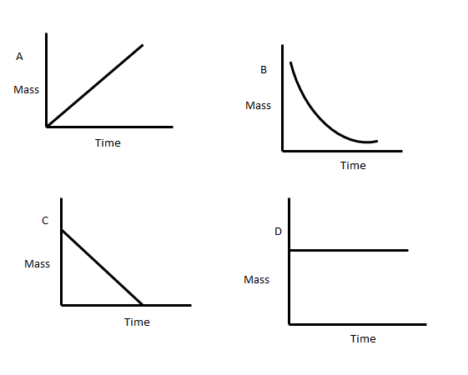
 |  |  |  |  | (2)
 |  |  |  |  | (2)
1.4 |  | Consider the following energy profile:
 |  | 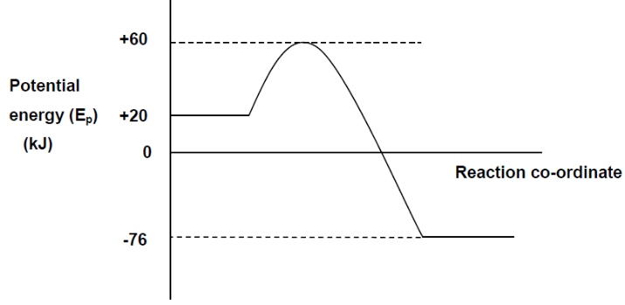
 |  | According to this profile, what would be the Activation Energy and Heat of Reaction for the reverse reaction?
 |  | Activation Energy (kJ) | Heat of Reaction (kJ)
A |  | –20 | +96
B |  | +40 | +96
C |  | –136 | –96
D |  | +136 | +96 |  | (2)
1.5 |  | When zinc reacts with dilute hydrochloric acid, hydrogen gas is produced as one of the products. The volume of hydrogen gas evolved is measured every second. Shortly after the reaction started, a catalyst is added to the reaction. Which one of the following graphs is an accurate representation of the course of the reaction?
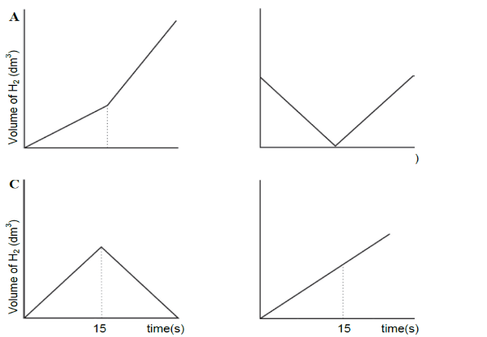 |  |  |  |  | (2)

QUESTION 2
A learner investigates a way to increase the rate at which hydrogen gas develops in the reaction between zinc and hydrochloric acid. The reaction takes place as shown below.
A learner obtained the following Maxwell- Boltzmann distribution curve: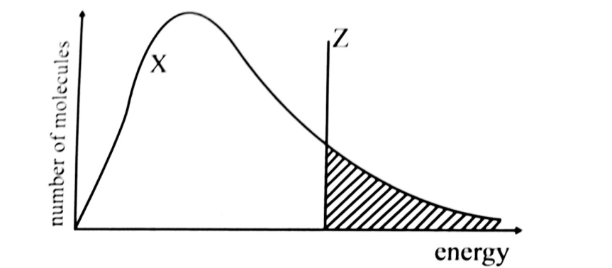
Curve X shows the initial condition.

2.1.1 |  | Why does the curve go through the origin of the graph? | (2)
2.1.2 |  | What does the shaded part of the graph represent? | (1)
2.1.3 |  | What does line Z represents | (1)
Redraw the graph in your answer sheet, mark the original curve X and line Z
clearly and then indicate clearly how curve X and/ or line Z will change if the learner :
2.1.4 |  | Increases the temperature of the H${Cl}_{\left(aq\right)}$ solution.  (Mark this curve line with A ) | (2)
2.1.5 |  | Increases the concentration of the H${Cl}_{\left(aq\right)}$ solution.  (Mark this curve/line with B) | (2)
2.1.6 |  | Adds a suitable catalyst (Mark this curve/line with C) | (2)
2.1.7 |  | Apply the collision theory and explain why an increase in the temperature of the H${Cl}_{\left(aq\right)}$ solution results in a higher reaction rate. | (3)
2.2 |  | Manganese dioxide (MnO₂) catalyses the decomposition of a hydrogen peroxide solution (H₂O₂ (aq)) into water and oxygen.
 |  | 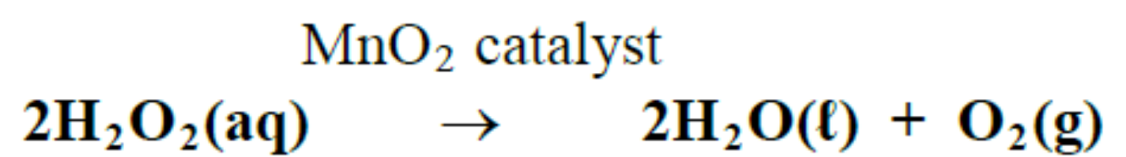
0,1 g of manganese dioxide (MnO₂) was added to 200 cm³ of a 0,2 mol·dm⁻³ solution of hydrogen peroxide (H₂O₂ (aq)). The oxygen gas produced was collected at standard temperature and pressure and measured every minute using a gas syringe. The readings were plotted to give the following graph:
 |  | 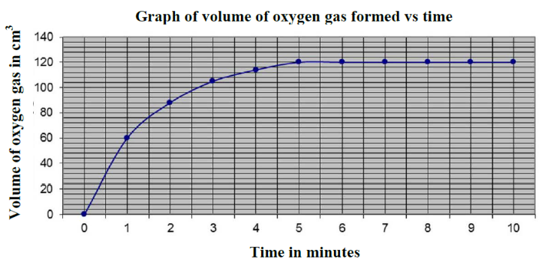
 |  | Use the graph to answer the following questions.
2.2.1 |  | Define the term reaction rate | (2)
2.2.2 |  | Explain why the gradient of the graph decreases as the reaction proceeds. | (2)
2.2.3 |  | The reaction stops on reaching completion.  Write down the time at which the reaction stopped. | (1)
2.2.4 |  | Define the term positive catalyst. | (2)
2.2.5 |  | How much of the catalyst manganese dioxide, MnO₂, remains at the end of the reaction? Explain | (2)
2.2.6 |  | Calculate the concentration of the hydrogen peroxide after the reaction has stopped. | (6)
The Maxwell-Boltzmann distribution curve below shows the decomposition of the H₂O₂ without using a catalyst.
 |  | 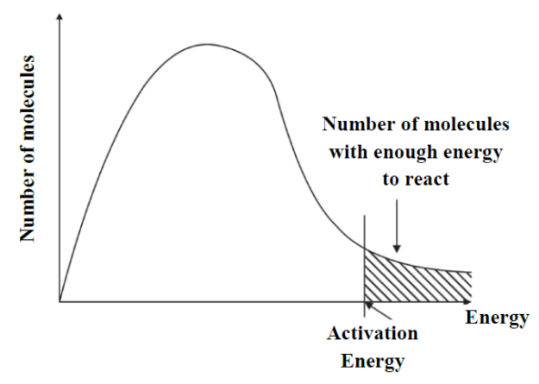
2.2.7 |  | Explain in terms of the collision theory how the MnO₂ catalyst  increases the rate of decomposition of the H₂O₂. | (4)
2.2.8 |  | Redraw the graph in your book and show how the activation energy changes when the decomposition reaction is carried out with the MnO₂ catalyst. | (2)

QUESTION 3

At room temperature and pressure a flask was connected to a gas syringe. 60 cm³ of 0.05 mol.dm⁻³ dilute hydrochloric acid (HCl) was placed in the flask. 2g (an excess) of granules of a reactive metal were added, the flask was quickly stoppered and the readings of the volume of gas in the syringe were recorded at half minute time intervals.
The diagram and the results of the experiment are shown below:
Time (minutes) | Volume of gas (cm³)
0 | 0
0.5 | 5
1 | 18
1.5 | 24
2 | 28
2.5 | 31
3 | 33
3.5 | 34
4 | 35
4.5 | 35.5
5 | 36
5.5 | 36

3.1 | A colourless gas is produced in the reaction.  What is the name AND formula of the gas? |  | (2)
3.2 | Plot and draw a graph that represents the gas produced against time. |  | (6)
3.3 | Use your to graph to determine how long it took for 29 cm³ of gas to be produced? |  | (3)
3.4.1 | Write down the volumes of gas produced at the following times:  t = 1 minute (1)  t = 2 minutes (1)  t = 3 minutes (1) |  | (2)
3.4.2 | Explain the trend observed in question 3.4.1, refer to RATE OF GAS PRODUCED and the REACTION RATE |  | (2)
3.4.3 | Use the collision theory to explain the differences in the rate of production of gas at these times. |  | (4)
 | The experiment was repeated using larger pieces (chunks) of excess metal, under the same conditions.
3.5 | On the same set of axis of question 3.2 above sketch the graph that will represent the results obtained when the chunks of excess metal is used.  Label this A. |  | (3)
3.6 | Give reasons for your choice of sketch labelled A. |  | (3)
The experiment was repeated , but this time only the temperature was
increased. (The larger granules WERE NOT used.)
3.7 | On the same set of axis of question 3.2 above sketch the graph that will represent the results obtained when the temperature is increased.  Label this B.

QUESTION 4

2g of magnesium ribbon was covered in a flask with excess of hydrochloric
acid with a concentration of 1 mol/dm3. The hydrogen evolved was collected
in a gas syringe and the volume measured every half minute. The equation for the reaction is given below
Mg_{(s)} + 2HCl_{(aq)} -----> MgCl_{2(aq)} + H_{2(g)}

The following results were obtained:
Time(min) | 0 | ½ | 1 | 1½ | 2 | 2½ | 3 | 3½ | 4
Volume(cm3) | 0 | 25 | 40 | 51 | 57 | 60 | 62 | 63 | 63

4.1 | Which other substance besides hydrogen was formed during this reaction? | (2)
4.2 | Calculate the rate of reaction in cm³.m⁻¹ between t =½ min and t = 2 min | (4)
4.3 | During which time interval was the rate of the reaction the greatest? | (2)
4.4 | Give one reason why the rate of the reaction gradually decreased. | (2)
4.5 | Name three ways in which the rate of the reaction between magnesium and hydrochloric acid can be increased. | (6)
 |  | [16]

QUESTION 5

5.1 | Give four factors which influence the rate of chemical reactions and state the effect of each. | (8)
5.2 | Given the following potential energy diagram for the reaction between gases:
5.2.1 | Give the value of the following in terms of A, B and C  a) the activation energy of the forward reaction.  b) ΔH  c) the activation energy for the reverse reaction | (2)
5.2.2 | How would the a) activation energy, and  b) the ΔH be affected if a catalyst is added to the reactants? | (4)

QUESTON 6

A group of learners uses the reaction of EXCESS hydrochloric acid (HCℓ) with zinc (Zn) to investigate factors which influence reaction rate. The balanced equation for the reaction is:
Zn(s) + 2HCℓ(aq) → ZnCℓ₂(aq) + H₂(g)

They use the same volume of hydrochloric acid and 1,2 g of zinc in each of five experiments. The reaction conditions and temperature readings before and after completion of the reaction in each experiment are summarised in the table below.
Experiment | REACTION CONDITIONS |  |  |  | Time  (s)
 | Concentration of  HCℓ (mol·dm⁻³) | Temperature (°C) |  | State of division of the 1,2 g of Zn
 |  | Before | After
1 | 0,5 | 20 | 34 | granules | 50
2 | 0,5 | 20 | 35 | powder | 10
3 | 0,8 | 20 | 36 | powder | 6
4 | 0,5 | 35 | 50 | granules | 8
5 | 0,5 | 20 | 34 | granules | 11

6.1 | Is the reaction between hydrochloric acid and zinc EXOTHERMIC or  ENDOTHERMIC? Give a reason for the answer by referring to the data in the table. | (2)
6.2 | Give a reason for the difference in reaction rate observed for Experiments 1 and 2. | (1)
6.3 | The learners compare the results of Experiments 1 and 3 to draw a conclusion  regarding the effect of concentration on reaction rate. Give a reason why this is not a fair comparison. | (1)
6.4 | How does the rate of the reaction in Experiment 5 compare to that in Experiment 1? Write down FASTER THAN, SLOWER THAN or EQUAL TO.  Write down the factor responsible for the difference in the rate of reaction and fully explain, by referring to the collision theory, how this factor affects reaction rate. | (5)
6.5 | Calculate the rate at which the hydrochloric acid reacts in Experiment 4 in mol·s⁻¹. | (6)
 |  | [15]

