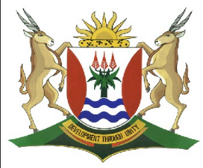
Province of the
EASTERN CAPE
EDUCATION

DIRECTORATE SENIOR CURRICULUM MANAGEMENT
(SEN-FET)
HOME SCHOOLING SELF-STUDY WORKSHEET ANSWER SHEET
SUBJECT | LIFE SCIENCES | GRADE | 12 | DATE | 21 May 2020
TOPIC | RESPONDING TO THE ENVIRONMENT: CNS & REFLEX ACTION | TERM 1  REVISION |  | TERM 2  CONTENT

1.1 C
1.2 B
1.3 B
1.4 C 4x2

2.1
 | Name | Function
1 | Cerebrum | - Controls all voluntary actions  - Interpret nerve impulses from the sense organs so that the sensation of sight, sound, smell, taste and touch can arise  - Seat of higher mental functions such as memory, intelligence etc.
2 | Corpus callosum | - Allows for communication between the left and right side of the brain
3 | Cerebellum | - It co-ordinates and controls the actions of all voluntary muscles to make smooth and precise movement possible e.g. walking and running  - It controls the tension in the muscles (muscle tone) to maintain balance and posture
4 | Medulla Oblongata | - It transmits nerve impulses between the spinal cord and the higher parts of the brain  - It controls autonomic functions i.e. rate and depth of breathing, heartbeat, narrowing and widening of the blood vessels
5 | Spinal cord | - Pathway for impulses to and from the brain and from receptors and effectors  - Serves as a reflex centre for certain actions
15
2.2 (a) D - Medulla oblongata
(b) A - Cerebrum
(c) F - Cerebellum
(d) D - Medulla oblongata
(e) B - Corpus callosum
(f) D - medulla oblongata 6 x 2

3.1 A – Dorsal root
B – Dorsal root ganglion
C – spinal nerve
D – Ventral root
E- Central canal
F – Grey matter
G – White matter 7

3.2.1 A - Interneuron
B – Sensory neuron
C – Motor neuron 3

3.2.2 Synapse 1

3.2.3 X to Y 1

4 ` 1.5m = 0.02 s 3
75 m.s⁻¹

TOTAL: 50 MARKS

