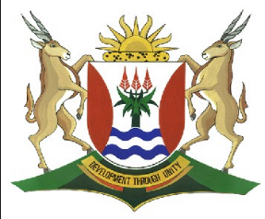
Province of the
EASTERN CAPE
EDUCATION

DIRECTORATE SENIOR CURRICULUM MANAGEMENT (SEN-FET)
HOME SCHOOLING SELF-STUDY WORKSHEET
SUBJECT | LIFE SCIENCES | GRADE | 10 | DATE
TOPIC | ANIMAL TISSUES: CONNECTIVE TISSUES | TERM 1  REVISION | (Please tick) | TERM 2 CONTENT
TIME ALLOCATION | 45 MINUTES | TIPS TO KEEP HEALTHY  1. WASH YOUR HANDS thoroughly with soap and water for at least 20 seconds. Alternatively, use hand sanitizer with an alcohol content of at least 60%.  2. PRACTICE SOCIAL DISTANCING – keep a distance of 1m away from other people.  3. PRACTISE GOOD RESPIRATORY HYGIENE: cough or sneeze into your elbow or tissue and dispose of the tissue immediately after use.  4. TRY NOT TO TOUCH YOUR FACE. The virus can be transferred from your hands to your nose, mouth and eyes. It can then enter your body and make you sick.  5. STAY AT HOME.
INSTRUCTIONS | Use the following resources to answer the worksheet:  - Textbook  - Via Afrika Grade 10 Study Guide  - PowerPoint Presentation on Animal Tissues  - Video Lesson on Connective Tissues

1. | Give a biological term for each of the following statements:

 | 1.1 | A tissue that insulates the body protects organs by serving as a packing tissue
 | 1.2 | A tissue that acts as shock absorber
 | 1.3 | A tissue that reduces friction between the bones at joints
 | 1.4 | A tissue that transports digested food, hormones and enzymes
 | 1.5 | A tissue that makes up tendons which connects muscles to bones |  | (5)

2. | Match column A to column B

 |  | Column A | Column B
 | 2.1 | Fibrous connective tissue | a) blood
 | 2.2 | Fluid connective tissue | b) cartilage
 | 2.3 | Supportive connective tissue | c) connects a bone to another bone
 | 2.4 | Ligament | d) areolar tissue
 | 2.5 | Tendon | e) connects a muscle to a bone |  | (5)

3. | Identify the following connective tissues:

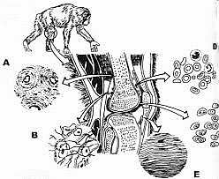
(5)

4. | State the main function of the following tissues:
 | 4.1 | Tendon
 | 4.2 | Blood
 | 4.3 | Cartilage
 | 4.4 | Ligaments
 | 4.5 | Epiglottis |  | (5)

5. | Give four components of blood tissue |  | (4)

6. | State:
 | 6.1 | TWO types of fibres in connective tissues |  | (2)
 | 6.2 | Percentage composition of the TWO major components of blood tissue |  | (2)

7 | Make a neat, detailed drawing with a caption and three labels of a long bone. |  | (5)
 | TOTAL |  | (30)

