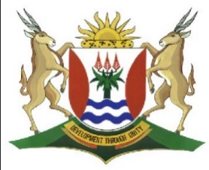
Province of the
EASTERN CAPE
EDUCATION

DIRECTORATE SENIOR CURRICULUM MANAGEMENT (SEN-FET)
HOME SCHOOLING SELF-STUDY WORKSHEET ANSWER SHEET
SUBJECT | GEOGRAPHY | GRADE | 10 | DATE | 6/07/20
TOPIC | VOLCANOES | TERM 2  REVISION | √√ | TERM 2 CONTENT | √√

QUESTION 1
1.1.1 An active volcano is a volcano that erupts regularly, for example once
for every 20 years. ✓ (Concept) (1 x 1) (1)

1.1.2 Lava refers to liquid material that flows on the surface of earth. ✓

Magma refers to liquid material in the earth. ✓ (2 x 1) (2)

    - Volcanic ash can cover buildings and smother vegetation. ✓✓
People can become ill because of breathing in ash. ✓✓ (Any 1 x 2) (2)

1.1.4 Ash from volcanic eruption can block pilot’s view which make flying more difficult. ✓✓
Ash from volcanic eruption is dangerous to aircraft engines. ✓✓
(Any 1 x 2) (2)

    - Negative effects of volcano
Lava flows burn and bury vegetation and buildings ✓✓
Earth movements associated with a volcano can set off mudslides ✓✓
Harden lava can injure or kill people ✓✓
Positive effects of volcano
Volcano ash can act as a fertiliser for soil ✓✓
Volcanic regions such as Hawaii become tourist attractions ✓✓
Underground water in volcanic regions is hot enough to use for heating systems and electricity generation ✓✓ (Any 4 x 2) (8)
[15]

