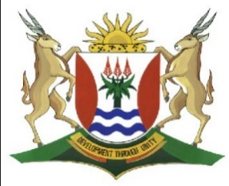
Province of the
EASTERN CAPE
EDUCATION

DIRECTORATE SENIOR CURRICULUM MANAGEMENT (SEN-FET)
HOME SCHOOLING SELF-STUDY WORKSHEET ANSWER SHEET
SUBJECT | GEOMORPHOLOGY | GRADE | 10 | DATE | 6/07/20
TOPIC | FOLDING AND MAJOR PLATES | TERM 2  REVISION | √√ | TERM 2 CONTENT | √√

QUESTION 1
1.1
1.1.1 Syncline

1.1.2 Anticline

1.1.3 Limb

1.1.4 Asymmetrical fold

1.1.5 Overturned fold

1.1.6 Recumbent
(6 x 1) (6)
1.2

1.2.1 Indian-Australian Plate/Indo-Australian Plate ✓ (1 x 1) (1)

1.2.2. Pangaea ✓ (1 x 1) (1)

    - Alfred Wegener ✓ (1 x 1) (1)

    - In convergent plate boundaries, plates are moving towards each other. ✓✓

Folded mountain ranges usually form along convergent plate boundaries.
ANY 1X2 (2)

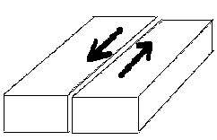
1.2.5
(2) Marks for showing passive arrows

(2) Marks for overall sketch
(2 x 2) (4)

[15]

