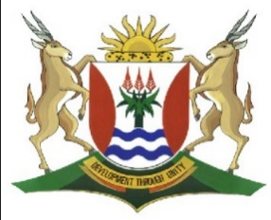
Province of the
EASTERN CAPE
EDUCATION

DIRECTORATE SENIOR CURRICULUM MANAGEMENT (SEN-FET)
HOME SCHOOLING SELF-STUDY WORKSHEET
SUBJECT | GEOGRAPHY | GRADE | 10 | DATE | 6/07/20
TOPIC | GEOMORPHOLOGY | TERM 2  REVISION | √√ | TERM 2 CONTENT | √√
THE STRUCTURE OF THE EARTH AND PLATE TECTONICS |  | TIPS TO KEEP HEALTHY  1. WASH YOUR HANDS thoroughly with soap and water for at least 20 seconds. Alternatively, use hand sanitizer with an alcohol content of at least 60%.  2. PRACTICE SOCIAL DISTANCING – keep a distance of 1m away from other people.  3. PRACTISE GOOD RESPIRATORY HYGIENE: cough or sneeze into your elbow or tissue and dispose of the tissue immediately after use.  4. TRY NOT TO TOUCH YOUR FACE. The virus can be transferred from your hands to your nose, mouth and eyes. It can then enter your body and make you sick.  5. STAY AT HOME.
INSTRUCTIONS

QUESTION1

  - Refer to FIGURE 1.1 which shows various igneous intrusions.

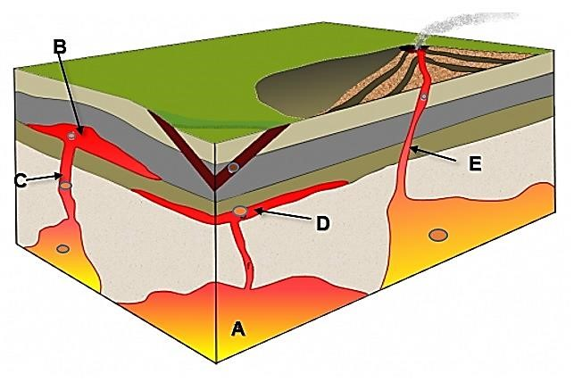

[
Source:
Google Images
]

1.1.1 Label the igneous intrusions indicated by letters A, B, C and D as
dyke, sill, batholith and laccolith. (4)

    - Name the process that is responsible for the exposure of intrusive
igneous features on the Earth surface. (1)

    - Which letter indicates a volcanic pipe? (1)

    - Name ONE intrusive igneous feature that is associated with granite. (1)

  - Refer to FIGURE 1.2 which shows Laurasia and Gondwanaland 200 million years ago

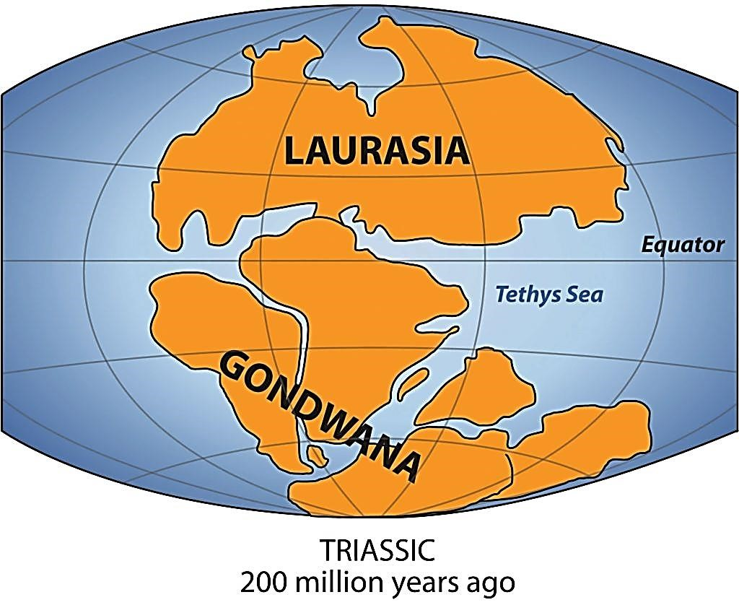

    - All the continents and adjacent water masses are divided into
tectonic plates. What is plate tectonics? (1 x 1) (1)

    - Which theory is illustrated in FIGURE 1.2? (1 x 1) (1)

    - Which continent in Gondwanaland is part of both the Southern and Northern hemisphere? (1 x 1) (1)

    - (a) Name TWO continents that formed Laurasia. (2 x 1) (2)

(b) Name THREE continents that formed Gondwanaland. (3 x 1) (3)

    - What was the name of the single continent that existed before Laurasia and Gondwanaland? (1 x 1) (1)

1.2.6 Provide THREE points of evidence that suggest that continents were
once all joined in a single landmass. (3 x 2) (6)
[22]

