Province of the EASTERN CAPE EDUCATION

DIRECTORATE SENIOR CURRICULUM MANAGEMENT (SEN-FET)

WORKSHEET

SUBJECT | English HL
GRADE (Please tick) |  | GRADE 10 |  | GRADE 11 |  |  | GRADE 12
 |  | √ |  | √ |  |  | √
DATE | 14 JULY 2020
TIME ALLOCATION | 60 minutes
CURRICULUM DETAIL  (Please tick) |  | TERM 1 REVISION | TERM 2 CONTENT |  | TERM 2 REVISION | TERM 3 CONTENT |  | TERM 4 REVISION
 |  |  |  |  | √
TIPS TO STAY HEALTHY DURING LOCKDOWN | - STAY AT HOME.  - WASH YOUR HANDS thoroughly with soap and water for at least 20 seconds. Alternatively use hand-sanitizer with an alcohol content of at least 70%.  - PRACTISE GOOD RESPIRATORY HYGIENE. Cough or  sneeze into your elbow, or a tissue and throw the tissue away immediately after use.  - TRY NOT TO TOUCH YOUR FACE. The virus can be transferred from your hands to your nose, mouth, and eyes. It can then enter your body and make you sick.  - PRACTISE SOCIAL (PHYSICAL) DISTANCING. Keep a  distance of at least 1m (about an arm’s length) from other people.
TOPIC | Transactional Writing: Planning – For Different Questions on the Obituary

TRANSACTIONAL WRITING: THE OBITUARY

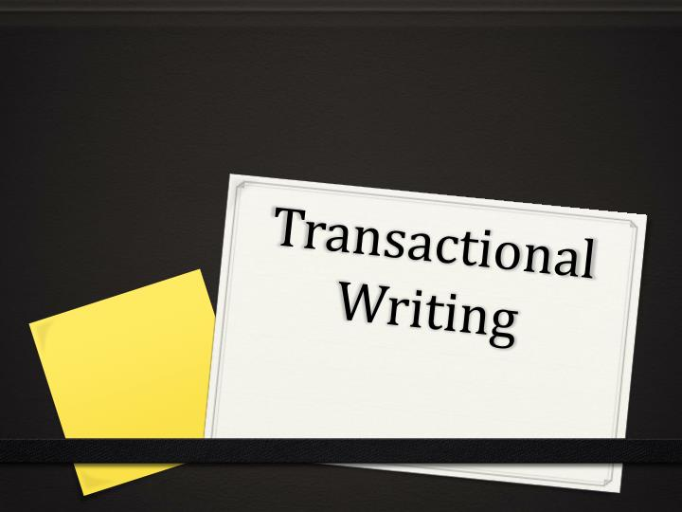

Points to remember when doing a plan for a Transactional piece

- Transactional writing is writing with a clear sense of purpose, audience and format, aimed at communicating ideas and information between individuals.
- Different transactional pieces have a different STRUCTURE (format/layout), TONE AND STYLE. You need to master these well before being assessed on them.
- The key instruction in the assessment of the transactional piece is usually:
- … Pay careful attention to the following:
- Audience, register, tone and style
- Choice of words and language structures
- Format
- The given questions always require you to assume a certain character as you give your response. This is what will assist you to use the correct register, tone, diction and style.

Planning
- Planning is very important for this type of writing.
- A good plan will make your writing easy, especially if you are someone who STRUGGLES to generate ideas fast under exam conditions.
- Use the C.R.A.P method in planning the structure your response.

THE C.R.A.P METHOD of planning a response for a transactional piece
- Read the given Question and ask yourself the following questions:
- C- Content: In what form is my supposed to be presented? What is it that I am being asked to write? (formal letter, email, review, newspaper article, formal report, interview, obituary, etc.

- R- REGISTER: In the given situation, what kind of language am I supposed to use? What degree of formality am I expected to adopt? (formal, semi-formal or informal).

- A- AUDIENCE: Who is my target audience in this piece? (a mixed audience, adults, teenagers, officials, etc.).

- P- PURPOSE: What are my reasons for writing this piece? Why am I writing this piece? (Is it to inform, to persuade, to complain, to review, to praise, to enquire, etc.).
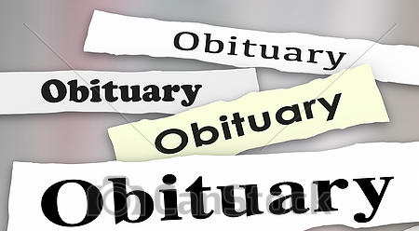
THE OBIRTUARY

An obituary is a notice of the passing on of someone known by the target audience. Over and above ‘formally’ announcing the death, it also sketches the cause of death. It is also designed to share the noteworthy events, special relationships and unique qualities of the deceased, and the funeral arrangements.

TASK

- This tasks assumes that you already know the key characteristics of an obituary.
- The main focus of the task is PLANNING.
- Note that not all obituaries require the same information. The question will guide you to focus on the specific requirements of each obituary.
- Below are some sample questions from past papers, on the obituary.
- Using the C.R.A.P Method, do a plan for each one of them. Note that Question One has been done for you as an example.

1. | QUESTION  A maintenance worker from your school has was involved in fatal car accident and sadly passed away.  Write his/her obituary.  PLAN  My script: Assuming the role of a teacher/ learner/ principal/ or any other school personnel, the question requires me to:  Content: Write an Obituary (An obituary is made up of….).  Register: In formal language  - Using the correct format and information  Audience: For a mixed audience  Purpose: Notifying every one about the unexpected death (car accident)  of Mr./Mrs. X, a male/ female worker at my school, in charge of  …. (state exactly what his/her duties were in relation to  maintenance work, e.g. at the workshop repairing  school machinery, broken chairs and desks, plumbing  jobs, electrical maintenance, painting etc.)  NB: The PURPOSE makes up the body of the essay. This is where knowledge of the characteristics of the obituary comes in.  - The person whose obituary you are writing and the persona you assume in your writing is what makes the obituaries (you have written so far/ or the ones you yet to write) differ from one another. This is why you have to pay particular attention to this aspect of whatever question you are given when writing an obituary.  ATTEMPT PLANNING FOR THE FOLLOWING QUESTIONS USING | [25]
2. | One of your classmates has died of cancer. Write her/his obituary. | [25]
3. | A renowned local musician has passed away after a short illness. He/ she was a life-long inspiration and role model.  Write an obituary which will be read at her/his funeral. | [25]
4. | After a short illness, your former coach suddenly passed away. Write an obituary for him/her. | [25]
You can use this sort of plan for any other form of transactional writing. The more you practise planning your essays, the better for you. You are also encouraged to be familiar with the rubric for transactional writing so that you know exactly where your marks will come from.

