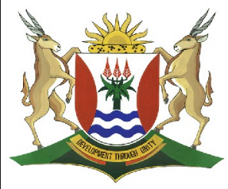 Province of the

EASTERN CAPE

EDUCATION

**DIRECTORATE SENIOR CURRICULUM MANAGEMENT (SEN-FET)**

**HOME SCHOOLING SELF-STUDY WORKSHEET ANSWER SHEET**

|  |  |  |  |  |  |
| --- | --- | --- | --- | --- | --- |
| **SUBJECT** | LIFE SCIENCES | **GRADE** | 11 | **DATE** | 30 JULY 2020 |
| **TOPIC** | INTRODUCTION TO HUMAN NUTRITION | **TERM 1**  **REVISION** |  | **TERM 2 CONTENT** | ✓ |

