EC - LEARNER SUPPORT MATERIAL: CIVIL TECHNOLOGY CONSTRUCTION: GRADE 11

CONTENT TO BE COVERED:

TOPICS:
- FORMWORK (SPECIFIC)

- Definition of formwork
- Purpose of formwork
- Form oils and emulsions
Properties of good formwork,
Materials used and the identification of different parts of formwork used for:
- Columns
- Arches
- Stairs
- Methods of erecting of formwork
- Constructional details.
Lintels:
Drawing of formwork and methods of erecting and supporting
- Purpose
- Use
- Types
- Sizes of pre-stressed lintels

- CONSTRUCTION STEEL (SPECIFIC)
Identification, use, sketches and properties of the following steel sections:
- I – beam
- H – beam
- U – channel
- Lip channel
- Angle iron

- CONSTRUCTION (CAVITY WALL)
The purpose, advantages and disadvantages of cavity walls:
Scale drawings of the following:
- Vertical section through a cavity wall
Different methods of finishing off openings of tops of cavity walls
- CONSTRUCTION (BRICKWORK)
Front elevation and alternate plan courses of a wall built in English bond. Scale drawings of alternate plan courses of corners (quoin), “T” junctions and cross junctions of walls built in English bond.
Waterproofing:
Position and method of installing DPC in the following areas in a building:
- Windows
- Doors
Walls
- STAIRCASE (SPECIFIC)
Concrete staircase:
- Terminology for staircases
General principles of staircase design
- ROOFCOVERING (SPECIFIC)
Roof covering:
- Purpose of roof covering
- Material used for roof covering
Characteristics of IBR and corrugated iron sheeting under the following heading:
- Width
- Length available
- Weight
- Insulation
- Wind pressure
- Corrosion
- Cost
Characteristics of concrete roof tiles under the following heading:
- Wind pressure
- Maintenance
- Joining each other
- Sizes
- Weight
- Pitch
- Cost
Characteristics of concrete roof tiles under the following heading:
Roof underlay:
- Materials used
- Purpose and Properties

EXAMPLE 1: QUESTION 1: FORMWORK, CONSTRUCTION STEEL AND CAVITY WALLS

1.1 Explain TWO safety precautions that must be adhered to when using a power
float on site. (2)

1.2 What safety practice should you apply when adhesives are used that give off
toxic fumes? (1)

1.3 FIGURE 1.3 below shows the floor plan of a one-room building.

FIGURE 1.3

10 400

4 400

Specifications:
- The width of the wall is 220 mm
- The opening for the door is 2 100 mm x 900 mm
- The minimum overhang of the lintel on each side of an opening is 150 mm

Use ANSWER SHEET 1.3 and calculate the following:

1.3.1 The length of the lintel needed above the opening of the door (2)

1.3.2 The area of floor covering needed (5)

ANSWER SHEET 1.3
A | B | C | D
 |  |  | Length of lintel needed above the door opening
 |  |  | Width of door = 900 mm
 |  |  | Length of lintel = opening + 2(overhang)
 |  |  | = +
 |  |  | =
 |  |  | Internal measurements of the interior walls
 |  |  | Internal length of long wall = 10 400 mm – 220 mm – 220 mm
 |  |  | =
 |  |  | Internal length of short wall = 4 400 mm – 220 mm – 220 mm
 |  |  | =
 |  |  | Area of floor covering needed
1/ |  |  | Internal length of long wall = 9 960 mm
 |  |  | Internal length of short wall = 3 960 mm

1.4 FIGURE 1.4 below shows illustrations of steel profiles that are used on a construction site.

FIGURE 1.4

A

B

C

1.4.1 Identify A, B and C. (3)

    - Explain ONE use of EACH steel profile. (3)

1.5 Complete a drawing, to scale 1: 10, of a horizontal sectional view of the formwork of a square column.

Use the following specifications:
- Size of the column is 500 mm x 500 mm
- Shuttering board 21 mm thick
- Two clamps 76 mm x 50 mm
- Two yokes 76 mm x 50 mm
- Four wedges
- Two 16 mm diameter (Ø) threaded rods with nuts

Label ONE part of the drawing. (6)

1.6 FIGURE 1.6 below is a photograph of construction site equipment.

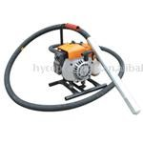

FIGURE 1.6

1.6.1 Identify the construction site equipment. (1)
1.6.2 Suggest ONE precautionary measure that should be in place if
the equipment in FIGURE 1.6 breaks down. (1)

1.7 Complete FIGURE 1.7 to illustrate the centre of a flat arch. (2)

FIGURE 1.7

1.8 FIGURE 1.8 below is a sketch of TWO types of wall ties that may be used in a cavity wall. Identify wall ties A and B.

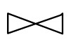
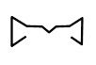

FIGURE 1.
8

B

A

(2)

1.9 Explain TWO regulations in terms of the horizontal and vertical spacing of
wall ties in a cavity wall. (2)

[30]

ANSWER 1: QUESTION 1: FORMWORK, CONSTRUCTION STEEL AND CAVITY WALLS

QUESTION 5: FORMWORK, CONSTRUCTION STEEL AND CAVITY WALLS

1.1 • Always hold the power float by the handles provided √
- Wear suitable clothing, avoid loose garments
- Wear protective gloves and foot wear
- Driving and rotating parts should be covered

ANY TWO OF THE ABOVE OR ANY OTHER ACCEPTABLE ANSWER (2)

1.2 • Use in well-ventilated areas √
- Keep open flames away from it
- Use safety goggles to protect your eyes
- Use safety gloves to protect your hands
- Use a respiratory mask

ANY ONE OF THE ABOVE OR ANY OTHER ACCEPTABLE ANSWER (1)

1.3
A | B | C | D
 |  |  | Length of lintel needed above the door opening
 |  |  | Width of door = 900 mm
 |  |  | Length of lintel = opening + 2(overhang)
 |  |  | = 900 mm + 2(150) mm √
 |  |  | = 1 200 mm √ (2)
 |  |  | Internal measurements of the interior walls
 |  |  | Internal length of long walls = 10 400 mm – 2/220 mm
 |  |  | = 9 960 mm √
 |  |  | Internal length of short walls = 4 400 mm – 2/220 mm
 |  |  | = 3 960 mm √ (2)
 |  |  | Area of floor covering needed
1/ | 9,96 m² √ |  | Internal length of long wall = 9 960 mm
 | 3,96 m² √ | 39,44 m² √ | Internal length of short wall = 3 960 mm
 |  |  | (3)
1.4 | 1.4.1 | - H-beam √  - I-beam √  - Channel iron √ |  | (3)
1.3.1

1.3.2

1.4.2 | H-beam  Used:  • In construction and civil engineering where structures require  good stability √  - For bridges  - For shipbuilding  - For conveying machinery  - As columns or beams when steel constructions are erected  I-beam  Used:  As beams when steel structures are erected √  - When building factories.  - For shipbuilding  - For bridge building  - For framed structures | (1)  (1)
Channel iron
- Used:
- In the construction industry √
- Frames of steel structures
- Columns
- Beams
- Roof structure

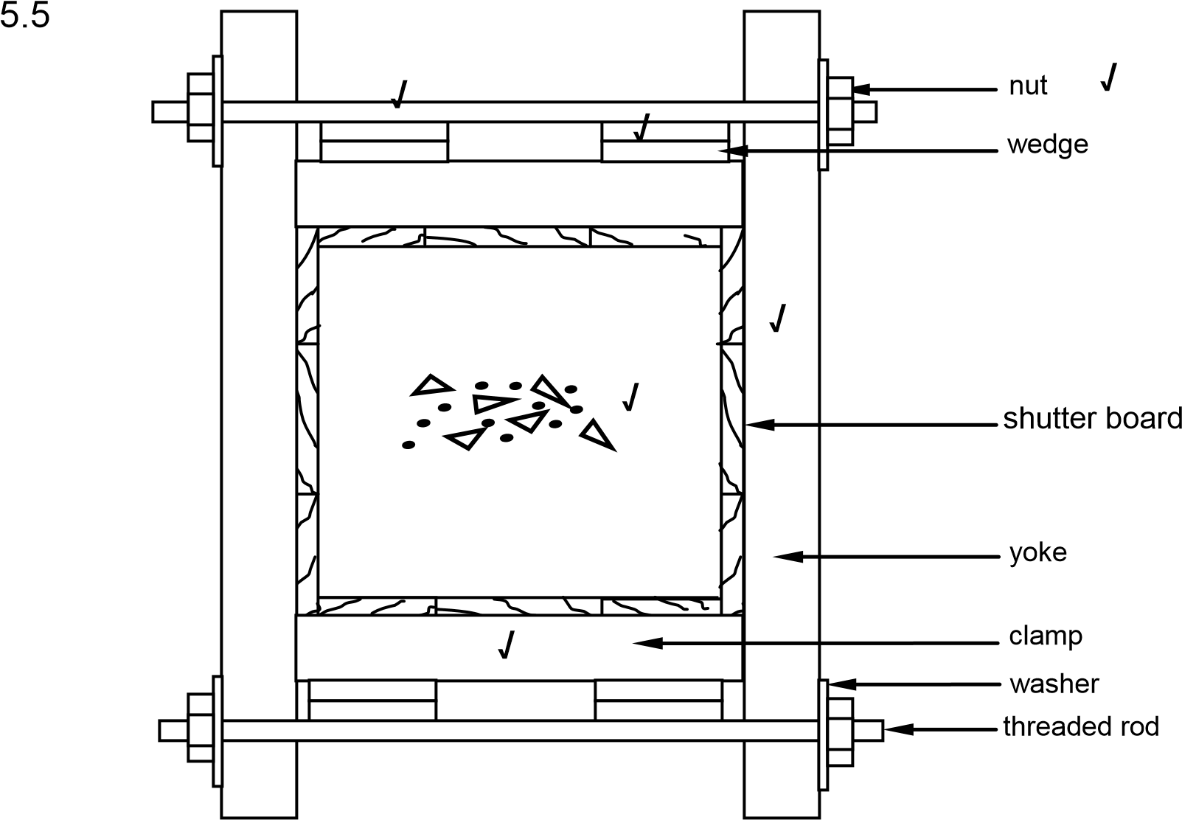

ASSESSMENT CRITE | RIA
16 mm Ø threaded rod | 1
Yokes | 1
Clamps | 1
Wedges | 1
Labels | 1
Application of scale | 1
TOTAL | 6

(6)

1.6 1.6.1 Portable vibrator (poker and drive unit) (1)

1.6.2 • A spare concrete vibrator should be on standby √
- Hand compaction is an alternative option (1)

1.7

(2)

√

√

1.8 • A- Butterfly pattern √
- B- Double triangle pattern √ (2)

.9 • The walls must be connected using wall ties that are set 900 mm horizontally √ • 450 mm vertically apart, as closely as possible to any opening √
- Must also be placed at 300 mm intervals along the junctions and openings
of the wall (2)
[30]

EXAMPLE 2: QUESTION 2: BRICKWORK, STAIRCASES AND ROOF COVERING
2.1 Recommend TWO types of protective clothing that one may wear when
working with cement. (2)

2.2 When developing a table for a cutting list, the heading of each column must be
indicated. Name THREE headings for a cutting list. (3)

2.3 Describe TWO methods that may be used to join a timber window frame stile
onto brickwork. (2)
2.4 State THREE hand tools that you will need to make the formwork for a square
column. (3)

2.5 Name ONE type of nail that you will use to join roof truss members to one
another. (1)

2.6 The sketch 2.6 shows a plan course of a one-brick wide corner junction wall (quoin) built in English bond.

√

√

ASSESSMENT CRITERIA |  | LM
Header course | 2
Stretcher course | 2
Queen closer | 1
Proportion and line work | 2
Label: Header | 1
Label: Queen closer | 1
TOTAL | 9

Project and draw, from the given view, the alternate plan course of the wall in good proportion.
Label the following on the drawing:
- Header course
- Queen closer

NOTE: Proportion and line work will count two marks. (9)

2.7 FIGURE 2.7 below shows the formwork for a concrete staircase. Study the picture and answer the questions that follow.

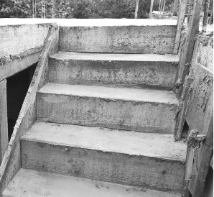

FIGURE 2.7

C

D

A

B

    - Identify part A. (1)

    - Recommend a suitable height for B. (1)

    - Identify part C. (1)

    - Identify part D. (1)

    - Draw the symbol for concrete. (2)

  - Describe the purpose of roof covering in a building (2)

2.9 Name TWO types of profiles of metal roof sheeting that are used in the
building industry. (2)
FIGURE 2 .10 shows an incomplete gauged segmental arch with construction lines. The incomplete courses of surrounding brickwork are also shown on the right-hand side.

FIGURE 2.10

ASSESSMENT CRITERIA | MARKS | LEARNER'S MARK
Voussoirs | 3
Key voussoir | 1
Surrounding brickwork | 2
Rise (indicate and label) | 1
Span (indicate and label) | 1
Intrados (indicate and label) | 1
Extrados (indicate and label) | 1
TOTAL | 10

    - Complete the gauged segmental arch by drawing the voussoirs (bricks) just past the centre of the arch. (3)

    - Label the key voussoir (brick). (1)

    - Complete the surrounding brickwork in stretcher bond on the right- hand side of the arch within THREE of the given courses. (2)

    - Indicate the rise on your drawing. (1)

    - Indicate the span on your drawing. (1)

    - Indicate the intrados on your drawing. (1)

    - Indicate the extrados on your drawing. (1)
[40]

ANSWER: QUESTION 2: BRICKWORK, STAIRCASES AND ROOFCOVERING CONSTRUCTION

2.1 • Safety goggles √
- Overall √
- Safety gloves
- Safety shoes
- Dust mask (2)

2.2 • Component √
- Number √
- Unit √ • Length
- Breadth
- Thickness
- Subtotal
- Total
- Material

ANY THREE OF THE ABOVE OR ANY OTHER ACCEPTABLE ANSWER (3)

2.3 • Timber window frames can be joined into brickwork with steel ties. √
• Long nails can also be hammered into the sides of the stiles. √ • Metal straps, lugs and screws can also be used to join frames to a wall.

ANY TWO OF THE ABOVE OR ANY OTHER ACCEPTABLE ANSWER (2)
2.4 • Claw hammer √
- Cross-cut saw √
- Tape measure √
- Square
- Shifting spanner
- Spanners

ANY THREE OF THE ABOVE OR ANY OTHER ACCEPTABLE ANSWER (3)

2.5 Wire nail √ (1)
2.6
ASSESSMENT CRITERIA |  | LM
Header course | 2
Stretcher course | 2
Queen closer | 1
Proportion and line wo k | 2
Label: Header | 1
Label: Queen closer | 1
TOTAL | 9

header course
√

queen closer
√

√

√

√

√

√

√

√

proportion of line work
√

√

FIGURE 2.6 (9)
2.7 2.7.1 Rise (1)

2.7.2 75–200 mm (1)

2.7.3 Stringer (1)

2.7.4 Tread/Going (1)

2.7.5

√ √ (2)

2.8 The purpose of roof covering is to:

- Resist weather conditions, such as wind and rain √
- Keep heat, rain and cold out of the house √
- Provide shade from direct sunlight • Keep the interior of the house cool
- Provide the occupants with security as well as privacy
- Prevent birds, insects and rodents from entering the house
- Enhance the appearance of the building

ANY TWO OF THE ABOVE OR ANY OTHER ACCEPTABLE ANSWER (2)

2.9 • Corrugated iron roof sheeting √
• IBR (Inverted box rib) √
(2)
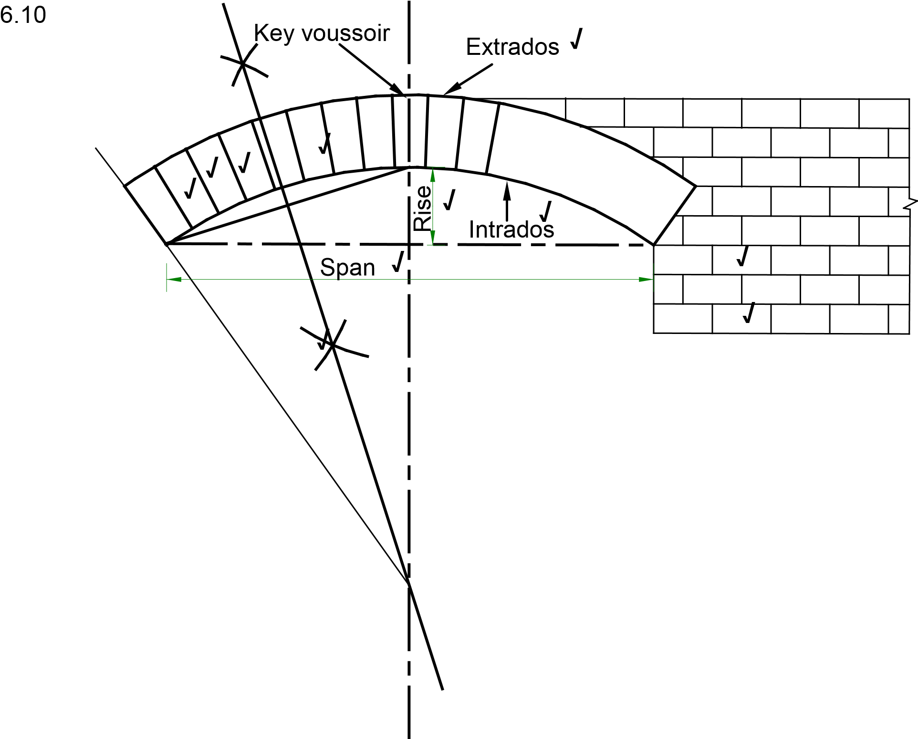
1 mark will be given if voussoirs are vertical lines.

ASSESSMENT CRITER A | MARKS | LEARNER'S MARK
Voussoirs | 3
Key voussoir | 1
Surrounding brickwork | 2
Rise (indicate and label) | 1
Span (indicate and label) | 1
Intrados (indicate and label) | 1
Extrados (indicate and label) | 1
TOTAL | 10
(10)
[40]

EXAMPLE 3: QUESTION 3: TOOLS, CONCRETE, FORMWORK AND LINTELS (SPECIFIC)

3.1 Answer the following questions with regard to the tool in FIGURE 3.1.

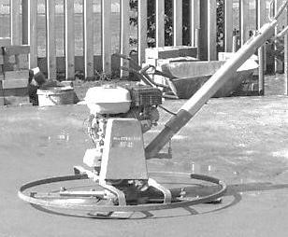

FIGURE 3.1

3.1.1 What is this tool called? (1)

3.1.2 Briefly describe the use of the tool. (2)

3.2 Briefly state the definition of scaffolding. (3)

3.3 Identify the structural forces illustrated by sketches 3.3.1 to 3.3.3: (3)

3.3.1

3.3.2

3.3.3

3.4 Briefly motivate why steel reinforcement must be free from rust and
oiliness. (2)

3.5 Answer the following questions with regard to the installation of steel reinforcement in FIGURE 3.5.

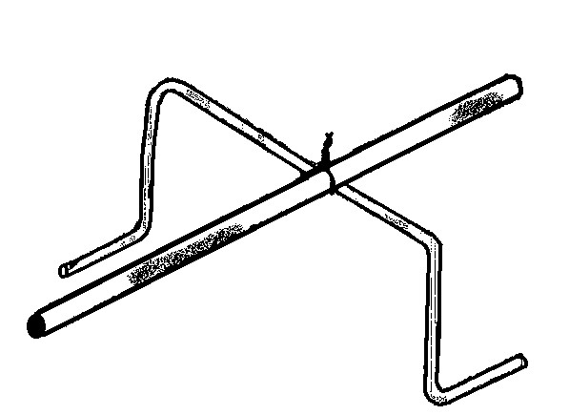

FIGURE 3.5

.A
3.5

3.5
.B

3.5.1 What is part 3.5.A called? (1)

3.5.2 What is the purpose of part 3.5.A? (1)

3.5.3 Identify the type of steel bar illustrated by part 3.5.B. (1)
3.6 FIGURE 3.6 shows the outside lines of the top view of a concrete column.
Draw the following steel reinforcing to scale 1: 10.

3.6.1 10 mm stirrups with a concrete cover of 50 mm (4)

3.6.2 Four main reinforced bars with a diameter thickness of 40 mm (3)
Stirrups | 2
Scale | 1
Concrete covering | 1
Main reinforcement | 2
Scale | 1
TOTAL | 7

FIGURE 3.6

3.7 Name TWO advantages of steel reinforcement in concrete constructions.
(2 x 1) (2)

3.8 Give the correct concrete mixture for a reinforced concrete floor. (3)

3.9 Describe the purpose of the following requirements that are applicable to formwork:

3.9.1 Joints must be sealed (1)

3.9.2 Must be free of dirt (1)

3.9.3 A release agent must be applied to the inside (1)

3.9.4 Must be built sturdily enough (1)

3.10 Answer the following questions with regard to the staircase in FIGURE 3.10.

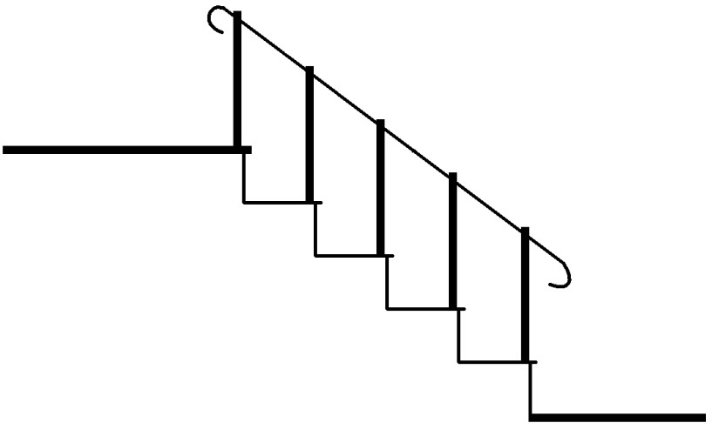
3.10
.A

3.10
.B

3.10
.C

FIGURE 3.10

3.10.1 Name the parts 3.10.A to 3.10.C. (3 x 1) (3)

3.10.2 What is the minimum height of part 3.10.C? (1)

3.11 Answer the following with regard to the construction in FIGURE 3.11.
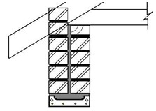
3.11
.B

3.11
.A

3.11.1 What is the thickness of the single-brick wall 3.11.A? (1)

3.11.2 What is part 3.11.B called? (1)

3.11.3 Briefly describe the purpose of part 3.11.B. (2)

3.11.4 Name TWO advantages of part 3.11.B. (2)

[40]

ANSWER 3: QUESTION 3: TOOLS, CONCRETE, FORMWORK AND LINTELS (SPECIFIC)

3.1 3.1.1 Power float (1)

3.1.2 (1) Provides a level, smooth finish (2) on large concrete floors (2)

3.2 (1) A temporary platform / gantry (2) that is erected to reach parts of a
building, (3) that are hard to reach. (3)

3.3 3.3.1 Tensile force
3.3.2 Compression force
3.3.3 Shear force (3)

3.4 (1) Oiliness will influence the bonding to the concrete and (2) can cause
movement. (2)

3.5 3.5.1 Steel stand (1)
3.5.2 To ensure that the required concrete cover is obtained during the
pouring of the concrete (1)
3.5.3 Round bar / soft steel / mild steel (1)

3.6
Stirrups | 2
Scale | 1
Concrete covering | 1
Main reinforcement | 2
Scale | 1
TOTAL | 7
(7)

3.7 TWO advantages of steel reinforcement in concrete constructions.
- The size of the beam or column can be reduced
- The beam can carry heavier loads (2)

  - 1: 2: 4 (3)

  - Describe the purpose of the following requirements that are applicable to formwork:

    - For the concrete not to leak and form honeycomb or fins (1)

    - Dirt can influence the bonding to the concrete (1)

    - For the concrete not to stick to the shutter boards (1)

    - To withstand the mass of the wet concrete / provide sufficient
support, without too much deflection, until concrete has set (1)

3.10 3.10.1
3.10.A – Landing
3.10.B – Tread
3.10.C – Riser (3)

3.10.2 150 mm (1)

3.11 3.11.1 220 mm (1)

    - Lintel (1)

    - (1) It’s a horizontal beam (2) and it supports a wall or any
construction above the lintel (2)

    - Any TWO advantages of part 3.11.B.
- Readily available
- Saves time and labour to construct formwork
- Strongest lintels
- Suitable for spanning widths of 900 mm and more
- Restricts cracks from forming
- Easier to handle (2 x 1) (2)
[40]

EXAMPLE 4: QUESTION 4: CONCRETE, FORMWORK, BRICKWORK, STAIRS AND ROOFS (SPECIFIC)

4.1 Answer the following questions with regard to the bar (rod) code in FIGURE 4.1.

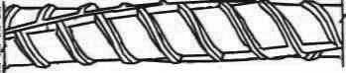

BAR CODE:
8Y10-01-250

FIGURE 4.1

4.1.1 What type of steel is used here? (1)

4.1.2 What is the thickness of the bars (rods)? (1)

4.1.3 How many bars are required? (1)

4.1.4 Determine the centre-to-centre spacing of the stirrups. (2)

4.2 Draw a neat sectional sketch of the reinforcement for a rectangular column in the ANSWER BOOK. Use the following information:
Use scale = 1: 10
- Column = 800 x 500 mm (2)
- Main bars = 25 mm diameter (3)
- Stirrups = 10 mm diameter (2)
- Concrete cover = 50 mm (1)

4.3 Name the purpose of the following bars in a concrete beam:

    - Anchor bars (1)

    - Stirrups (1)

    - Main bars (1)

4.4 Indicate whether the following statements are TRUE or FALSE. Write only the word ‘true’ or ‘false’ next to the question number (4.4.1–4.4.3)

    - Release agents for steel formwork should contain an anti-rust agent. (1)

    - An arch is the strongest structure that can be used to span a distance. (1)

    - The profile for the construction of arches is made from plastic. (1)

  - Describe THREE properties of a good formwork. (3 x 1) (3)

  - Answer the following questions with regard to the formwork in FIGURE 6.6.

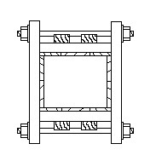

FIGURE 4.6

4.6
. A
4.6
. B
4.6
.C
4.6
. D

    - Is this formwork used for a beam or a column? (1)

    - Name parts 4.6.A to 4.6.D. (4)

4.7 Answer the following questions on the wall construction in FIGURE 4.7.

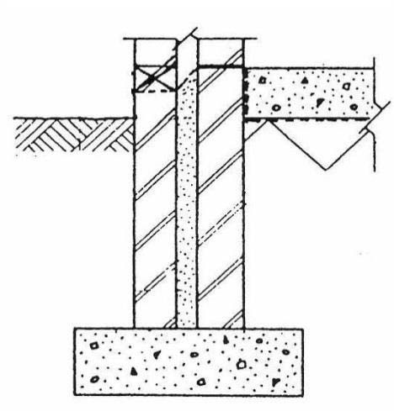

FIGURE 4.7

4.7
.A
4.7
.B

    - Name the type of wall in this construction. (1)

    - What is the thickness of this unplastered brick wall? (1)

    - Name parts 4.7.A and 4.7.B. (2)

    - What is the purpose of part 4.7.A? (1)

  - Briefly describe what a rough arch is. (2)

  - Name THREE properties of a roof underlay. (3 x 1) (3)

  - Provide ONE word/term for the following components of a staircase:
    - The horizontal part of a step (1)

    - The vertical posts that hold up the handrail (1)

    - A platform at the top of a flight of stairs (1)

[40]

ANSWER 4: QUESTION 4: CONCRETE, FORMWORK, BRICKWORK, STAIRS AND ROOFS (SPECIFIC)

4.1 4.1.1 High tensile steel (1)

4.1.2 10 mm (1)

4.1.3 8 Bars (1)

4.1.4 12 x main bar diameter = 12 x 10 (1) = 120 mm (1) (2)

4.2 Section sketch of reinforcement for a rectangular column. (8)

mm
80

5

mm 50 mm

Not to scale

4.3 4.3.1 To resist compressive forces. (1)

4.3.2 Any ONE: (1)
- Join the main bars together
- Resist shear stress forces

4.3.3 To resist tensile forces. (1)

4.4 4.4.1 True (1)
    - True (1)

    - False (1)

4.5 Any THREE properties of a good formwork:
- Sturdy enough to bear the mass of wet concrete without collapsing …………
- Strong enough to provide sufficient support, without deflection
- Easy to repair on site
- Erected accurately
- Sealed properly – no leaking and forming of honeycombing / fins
- Free of dirt (sawdust / release agents)
- Quick and simple to erect (hand / mechanical)
- Correct depth for reinforcing – prevents failure
- Easy to remove
- Close-fitting along joints and seams
- Made of recyclable components (3 x 1) (3)

4.6 4.6.1 Column (1)

4.6.2 4.6.A – Wedge (1)

4.6.B– Clamp (1)

4.6.C– Yoke (1)

4.6.D– Plank / formwork boards (1)

4.7 4.7.1 Cavity wall (1)

    - 270 mm (1)

    - 4.7.A – Weep hole (1)

4.7.B – Grout (1)

4.7.4 Extraction of moisture / water in the wall. (1)

  - The bricks are placed in wedge-shaped mortar joints (1) and plastered (1). (2)

  - Any THREE properties of a roof underlay.
- Excellent tear and puncture resistant properties
- Waterproof
- Dustproof
- UV and heat stabiliser
- Superior wind uplift strength
- Vapour-resistant
- High tensile resistance
- Cost-effective
- High heat resistance (3 x 1) (3)

4.10 4.10.1 Tread (1)

    - Baluster (1)

    - Landing (1)
[40]

