Province of the
EASTERN CAPE
EDUCATION

DIRECTORATE SENIOR CURRICULUM MANAGEMENT (SEN-FET)
HOME SCHOOLING SELF-STUDY WORKSHEET
SUBJECT | LIFE SCIENCES | GRADE | 12 | DATE | 27 August 2020
TOPIC | Introduction to Evolution, evidence and variation | MARKS  50 |  | TERM 3 CONTENT
TIME ALLOCATION | 50 minutes | TIPS TO KEEP HEALTHY  1. WASH YOUR HANDS thoroughly with soap and water for at least 20 seconds. Alternatively, use hand sanitizer with an alcohol content of at least 60%.  2. PRACTICE SOCIAL DISTANCING – keep a distance of 1m away from other people.  3. PRACTISE GOOD RESPIRATORY HYGIENE: cough or sneeze into your elbow or tissue and dispose of the tissue immediately after use.  4. TRY NOT TO TOUCH YOUR FACE. The virus can be transferred from your hands to your nose, mouth and eyes. It can then enter your body and make you sick.  5. STAY AT HOME.
INSTRUCTIONS | Use Mind The Gap Study Guide and read:  Study the notes provided with this lesson  Answer the questions on the Worksheets below

QUESTION 1
1.1 | Indicate whether each of the statements in COLUMN I applies to A ONLY, B ONLY, BOTH A AND B or NONE of the items in COLUMN II. Write A only, B only, both A and B, or none next to the question number (1.1.1 to 1.1.3) in the ANSWER SHEET.  COLUMN I COLUMN II  1.1.1 Example of continuous variation A: Height B: Skin colour  1.1.2 Source of variation that results in formation of new alleles A: Crossing over B: Random arrangement of chromosomes
( 2 X 2) (4)
1.2 Give the correct biological term for each of the following descriptions. Write only
the term next to the question number (1.2.1 to 1.2.6) in the ANSWER BOOK
1.2.1 The distribution of species in different parts of the world.
1.2.2 Similar structures on different organisms that suggest they have a common
ancestor.
1.2.3 Genetic changes that occur in living organisms over time.
1.2.4 Change in the structure or number of chromosomes.
1.2.5 The study of fossils
1.2.6 The wide variety of living organisms on Earth (6)

1.3 Differentiate between:
(a) Hypothesis and theory (4)
(b) Species and population (4)
(8)
[18]
QUESTION 2
2.1 The diagram below represents the possible evolution of the horse.

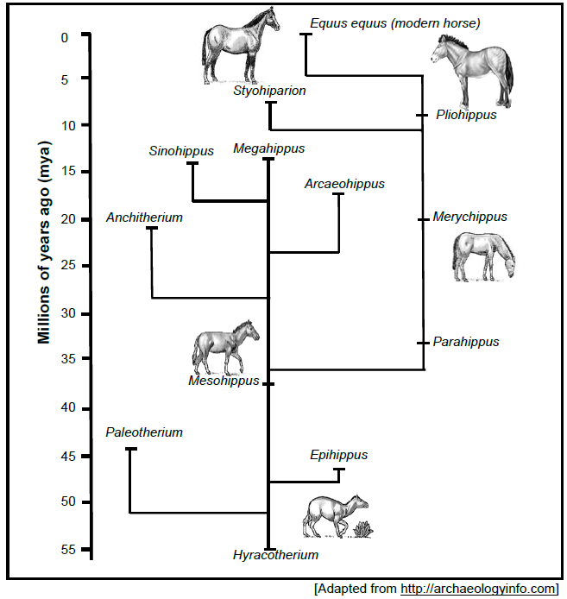
2.1.1 Name the:
(a) Common ancestor of all horses  (b) Genus most closely related to Megahippus | (1)  (1)
2.1.2. When did Paleotherium become extinct? (2)
2.1.3 How long did it take for the modern horse to evolve from Hyracotherium? (2)
2.1.4 What is the scientific name for the modern horse? (1)
2.1.5 State the conclusion that can be drawn regarding the height of the horse over
time. (1)
(8)

2.2 Read the extract below.
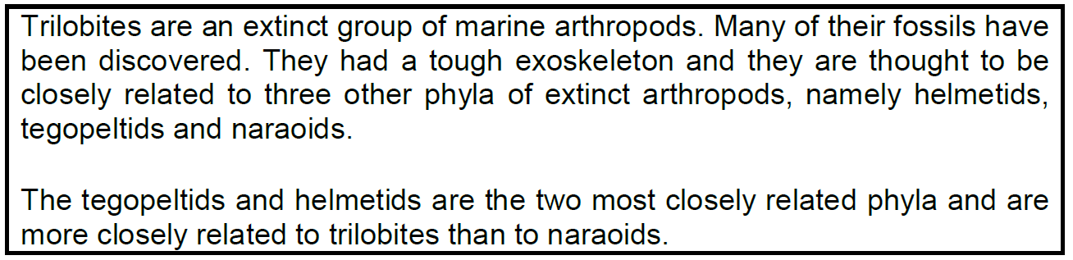
Study the diagram below, which illustrates the possible evolutionary relationships among
the four phyla, represented by the letters M, N, O and P.
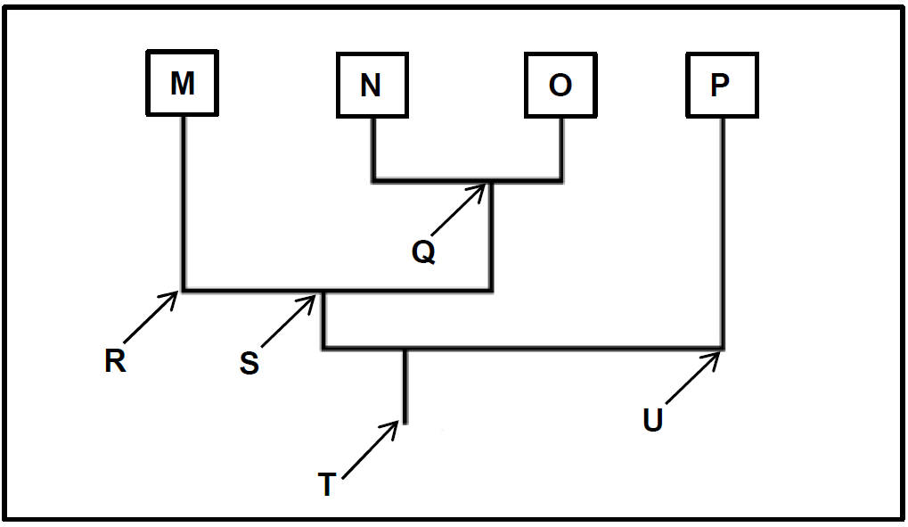
2.2.1 Name the type of diagram illustrated. (1)
2.2.2 What structural feature of trilobites, described in the extract, improved the chances
of fossilisation? (1)
2.2.3Give the letter of the most recent common ancestor for phyla:
(a) M and O (1)
(b) M,N,O and P (1)
2.2.4 Which of the extinct arthropods (trilibetes, helmetids, tegopeltids or naraoids) are
represented by phylum:
(a) M (1)
(b) N (1)
(c) O (1)
(d) P (1)
(8)

2.3 A group of learners from a school decided to do an investigation, using scientific
literature on the evidence presented by fossils, to support the theory of evolution. They
formulated the following hypothesis:

'First appearance of fossils of single-cell/simple organisms are found in the
oldest layers of rock’

A summary of their research from the scientific literature is shown in the table below.

2.3.1 According to the results in the table above, will the learners accept or reject their
hypothesis? (1)
2.3.2 Explain your answer to QUESTION 2.3.1. (2)
2.3.3 Explain the implications to the evolution theory if fossils of dinosaurs from the
early Pre-Cambrian period were found. (2)
2.3.4 Explain why the invertebrates might have appeared earlier than our fossil record
currently shows. (2)
2.3.5 State TWO other studies that provide evidence for evolution. (2)
(9)

2.4 Grade 12 learners investigated the frequency of the four blood groups in the human
population. They used a sample of 38 learners who already knew their blood groups. The
graph below shows the results.

2.4.1 What type of variation is displayed by the blood groups? (1)
2.4.2 Provide a reason for the answer to QUESTION 2.4.1. (2)
2.4.3 State the independent variable for this investigation. (1)
2.4.4 State ONE way in which the results of the investigation could be made reliable. (1)
2.4.5 State TWO sources of variation in humans that are not related to meiosis. (2)
(7)
[32]
Grand Total {50}

