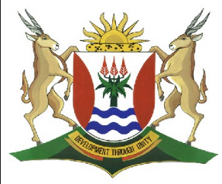
Province of the
EASTERN CAPE
EDUCATION

DIRECTORATE SENIOR CURRICULUM MANAGEMENT (SEN-FET)
HOME SCHOOLING SELF-STUDY WORKSHEET
SUBJECT | ECONOMICS | GRADE | 12 | DATE | 17/06/2020
TOPIC | CONTEMPORARY ECONOMIC ISSUES | TERM 1  REVISION |  | TERM 3 CONTENT | X
TIME ALLOCATION | 30 MINUTES MARKS: 40 | TIPS TO KEEP HEALTHY  1. WASH YOUR HANDS thoroughly with soap and water for at least 20 seconds. Alternatively, use hand sanitizer with an alcohol content of at least 60%.  2. PRACTICE SOCIAL DISTANCING – keep a distance of 1m away from other people.  3. PRACTISE GOOD RESPIRATORY HYGIENE: cough or sneeze into your elbow or tissue and dispose of the tissue immediately after use.  4. TRY NOT TO TOUCH YOUR FACE. The virus can be transferred from your hands to your nose, mouth and eyes. It can then enter your body and make you sick.  5. STAY AT HOME.
INSTRUCTIONS | INSTRUCTIONS AND INFORMATION  - Answer ALL questions in the ANSWER BOOK  - Number the answers correctly according to the numbering system used in this question paper.  - Write the question number above each answer.  - Leave 2–3 lines between subsections of questions  - Write neatly and legibly.

QUESTION 1 CONTEMPORARY ECONOMIC ISSUES 40 MARKS − 30 MINUTES
DBE/Feb.–Mar. 2018
1.1 | Answer the following questions.
 | 1.1.1 | State any TWO measures used by the government to ensure environmental sustainability. (2 x 1) |  | (2)
 | 1.1.2 | What do monetarists believe to be the main reason for inflation? (1 x 2) |  | (2)
1.2 | Study the information below and answer the questions that follow.
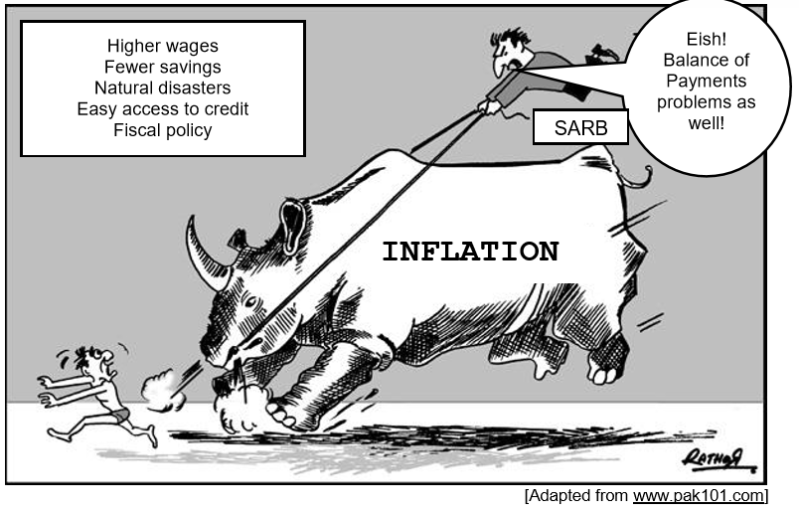
 | 1.2.1 | Identify ONE cause of demand-pull inflation in the information above. |  | (1)
 | 1.2.2 | Identify ONE cause of cost-push inflation in the information above. |  | (1)
 | 1.2.3 | Briefly describe the term inflation. |  | (2)
 | 1.2.4 | What is the main instrument used by the South African Reserve Bank to control inflation? |  | (2)
 | 1.2.5 | Why is the SARB concerned about the impact of inflation on the Balance of Payments? (2 x 2) |  | (4)
1.3 | Study the information below and answer the questions that follow.
 |  | 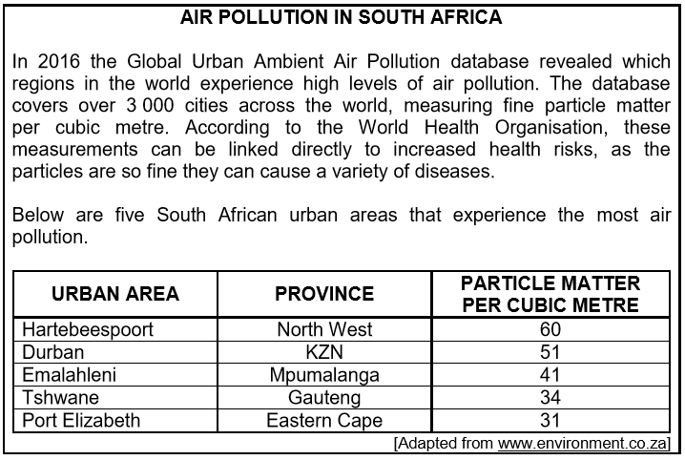
 | 1.3.1 | Identify the most polluted urban area in South Africa in the information above. |  | (1)
 | 1.3.2 | Which organisation, in the information above, links health risks to air pollution? |  | (1)
 | 1.3.3 | Briefly describe the term air pollution. |  | (2)
 | 1.3.4 | Why is pollution resulting from production such a serious problem? |  | (2)
 | 1.3.5 | Why are the major cities in South Africa the most polluted? (2 x 2) |  | (4)
1.4 | Briefly describe the negative effects of tourism on the environment. (4 x 2) |  |  | (8)
1.5 | How does the government contribute to higher inflation? |  |  | (8)
 |  |  |  | [40]

