Province of the
EASTERN CAPE
EDUCATION

DIRECTORATE SENIOR CURRICULUM MANAGEMENT (SEN-FET)
HOME SCHOOLING SELF-STUDY WORKSHEET
SUBJECT | ELECTRONICS | GRADE | 12 | DATE | MAY 2020
TOPIC | SWITCHING CIRCUITS | TERM 1  REVISION | () | TERM 2 CONTENT | (√)
TIME ALLOCATION | 2 hrs. | TIPS TO KEEP HEALTHY  1. WASH YOUR HANDS thoroughly with soap and water for at least 20 seconds. Alternatively, use hand sanitizer with an alcohol content of at least 60%.  2. PRACTICE SOCIAL DISTANCING – keep a distance of 1m away from other people.  3. PRACTISE GOOD RESPIRATORY HYGIENE: cough or sneeze into your elbow or tissue and dispose of the tissue immediately after use.  4. TRY NOT TO TOUCH YOUR FACE. The virus can be transferred from your hands to your nose, mouth and eyes. It can then enter your body and make you sick.  5. STAY AT HOME.
INSTRUCTIONS

QUESTION 1
  - List THREE types of multivibrators.
  - Refer to FIGURE 1.1 BELOW and answer the questions which follow.
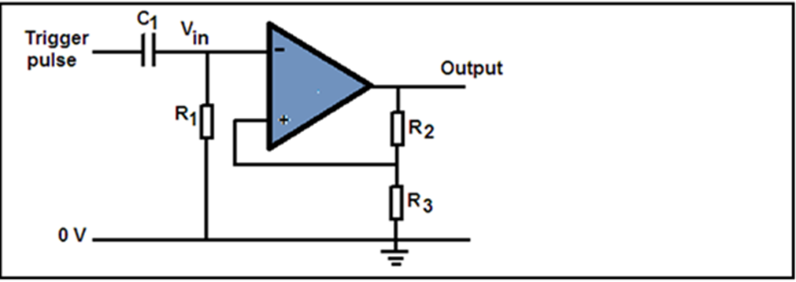
Figure 1.1
1.2.1 Identify the circuit diagram above.
1.2.2 Describe the operation of the circuit.
1.3 State two applications of a monostable multivibrator.
1.4 Design a circuit diagram of a Schmitt trigger.
1.5 Determine four applications of a Schmitt trigger
1.6 draw a fully labelled diagram of a monostable multivibrator
1.7 Sketch a fully labelled circuit diagram for a 555 IC Astable multivibrator circuit showing input and output waveforms.
1.8 Figure 1.2 below represents the summing amplifier. Calculate circuit output voltage.
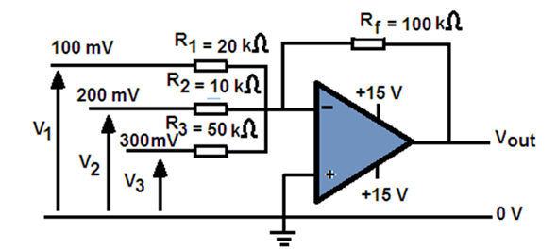
Figure 1.2
1.9 Refer to Figure 1.3 below and answer question that follows.
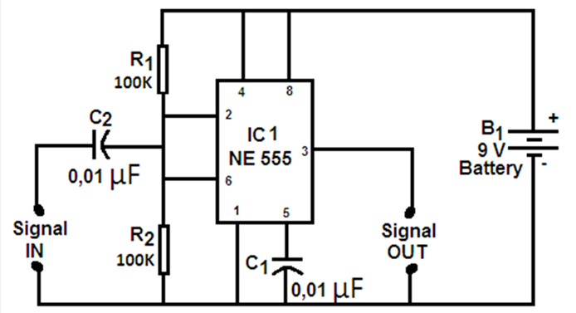
Figure 1. 3
1.9.1 Draw TWO full cycles of the input and output waveforms for this circuit if a sinusoidal waveform was added to its supply.
1.10 FIGURE 1.4 represents a passive RC differentiator. Answer the question that follows.
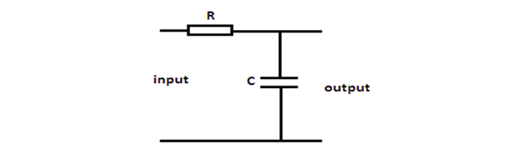

Figure 1.4
1.10.1 Sketch the output wave form.
1.11 Explain the operation of an integrator.
1.12 Design a circuit diagram of an op-amp integrator.
1.13 A 555 astable multivibrator circuit has the following components:
Given: R1 = 47 kΩ
C = 1$μF$
R₂ = 5 kΩ
Calculate the following:
1.13.1 Charging time
1.13.2 Discharging time
1.13.3 Time to complete one cycle
1.13.4 Frequency of oscillation

