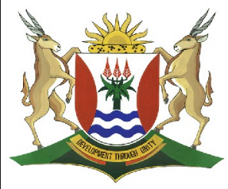
Province of the
EASTERN CAPE
EDUCATION

DIRECTORATE SENIOR CURRICULUM MANAGEMENT (SEN-FET)
HOME SCHOOLING SELF-STUDY WORKSHEET
SUBJECT | GEOGRAPHY | GRADE | 12 | DATE | 15/06/20
TOPIC | Economic Geography of South Africa | TERM 3  REVISION | √√ | TERM 3 CONTENT | √√
TIME ALLOCATION | 1 Hour | TIPS TO KEEP HEALTHY  1. WASH YOUR HANDS thoroughly with soap and water for at least 20 seconds. Alternatively, use hand sanitizer with an alcohol content of at least 60%.  2. PRACTICE SOCIAL DISTANCING – keep a distance of 1m away from other people.  3. PRACTISE GOOD RESPIRATORY HYGIENE: cough or sneeze into your elbow or tissue and dispose of the tissue immediately after use.  4. TRY NOT TO TOUCH YOUR FACE. The virus can be transferred from your hands to your nose, mouth and eyes. It can then enter your body and make you sick.  5. STAY AT HOME.
INSTRUCTIONS | Please answer these questions with:  - use of the attached PowerPoints slides  - Your textbook.

Economic
Geography of
South Africa
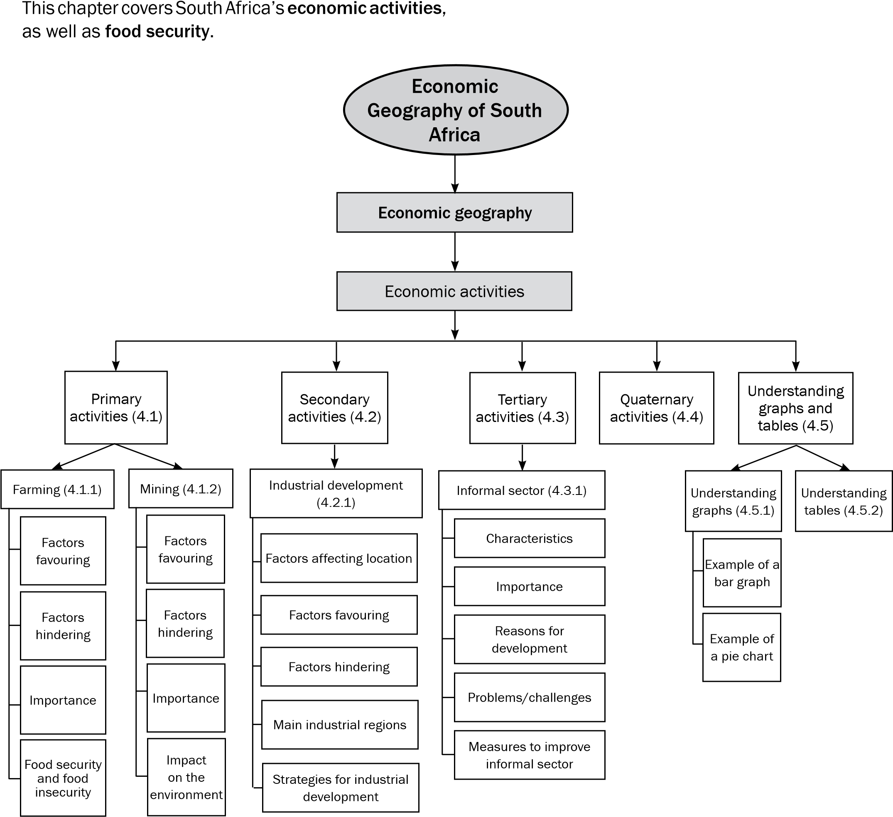

If know and understand all the definitions of economic geography, you will be able to answer most of the questions in the economic geography section of the final exam. Use mobile notes to help you memorise these key concepts.

Key concepts

Concept | Definition
Balance of payment | A country’s financial statement showing its transactions with the rest of the world
Balance of trade | The value of exports minus the value of imports
Bridge industries | Industries that are located between the source of raw materials and the customer, e.g. oil refineries
Centralisation | Movement of industries into core areas
Decentralisation | Movement of activities away from over-centralised areas
Economic activities | Activities that people practise to meet their needs or earn a living
Exports | Goods and services that are sold to foreign countries
Favourable trade balance | Occurs when the value of exports is greater than the value of imports
Food insecurity | When not all the people have enough food to meet their needs for a healthy and productive life
Food security | When all the people have enough food to meet their needs for a healthy and productive life
Footloose industries | Industries that can be located in any place without being affected by factors such as resources or transport, e.g. diamond processing and computer chip manufacturing
Foreign exchange | The money paid to South Africa by other countries, e.g. dollars and pounds, in exchange for goods and services
Formal sector | Registered businesses that are licensed to sell goods or provide services
Globalisation | The way in which the economic, social, political and cultural activities of countries across the world are interconnected (working together)
Gross Domestic Product (GDP) | The total value of goods and services produced within the borders of the country in a year
Gross National Product (GNP) | The total value of goods and services produced by the permanent citizens of a country in one year (note that permanent citizens may work out of the country)
Hawker | An informal street trader
Imports | Goods and services that are bought from foreign countries
Industrial Development Zone  (IDZ) | Industrial estates or areas aimed at economic growth and new investment; used by developing countries to attract investment, create jobs and boost exports
Informal sector | Activities by small, unregistered businesses that sell goods or provide services without being licensed, e.g. petty trade, casual employment, spaza shops and street hawkers or traders
Infrastructure | Transport network (roads, railways) and services (electricity, telecommunication, water and sewerage) that are in place

Concept | Definition
Primary activities | Activities that involve taking natural resources from the earth, e.g. farming  (livestock, crops), forestry, mining, fishing
Quaternary activities | Activities that deal with information and research
Secondary activities | Activities that involve the processing of raw materials and manufacturing of goods, e.g. factories and industries
Semi-skilled worker | A worker who does routine tasks (simple tasks that are done on a regular basis); someone who is not skilled or trained to do specialised work (difficult tasks that need special training)
Skilled worker | A worker who has a specific set of skills or specialised knowledge that has usually been obtained through some kind of formal training
Spatial Development  Initiatives (SDI) | Programme aimed at improving infrastructure and attracting business investments in rural areas that were neglected and underdeveloped
Tertiary activities | Activities that deal with the supply of services, e.g. banking, trade and transport
Trade | The flow of goods and services from producers to consumers across the world
Trading bloc | A group of countries that have common markets or trade agreements
Unskilled worker | A worker who performs simple duties that do not require any specific skills, training or previous experience; usually involves hard physical labour

The economic geography section will appear in Section B of the theory paper in Questions 3 and 4. Note that you will be asked to answer questions based on information contained in texts, graphs and tables. The answers can be found in the information given, so read the information carefully to find the answer.

When a question in the exam refers to a table or graph, it is important that you study the table or graph before you read the questions. This is similar to reading a comprehension text before answering the questions. You will need to UNDERSTAND the table or graph in order to answer the questions.

1 Understanding graphs
In this section we look at two types of graphs: bar graphs and pie charts. Follow these steps when you read a graph:
Steps to reading a bar graph
Step 1: The heading of a graph will tell you what the graph shows and what is being compared. It will tell you how the two or more factors shown on the graph are connected. In other words, it will tell you what the relationship is between the factors shown.
Step 2: Look at the labels on the different axes to see what factors are being compared on the graph. These should be the same factors mentioned in the heading.
Step 3: Look at the units of measurement on the different axes, for example percentage and time, or amount of money compared across economic sectors.
Step 4: Look at what is being compared and how the factors affect one another. In other words, try and understand the relationship between the different factors. For example, as the one factor increases so the other factor may decrease, or as one factor increases so the other factor may stay the same.

The next section will help you to understand graphs and tables in economic geography. Learn this information to prepare for this section of the exam.

Step 5: Look for anything that is unusual on the graph. See if there is anything that does not fit the relationship between the factors. In other words ,if the relationship shown is that the factor increases and all the other factors except for one factor decrease, we will have something to say about the exception. For example, on a graph it could be shown that the contribution of primary economic activities increased production over time, except for mining who’s production decreased.
Step 6; Now read the question set. Circle the question word to understand what is asked. Set about answering the questions. You will find the answers by reading the information in the graph.
2. Example of a bar graph
Carefully study the bar graph in Figure 4.5.1 A below which shows the contribution of different economic sectors to South Africa’s GDP(Gross domestic Product)
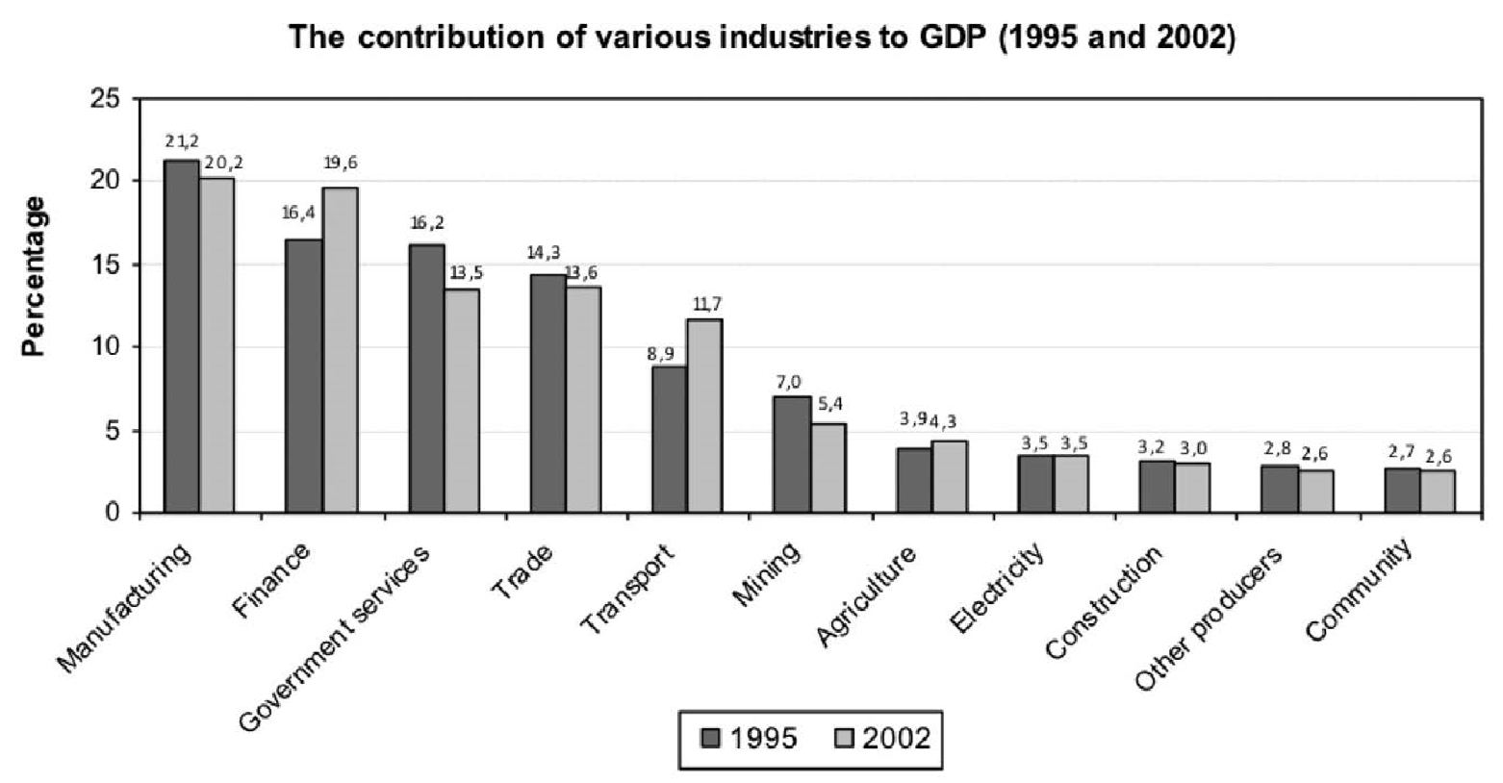

3. Example of a pie chart
Follow these steps to read the graph.
- The heading – the graph shows GDP(factor 1)in relation to different industries (factor 2 and time (factor 3).
- The axes- the vertical axes shows factor 1(the GDP). The horizontal axis shows factor 2(different industries) and factor 3 (time)
- Units of measurement – on the vertical axis factor 1(GDP) is shown as a percentage of total GDP. The horizontal axis lists factor 2(industries by name and facor 3 (times) in years.
- Look at whether the GDP trend goes up or down from 1995 to 2002 in each industry. For example ,the manufacturing goes down from1995 to 2002. The amount it decreases is calculated by subtracting the lower amount from the higher amount : 21,2% - 20,2% =1%.
- Look at what is unusual – the contribution of finance and transport is much higher in 2002.

Carefully study the pie chart or pie graph below(fig 4.5.1B) illustrating the contribution of different provinces to the national GDP.
Western Cape 14.4%
North West 6.3%
Northern Cape 2.2%
Mpumalanga 6.8%
Limpopo 6.7%
Eastern Cape 8.1%
Free State 5.5%
Gauteng 33.3%
KwaZulu-Natal 16.7%
Contribution of different Provinces to the National GDP

- The heading: - the graph show GDP (factor1) in relation to different provinces.(factor2)
- The sectors (pieces or slices) of the pie graph shows factor 1 – the contribution of each province to the GDP.
- Units of measurement – the sectors of the pie graph show factor 1(GDP) in percentage.
- The relationship between the different factors – because a pie chart compares parts of the whole, you need to note the different sizes of the sectors. This tells you how much each Province contributes to the total GDP.
- Look for anything that is unusual- for example,which is the smallest piece of the pie (Northern Cape)

4. Understanding Tables
In this section we look at how to read and understand the information in a table.

Steps to read a table:
Step 1: Look at the heading for the table to see what is shown
Step 2: Look at the labels
Step 3: Look at the relationship between what is compared
Step 4:Now read the questions

South Africa's mineral production and relative ranking in the world
Mineral | SA’s percentage of world production | World position
Asbestos | 6 | 4
Chromium | 76 | 1
Coal | 11 | 4
Diamonds | 24 | 2
Iron | 7 | 5
Manganese | 78 | 1
Platinum group | 79 | 1

1 | The heading – the table shows which minerals (factor 1) South Africa produces, how much we produce (factor 2), and where we are ranked in the world of production (factor 3).
2. | The first column lists factor 1 (minerals), the second column shows factor 2 (percentage of world production), and the third column shows factor 3 (the country’s ranking in world production).
3. | What mineral do we produce most of (Platinum) and where are we ranked in the world for manganese (first)? For how many minerals do we rank in first or second place? (three – chromium, manganese and platinum group)

Possible questions on Economic Geography of South Africa (Based on past question papers (2016 -2019)

  - FIGURE 1.1. is a bar graph that compares South Africa's imports and exports of agricultural products from 2008 to 2013, with an accompanying statement.
According to the 2012/13 export values, citrus fruit (R7 981 million), wine (R6 965 million), maize (R5 294 million), apples, pears and quinces (R5 172 million) and grapes (R4 576 million) were the most important agricultural export products.
[Source: http://www.daff.gov.za/docs/statsinfo/EcoReview1213.pdf]

1.1
 | 1.1.1 | Indicate whether South Africa imported or exported more of its agricultural products in 2008/2009. | (1x1) | (1)
 | 1.1.2 | Indicate the general trend of imports/exports from 2009/2010 to 2012/2013. | (1x1) | (1)
 | 1.1.3 | Which agricultural product earned the greatest income for South Africa in 2012/2013? | (1x1) | (1)
 | 1.1.4 | South Africa could earn more money by exporting the agricultural product in QUESTION 1.1.3 in a processed form. Explain why this is the case. | (1 x 2) | (2)
 | 1.1.5 | Explain TWO factors related to trade that have encouraged people to buy South African agricultural products. | (2 x 2) | (4)
 | 1.1.6 | Discuss the importance of agriculture to the South African economy. | (3 x 2) | (6)
 |  |  |  | [15]
1.2 | Informal trade is a common feature in developing countries.
 | 1.2.1 | Define the term informal sector. | (1x1) | (1)
 | 1.2.2 | State the relationship between the unemployment rate and the percentage of people working in the informal sector | (1 x 2) | (2)
 | 1.2.3 | Why is informal trade common in developing countries? | (1 x 2) | (2)
 | 1.2.4 | How would formalising businesses impact positively on the economy? | (1 x 2) | (2)
 | 1.2.5 | Write a paragraph of approximately EIGHT lines in which you suggest ways in which informal traders can be empowered to make a meaningful contribution to the South African economy. | (4 x 2) | (8)
 |  |  |  | [15]
1.3. Choose the correct word(s) from those given in brackets.
Write only the word(s) next to the question number (1.3.1 -1.3.7)
in the ANSWER BOOK, for example 4.2.8 tertiary.
1.3
 | 1.3.1 | (large-scale/small-scale) farmer has a small, but economically viable piece of land which is profitably and intensively farmed.
 | 1.3.2 | The lack of access to food and water, which could lead to chronic starvation and related diseases, is known as (food security/food insecurity).
 | 1.3.3 | When a government takes over the ownership and operations of the mines, it is called (privatisation/nationalisation).
 | 1.3.4 | The processing of raw materials into manufactured products is known as the (primary/secondary) sector.
 | 1.3.5 | An industry that develops when raw materials are evenly distributed and have no influence on the location of the industry is called a/an (bridge/ubiquitous) industry.
 | 1.3.6 | (Centralisation/Decentralisation) is the clustering of industries in one area.
 | 1.3.7 | (Bridge/Ubiquitous) industries are located between the source of the raw material and the customer.
 |  |  | (7x1) | (7)
1.4 | Read the extract in FIGURE 1.4 on coal mining in South Africa.  COAL MINING IN SOUTH AFRICA  Coal mining in South Africa plays a significant role in the country's economy, as it is responsible for nearly three quarters of Eskom's fuel supply. It also supplies coal to SASOL, who produces around 35% of the country's liquid fuel.  Coal mining in South Africa is centred on the Highveld, with roughly 60% of the country's deposits located in eMalahleni (Witbank) and surrounding areas.  [Source: http://www.projectsiq.co.za/coal-mining-in-south-africa.htm]
1.4
 | 1.4.1 | Name the province in which most of South Africa's coalfields are found. | (1 x 1) | (1)
 | 1.4.2 | Name TWO of South Africa's major industries that are dependent on coal as a raw material. | (2 x 1) | (2)
 | 1.4.3 | State TWO environmental problems resulting from coal mining in South Africa. | (2 x 2) | (4)
 | 1.4.4 | Mining and coal-dependent companies should work together to rectify environmental injustices associated with coal mining. In a paragraph of about EIGHT lines, explain how this can be achieved. | (4x2) | (8)
 |  |  |  | [15]
Study FIGURE 1.5 that illustrates key sectors of South Africa’s economy.

Figure 1.5 Key Sectors of the South African Economy
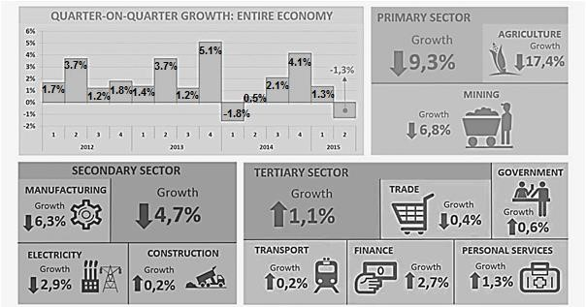

[
Source:
Statssa.co.za
]

1.5
 | 1.5.1 | List the following from the data that is provided:  - The year in which the first quarter shows a negative growth rate | (1 x 1) | (1)
 |  | (b)The economic activity that shows a growth rate in the secondary sector | (1 x 1) | (1)
 | 1.5.2 | Refer to the second quarter economic growth rates from 2012 to 2015.  - Mention the general trend in the economic growth rate from 2012 to 2015.  - Calculate the difference in the economic growth rate between the second quarter of 2014 and 2015. | (1 x 1)  (1 x 1) | (1)  (1)
 |  | © Using the data provided by the different economic sectors, discuss the economic growth rate in the second quarter of 2015. | (2 x 2) | (4)
 | 1.5.3 | Suggest a reason why trade in the tertiary sector, may have recorded a negative economic growth rate. | (1 x 2) | (2)
 | 1.5.4 | Analyse the impact that the negative  growth rate of agriculture might have on  the broader population of South Africa,  if this trend continues. | (2 x 2) | (4)
 |  |  |  | [14]
Refer to the extract in FIGURE 1.6 on manufacturing in South Africa.

FIGURE 1.6: MANUFACTURING IN SOUTH AFRICA

Manufacturing in South Africa

South Africa has developed an established, diversified manufacturing base that has shown its resilience (staying power) and potential to compete in the global economy. The manufacturing sector provides a locus for stimulating the growth of other activities, such as services, and achieving specific outcomes, such as employment creation and economic empowerment. This platform of manufacturing presents an opportunity to significantly accelerate the country’s growth and development
[Source: www.brandsouthafrica.com]

1.6 | 1.6.1 | Define the term manufacturing. | (1 x 1) | (1)
 | 1.6.2 | Name the economic sector that manufacturing falls under | (1 x 1) | (1)
 | 1.6.3 | Give ONE specific outcome that the manufacturing sector can achieve according to the extract. | (1 x 1) | (1)
 | 1.6.4 | Explain the economic importance to South Africa if the  manufacturing sector can ‘compete in the global  economy’. | (2 x 2) | (4)
 | 1.6.5 | ‘… manufacturing presents an opportunity to significantly accelerate the country’s growth and development.’ In a paragraph of EIGHT lines, comment on how labour supply and international competition may hinder any proposed acceleration in the manufacturing sector. | (4 x 2) | (8)
 |  |  |  | [15]
1.7. Refer to FIGURE 1.7 based on industrial development zones (IDZ),
which create opportunities for industrial decentralisation.

Source: Examiner's notes]
[
IDZ

Create new
employment
opportunities
Increase
exports of
value-added
products
Create
opportunity for
industrial
decentralisation
Increase
beneficiation
and localised
value chains
Improve local
socio-economic
conditions

1.7
 | 1.7.1 | Give an example of an IDZ in South Africa. | (1 x 1) | (1)
 | 1.7.2 | What is the main aim of an IDZ? (1 | (1 x 1) | (1)
 | 1.7.3 | How does an IDZ create the opportunity for industrial decentralisation? | (2 x 2) | (4)
 | 1.7.4 | State TWO advantages of industrial  decentralisation for the core industrial  regions in South Africa. | (2 x 2) | (4)
 | 1.7.5 | Explain how an IDZ will improve local socio-economic conditions. | (2x2) | (4)
 |  |  |  | [14]

FIGURE 1.8 SOUTH AFRICA'S POSITION ON THE GLOBAL FOOD SECURITY INDEX 2012–2016

RANKING OF SOUTH AFRICA IN 2016 COMPARED TO 2012
COUNTRY | GLOBAL FOOD SECURITY INDEX |  |  |  | GDP US$ 2016
 | 2012  Score | 2012  Ranking | 2016 Score | 2016  Ranking
South Africa | 61,7 | 40 | 62,9 | 47 | 13 481
[Source: Economist Intelligent Unit (EIU) Report, 2016 GFSI Edition]
1.8
 | 1.8.1 | Describe the change in South Africa's food security index score from  2012 to 2016. | (1 x 1) | (1)
 | 1.8.2 | State the change in South Africa's world  Ranking in terms of the food security  index from 2012 to 2016 | (1 x 1) | (1)
 | 1.8.3 | When is a country considered to be food  secure? | (1 x 2) | (2)
 | 1.8.4 | Explain the positive impact of having food security in South Africa. | (2 x 2) | (4)
 | 1.8.5 | Write a paragraph of approximately  EIGHT lines in which you analyse the  reasons for South Africa's low food  security index. | (4x2) | (8)
 |  |  |  | [16]
Refer to FIGURE 1.9 depicting the sector composition of the South African
economy in 2017. Various options are provided as possible answers to the
following questions. Choose the answer and write only the letter (A–D) next to the
question numbers (1.9 1 to 1.9.7) in the ANSWER BOOK, e.g. 3.2.8 A.

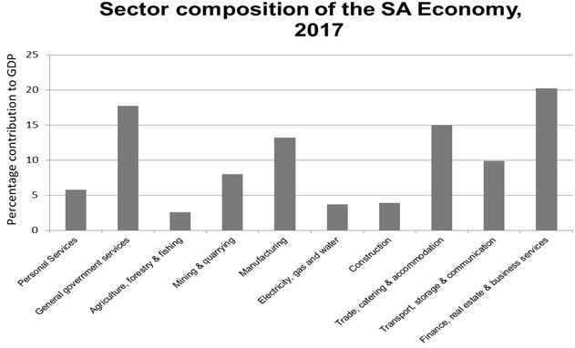

1.9
 | 1.9.1 | The total value of goods and services produced in a country in one year:  - GNP  - GDP  - GPP  - RDP
 | 1.9.2 | Which tertiary activity contributed the most to the  South African economy?  - General government services  - Manufacturing  - Trade, catering, and accommodation  - Finance, real estate and business services
 | 1.9.3 | … form(s) part of the tertiary sector of the economy.  - Agriculture, forestry, and fishing  - Electricity, gas, and water  - Mining and quarrying  - Manufacturing
 | 1.9.4 | Name the category that contributed the least to the  primary sector in 2017:  - Mining and quarrying  - Construction  - Transport, storage, and communication  - Agriculture, forestry, fishing
 | 1.9.5 | This category dominated the secondary sector in 2017:  - General government services  - Manufacturing  - Trade, catering and accommodation  - Finance, real estate and business services
 | 1.9.6 | Which tertiary activity contributed the least to the South  African economy in 2017?  - Personal services  - General government services  - Electricity, gas and water  - Transport, storage and communication
 | 1.9.7 | What percentage did the tertiary sector contribute to the  South African economy in 2017?  - 10%  - 25%  - 77%  - 91% | (7 x 1) | (7)
1.10. Study the graphs below depicting the volume of mining production (2012–2017) and the exchange rates (2016–2017) in FIGURE 1.10

Figure1.10 MINING PRODUCTION AND EXCHANGE RATE STATISTICS OF SOUTH AFRICA

Figure 1.10
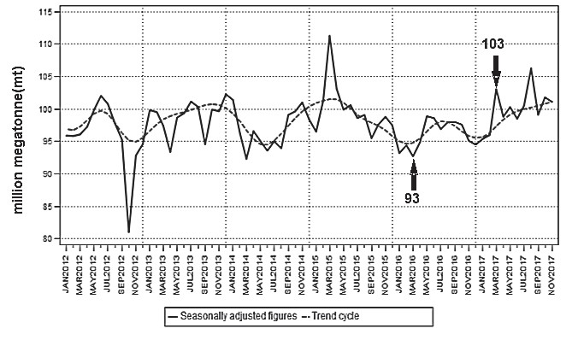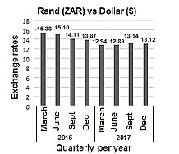
VOLUMES OF MINING PRODUCTION

EXCHANGE RATES

[
Source: Data from
www.x-rates.com
]

1.10
 | 1.10.1 | Why is mining a primary activity? | (1 x 1) | (1)
 | 1.10.2 | Identify the year or years when the volume of mining production was at its lowest and highest. | (2 x 1) | (2)
 | 1.10.3 | Refer to the volumes of mining production (2012–2017) and the exchange rates between 2016 and 2017.  - Describe the trends of the volume of mining production between March 2016 and March 2017.  - Explain why the decrease in the exchange rates may have caused these trends (answer to QUESTION 3.5.3(a)), between March 2016 and March 2017.  - Mention TWO other factors (besides exchange rate), that may have contributed to the trends (answer to QUESTION 3.5.3(a) between March 2016 and March 2017. | (2 x 1)  (1 x 2)  (2x2) | (2)  (2)  (4)
 | 1.10.4 | Evaluate how a labour force can increase profits in the mining industry. | (2 x 2) | (4)
 |  |  |  | [15]

FIGURE 1.11: Refer to the extract on GEAR in South Africa

In 1996 the government created a five-year plan, GEAR that focused on privatisation and the removal of exchange controls. GEAR was only moderately successful in achieving some of its goals but was hailed by some as laying an important foundation for future economic progress. GEAR was also implemented and its programs designed to improve the economic situation of the marginalised (disregarded) majority.

[Source: Extract from http://www.britannica.com/place/South Africa]

1.11
 | 1.11.1 | What does the acronym GEAR stand for? | (1 x 1) | (1)
 | 1.11.2 | According to the article, what are the TWO main focuses of GEAR? | (2x1) | (2)
 | 1.11.3 | Justify the fact that GEAR was implemented to improve ‘the economic situation of the marginalised (disregarded) majority’ in South Africa. | (2 x 2) | (4)
 | 1.11.4 | GEAR was only moderately successful in achieving some of its goals. In a paragraph of approximately EIGHT lines, explain TWO goals and TWO failures of GEAR. | (4 x 2) | (8)
 |  |  |  | [15]
1.12. Choose the correct word/term from those given in brackets. Write ONLY the word/term next to the question number (1.12.1 – 1.12.8)
1.12
 | 1.12.1 | (GDP/GNP) is the value of all goods and services produced over a specific period.
 | 1.12.2 | When a small amount of agricultural produce is obtained from a large piece of land, it is called  (intensive/extensive) farming.
 | 1.12.3 | (Economy/Trade) refers to the industrial and commercial activity of a country.
 | 1.12.4 | Products which are specifically produced for the locals of a country is referred to as the (home/export) market.
 | 1.12.5 | (Resource/Market) orientated industries are situated near the people who buy the products.
 | 1.12.6 | Subsistence farming is an example of (large/small) scale farming.
 | 1.12.7 | The point where goods are being transferred from one mode of transport to another, is called the (shipping/break-of-bulk) point.
 | 1.12.8 | The (economically active/economically stable) is that part of the population who is either working, or looking for work. | (8 x 1) | (8)
1.13. Refer to FIGURE 1.13. an extract on South Africa’s beef industry.

FIGURE 3.5: BEEF FARMING

2020 AND BEYOND: A VISION FOR THE SOUTH AFRICAN BEEF INDUSTRY

By Lloyd Phillips, 7 December 2017

In 2016 South Africa became a net red meat exporter for the first time, supplying mainly the cheap beef market.

In 2016 global red meat exports amounted to 9,44 million tons. Brazil led the way, exporting 1,85 million tons or 19,6% of the total. South Africa ranked 15th at 60 000 tons, or 0,64%, of the world total.

The recent drought showed how crucial it was for the country's beef industry to stop focusing on exporting only cheap beef. By exporting higher quality beef, our industry can protect itself from shocks that result in reduced profits.

It must be noted, however, that with the current high beef price in South Africa, the country will be unable to compete against the likes of Brazil and other top beef exporters.
Adapted from https://www.farmersweekly.co.za/agri-business/agribusinesses/2020-beyond-vision-sa-beef-industry/

1.13
 | 1.13.1 | Which country had the highest exportation of beef in 2016? | (1 x 1) | (1)
 | 1.13.2 | Quote evidence from the extract that suggests that the beef industry is growing in South Africa. | (1 x 1) | (1)
 | 1.13.3 | Refer to the statement below. By exporting higher quality beef, our industry can protect itself from shocks that result in reduced profits.  - Why does the exportation of low quality beef reduce profits?  - Suggest how farmers can produce higher quality beef. | (1 x 1)  (2 x 2) | (1)  (4)
 | 1.13.4 | Write a paragraph of approximately EIGHT lines explaining the factors preventing South Africa from being competitive with other top beef exporters. | (4 x 2) | (8)
 |  |  |  | [15]
FIGURE 1.14: GOLD MINING STATISTICS FOR 2017

Refer to FIGURE 1.14. showing statistics on gold mining in January 2017.

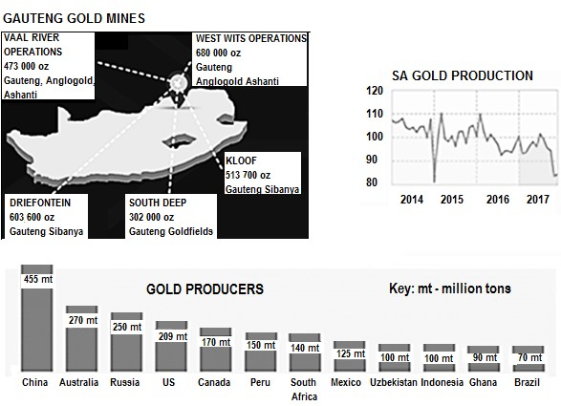

[Adapted from http://www.statssa.gov.za/wpcontent/uploads/2018/02/Infographic_v04-1]

1.14
 | 1.14.1 | Name the province where the most gold is mined in South Africa.
 | 1.14.2 | Which gold mine in Gauteng produces the most gold per ounce (oz) in South Africa?
 | 1.14.3 | Name the mining company that produced the most gold.
 | 1.14.4 | Name the country with the highest production of gold in the world.
 | 1.14.5 | What is the ranking of South Africa in terms of gold production in the world?
 | 1.14.6 | Calculate the contribution that Africa made to the world's gold production in January 2017.
 | 1.14.7 | 4.2.7 At the end of which year did South Africa’s gold production drop to its lowest point?
 | 1.14.8 | 4.2.8 Is the most recent production of gold in South Africa showing an increasing or decreasing trend? | (8 x 1) | (8)

