Province of the
EASTERN CAPE
EDUCATION

DIRECTORATE SENIOR CURRICULUM MANAGEMENT (SEN-FET)
HOME SCHOOLING SELF-STUDY WORKSHEET
SUBJECT | AUTOMOTIVE | GRADE |  |  | 12 | DATE | JUNE 2020
TOPIC | SYSTEMS AND CONTROL (AXLES, STEERING GEOMETRY  AND ELECTRONICS) (SPECIFIC) | TERM  REVISION |  |  | () | TERM 3 CONTENT | (√)
TIME ALLOCATION | 2 hrs. |  |  | TIPS TO KEEP HEALTHY  1. WASH YOUR HANDS thoroughly with soap and water for at least 20 seconds. Alternatively, use hand sanitizer with an alcohol content of at least 60%.  2. PRACTICE SOCIAL DISTANCING – keep a distance of 1m away from other people.  3. PRACTISE GOOD RESPIRATORY HYGIENE: cough or sneeze into your elbow or tissue and dispose of the tissue immediately after use.  4. TRY NOT TO TOUCH YOUR FACE. The virus can be transferred from your hands to your nose, mouth and eyes. It can then enter your body and make you sick.  5. STAY AT HOME.
INSTRUCTIONS | SELF – STUDY ACTIVITY
QUESTION 1
1.1 Briefly explain the purpose of the following alignment applications in vehicles:
1.1.1 Toe-in
1.1.2 Toe-out
1.1.3 Ackermann principles
QUESTION 2
2.1 What type of alignment can be responsible for the tyre wear below?
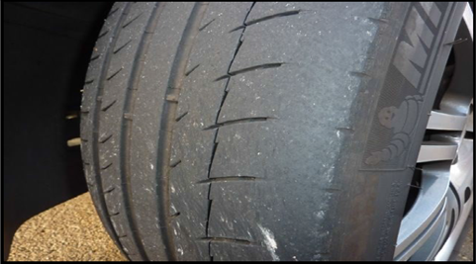

QUESTION 3
State the functions of the following steering angles:
3.1 Camber
3.2 Caster
3.3 King pin inclination
QUESTION 4
List FOUR factors that must be taken into account before wheel alignment can be checked or adjusted.
QUESTION 5
Name the TWO types of wheel imbalances.
QUESTION 2
2.1 State FIVE factors to be taken into account before attempting a wheel alignment adjustment or check.
2.2 Explain the purpose of toe-out on turns.
2.3 Define dynamic balance of a tyre and wheel assembly.
2.4 Give TWO reasons why a motor vehicle is equipped with a speed control system.
2.5 State TWO disadvantages of the speed control system.
2.6 What is the purpose of a diode in an alternator?
2.7 State TWO criteria that a fuel injector needs to comply with.
2.8 FIGURE 2.8 below, on the next page shows a wheel alignment angle. Answer the following questions.
2.8.1 Identify the wheel alignment angle shown in FIGURE 2.8 below.
2.8.2 Label A–F in FIGURE 2.8 below.
2.8.3 Define the alignment angle as shown in FIGURE 2.8 below.
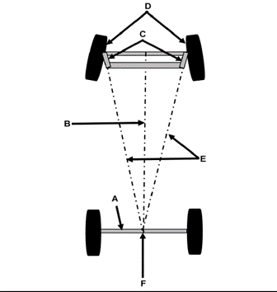

Figure 2.8

