Province of the
EASTERN CAPE
EDUCATION

DIRECTORATE SENIOR CURRICULUM MANAGEMENT
(SEN-FET)
HOME SCHOOLING SELF-STUDY WORKSHEET ANSWER SHEET
SUBJECT | LIFE SCIENCES | GRADE | 12 | DATE | 28 May 2020
TOPIC | PUPILLARY MECHANISM AND ACCOMMODATION | TERM 1  REVISION |  | TERM 2 CONTENT

QUESTION 1: MULTIPLE CHOICE QUESTIONS
  - Various options are provided as possible answers to the following questions. Choose the answer and write only the letter (A to D) next to the question numbers (1.1.1 to 1.1.2) in the ANSWER BOOK e.g. 1.1.3 D.

    - Which ONE of the following statements is CORRECT regarding the eyes represented in the diagrams below?

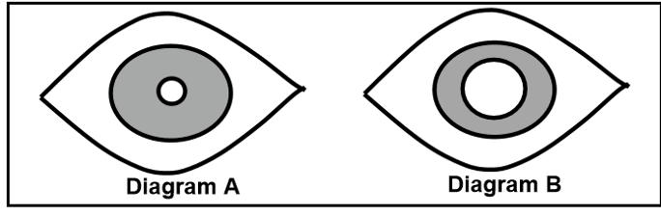

A Diagram A is looking at an object closer than 6 metres, while diagram B is looking at an object further than 6 metres.
B Diagram A is looking at an object further than 6 metres, while diagram B is looking at an object closer than 6 metres.
C The eye in diagram A is in dim light and the eye in diagram B is in bright light.
D The eye in diagram A is in bright light and the eye in diagram B is in dim light.

    - The data below represents the results of an investigation used to determine how the thickness of the lens changed as a pencil was moved away from the eye.

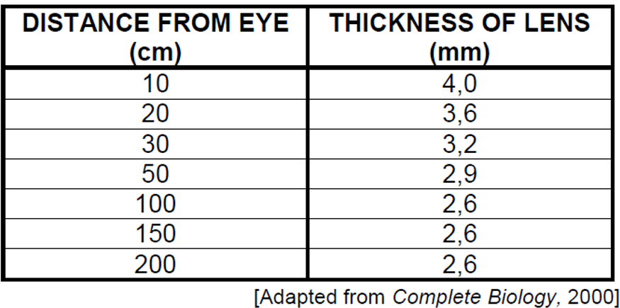

The general conclusion that can be made from the data is that …

A as the distance from the eye increased up to 100cm, the thickness of the lens increased, after which it remained constant.
B as the distance from the eye decreased, the thickness of the lens remained constant.
C as the distance from the eye increased up to 100cm, the thickness of the lens decreased, after which it remained constant.
D the thickness of the lens increased with an increase in distance from the eye. (2 × 2) (4)

QUESTION 2

2.1 The diagram below illustrates how a human eye accommodates distant and near vision. Study them and answer the questions.

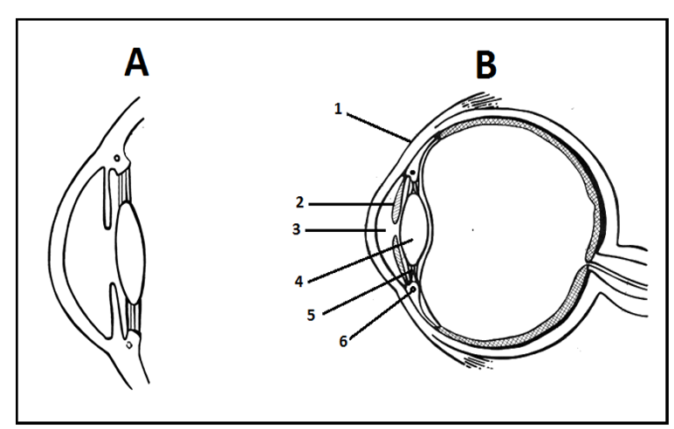

2.1.1 Which lens (A or B) is adjusted to accommodate distant vision? (1)

2.1.2 Which numbered part regulates the amount of light entering the eye? (1)

2.1.3 Explain how the changes from A to B were brought about. (4)
(6)

QUESTION 3

3.1 An experiment was conducted to investigate the diameter of the pupil to change in light intensity. An electric lamp was placed at various distances from the face of a person as displayed in the diagram below. Study the diagram and the table of data below to answer the questions.

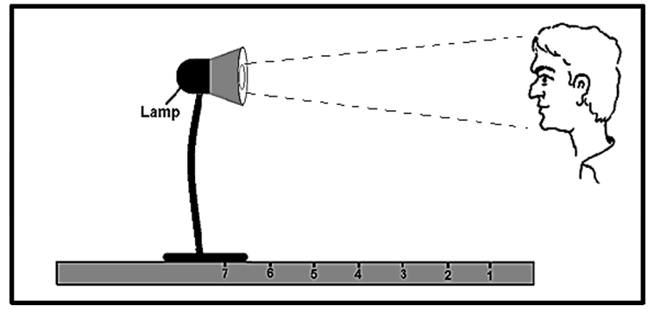

3.1.1 Suggest a possible hypothesis at the start of the investigation. (2)

3.1.2 Which TWO factors should be kept constant during this investigation? (2)

3.1.3 Identify the:

- Independent variable (1)

- Dependent variable. (1)

The table below shows the diameter of the pupil when the light was placed at various distances from the person’s face.

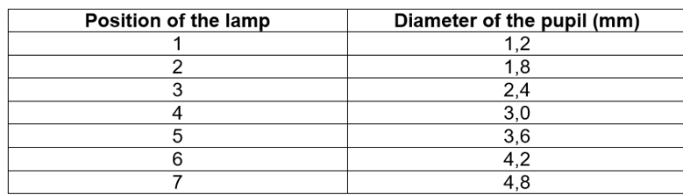

3.1.4 Based on the available data would you accept, or reject the initial
hypothesis? (1)

3.1.5 What conclusion can be deduced from the available data? (2)

3.1.6 Suppose the lamp was moved from position 2 to position 7. Describe
the mechanism that caused the change in the diameter of the pupil. (4)

3.1.7 Name the process mentioned in QUESTION 3.1.6. (1)

3.1.8 Plot a graph to represent the data gathered during this investigation. (6)
(20)

TOTAL 30

