**GRADE: 1 MATHEMATICS Name: ____________________**

**Date: 15 to 19 June 2020**

|  |  |
| --- | --- |
| **TIME ALLOCATION (1 hour)**   * **5** minutes for counting each day * **10** minutes for mental mathematics each day. * **45** minutes for concept of the day. | **TERM 2 CONTENT** |
| **TIPS TO PARENT**   * Use worksheets below * Use DBE workbook * Use relevant real objects from home with caution. * Use correct mathematical language as indicated in the worksheets and DBE Workbook.     Mathematics Grade 1 Xhosa Work Book 2 Term 3 & 4 | WCED ePortalMathematics Grade 1 English Work Book 1 Term 1 & 2 | WCED ePortal | **TIPS TO KEEP HEALTHY**  1. **WASH YOUR HANDS** thoroughly with soap and warm water for at least 20 seconds. Alternatively, use hand sanitizer with an alcohol content of at least 60%.  2. **PRACTICE SOCIAL DISTANCING** keep a distance of 1m away from other people.  3. **PRACTISE GOOD RESPIRATORY HYGIENE**: cough or sneeze into your elbow or tissue and dispose the tissue immediately after use.  4. **TRY NOT TO TOUCH YOUR FACE.** The virus can be transferred from your hands to your nose, mouth and eyes. It can then enter your body and make you sick.  5. **STAY AT HOME.**  Cartoon Washing Hands Stock Illustrations – 1,188 Cartoon Washing ... **C:\Users\School EC\AppData\Local\Microsoft\Windows\INetCache\Content.MSO\82EAADC.tmp** |

**Day 1**

**Groups of 5**

15

10

5

20

25

30

**Activity 1: Counting (orally)**

|  |
| --- |
|  |

1. Use the picture above to count the number of:

* shoes
* balls
* fingers of the three children playing a rope with a dog.

1. Count forwards and backwards in 2s, 5s and 10s between 0 and 50.

**Activity 2: Mental Mathematics**

|  |  |  |  |  |  |  |
| --- | --- | --- | --- | --- | --- | --- |
|  | **What is?** | **Answer** |  |  | **What is?** | **Answer** |
| 1. | 4 + 5 =? |  | 6. | 6 - 5 =? |  |
| 2. | 3 + 5 =? |  | 7. | 5 - 2 =? |  |
| 3. | 5 + 1 =? |  | 8. | 8 - 5 =? |  |
| 4. | 5 + 7 =? |  | 9. | 10 - 5 =? |  |
| 5. | 5 + 5 =? |  | 10. | 5 - 5 =? |  |

**Activity 3:**

|  |  |  |
| --- | --- | --- |
| **Objects** | **How many groups of 5** | **Left over** |
|  |  |  |
|  |  |  |
|  |  |  |
|  |  |  |
|  |  |  |

**Activity 4**

**Let us work together:**

**Let’s read together**

Mom bought me 10 sweets yesterday. She asked me to find groups of 5. How many groups of 5 did you get? Write the number sentence

Let’s work together:

|  |
| --- |
| **sweets**    **1 group of 5 1 group of 5 = 2 groups of 5**  **Number sentence 5 + 5 = 10** |

**For you to do:**

**Fill the table below**

|  |  |  |
| --- | --- | --- |
| **Picture** | **How many groups of 5?** | **Write the number sentence** |
|  |  |  |
|  |  |  |
|  |  |  |
|  |  |  |

**Activity 5**

**DBE Workbook pp. 122 and 123**

**Day 2**

**Repeated addition**

**+**

**5 + 5 + 5+ 5 =?**

**Activity 1: Counting (orally)**

**Count these objects in groups of 2s, 3s, 4s and 5s**

|  |
| --- |
| **How many groups of 2 did you find?**  **How many groups of 3 did you find?**  **How many groups of 4 did you find?**  **How many groups of 5 did you find?** |

**Activity 2: Mental Maths**

|  |  |  |
| --- | --- | --- |
|  | **What is?** | **Answer** |
| 1. | 4 + 4? |  |
| 2. | 3 + 3 + 3? |  |
| 3. | 2 + 2? |  |
| 4. | 3 + 3? |  |
| 5. | 2 + 2+ 2 + 2 + 2? |  |

* **How many fingers do you have?**
* **How many fingers do you have in each hand?**
* **Look at your toes, how many do you have on your left foot?**

**Activity 3**

|  |  |
| --- | --- |
| **Put 5 oranges in each container** | **How many oranges altogether?**  **Write number sentence** |
|  | __________________________ |
|  | **______________________** |

**Activity 4**

**Use the number line below to solve 5 + 5 = ___**

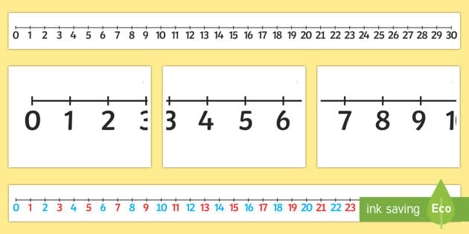

**Activity 5**

* **I have 2 hands with 5 fingers in each hand. How many fingers are there altogether? cars. Write the number sentence**

|  |
| --- |
|  |

**Activity 6**

**DBE workbook pages 120 and 121**

**Day 3 and 4**

**Money**

**How much?**

**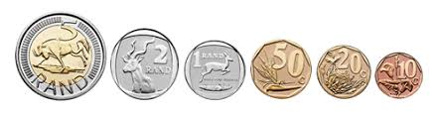  
**

** **



**Activity 1 Counting (orally)**

|  |
| --- |
|  |

Look at the collection of coins above. Answer the questions below

1. How many groups of five

* 10c coins can you find?
* 50c coins can you find?

**Activity 2 Mental Mathematics**

**How much will be left if you**

|  |
| --- |
| **take away two 10c? ____________**  **take away two 10c? ___**    **Take away five 10c? ___________** |

**Activity 4 look at the shop below and answer questions that follow**

|  |
| --- |
| Watermelon Mango      Apple  Banana    (each)      Orange  (each)  (each) |

**Activity 3**

* How many balls can you buy if you have one R10 note?
* How much will you pay for 5 apples?
* How much will you pay for a mango and an apple?

**Activity 4**

Solve these problems

* I bought sweets for R5 and chips for R5. How much did I spend? Show your calculations in box below

|  |
| --- |
|  |

* Mom bought a book for R7, a pen for R3. How much did she pay? Show your calculations in the box below

|  |
| --- |
|  |

* Lulo collected 20c, R1, R2. How much money did he collect? Show your calculations in the box below.

|  |
| --- |
|  |

**Day 5**

**2- D shapes**

**Activity 1 Counting**

Count forwards and backwards in 2s, 5s and between 2 and 50.

**Activity 2 Mental Maths (orally)**

* How many sides does a square have?
* How many sides does a circle have?
* How many sides do 3 rectangles have?
* How many sides does a circle have?
* Add sides of 4 triangles, what do you get?

**Activity 3**

|  |  |  |
| --- | --- | --- |
| Shape | Name of the shape | Draw the shape |
|  |  |  |
|  |  |  |
|  |  |  |
|  |  |  |

**Activity 4**

**Make cut outs of the shapes above, paste them on a sheet of paper and write their names.**