

**Grade 3**

**ENGLISH FIRST ADDITIONAL LANGUAGE WORKSHEET**

**Term 3 Week 24-28 August 2020**

**Theme: Learning New Things**

**Name --------------------------------------------------**

**Grade -------------------------------------------------**

**Date --------------------------------------------------**



1. **Listening and Speaking**

**1.1 Activity 1: DBE Workbook page 22**. Look at the picture and tell what you see.

**1.2 Activity 1: DBE Workbook page 23**. Read the story on page 22 and then answer the questions.

 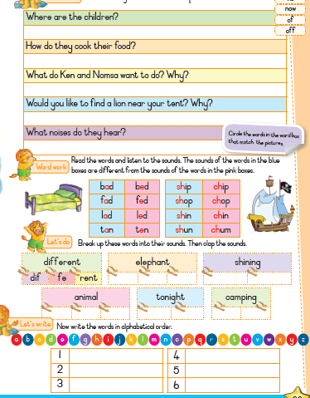

1. **Phonics**

**2.1 Activity 1 DBE Workbook page 23** , Read the words and listen to the sounds. The sounds of the words in the blue boxes are different from the sounds o Word work f the words in the pink boxes.

**2.2Activity 1 DBE Workbook page 22,** Break up these words into their sounds. Then clap the sounds. Then write the words in alphabetical order.

**ar**

**ar**

**ar**

**ar**

**ar**

**ar**

**ar**

**ar**

**e**

**n**

**d**

**g**

**k**

**sh**

**t**

**d**

**f**

**m**

**m**

**j**

**c**

**t**

**s**

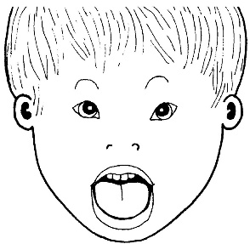  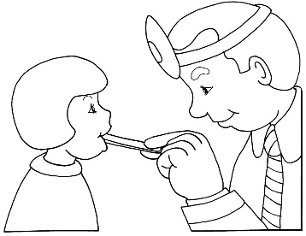

**farm arm jar star car**

**dart garden shark scarf**

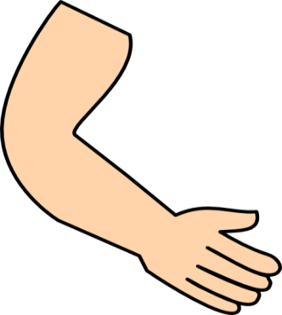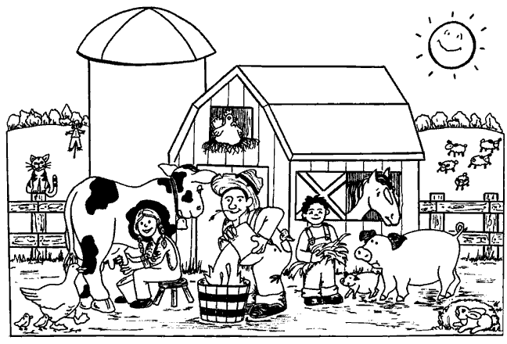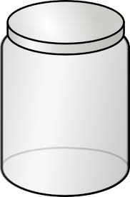

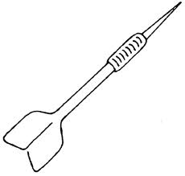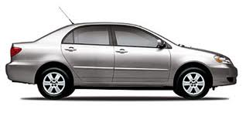

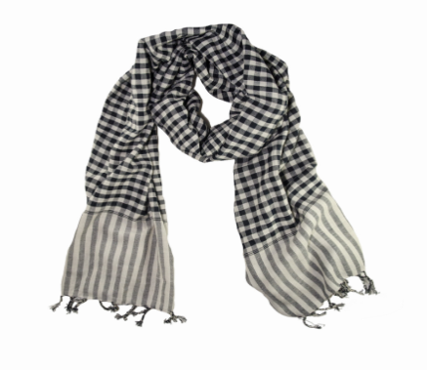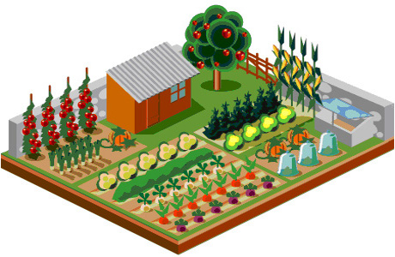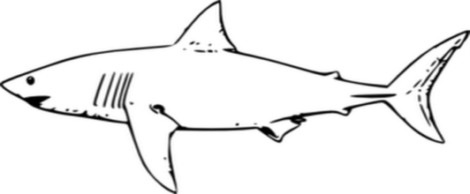

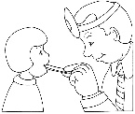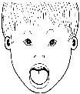**Fill in the missing ar words. Choose from the box.**

‘ar’ Missing Word Sentecnes

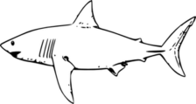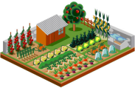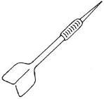

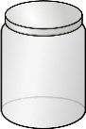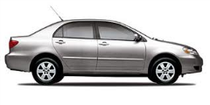 dart shark garden star

farm arm car jar

1) A __________ has got four wheels.

2) In the old jam __________ there are a lot of coins.

3) On the __________ there are a lot of sheep, pigs, cows, chickens, and ducks.

4) The teacher checked my work and I got a __________.

5) A __________ has got long, sharp teeth and can swim.

6) I fell down hurt my __________.

7) My granddad has got a nice big __________ with lots of beautiful flowers in it.

8) Do not throw a __________ in the classroom.

3.Writing

Past Tense

Activity 1 DBE Workbook page 24 Re-write these sentences starting with “Yesterday”.

----------------------------------------------------------------------------------------------------------------------------------------------------------------------------------------------------------------------------------------------------------------------------------------------------------------------------------------------------------------------------------------------------------------------------------------------------------------------------------------------------------------------------------------------------------------------------------------------------------------------------------------------------------------------------------------------------------------------------. 4. Reading

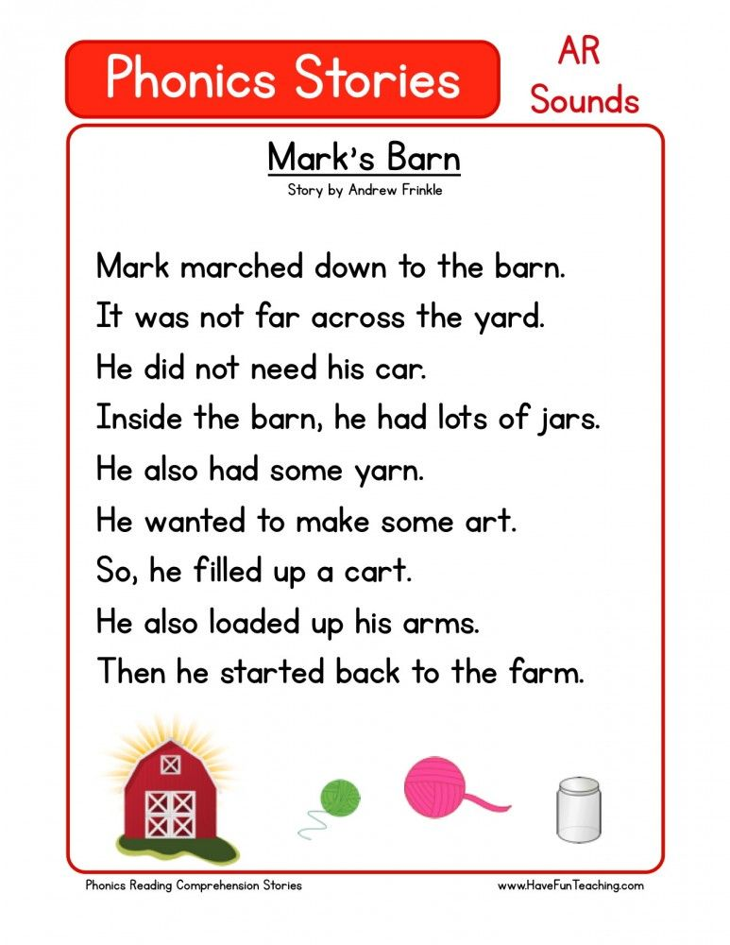

Vocabulary words

|  |  |  |  |
| --- | --- | --- | --- |
| camping | footprints | elephant | twinkle |
| millions | Through | phone | watch |
| video | article | question | internet |

Sight words

|  |  |  |  |
| --- | --- | --- | --- |
| having | night | sleep | very |
| follow | little |  |  |

