Name:
Date:
Grade: 3
Topic:
Read the passage
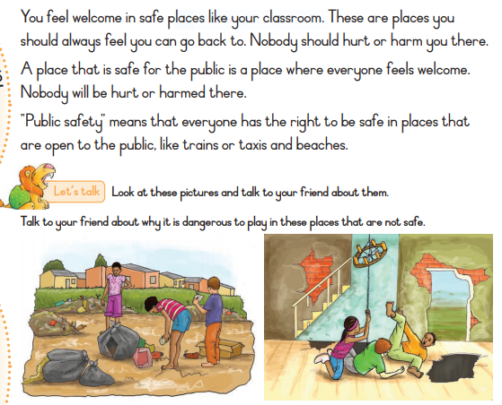
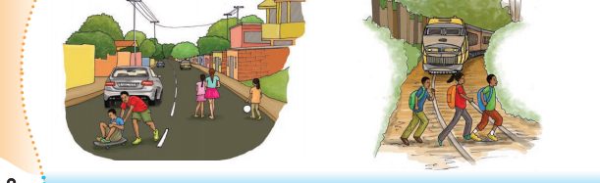
What does the word Public safety mean?
……………………………………………………………………………..
Name 3 places that are open to public
…………………………. ……………………………………. ……………………………………………….

