**Day 1 and 2**

|  |  |  |  |  |  |
| --- | --- | --- | --- | --- | --- |
| **SUBJECT** | Mathematics | **GRADE** | 3 | **DATE** | 6 and 7 /4/ 2020 |
| **CONCEPT** | Fractions | Term 1 Revision | | | |
| **TIME ALLOCATION PER DAY** | 15min for counting  45 minutes for Fractions | **TIPS TO KEEP HEALTHY**  1. **WASH YOUR HANDS** thoroughly with soap and water for at least 20 seconds. Alternatively, use hand sanitizer with an alcohol content of at least 60%.  2. **PRACTICE SOCIAL DISTANCING** – keep a distance of 1m away from other people.  3. **PRACTISE GOOD RESPIRATORY HYGIENE**: cough or sneeze into your elbow or tissue and dispose of the tissue immediately after use.  4. **TRY NOT TO TOUCH YOUR FACE.** The virus can be transferred from your hands to your nose, mouth and eyes. It can then enter your body and make you sick.  5. **STAY AT HOME.** | | | |
| **INSTRUCTIONS** | Use worksheet below  Use relevant resources from home with caution |

**Activity 1 (counting) 5 minutes**

**Count in forwards in 2s, 3s, 5s from 0 to 200.**

**Count backwards in 2s and 5s from 200 to 0.**

**Activity 2 Mental Mathematics (10 minutes)**

|  |  |  |  |
| --- | --- | --- | --- |
| **Double** | | **Half** | |
| **2** |  | **18** |  |
| **8** |  | **10** |  |
| **25** |  | **2** |  |
| **4** |  | **60** |  |
| **45** |  | **16** |  |

**Activity 3** Fraction wall

|  |  |  |  |  |  |  |  |  |
| --- | --- | --- | --- | --- | --- | --- | --- | --- |
| **Row 1** | **1 whole** | | | | | | | |
| **Row 2** | **1**  **2** | | | | **1**  **2** | | | |
| **Row 3** | **1**  **4** | | **1**  **4** | | **1**  **4** | | **1**  **4** | |
| **Row 4** | **1**  **8** | **1**  **8** | **1**  **8** | **1**  **8** | **1**  **8** | **1**  **8** | **1**  **8** | **1**  **8** |

**Follow these steps to make your own Fraction wall**

* Cut 4 strips of paper of the same size.
* Stick the first strip (Row 1) into Mathematics book and label this *1 whole*.
* Take the 2nd strip (Row 2). Fold in the middle. Label each part *1 half*. Stick into Mathematics book.
* Take the 3rd strip (Row 3). Fold it 4 times equally. Label each part 1 quarter. Stick it into Mathematics book.
* Do the same for eighths (Row 4). Stick it into Mathematics book.

Note:

* **1**

**2 is 1 half,**

**1**

**4 is 1 quarter**

**1**

**8 is 1 eighth**

* **Answer these questions:**
* 1 half and 1 half make ___________
* 1 quarter is ________ than a half.
* 3 quarters is _________ than half.
* 4 eighths is equal to a ___________
* How many eighths are there in 2 quarters? _________
* 1 whole = _______ quarters
* one half = _________ quarters
* 4 quarters = ________ halves.

**Day 3 and 4**

|  |  |  |  |  |  |
| --- | --- | --- | --- | --- | --- |
| **SUBJECT** | Mathematics | **GRADE** | 3 | **DATE** | 8 and 9 /4/ 2020 |
| **CONCEPT** | Capacity/ volume | Term 1 Revision | | | |
| **TIME ALLOCATION PER DAY** | 15min for counting  45 minutes for Capacity/ volume | **TIPS TO KEEP HEALTHY**  1. **WASH YOUR HANDS** thoroughly with soap and water for at least 20 seconds. Alternatively, use hand sanitizer with an alcohol content of at least 60%.  2. **PRACTICE SOCIAL DISTANCING** – keep a distance of 1m away from other people.  3. **PRACTISE GOOD RESPIRATORY HYGIENE**: cough or sneeze into your elbow or tissue and dispose of the tissue immediately after use.  4. **TRY NOT TO TOUCH YOUR FACE.** The virus can be transferred from your hands to your nose, mouth and eyes. It can then enter your body and make you sick.  5. **STAY AT HOME.** | | | |
| **INSTRUCTIONS** | Use worksheet below  Use relevant resources from home with caution |

**Activity 1 counting (5 minutes)**

**Count backwards in 3s from 30 to 3.**

**Count forwards and backwards in 2s, 3s, 5s from any number between 1 and 200.**

**Activity 2 Mental Mathematics (10 minutes)**

**Circle the smaller fraction**

**1 1**

**2 and 4**

**3**

**8 and 1 whole**

**Circle the biggest number**

* **34, 43, 143, 134**
* **98, 108, 198, 189**
* **114, 14, 41, 141**
* **200, 20, 120, 102**
* **96, 69, 19, 16**

**Activity 3**

**Note:** 1 litre = 1 000 millilitres.

We often use abbreviations (shortened forms) to write the standard units of

measurement. 1 ℓ = 1 000 *ml*

* 1 litre container can hold = 1 000 millilitres.
* A standard cup holds 250 ml
* A teaspoon holds 5 ml.
* Which container can hold the most ml? how much?
* Which container can hold the least ml? (teaspoon).

**Activity 4 look at the pictures below and answer the questions**

** **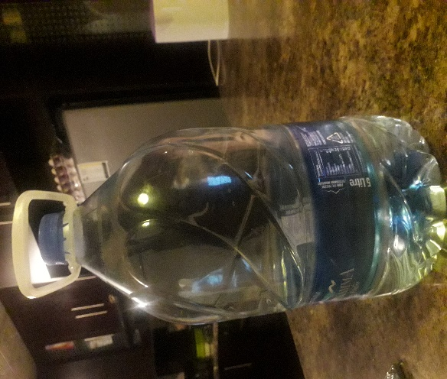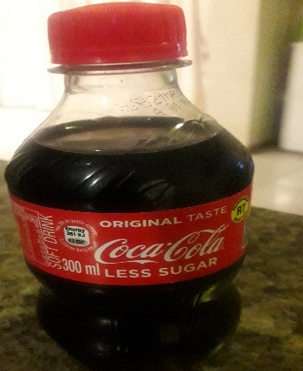

**1L 500 ml 5L 300 ml**

* Order the containers from the one that holds the least to the one that holds the most.
* Between the Pepsi juice container and the yoghurt container which holds the least? Why? _________________________________________
* Use set of containers at home to order and compare products whose capacity is stated only in millilitres.

**Activity 5**

**Use the above pictures to answer**

* How many yoghurt containers can fill up the 5L bottle? ____________
* How many standard cups (250ml) will fill up the Pepsi container? ________
* How many Pepsi juice containers can fill up the 5L bottle?

**Activity 6 Activity 2**

DBE Workbook page 31.