**Day 1 and 2**

|  |  |  |  |  |  |
| --- | --- | --- | --- | --- | --- |
| **SUBJECT** | Mathematics | **GRADE** | 1 | **DATE** | 6 and 7 /4/ 2020 |
| **CONCEPT** | 3D objects | Term 1 Revision | | | |
| **TIME ALLOCATION** | 15min for counting  45 minutes for 3D objects | **TIPS TO KEEP HEALTHY**  1. **WASH YOUR HANDS** thoroughly with soap and water for at least 20 seconds. Alternatively, use hand sanitizer with an alcohol content of at least 60%.  2. **PRACTICE SOCIAL DISTANCING** – keep a distance of 1m away from other people.  3. **PRACTISE GOOD RESPIRATORY HYGIENE**: cough or sneeze into your elbow or tissue and dispose of the tissue immediately after use.  4. **TRY NOT TO TOUCH YOUR FACE.** The virus can be transferred from your hands to your nose, mouth and eyes. It can then enter your body and make you sick.  5. **STAY AT HOME.** | | | |
| **INSTRUCTIONS** | Use worksheet below  Use DBE workbook  Use relevant resources from home with caution |

**Activity 1 (counting) 5 minutes**

Count forwards in 1s from 1 to 20

Count backwards in 1s from 20 to 1

**Activity 2 Written Mental Mathematics (10 minutes)**

|  |  |
| --- | --- |
|  | **How many people?**  **How many dogs?**  **How many birds?**  **___________________** |

**Activity 3: size of 3D objects**

**Put X on the smallest object**

|  |
| --- |
|  |
|  |
|  |
|  |

**Activity 4 Use real objects at home to compare bigger and smaller**

**Activity 5 DBE Workbook pages 58 and 59.**

**Day 2**

|  |  |  |  |  |  |
| --- | --- | --- | --- | --- | --- |
| **SUBJECT** | Mathematics | **GRADE** | 1 | **DATE** | 8 and 9 /4/ 2020 |
| **CONCEPT** | 3D objects | **TERM 1 REVISION** | | | |
| **TIME ALLOCATION** | 15min for counting  45 minutes for 3D objects | **TIPS TO KEEP HEALTHY**  1. **WASH YOUR HANDS** thoroughly with soap and warm water for at least 20 seconds. After every 20 minutes. Alternatively, use hand sanitizer with an alcohol content of at least 60%.  2. **PRACTICE SOCIAL DISTANCING** – keep a distance of 1m away from other people.  3. **PRACTISE GOOD RESPIRATORY HYGIENE**: cough or sneeze into your elbow or tissue and dispose of the tissue immediately after use.  4. **TRY NOT TO TOUCH YOUR FACE.** The virus can be transferred from your hands to your nose, mouth and eyes. It can then enter your body and make you sick.  5. **STAY AT HOME.** | | | |
| **INSTRUCTIONS** | Use worksheet below  Use DBE workbook  Use relevant resources from home with caution |

**Activity 1 Counting (5 minutes)**

Count forwards in 2s from 2 to 20

Count backwards in 2s from 20 to 1

Count forwards in 2s from 12 to 20

Count backwards in 2s from 16 to 2

**Activity 2 Mental Mathematics (10 minutes)**

|  |  |
| --- | --- |
| **Pictures** | **How many ears?** |
|  |  |
|  |  |
|  |  |
|  |  |

**Activity 3 Building with 3D objects**

Can you build a tower with all the following objects?

Tick yes or no.



|  |  |
| --- | --- |
| **Yes** | **No** |



|  |  |
| --- | --- |
| **Yes** | **No** |

********

|  |  |
| --- | --- |
| **Yes** | **No** |

**Activity 4**

**Use any ball and box shape objects that you have at home and build a tower.**

**Activity 5 DBE workbook pages 66 and 67.**

**Day 3**

|  |  |  |  |  |  |
| --- | --- | --- | --- | --- | --- |
| **SUBJECT** | Mathematics | **GRADE** | 1 | **DATE** | 9 /4/ 2020 |
| **TOPIC** | Length | **TERM 1 REVISION** | | | |
| **TIME ALLOCATION** | 15min for counting  30 minutes for 3D objects | **TIPS TO KEEP HEALTHY**  1. **WASH YOUR HANDS** thoroughly with soap and warm water for at least 20 seconds after every 20 minutes. Alternatively, use hand sanitizer with an alcohol content of at least 60%.  2. **PRACTICE SOCIAL DISTANCING** – keep a distance of 1m away from other people.  3. **PRACTISE GOOD RESPIRATORY HYGIENE**: cough or sneeze into your elbow or tissue and dispose of the tissue immediately after use.  4. **TRY NOT TO TOUCH YOUR FACE.** The virus can be transferred from your hands to your nose, mouth and eyes. It can then enter your body and make you sick.  5. **STAY AT HOME.** | | | |
| **INSTRUCTIONS** | Use worksheet below  Use DBE workbook  Use relevant resources from home with caution |

**Activity 1 counting (5 minutes)**

Count forwards in 2s from 9 to 19.

Count in backwards in 2s from 17 to 5.

**Activity 2 Mental Mathematics (10 minutes)**

|  |  |
| --- | --- |
| **Objects** | **How many?** |
|  |  |
|  |  |
|  |  |
|  |  |
|  |  |

|  |  |
| --- | --- |
|  |  |
|  |  |

**Activity 3 Length**

**Write numbers 1 to 4. Start with the tallest person up to shortest.**

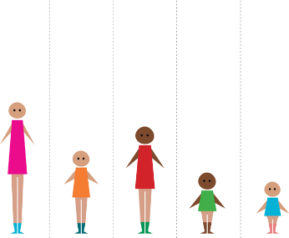

**Activity 4 circle the narrow box**



**Circle the thick pencil**

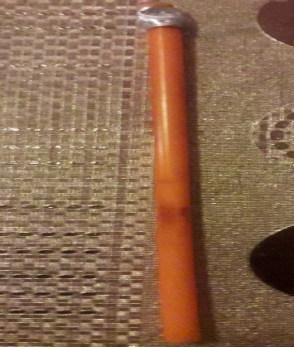



**Activity 5 DBE workbook pages 26 and 27.**