IBANGA - 6
IBALI ELIFUTSHANE ELIYINYANISO
IMIZUZU: 30
Bhota mfundi-ntsapho
Qaphela:

- Injongo yesifundo: Ufundisa abafundi indlela yokufunda ibali elifutshane

- Okuqulathwe yitekisi:

- Isihloko sebali
- Imifanekisi kwibali
- Umxholo obhaliweyo kwibali
- Imibuzo ebuzwa kumfundi mayibonakalisa amazinga okuqiqa ngokukaCAPS ( iphepha 95-96)

INTLUNGU YOMBHEXESHI KWAYALA : NGUNSKZ. N.L.ZIHLE-MAPEKULA
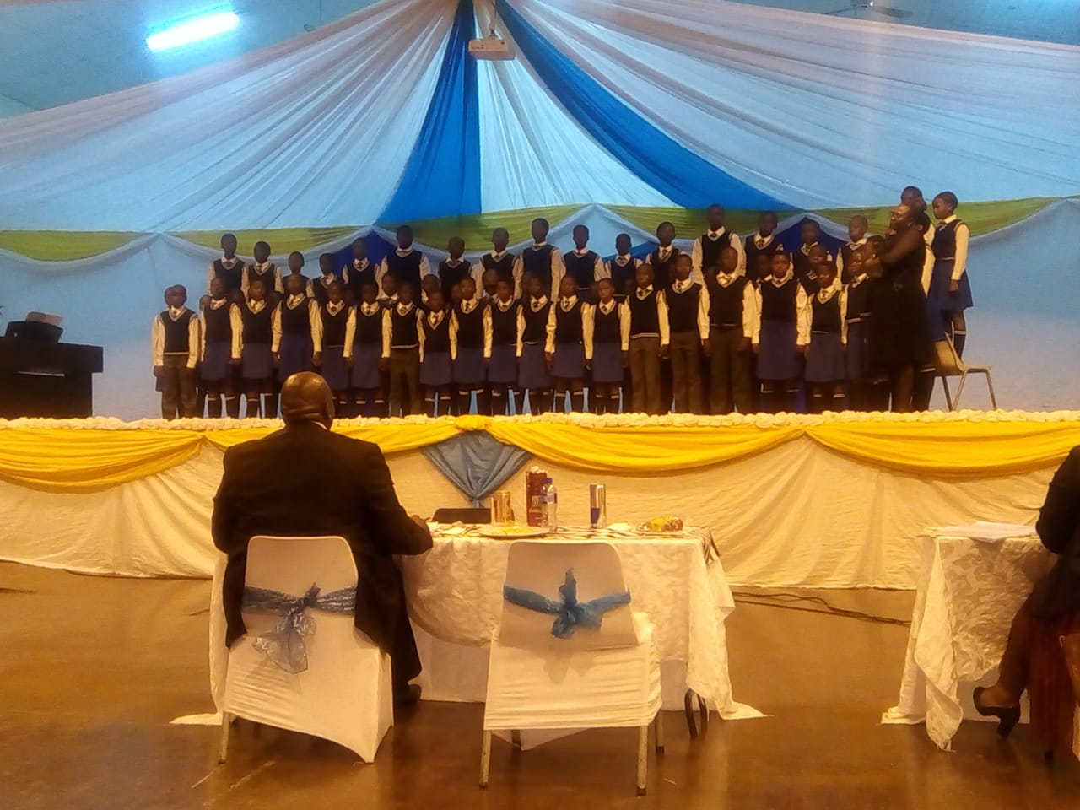

INTLUNGU YOMBHEXESHI KWAYALA.
Mandulo phaya kwilali yaseTshungwana kwisithili sakwaBhaca kumhlaba kaZulu ka Madzikane, kwaye kumi isikolo kwindawo ethambekileyo. YayingumMbo nomXesibe abantwana ndawonye neetitshala zabo. Kukho titshala yayiwuva egazini umculo. Utitshala lo wanikezwa ikwayala aza kuyibhexesha. Yenye yezinto awaye ezithanda kakhulu kwezininzi awaye ezenzela isikolo sakhe esitsha. Waqalisa ke ngoko ukulungiselela ukhuphiswano kunjalonje kwizinga elisezantsi neliphakathi. Aphumelela phantse onke amaculo awenzileyo. Utitshala ubeye azinikezele ke kulo msebenzi asale xa kuphuma isikolo ukanti nangeempelaveki. Ngeeholide ubehlala enabantwana bekwayala. Yonke le nto isikolo nesigqeba saso ibisibeka kwizinga eliphezulu.
Minazana ithile uthe xa eza kuya kwizinga lesithathu ukuze abe nokuya ePhondweni xa enokuphumelela, wacela ukuba afunelwe umncedisi kwayala.Ngokwenene emva kwemigudu wafumaneka umtu.
Umnqa bekuye kubonakale ukuba utitshala lo umsebenzi wakhe ucocekile kwaye uphum’izandla. Uyile kolu khuphiswano abantwana batsho ngentsholo emnandi kanobomi de baphuma emagqabini. Kwabakho isankxwe ke koogxa bakhe xa eqabela eqongeni begragrama xa kukho othile obhiyozayo ukunika amandla, inkuthazo kwanokuzithemba kuba kakade kuphela kwento efunwa yikwayala eqongeni. Khun’ubembe abaxhasi bambuna okwesela libhaqiwe. Zafika ezo ndaba kumbhexeshi kaloku zona azilali mbetheni kodwa akanikezela.
Inye into eyayisentliziyweni yakhe, ‘‘Yabona aba bantwana ndifuna baphumelele bade baye ePhondweni”, ngenene kwabanjalo amatyeli de amathathu. Wayeye ade akhuphe kweyabantwana bakhe imali ukongeza kuloo ntwana yayinikezwa umncedisi. Zajik’izinto nyakana uthile kwafunwa umncedisi wasekuhlaleni yathiwa chatha de wahlawulwa rhoqo emva kokhuphiswano olulandelayo kunjalo nje ikhutshulwe qho kudlulelwa kwinqanaba elingasentla. Inyaniso ngumbhexeshi owayebulaleka kodwa u-enkosi abezinkwenkwezi. Umntu!
Into awayengayifuni ke umbhexeshi lo kukuba badlulele kuZwelonke ngenxa yenkxaso eyayingekho, ebizwa ngamagama onke apho esikolweni esokoliswa xa ecela izinto eziza kuncedisa ikwayala. Ndamva ngenye imini esithi “akunani ukutyibekwa ngaphandle kunasekhaya ”Uwooo! Wayezixolisa ngelithi, ‘‘kakade izinja zikhonkotha ehambayo’’. Amandla ababhexeshi afana nqwa nezithukuthuku zenja zona ziphelela eboyeni. Kodwa inye into awayengayilibali kukuba abantwana besikolo sakhe baye eqongeni beqhelene nezixhobo zokucula.
Yayisinceda ke isikolo le nto yokuphumelela kuba yayiba yimiqodi abantwana abasuka kwiilali ezikufuphi beze kucela indawo yokufunda apha kunyaka olandelayo. Kwiinzima awayedibana nazo angayilibaliyo kukuvukelwa kwezigqibo ebezithathwe kwintlanganiso nokunyhukulwa komntu wasemzini oncedisa ikwayala de isikolo sigqibe ekubeni asizukubhatala. Umbhexeshi avuthulule eyakhe ingxowa yemali ambhatale ngokwakhe umncedisi kwayala, iphumelele ikwayala kubhiyozwe ikhatshwe ukuya ePhondweni. Lalibakho iqaqobana elalisikwa yimfesane limncedise kuloo mali abhatala ngayo umncedisi. Kwakuthi kwakuphuma iziphumo ezincumisayo isikolo sigqame siqaqambe kuvuye nabo bebengamnqweneleli okuhle utitshala nekwayala yakhe. Kunzima ukuba ngumbhexeshi kwayala ungasuswa naseqongeni inikwe umakhelwane ukhona, kodwa bayanyamezela abo bantu.
Kwakungekho nkxaso ayifumana esikolweni naye ezixolisa ngelithi sele esenzela abazali. Ayebakho amaxesha okufuna ukunikezela kodwa acinge ngokuba uMdali wayemphile italente namandla okumelana neenzima awayejongene nazo. Abenzi bongcikivo namayelenqe babengapheli mandla kumsebenzi wabo. Wawuthi xa umjongile abengathi uthi, ‘‘ Ndazenza ngokuza kuphangela apha kuba abantu abanexabiso ngabo bomgquba’’. Wayeqhwatyelwa izandla ngootitshala besithili. Mbone eqhaqhatheka nabo phandle ngongcwalazi ephepha izihange ekhusela ezo mveku,kodwa u-enkosi zinkwekwezi. Kwathi kuba iliso loMdali libona apho singaboniyo thina bantu basemhlabeni wawelwa ngumqa esandleni utitshala. Wonyuselwa waya kuba lisekela nqununu kwisikolo esingekude kuyaphi kweso saseTshungwana utitshala. Kumhla baqala ukuyiqonda intetho ethi, ‘‘ixabiso lento yakho uliqonda mhla yakulahleka’’. Bancipha abantwana, zaphungulwa iititshala. Akuzange kuphinde kubekho titshala ifuna ukuculisa apho, nabo babembeka amabala babehambela kude nekwayala. Yena utitshala wamkelwa ngezandla ezishushu kweso sikolo sitsha. Sona santinga okokhozi kuba zazitsala ngamxhelo mnye ezalapho iititshala. Umanyano ngamandla
Ibali eliyinyani lilungiselelwe ibanga lesi-6 ,umfanekiso ngowesikolo sakwaBhaca iNcapai P.S kwilali yaseDangwana .Konke okubhalwe apha kuyinyani kukwayingqokelela yeenzima zababhexeshi ngokwahluka hlukana kwabo

*************************************************

