NATURAL
SCIENCES
&
TECHNOLOGY
LESSON PLAN GRADE 5 TERM 2

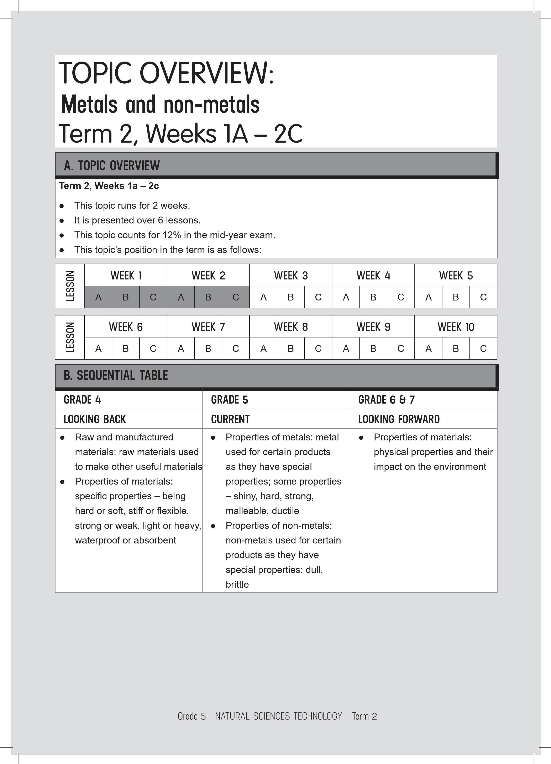
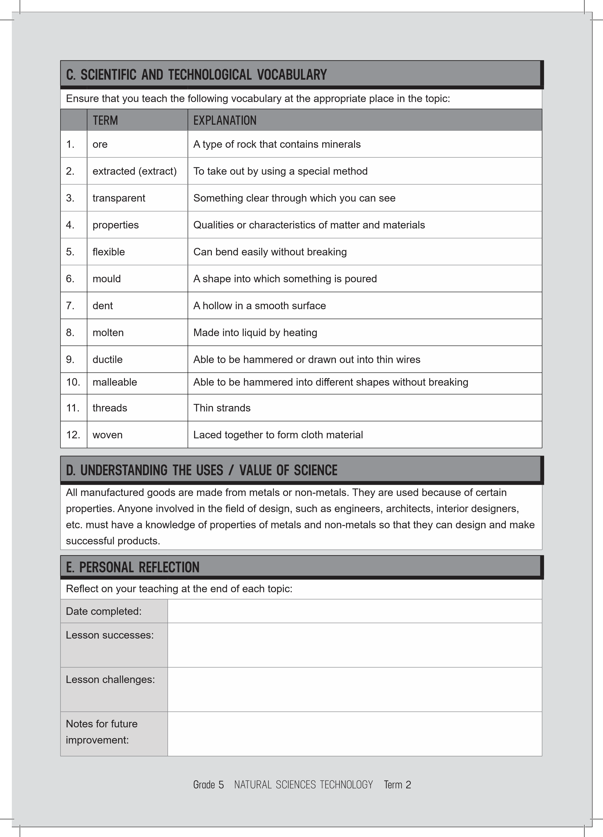
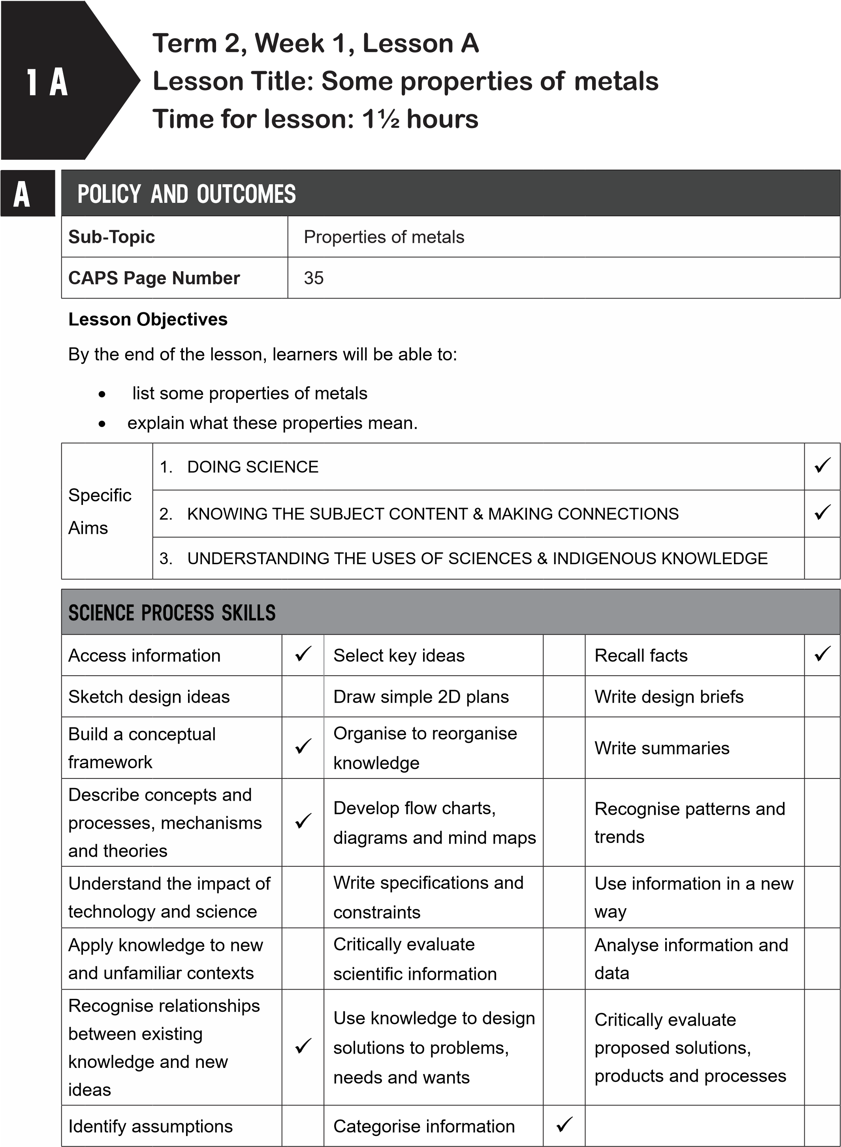

B | POSSIBLE RESOURCES
1 | AFor this lesson, you will need:
 | IDEAL RESOURCES | IMPROVISED RESOURCES
 | Resource Page 1: Metal tools are hard
 | Resource Page 2: Some metals are shiny, some are light and strong
 | Resource Page 3: Some metals can be heated and shaped; some are strong
 | Resource Page 4: Some metals are ductile, some are malleable
 | Poster: Properties of metals and non-metals
CLASSROOM MANAGEMENT
- Make sure that you are ready and prepared.
- Write the following question onto the chalkboard before the lesson starts:
What does the word ‘manufactured’ mean?
- Learners should enter the classroom, then discuss the seven life processes with the teacher and then answer the question in their workbooks.
- Discuss their answers with the learners.
C
- Write the model answer onto the chalkboard.
Manufactured means that raw material has been used to make a product or other material.
D | ACCESSING INFORMATION
- Write the following onto the chalkboard (always try to do this before the lesson starts):
SOME PROPERTIES OF METALS
- Metals are raw materials found in rocks.
- This rock is mined from under the ground.
- Rock that has metal is called ore.
- We make products from metals because they have useful properties.
- Metals are strong.
- You will not be able to pull a metal object apart.
- If something was dropped on a metal object, the object would not break.
- Some metals are hard.
  - Objects made from these metals will not dent easily.
  - Metals are shiny.
  - Some shiny metals become dull when they are left for a long period of time.
  - With cleaning, they become shiny again.
  - Metals are malleable.
  - This means they can be made hammered into shapes without their breaking.
  - Metals are ductile.
  - This means they can be made into thin, flexible wires without their breaking.
  - They can be stretched.
  - Metals melt at high temperatures.
  - Metals are heated so they can be hammered into shapes.
- Explain this to the learners as follows:
  - In Grade 4, the learners found out how raw materials are used to make manufactured products.
  - Metal ore is a raw material.
  - Metal is extracted from the ore and used to make many useful objects.
- Go through each of the six properties of metals on the chalkboard: strong, hard, shiny, malleable, ductile, able to be heated to high temperatures. If a metal is hard, it means it will not dent easily.
- Show learners Resource 1: ‘Metal tools are hard’ and explain that metal tools must be hard to do their job properly.
- Show learners Resource Page 2: ‘Some metals are shiny‘. Explain:
  - Jewellery is often made from silver and gold, as these metals are shiny.
  - A metal is malleable if it can be made into another shape without it breaking.
  - Most metals have a high melting point.
  - Some metals are heated up so that they can be made into other shapes.
- Show learners Resource Page 3: ‘Some metals can be heated and shaped; some are strong’. Point out that the metal is melted and then poured into a mould. Explain:
  - Aluminum is a strong but light metal and is therefore useful for packaging food.
  - An iron chain is a very strong product which can be used to lift heavy loads.
- Show learners the Poster: ‘Properties of metals and non-metals’.
- Read through the properties of hardness, appearance, malleability and ductility on the poster.
- Show learners the metals associated with these properties.
- Give learners time to copy this information into their workbooks.
Checkpoint 1
Ask the learners the following questions to check their understanding at this point:
a.
What does the word ‘malleable’ mean?
b.
What does the word ‘ductile’ mean?
Answers to the checkpoint questions are as follows:
a.
A metal is ‘malleable’ if it can be hammered into different shapes without breaking.
b.
A metal is ‘ductile’ if it can be made into thin wires without breaking.
E | CONCEPTUAL DEVELOPMENT
- Write the following on the chalkboard (always try to do this before the lesson starts):
INVESTIGATE AND COMPARE THE PROPERTIES OF SOME METAL AND NON-METAL OBJECTS
You will need:
A coin
A piece of chalk
A nail
A stainless steel fork A piece of cloth.
- Copy the following table into your workbook.
- Complete the table by testing the objects below:
Properties of materials
Object | Hard or soft | Shiny or dull | Stiff or bendy | Strong or weak
coin
piece of chalk
nail
fork
piece of cloth
- Answer the following questions in your workbook:
  - Which objects were shiny?
  - Are these objects made from metals or non-metals?
  - Which objects do you think would break easily?
  - Are these objects made from metals or non-metals?
- Explain this to the learners as follows:
  - First, learners must draw the table in their workbooks.
  - If learners are doing this in groups, then get one person from each group to come up and collect the objects.
  - If this is a teacher-led investigation, then the teacher must go through each object oneby-one.
  - When the table is complete, learners must answer the questions in their workbooks.
- A model answer:
- Properties of materials
Object | Hard or soft | Shiny or dull | Stiff or bendy | Strong or weak
coin | hard | shiny | stiff | strong
piece of chalk | soft | dull | stiff | weak
nail | hard | shiny | stiff | strong
fork | hard | shiny | stiff | strong
piece of cloth | soft | dull | bendy | weak
- a. The coin, nail and fork were shiny.
  - These objects are made from metal.
  - The piece of chalk and the piece of cloth would break easily.
  - These objects are non-metals.
- Write the following on the chalkboard (always try to do this before the lesson starts):
HOW TO MAKE DULL METAL OBJECTS SHINY
- Sometimes metal objects lose their shine.
- Metals can be polished to make them shiny.
- They can be cleaned with natural or chemical cleaners.
INVESTIGATE HOW TO MAKE COPPER COINS SHINY
You will need: ½ cup of vinegar table salt teaspoon lemon some old copper coins a soft cloth.
METHOD:
- Pour ½ cup of vinegar into a bowl.
- Add a spoonful of salt to the vinegar.
- Stir the salt and vinegar until the salt has dissolved.
- Add a teaspoonful of lemon juice to the mixture.
- Put the copper coins into the mixture for five minutes.
- Take the coins out and wipe them with a cloth until they are shiny.
- Explain this to the learners as follows:
  - Read through the information on the chalkboard with the learners.
  - The investigation can either be done in groups or as a teacher-led demonstration.
  - Metals can be cleaned and polished to make them shiny.
  - Ask the learners why they think coins are made from metal. (Answer: The metal is hard and strong so the coins will last a long time.)
Checkpoint 2
Ask the learners the following questions to check their understanding at this point:
- What property does copper have when it is pulled to make wire?
- What property do metals have when they can be hammered to make different shapes?
Answers to the checkpoint questions are as follows:
- Copper is ductile.
- Metals that can be hammered to make different shapes are malleable.
- Ask the learners if they have any questions and provide answers and explanations.

F | REFERENCE POINTS FOR FURTHER DEVELOPMENT
 | If you need additional information or activities on this topic, you can find these in your textbook on the following pages:
 | NAME OF TEXTBOOK | TOPIC | PAGE NUMBER
 | Study & Master | Metals and non-metals | 68-74
 | Viva | Metals and non-metals | 53-56
 | Platinum | Metals and non-metals | 62
 | Solutions for All | Metals and non-metals | 69-72
 | Day-by-Day | Metals and non-metals | 57-58
 | Oxford | Metals and non-metals | 48-49
 | Spot On | Metals and non-metals | 32-33
 | Top Class | Metals and non-metals | 43-44
 | Sasol Inzalo Bk A | Metals and non-metals | 122-125
G | ADDITIONAL ACTIVITIES/ READING
In addition, further reading, listening or viewing activities related to this sub-topic are available through the following web links:
- http://e-classroom.co.za/wp-content/uploads/2013/05/EngGr5T2-NATSCIENCE-Metalsand-no-metals.pdf [Metals and non-metals]
- http://www.bbc.co.uk/bitesize/ks2/science/materials/material_properties/read/1/ [Material properties]
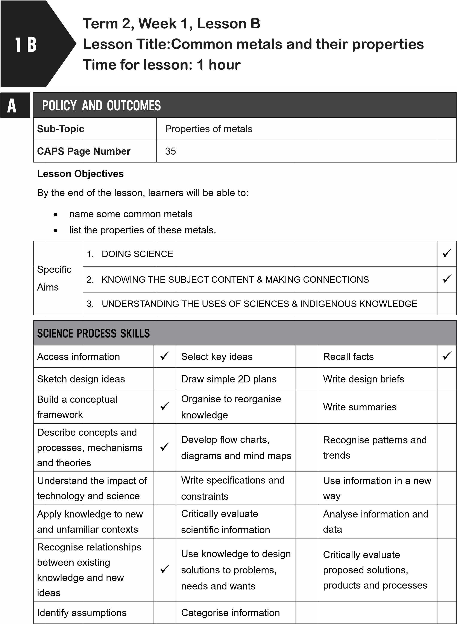
B | POSSIBLE RESOURCES
 | For this lesson, you will need:
 | IDEAL RESOURCES | IMPROVISED RESOURCES
 | Resource Page 4: Some metals are ductile, some are malleable
CLASSROOM MANAGEMENT
- Make sure that you are ready and prepared.
- Write the following question onto the chalkboard before the lesson starts:
What word is used to describe a metal that can be hammered into different shapes?
- Learners should enter the classroom, then discuss the seven life processes with the teacher and then answer the question in their workbooks.
D
C
- Discuss their answers with the learners.
- Write the model answer onto the chalkboard.
A metal that can be hammered into different shapes is called malleable.
ACCESSING INFORMATION
1. Write the following onto the chalkboard (always try to do this before the lesson starts):
COPPER
- Copper is ductile.
- It can be made into thin wire.
- Copper is used for electric wires.
- Electrical wiring is used in cars, in electrical goods and to carry electricity to our homes and businesses.
GOLD AND SILVER
- Gold and silver are extremely ductile, malleable, shiny and have a high melting point.
- They can be made into very thin wire.
- They are used for jewellery.
STEEL
- Steel is a mixture of iron and carbon.
- It is very strong and malleable.
- Steel is used to make car bodies, as it can be moulded into shapes.
- Steel rods are used in buildings and bridges to add strength.
IRON
- Iron is strong, hard and has a high melting point.
- Corrugated iron is used for roofing.
- Some pots and pans are made from iron.
- Gates are sometimes made from iron.
- Benches need to be strong so they can also be made from iron.
- Explain that Metals are used for a variety of purposes because of their properties.
- Show learners Resource Page 4: ‘Some metals are ductile’. Explain:
  - Copper is ductile.
  - It can be made into thin wires without breaking.
  - It can be stretched.
  - It is used for electrical wiring.
- Show learners Resource Page 5: ‘Gold is malleable’. Explain:
  - Gold and silver are malleable.
  - These metals can be shaped.
  - Gold is used to make Kruger Rands and was used for the death mask of King Tutankhamen of Egypt.
  - Steel is a mixture of iron and carbon.
  - It is very strong, malleable and hard.
- Show learners Resource Page 6: ‘Steel is strong and malleable’. Explain:
  - Steel is used to make buildings and bridges stronger.
  - A material is strong if it does not break easily when a load is placed on it.
  - Steel is also used for car and bus bodies.
  - Steel is used to make tools, as it is strong.
- Show learners Resource Page 1: ‘Metal tools are hard’. Explain:
  - A material is hard if it does not dent easily.
  - Tools do not get dented.
- Give learners time to copy this information into their workbooks.
Checkpoint 1
Ask the learners the following questions to check their understanding at this point:
- Why is gold used for jewellery?
- Why is steel used to add strength to buildings?
Answers to the checkpoint questions are as follows:
- Gold is malleable and ductile, so it is ideal for jewelry.
- Steel is very strong so it adds strength to buildings.
E | CONCEPTUAL DEVELOPMENT
- Write the following onto the chalkboard:
SOME METALS AND THEIR PROPERTIES
Copy and complete the table below:
metal | properties | used for
copper
gold and silver
steel
iron

- Explain this to the learners as follows:
  - Fill in the table with the properties that are on the chalkboard.
  - Also fill in what each type of metal is used for.
- A model answer:
SOME METALS AND THEIR PROPERTIES
metal | properties | used for
copper | ductile | electrical wires
gold and silver | ductile, malleable, shiny, has a high melting point | jewellery
steel | strong, malleable | car bodies; makes buildings and bridges stronger
iron | strong, hard, high melting point | corrugated roofs; benches; gates; pots and pans

Checkpoint 2
Ask the learners the following questions to check their understanding at this point:
- What properties does steel have?
- What is steel used for?
Answers to the checkpoint questions are as follows:
- Steel is strong and malleable.
- Steel is used to make buildings and bridges stronger, and in car bodies..
- Ask the learners if they have any questions and provide answers and explanations
F | REFERENCE POINTS FOR FURTHER DEVELOPMENT
 | If you need additional information or activities on this topic, you can find these in your textbook on the following pages:
 | NAME OF TEXTBOOK | TOPIC | PAGE NUMBER
 | Study & Master | Metals and non-metals | 68-70; 73-74
 | Viva | Metals and non-metals | 48-62
 | Platinum | Metals and non-metals | 62-65
 | Solutions for All | Metals and non-metals | 77-78
 | Day-by-Day | Metals and non-metals | 57-59
 | Oxford | Metals and non-metals | 48-52
 | Spot On | Metals and non-metals | 30-31
 | Top Class | Metals and non-metals | 46-47
 | Sasol Inzalo Bk A | Metals and non-metals | 124-132
G | ADDITIONAL ACTIVITIES/ READING
In addition, further reading, listening or viewing activities related to this sub-topic are available through the following web links:
- https://goo.gl/JCafB8 (2min 22sec) [How stuff works: From ore to steel]
- https://goo.gl/oaSJGX (2min 26sec) [Stainless steel or aluminum: how to tell?]
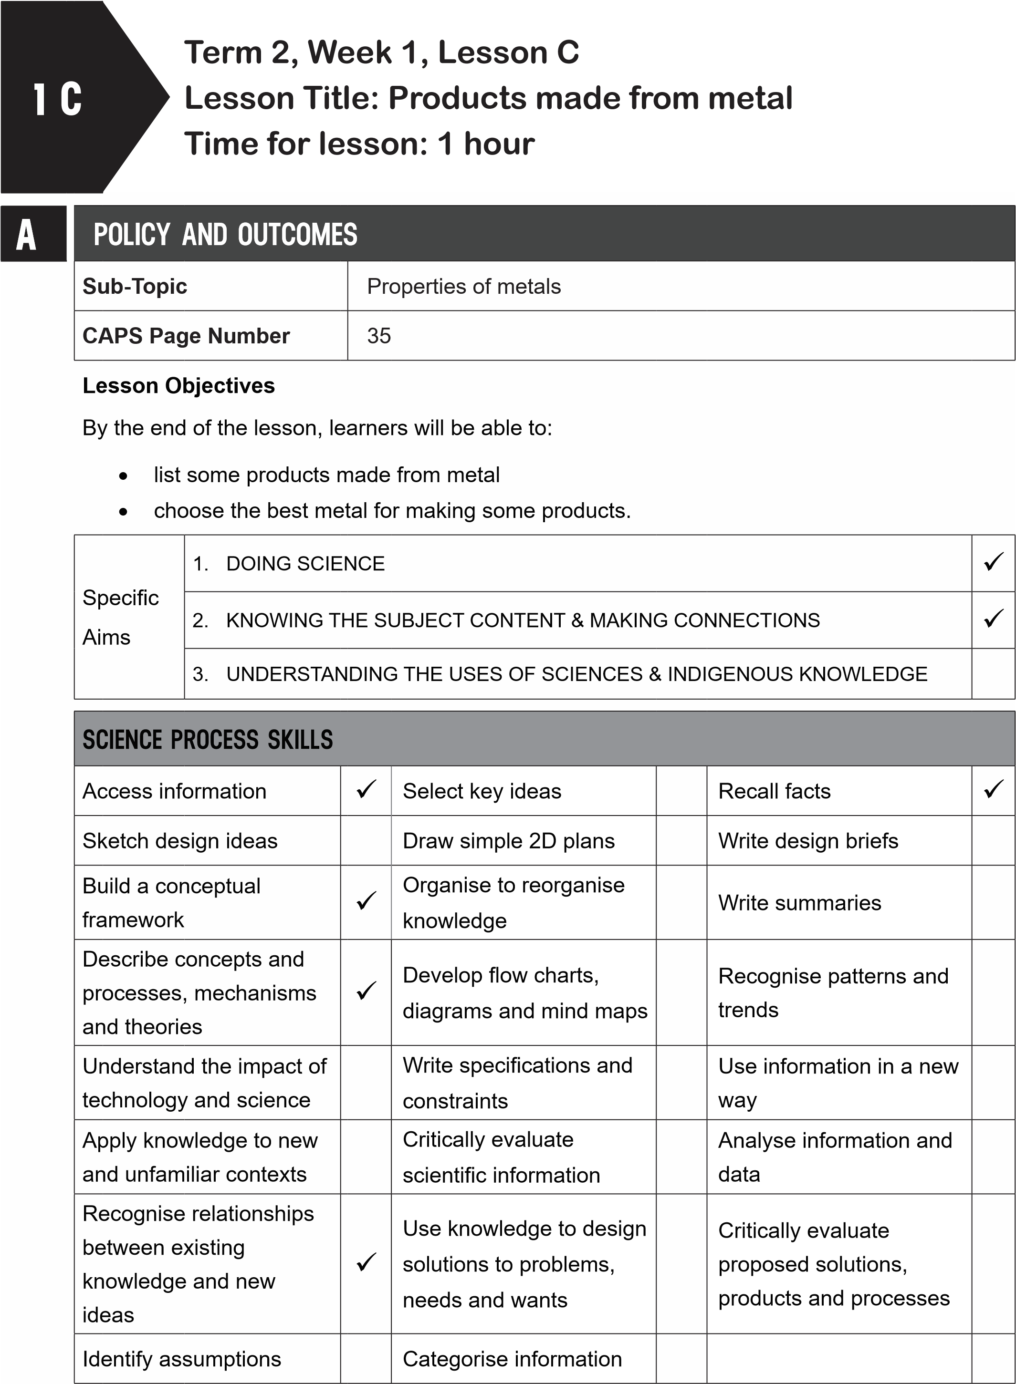
B | POSSIBLE RESOURCES
 | For this lesson, you will need:
 | IDEAL RESOURCES | IMPROVISED RESOURCES
 | Resource Page 7: Railway tracks
CLASSROOM MANAGEMENT
- Make sure that you are ready and prepared.
- Write the following question onto the chalkboard before the lesson starts:
Why is copper used to make electrical wires?
- Learners should enter the classroom, then discuss the seven life processes with the teacher and then answer the question in their workbooks.
C
- Discuss their answers with the learners.
- Write the model answer onto the chalkboard.
Copper is ductile and is therefore ideal for making electrical wires.
D | ACCESSING INFORMATION
 | 1. Write the following onto the chalkboard (always try to do this before the lesson starts):
PRODUCTS MADE FROM METAL
- Some metals are hard.
- Hardness is the ability to resist scratches.
- Metals that are hard do not bend or dent easily.
- Railway tracks are made from iron, as iron is a hard metal.
- Girders help support the weight of tall buildings.
- Metals have high melting points.
- Most metals are solid at room temperature.
- Most metals only melt at very high temperatures.
- The metal becomes a liquid.
- It is then poured into a mould.
- The metal then takes the shape of this mould when it cools down.
- Car engines, metal poles and pieces of steel for a building are made in this way.
2. Explain and discuss the following with the learners:
a. You have already learnt about some products made from metal in the previous lesson.
The learners studied grassland, forest, river and sea habitats.
  - Car bodies, roofs, buildings, bridges, electrical wire, pots and pans, jewellery are all made from metal.
  - Hardness is an important property of some metals.
  - Many products are made out of metals that are hard: railway tracks, girders for buildings.
3. Show learners Resource Page 7: Railway tracks. Explain that:
- Railway tracks are made from a metal that is hard: iron.
- The high melting point of metal is another important property.
- Molten metals are poured into moulds to make many products, like car engines.
6. Give learners time to copy this information into their workbooks.
Checkpoint 1
Ask learners the following questions to check their understanding at this point:
- Why are railway tracks made from iron?
- How are car engines made using metal?
Answers to the checkpoint questions are as follows:
- Iron is a hard metal that does not bend or dent easily.
- The metal is molten and then poured into a mould to take the shape of the car engine.
E | CONCEPTUAL DEVELOPMENT
 | 1. Write the following on the chalkboard (always try to do this before the lesson starts):
TASK: KNOW THE PROPERTIES OF METALS
Rewrite the following sentences and fill in the missing words from the list.
hard, melting point, mould, molten, dent, car engines, solid
- Metals that are ____ do not bend or ____ easily.
- Metals have a high ____ ____.
- This allows the ____metal to be poured into a ____.
- Metals are ____ at room temperature.
- ____ ____ are made from molten metal being poured into a mould.
- Explain this to the learners as follows:
  - Read through the list of words and sentences.
  - Make sure that the learners understand the meaning of the words and the sentences.
  - Learners must underline the words that they have filled in.
- A model answer:
TASK: KNOW THE PROPERTIES OF METALS

- Metals that are hard do not bend or dent easily.
- Metals have a high melting point.
- This allows the molten metal to be poured into a mould.
- Metals are solid at room temperature.
- Car engines are made from molten metal being poured into a mould.
Checkpoint 2
Ask the learners the following questions to check their understanding at this point:
- Can you name a product that is made from a molten metal being poured into a mould?
- Do metals melt at high or low temperatures?
Answers to the checkpoint questions are as follows:
a. Either of the following answers: car engines, metal poles or pieces of steel for buildings b. Metals melt at high temperatures.
- Ask the learners if they have any questions and provide answers and explanations.

F | REFERENCE POINTS FOR FURTHER DEVELOPMENT
 | If you need additional information or activities on this topic, you can find these in your textbook on the following pages:
 | NAME OF TEXTBOOK | TOPIC | PAGE NUMBER
 | Study & Master | Metals and non-metals | 68-70; 73-74
 | Viva | Metals and non-metals | 54-57
 | Platinum | Metals and non-metals | 63
 | Solutions for All | Metals and non-metals | 69-81
 | Day-by-Day | Metals and non-metals | 57-59
 | Oxford | Metals and non-metals | 48-52
 | Spot On | Metals and non-metals | 30
 | Top Class | Metals and non-metals | 43-50
 | Sasol Inzalo Bk A | Metals and non-metals | 126-145
G | ADDITIONAL ACTIVITIES/ READING
In addition, further reading, listening or viewing activities related to this sub-topic are available through the following web links:
- http://sbsciencematters.com/lesson-units/5th-grade/5physical-chemistryandmatter/ [Lesson 17: Properties of metals]
- http://schools.bcsd.com/fremont/5th_Sci_matter_Metal.htm [Properties of metals]
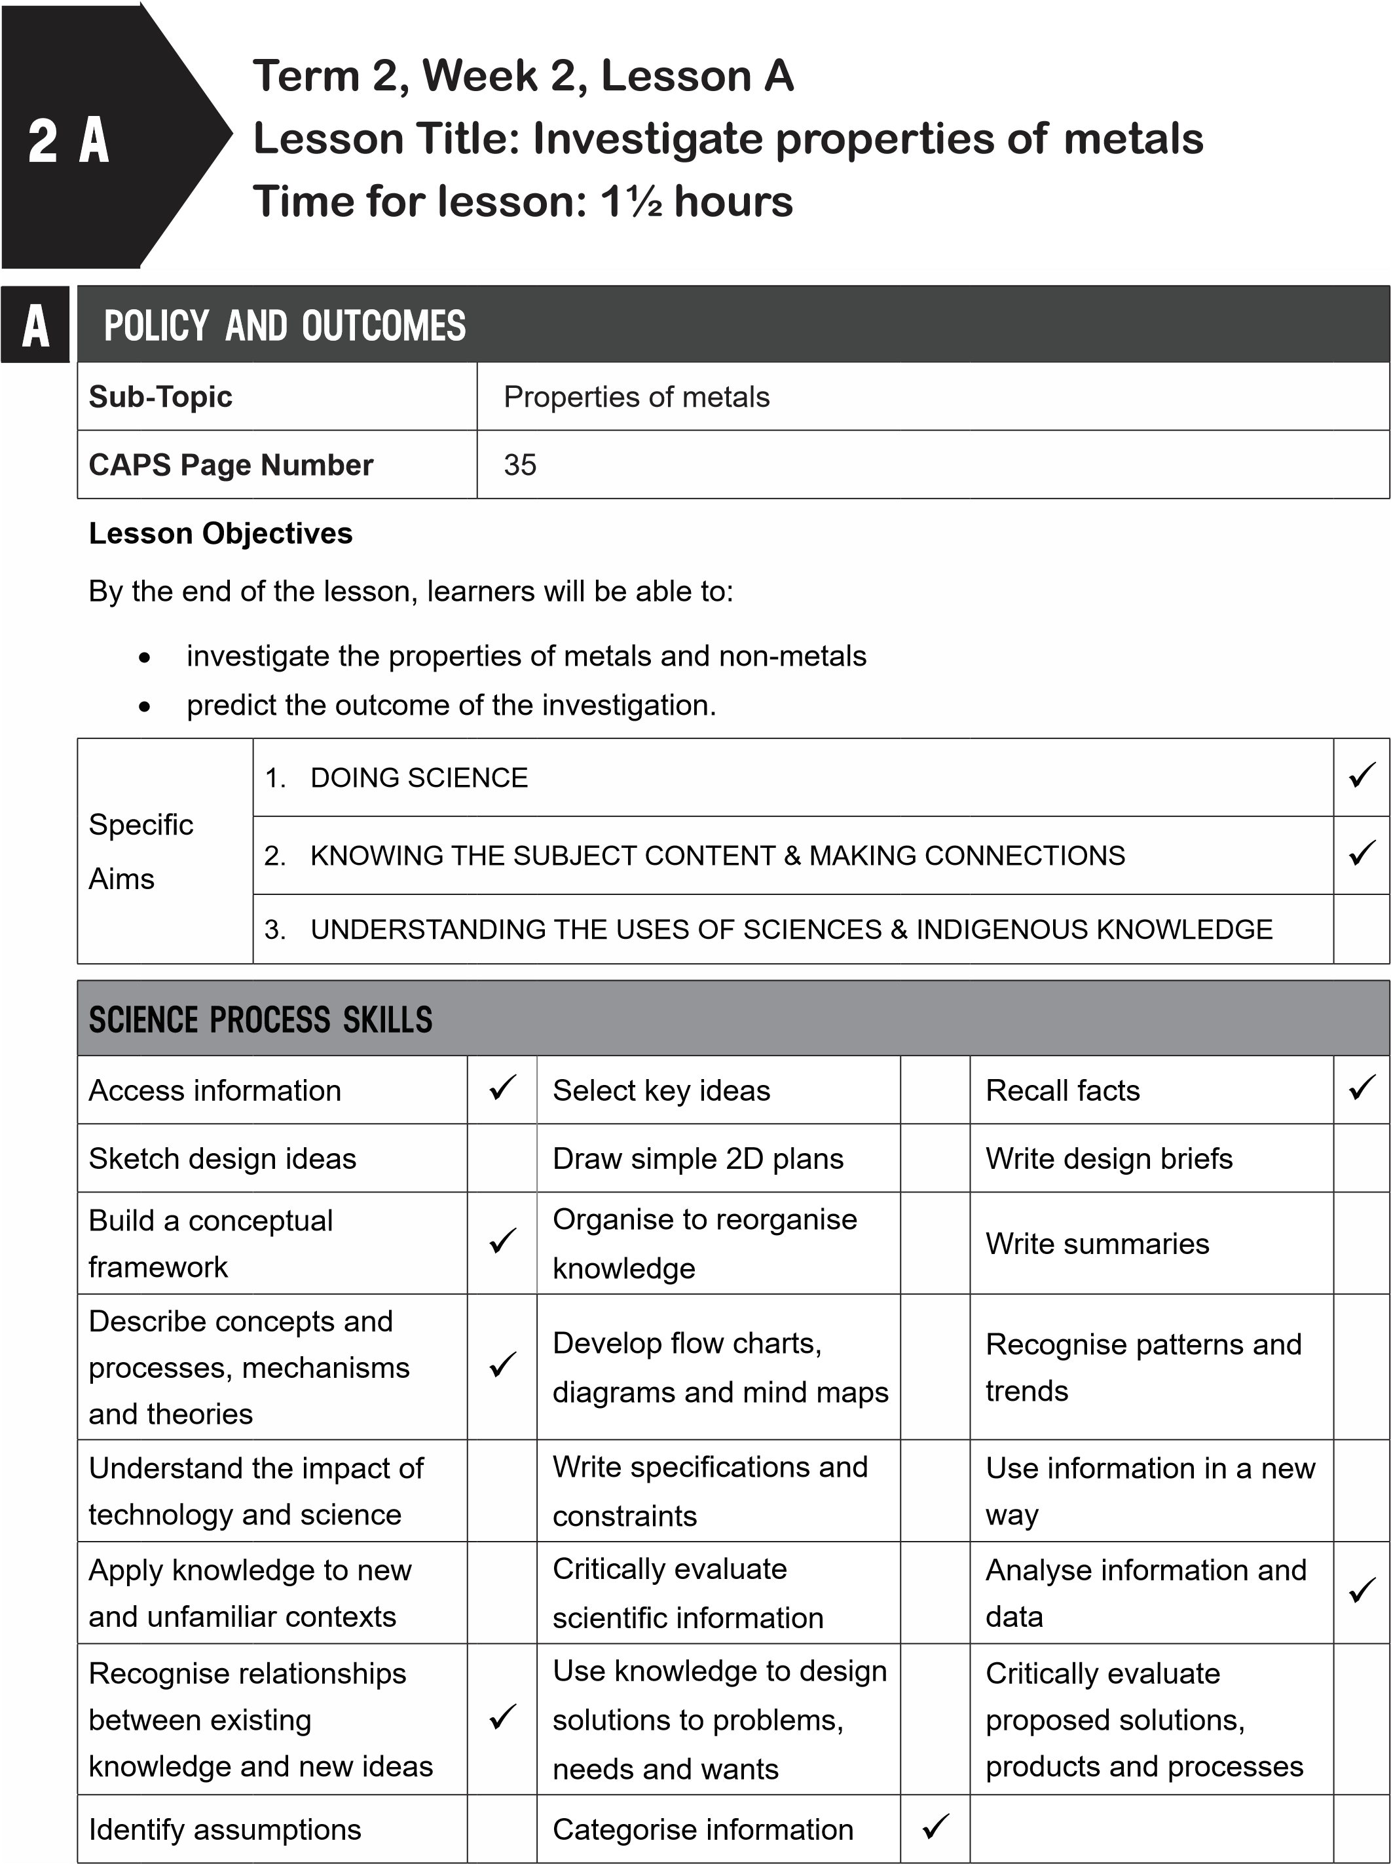
B
POSSIBLE RESOURCES
For this lesson, you will need:
IDEAL RESOURCES
IMPROVISED RESOURCES
Poster: Properties of metals and non-metals
Pieces of metal wire, two nails, coins, chalk,
pieces of coal
C | CLASSROOM MANAGEMENT
- Make sure that you are ready and prepared.
- Write the following question onto the chalkboard before the lesson starts:
 | How do we know that a metal is hard?
- Learners should enter the classroom and answer the question in their workbooks.
- Discuss the answer with the learners.
- Write the model answer onto the chalkboard.
The metal will not bend or dent easily, and it will resist scratches.
D | ACCESSING INFORMATION
 | 1. Write the following onto the chalkboard (always try to do this before the lesson starts):
PROPERTIES OF METAL
- The properties of metals that will be investigated are: shininess, hardness, malleability and brittleness.
- A material is brittle if it breaks when it is dropped.
- Glass is a brittle material.
- You will predict the outcome of the investigation.
- To predict means you forecast what will happen in the future.
- Data will be recorded in a table.
- You will write a conclusion.
- A conclusion is a summary of what you found.
- Explain this to the learners as follows:
  - Learners will do an investigation into the properties of metals.
  - They will investigate four properties: shininess, hardness, malleability and brittleness.
- Give learners time to copy this information into their workbooks.

Checkpoint 1
Ask learners the following questions to check their understanding at this point:
- What does ‘brittleness’ mean?
- What does ‘predict’ mean?
Answers to the checkpoint questions are as follows:
- A material is brittle if it breaks when it is dropped.
- To predict something means to forecast or to think about what will happen in the future.
E | CONCEPTUAL DEVELOPMENT
1. Write the following onto the chalkboard (always try to do this before the lesson starts).
INVESTIGATE, COMPARE AND RECORD THE PROPERTIES OF METALS AND NONMETALS
You will need: a piece of metal wire (about 10 cm long) two nails a coin chalk a piece of coal a stone
a piece of fine sandpaper a hammer.
- Copy the table below so that you can record your results.
- Before each investigation, predict the results and write them down in your workbook.
For example: ‘I think that metal wire will be shinier when rubbed with sand paper.’
Material | shininess | hardness | malleability | brittleness
metal wire
nail
coin
chalk
coal
stone

INVESTIGATE SHININESS
- Write a prediction for each item about whether the item will shine after being rubbed with fine sandpaper.
- Rub each item with sandpaper for about 30 seconds.
- Which objects shine and which do not?
INVESTIGATE HARDNESS
- Write a prediction for each item about whether the item will scratch easily, or not, after being scratched with a nail.
- Scratch each item with a nail.
- Observe and record which items scratch easily and which do not.
INVESTIGATE MALLEABILITY
- Write a prediction for the wire and the piece of chalk about whether each of these items will break when hammered or not.
- Try bending each item with your hands.
- Try to use the same amount of force.
- Observe and record what you found.
INVESTIGATE BRITTLENESS
- Write a prediction for each item about whether each item will break, or not, if dropped from a height of 30cm (a ruler’s length).
- Drop the first item. Record what happened.
- Drop the second item and record what happened.
- Repeat the procedure for all items.
- Observe and record what you have found.
- Explain this to the learners as follows:
  - This investigation should be done in groups of six to eight learners.
  - Read through the list of what they will need.
  - The one nail will be used to scratch the items in the investigation for hardness.
  - The sandpaper will be used to rub the items in the investigation for shininess.
  - Before they start the investigations, learners must copy the table into their workbooks.
  - Before each investigation, learners must predict what will happen for each investigation and write this down in their workbooks.
  - Learners must tidy up their workspace when they have completed the investigations.
- A model answer (answers may vary):
1. Table of properties of metals and non-metals
Material | shininess | hardness | malleability | brittleness
metal wire | became shinier when rubbed | hard, as did not scratch | did not break when hammered, but changed shape | not brittle as did not break when dropped
nail | became shinier when rubbed | hard, as did not scratch |  | did not break when hammered, but changed shape
coin | became shinier when rubbed | hard, as did not scratch |  | did not break when hammered, but changed shape
chalk | did not shine | scratched |  | did not break when hammered, but changed shape
coal | did not shine | scratched |  | did not break when hammered, but changed shape
stone | did not shine | scratched |  | did not break when hammered, but changed shape

Checkpoint 2
Ask the learners the following questions to check their understanding at this point: a. Is a coin hard?
b. How do you know?
c.
Answers to the checkpoint questions are as follows:
- A coin is hard.
- It is hard, as it did not scratch easily when we scratched it with a nail.
- Ask the learners if they have any questions and provide answers and explanations.

F | REFERENCE POINTS FOR FURTHER DEVELOPMENT
 | If you need additional information or activities on this topic, you can find these in your textbook on the following pages:
 | NAME OF TEXTBOOK | TOPIC | PAGE NUMBER
 | Study & Master | Metals and non-metals | 68-70; 73-74
 | Viva | Metals and non-metals | 54-57
 | Platinum | Metals and non-metals | 63
 | Solutions for All | Metals and non-metals | 69-81
 | Day-by-Day | Metals and non-metals | 57-59
 | Oxford | Metals and non-metals | 48-52
 | Spot On | Metals and non-metals | 30
 | Top Class | Metals and non-metals | 43-50
 | Sasol Inzalo Bk A | Metals and non-metals | 126-145
G | ADDITIONAL ACTIVITIES/ READING
In addition, further reading, listening or viewing activities related to this sub-topic are available through the following web links:
- https://goo.gl/U2x1ic (2min 4sec) [BBC Bitesize Metals and non-metals]
- https://goo.gl/XfaFoN [Tom Newby School Natural Science and Technology Grade 5]
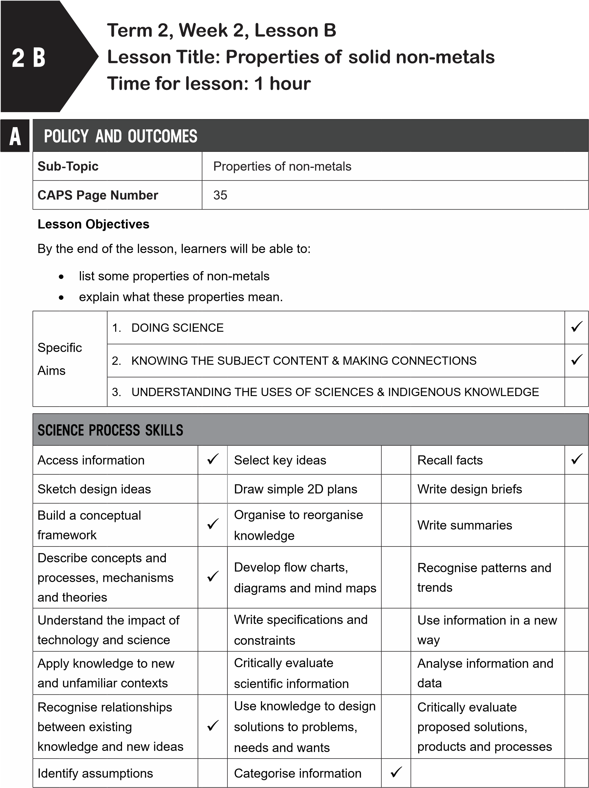
B
POSSIBLE RESOURCES
For this lesson, you will need:
IDEAL RESOURCES
IMPROVISED RESOURCES
Poster: Properties of metals and non-metals
Resource Page 8: Non-metals: plastic bucket
and electric plug
C | CLASSROOM MANAGEMENT
- Make sure that you are ready and prepared.
- Write the following question onto the chalkboard before the lesson starts:
 | How do we know that metal wire is malleable?
- Learners should enter the classroom and answer the question in their workbooks.
- Discuss the answer with the learners.
D
- Write the model answer onto the chalkboard.
When wire is hammered, it will change shape but it will not break.
ACCESSING INFORMATION
1. Write the following onto the chalkboard (always try to do this before the lesson starts):
SOME PROPERTIES OF NON-METALS
- Like metals, non-metals are used to make things because of their properties.
- Some non-metals, like glass and ceramic pots, break easily.
- They are brittle.
- They will break easily when dropped.
- Ceramic pots and glass are brittle.
- Most non-metals are dull.
- When they are rubbed or polished, they do not shine.
- Some non-metals are not malleable.
- They cannot be hammered into shapes.
- Non-metals are not ductile.
- They cannot be made into thin wire.
- Non-metals are not malleable.
- Non-metals do not conduct heat.
- This means heat does not pass through them.
- Non-metals are not good conductors of electricity.
  - Electrical current does not travel through non-metal materials.
  - Examples of non-metals are glass, sand, wood, plastic, leather and fabric.
2. Explain this to the learners as follows:
- Remind learners that in the investigations that they did in the previous lesson, some of the items were non-metals.
- The chalk, coal and stone were non-metals.
- Most non-metals can be dull and brittle.
- Non-metals do not conduct heat.
- Non-metals are not good conductors of electricity.
6. Show learners Resource Page 8: ‘Non-metals: plastic bucket and electric plug’.
- Ask learners why they think an electric plug is made from plastic. (Answer: It is made from plastic so that electrical current will not flow through it. Therefore, you will not get a shock.)
- Ask learners why they think the bucket is made from plastic?
- (Answer: Plastic is waterproof, strong and light).
- Show learners the Poster: ‘Properties of metals and non-metals’.
- Go through the properties of non-metals on the poster.
- Give learners time to copy this information into their workbooks.
Checkpoint 1
Ask learners the following questions to check their understanding at this point:
- Chalk and coal are non-metals. Is this true or false?
- Two of chalk’s properties are its dullness and brittleness. Is this true or false?
Answers to the checkpoint questions are as follows:
- True
- True
E | CONCEPTUAL DEVELOPMENT
1. Write the following onto the chalkboard (always try to do this before the lesson starts):
TASK: METALS AND NON-METALS
- Make a copy of the following table in your workbooks.
METALS | NON-METALS
- Write down and place each of the following materials in the correct column: plastic, glass, aluminium, copper, steel, coal, iron, gold, wood, charcoal.
- Explain this to the learners as follows:
  - Read through the list of materials to make sure the learners know each material.
  - Ask learners to copy the table into their workbooks.
  - They must write the materials in the correct column.
- Give learners time to complete this task in their workbooks.
- A model answer:
TASK: METALS AND NON-METALS
METALS | NON-METALS
aluminium, copper, steel, iron, gold | plastic, glass, coal, wood, charcoal

Checkpoint 2
Ask the learners the following questions to check their understanding at this point:
- Why is plastic a good material for a bucket?
- Why is plastic a good material for an electric plug?
Answers to the checkpoint questions are as follows:
- Plastic is a good material for a bucket as it is waterproof, strong and light.
- Plastic is a good material for an electric plug as it does not conduct electrical current.
- Ask the learners if they have any questions and provide answers and explanations.

F | REFERENCE POINTS FOR FURTHER DEVELOPMENT
 | If you need additional information or activities on this topic, you can find these in your textbook on the following pages:
 | NAME OF TEXTBOOK | TOPIC | PAGE NUMBER
 | Study & Master | Metals and non-metals | 75-81
 | Viva | Metals and non-metals | 58-60
 | Platinum | Metals and non-metals | 68-71
 | Solutions for All | Metals and non-metals | 80
 | Day-by-Day | Metals and non-metals | 63-65
 | Oxford | Metals and non-metals | 53-55
 | Spot On | Metals and non-metals | 32-33
 | Top Class | Metals and non-metals | 48-51
 | Sasol Inzalo Bk A | Metals and non-metals | 139-145
G | ADDITIONAL ACTIVITIES/ READING
In addition, further reading, listening or viewing activities related to this sub-topic are available through the following web links:
- http://e-classroom.co.za/wp-content/uploads/2013/05/EngGr5T2-NATSCIENCE-Metals-and-no-metals.pdf [Metals and non-metals]
- https://goo.gl/pDDm64 [Properties of metals and non-metals]
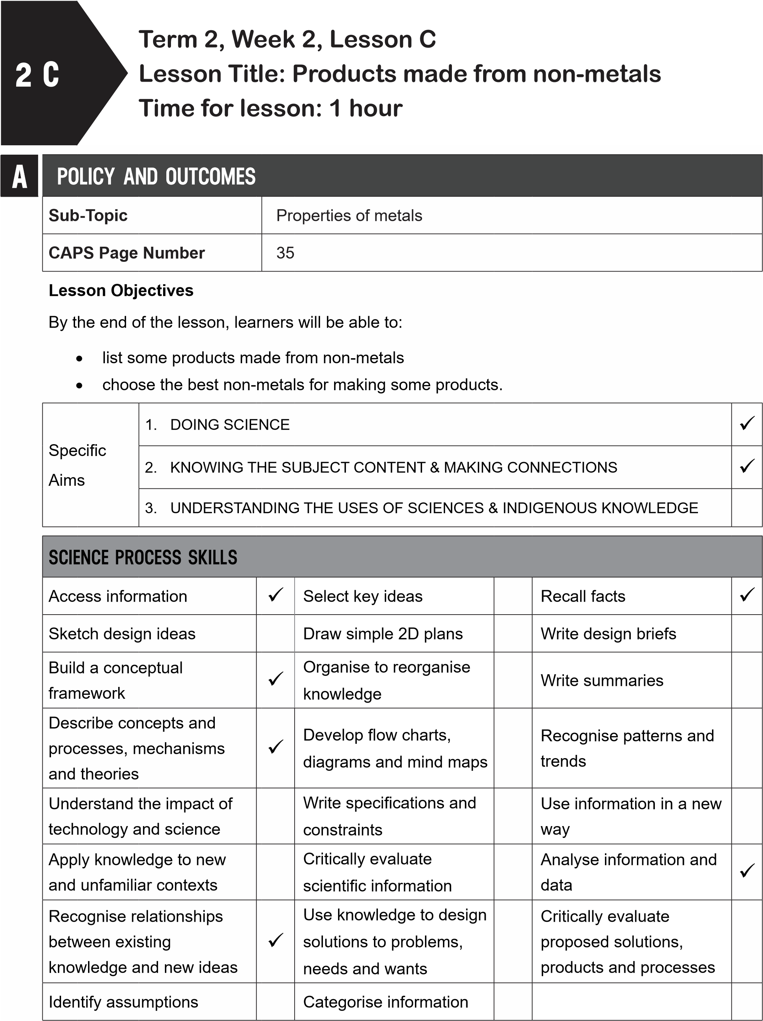
B
POSSIBLE RESOURCES
For this lesson, you will need:
IDEAL RESOURCES
IMPROVISED RESOURCES
Poster: Properties of metals and non-metals
Resource Page 8: Non-metals: plastic bucket
and electric plug
Resource Page 9: Non-metals: Rope and wool
Resource Page 10: Non-metals: Glass
windows
Tin mug, plastic mug, hot water
C
CLASSROOM MANAGEMENT
1
.
Make sure that you are ready and prepared.
2
.
Write the following question onto the chalkboard before the lesson starts:
Which non-metals are brittle?
- Learners should enter the classroom and answer the question in their workbooks.
- Discuss the answer with the learners.
- Write the model answer onto the chalkboard.
Ceramic pots and glass are brittle (learners might give other correct answers).
D | ACCESSING INFORMATION
- Write the following onto the chalkboard (always try to do this before the lesson starts):
PRODUCTS MADE FROM NON-METALS
- Plastics are waterproof, easily-shaped and are light.
- Plastic is not a good conductor of heat or electricity.
- Plastic is used to make products that need these properties, like plastic buckets and electric plugs.
- Glass is brittle and transparent.
- ‘Transparent’ means you can see through it.
- Windows are made from glass.
- Wood is strong and hard.
- Furniture is made from wood.
- Fabric is made from tiny threads.
  - These threads can be knitted or woven together.
  - These threads make strong, flexible fabric.
- Explain this to the learners as follows:
  - Non-metals have properties that are needed for certain products.
  - Read through the information on the chalkboard.
  - The non-metals are plastic, glass, wood and fabric.
  - The products that are made from these materials because the materials have certain properties.
- Show learners Resource Page 8: ‘Non-metals: plastic bucket and electric plug’. Explain:
  - Plastic is light and strong and not a good conductor of electricity.
  - It forms a good material for making buckets and electric plugs.
- Show learners Resource Page 9: ‘Non-metals: Rope and wool’. Explain:
  - Rope and wool are made from threads.
  - This makes them strong and flexible.
- Show learners Resource Page 10: ‘Non-metals: Glass windows.
Explain:
  - Glass is transparent so it forms a good material for windows.
  - Wood is strong and hard.
  - It forms a good material for furniture.
- Give learners time to copy this information into their workbooks.
Checkpoint 1
Ask learners the following questions to check their understanding at this point:
- Why are windows made from glass?
- Why is furniture made from wood?
Answers to the checkpoint questions are as follows:
- Glass is transparent.
- Wood is strong and hard.
E | CONCEPTUAL DEVELOPMENT
 | 1. Write the following onto the chalkboard (always try to do this before the lesson starts):
INVESTIGATION: A TIN MUG AND A PLASTIC MUG
You will need: a tin mug a plastic mug hot water.
METHOD
- Feel the outside temperature of each mug before hot water is poured in.
- Pour the same amount of hot water into each mug.
- Feel the outside temperature of each mug after 30 seconds.
- In your workbooks, describe the properties of each mug.
- Say which property makes one of the mugs a more useful mug.
- Explain this to the learners as follows:
  - This can be done in groups or as a teacher-led demonstration.
  - Be careful when working with hot water.
  - Get the learners to feel the temperatures of the outside of the mugs, after hot water has been poured in.
- Give learners time to complete the investigation and to write the properties of the mugs in their workbooks.
- A model answer (answers may vary): The model answers are as follows:
Properties of the tin mug:
hard, good conductor of heat, strong.
Properties of the plastic mug:
hard, not a good conductor of heat, strong.
The plastic mug is a more useful mug as it does not conduct heat and therefore does not
get hot.
Checkpoint 2
Ask the learners the following questions to check their understanding at this point:
- What property of metals makes the tin mug hot when it is filled with hot water?
- Why is the same amount of water poured into each mug?
Answers to the checkpoint questions are as follows:
- Metals are good conductors of heat.
- This is then a fair test for an investigation.
- Ask the learners if they have any questions and provide answers and explanations.

F | REFERENCE POINTS FOR FURTHER DEVELOPMENT
 | If you need additional information or activities on this topic, you can find these in your textbook on the following pages:
 | NAME OF TEXTBOOK | TOPIC | PAGE NUMBER
 | Study & Master | Metals and non-metals | 68-70; 73-74
 | Viva | Metals and non-metals | 54-57
 | Platinum | Metals and non-metals | 63
 | Solutions for All | Metals and non-metals | 69-81
 | Day-by-Day | Metals and non-metals | 57-59
 | Oxford | Metals and non-metals | 48-52
 | Spot On | Metals and non-metals | 30
 | Top Class | Metals and non-metals | 43-50
 | Sasol Inzalo Bk A | Metals and non-metals | 126-145
G | ADDITIONAL ACTIVITIES/ READING
In addition, further reading, listening or viewing activities related to this sub-topic are available through the following web links:
- http://chemistry.tutorvista.com/inorganic-chemistry/uses-of-non-metals.html [Uses of non-metals]
- http://www.edu.helsinki.fi/malu/materials/materials_around_us.pdf [Materials around us]

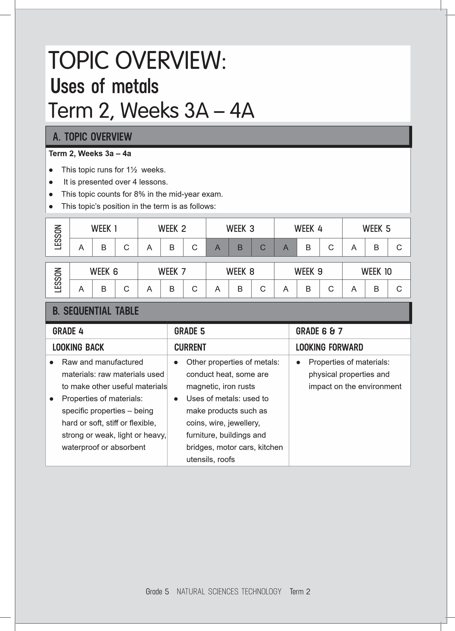
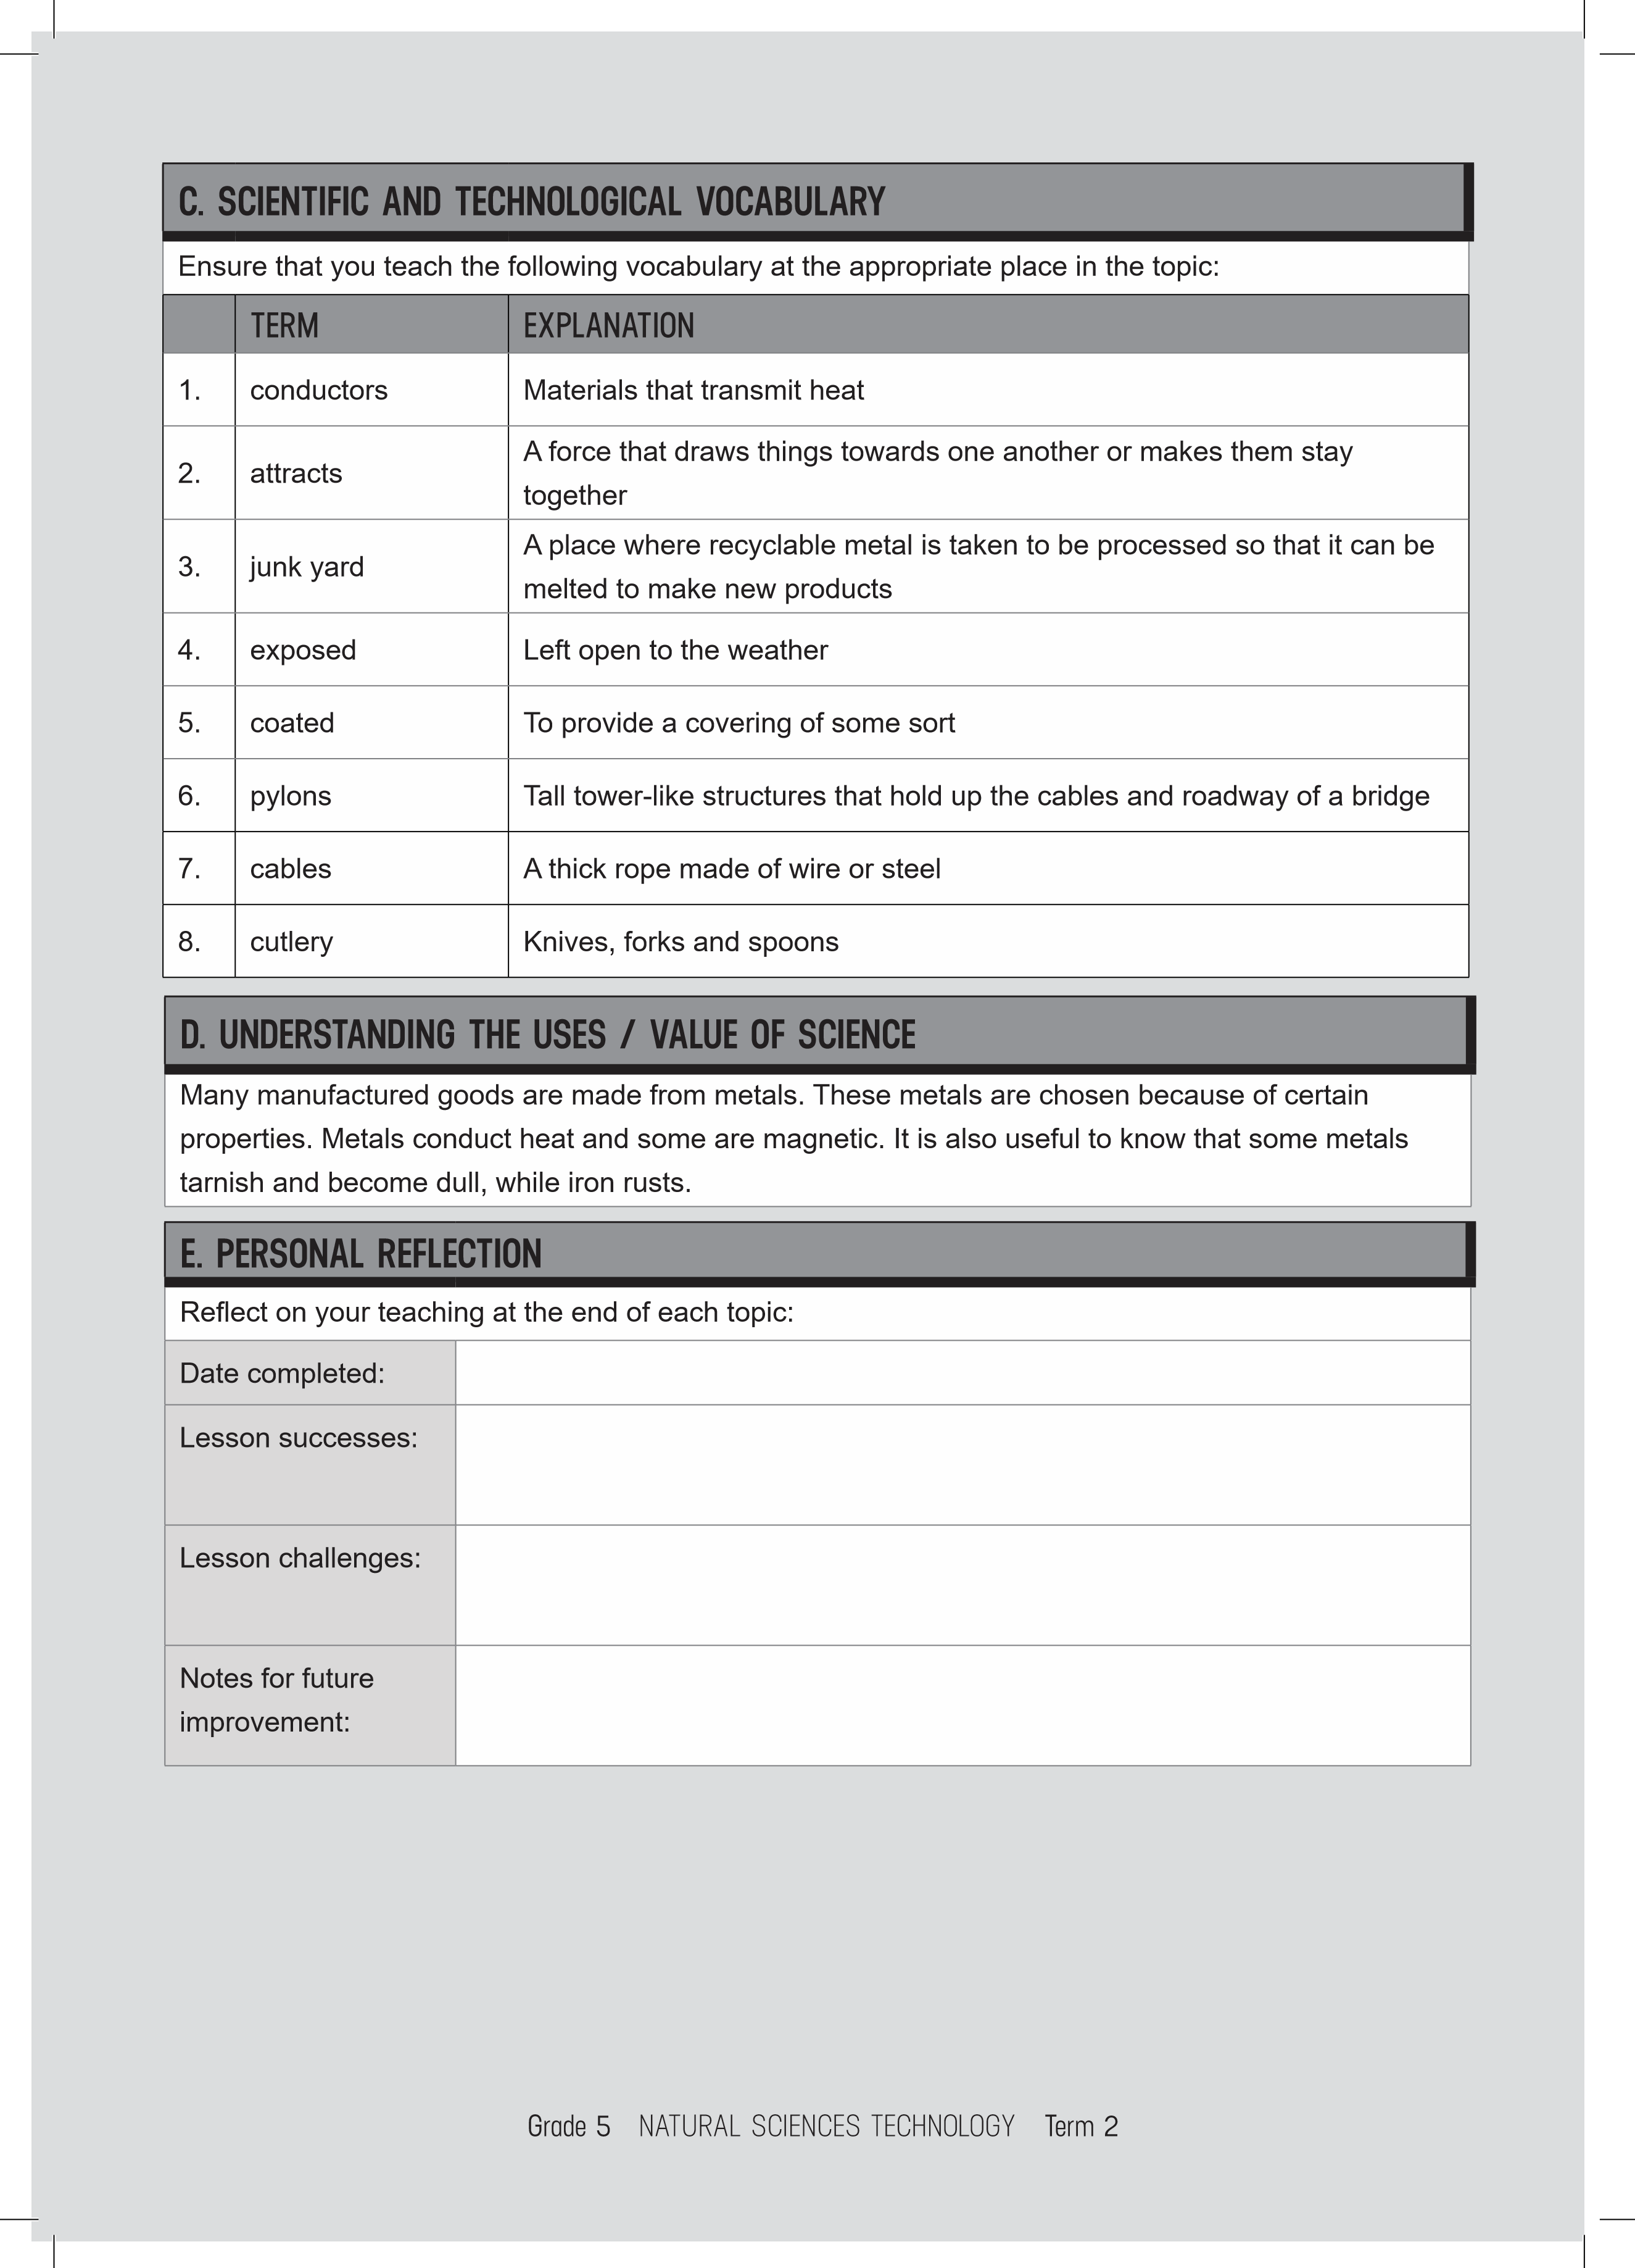

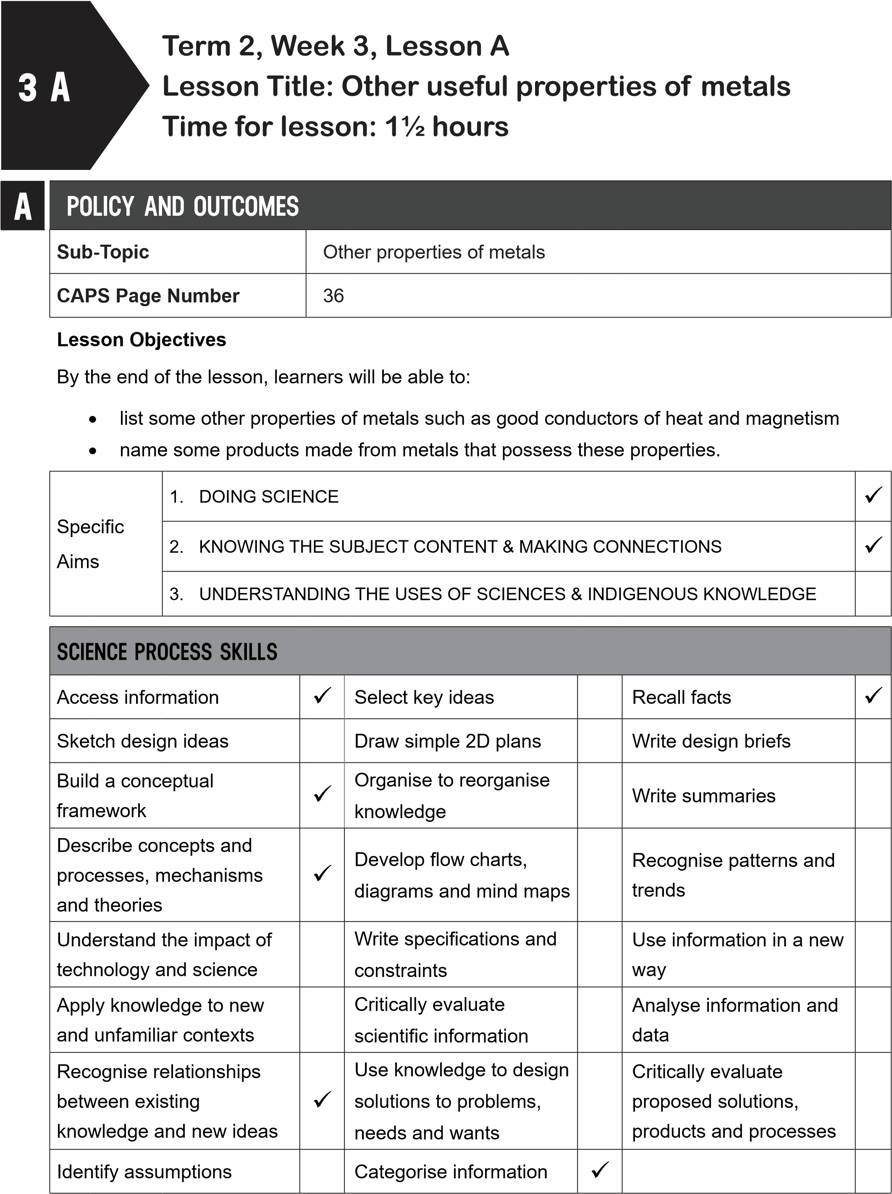

B
POSSIBLE RESOURCES
For this lesson, you will need:
IDEAL RESOURCES
IMPROVISED RESOURCES
Resource Page 14: Metals are good
conductors of heat
Resource Page 15: Iron is magnetic: Crane
used to lift cars
Resource Page 16: A magnet attracts paper
clips
A magnet, a 50c coin, a nail, a piece of chalk,
a piece of aluminium foil, a metal paper clip for
each group
C | CLASSROOM MANAGEMENT
- Make sure that you are ready and prepared.
- Write the following question onto the chalkboard before the lesson starts:
 | Why are windows made from glass?
- Learners should enter the classroom and answer the question in their workbooks.
- Discuss the answer with the learners.
D
- Write the model answer onto the chalkboard.
Windows are made from glass as glass is transparent.
ACCESSING INFORMATION
1. Write the following onto the chalkboard (always try to do this before the lesson starts):
MORE PROPERTIES OF METALS
1. Good conductors of heat
- Metals are good conductors of heat.
- This means that heat can travel easily through the metal.
- The metal heats up quickly.
- Therefore, cooking pots and pans are made from metal.
- Copper, iron and steel are good conductors of heat.
2. Some metals are magnetic
- Some metals are magnetic.
- A magnet is a piece of metal that can stick to some other metals or make other metals move towards it.
- Iron is a metal that is magnetic.
- Stainless steel is magnetic as it is made with iron.
- Copper, gold, tin and aluminium are not magnetic.
- Explain to the learners that some metals are good conductors of heat:
  - Some, not all, metals are good conductors of heat.
  - These metals are used to make pots and pans.
  - The heat will travel easily through the metal so that the food can cook quickly.
  - Show learners Resource Page 14: ‘Metals are good conductors of heat’.
  - Copper pots are used for cooking.
- Explain to the learners that some metals are magnetic:
  - A magnet is a piece of metal that pulls certain things towards it.
  - We say that the magnet attracts the objects.
  - Not all metals are magnetic.
  - Iron is a magnetic metal.
  - Show learners Resource Page 15: ‘Iron is magnetic: Crane used to lift cars’.
  - At the end of the cable is a huge magnet.
  - The magnet is strong enough to lift a car.
  - This type of crane is used in a junk yard.
- Give learners time to copy this information into their workbooks.
Checkpoint 1
Ask the learners the following questions to check their understanding at this point:
a. What product is made from metal because metals are good conductors of heat? b. What is a magnet?
Answers to the checkpoint questions are as follows:
- Pots and pans are made from metal so that heat can travel through the metal to the food.
- A magnet is a piece of metal that can stick to some other metals or make other metals move towards it.
E | CONCEPTUAL DEVELOPMENT
 | 1. Write the following onto the chalkboard (always try to do this before the lesson starts):
TASK: METALS ARE GOOD CONDUCTORS OF HEAT
Some homes are made from corrugated iron.
- What will these homes be like in summer?
- Why are spoons for cooking made from wood and not metal?
- Why are pots and pans for cooking made of metal?
- Explain the following to the learners:
  - Ask learners to think carefully about their answers and then write them down.
  - When they have written down their answers, give them two minutes to share their answers with a partner.
  - They can change their answers, if they would like to.
  - Get some learners to share their answers with the class.
- Give learners time to complete this task in their workbooks.
- A model answer:
METALS ARE GOOD CONDUCTORS OF HEAT
- Homes with corrugated iron roofs will be very hot in summer as iron is a good conductor of heat.
- Cooking spoons are made from wood as wood does not conduct heat.
Therefore, the spoons will not get hot.
- Pots and pans need to be made of metal as metal is a good conductor of heat and heat will travel quickly through the metal to the food.
- Write the following on the chalkboard (always try to do this before the lesson starts):
TASK: INVESTIGATE WHICH PRODUCTS ARE MAGNETIC
You will need:
a magnet a 50c coin a nail a piece of chalk a piece of aluminium foil a metal paper clip.
METHOD
- Take each item and move the magnet close to it.
- Observe which item moves toward the object.
- Record your results in a table.
Table: Magnetism of materials
Item | Magnetic: Yes or no?
a 50c coin
a nail
a piece of chalk
a piece of aluminium foil
a paper clip

- Explain this to the learners as follows:
  - This task is to find out which items are magnetic.
  - This can be done as a teacher-led demonstration or learners can be put into groups.
  - Learners must first draw the table into their workbooks.
  - Learners must then gather the magnet and items.
  - Learners can add their own items to the list.
  - They can use the metal legs of a chair, wooden desk tops, and the door handle.
  - Not all metals are magnetic.
- A model answer:
TASK: INVESTIGATE WHICH PRODUCTS ARE MAGNETIC
Table: Magnetism of materials
Item | Magnetic: Yes or no?
a 50c coin | Yes
a nail | Yes
a piece of chalk | No
a piece of aluminium foil | No
a paper clip | Yes

- Explain this to the learners as follows:
  - Not all metals are magnetic.
  - Metals with iron in them are magnetic.
Checkpoint 2
Ask the learners the following questions to check their understanding at this point:
a.
Can you name a metal that is magnetic?
b.
Can you name a metal that is not magnetic?
Answers to the checkpoint questions are as follows:
a.
Iron is magnetic.
b.
Any of the following answers: gold, silver, aluminium, copper.
- Ask the learners if they have any questions and provide answers and explanations.
F | REFERENCE POINTS FOR FURTHER DEVELOPMENT
 | If you need additional information or activities on this topic, you can find these in your textbook on the following pages:
 | NAME OF TEXTBOOK | TOPIC | PAGE NUMBER
 | Study & Master | Uses of metals | 82-84
 | Viva | Uses of metals | 63-66
 | Platinum | Uses of metals | 73-76
 | Solutions for All | Uses of metals | 83-86
 | Day-by-Day | Uses of metals | 67-68
 | Oxford | Uses of metals | 56-58
 | Spot On | Uses of metals | 34-36
 | Top Class | Uses of metals | 51-54
 | Sasol Inzalo Bk A | Uses of metals | 147-163
G
 | ADDITIONAL ACTIVITIES/ READING
In addition, further reading, listening or viewing activities related to this sub-topic are available through the following web links:
- https://goo.gl/h2ywPo (2min 9sec) [Magnetism - 5th Grade]
- https://goo.gl/vkpV8h (5min 38sec) [Bill Nye Magnetism Part 1]
- https://goo.gl/i4yKGr (3min) [Magnets for kids]
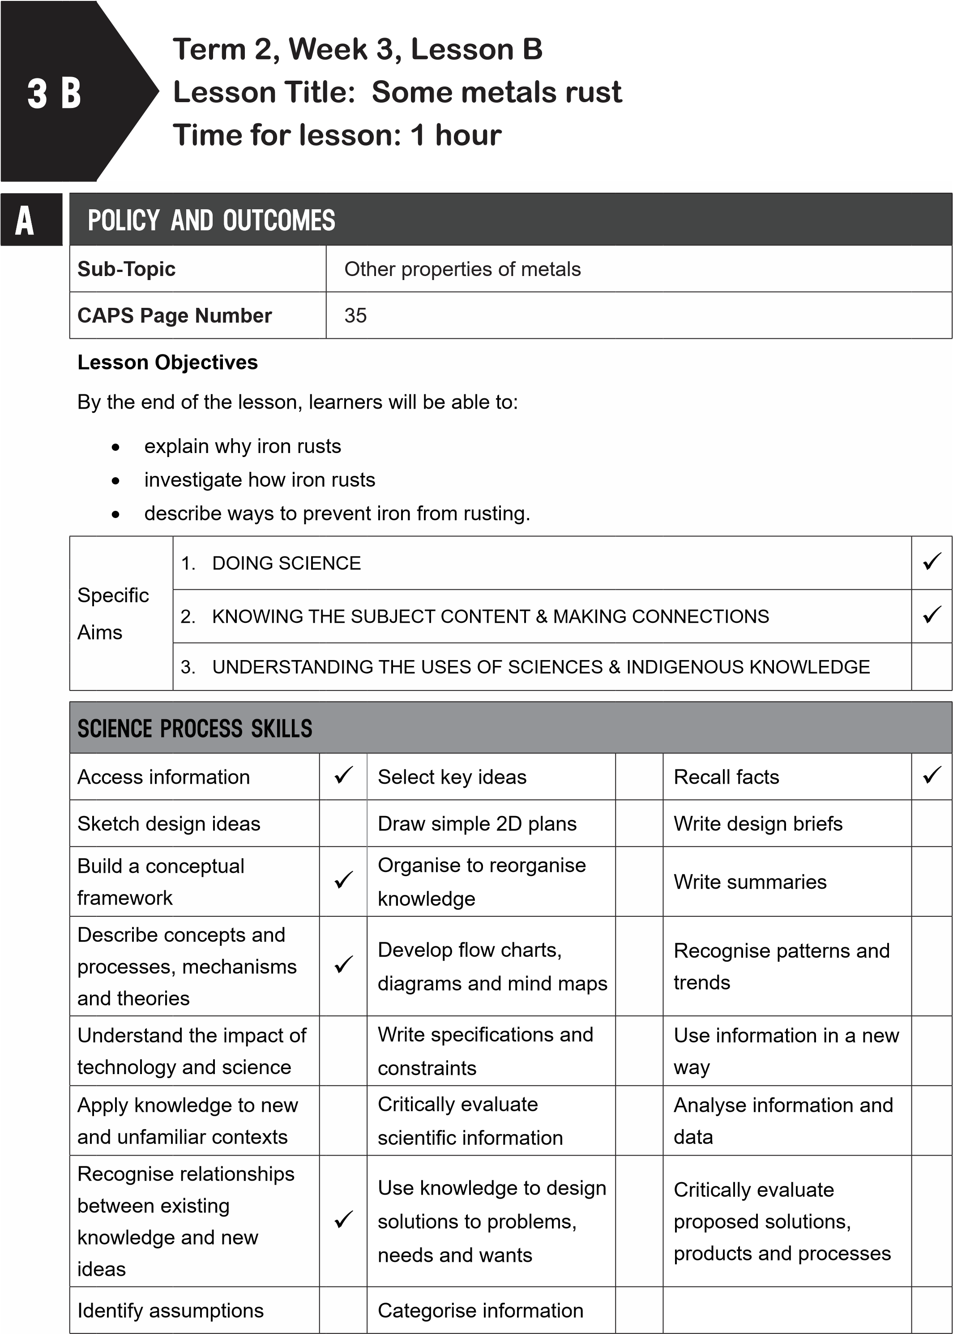
B | POSSIBLE RESOURCES
 | For this lesson, you will need:
 | IDEAL RESOURCES | IMPROVISED RESOURCES
 | Resource Page 11: Some metals rust: iron drums
 | Resource Page 12: Rusty corrugated iron roofing
 | Resource Page 13: Rusty nails
 | Resource Page 17: Prevent rusting: tin cans
 | Metal objects such as a nail, copper wire, copper coin, drawing pin, paper clip; a beaker, water | Glass jars can be used as beakers
CLASSROOM MANAGEMENT
- Make sure that you are ready and prepared.
- Write the following question onto the chalkboard before the lesson starts:
Why does a house with a corrugated iron roof get hot?
- Learners should enter the classroom and answer the question in their workbooks.
- Discuss the answer with the learners.
C
- Write the model answer onto the chalkboard.
As metals are good conductors of heat, the heat travels through the iron quickly.
D | ACCESSING INFORMATION
- Write the following onto the chalkboard (always try to do this before the lesson starts):
SOME METALS RUST
- Iron is a strong metal.
- It is used to make nails, wire and building materials.
- When iron comes into contact with air or water, it rusts.
- Iron and steel are both metals that rust.
- Steel has iron in it.
- A reddish-brown solid forms a layer on the outside of the metal.
- This weakens the metal.
TO PREVENT RUSTING
- Iron and steel can be prevented from rusting by painting the metal with anti-rust paint.
- Bridges and buildings are painted with anti-rust paint.
- Food cans are made from iron but coated with tin.
- Machine parts are covered with a layer of grease.
- These methods stop the air or water from getting to the iron or steel. Give learners some time to copy this information into their exercise books.
- Explain rusting to the learners as follows:
  - Rusting is a process that occurs when iron and steel are exposed to air or water.
  - Rusting weakens the metal.
  - Rusting can be prevented by using anti-rust paint, coating with a layer of tin or covering the iron or steel in grease.
  - Show learners Resource Page 11: ‘Some metals rust: iron drums’.
  - Show learners Resource Page 13: ‘Rusty nails’.
  - Remind learners that not all metals rust; however, iron and steel rust.
- Explain how to prevent rust to the learners as follows:
  - Show learners Resource Page 12: ‘Rusty corrugated iron roofing’.
  - Rusting on buildings can be prevented by painting.
  - Show learners Resource Page 17: ‘Prevent rusting: tin cans’.
  - Tell the learners that tin cans are made from iron and then coated with tin to stop them rusting.
- Give learners time to copy this information into their workbooks.
Checkpoint 1
Ask the learners the following questions to check their understanding at this point:
- Can you name two metals that rust?
- Can you give three ways to prevent rusting?
Answers to the checkpoint questions are as follows:
- Iron and steel are metals that rust.
- To prevent rusting, iron and steel can be painted with anti-rust paint, coated with a layer of tin or covered in grease.

E | CONCEPTUAL DEVELOPMENT
 | 1. Write the following onto the chalkboard (always try to do this before the lesson starts):
ACTIVITY: PLACING OBJECTS IN WATER TO SEE IF THEY RUST
You will need: metal objects such as a nail, copper wire, copper coin, drawing pin, paper clip a beaker for each item; water.
METHOD
- Place each object into a separate beaker of water.
- Leave the metal object in the beaker for 2-4 weeks.
- Record the results after 2-4 weeks in a table. Use the table below.
TABLE TO RECORD RESULTS OF RUSTING INVESTIGATION
Metal object | rusted | not rusted
iron nail
copper wire
copper coin
drawing pin
paper clip

- Explain this to the learners as follows:
  - Learners must copy the table into their workbooks.
  - Other metal objects can be chosen.
  - These must be filled in on the table.
  - This must be a teacher-led investigation.
  - The beakers must be left on the window sill for 2-4 weeks.
  - Learners must fill in the results after this time.
- A model answer (answers may vary):
TABLE TO RECORD RESULTS OF RUSTING INVESTIGATION
Metal object | rusted | not rusted
iron nail | Yes
copper wire |  | No
copper coin |  | No
drawing pin | Yes
paper clip | Yes

- Explain this to the learners as follows:
  - The paper clips and drawing pins have a coating of zinc.
  - When the zinc is worn through, the paper clip and drawing pin will then start to rust.
Checkpoint 2
Ask the learners the following questions to check their understanding at this point:
- Why does copper wire not rust?
- How does coating a can with tin stop rust?
Answers to the checkpoint questions are as follows:
- Not all metals rust, only those with iron in them.
- It stops the air or water from getting to the iron.
- Ask the learners if they have any questions and provide answers and explanations.
F | REFERENCE POINTS FOR FURTHER DEVELOPMENT
 | If you need additional information or activities on this topic, you can find these in your textbook on the following pages:
 | NAME OF TEXTBOOK | TOPIC | PAGE NUMBER
 | Study & Master | Uses of metals | 83-84
 | Viva | Uses of metals | 66-69
 | Platinum | Uses of metals | 76-77
 | Solutions for All | Uses of metals | 86-89
 | Day-by-Day | Uses of metals | 69
 | Oxford | Uses of metals | 58-59
 | Spot On | Uses of metals | 36
 | Top Class | Uses of metals | 54
 | Sasol Inzalo Bk A | Uses of metals | 126-145
G | ADDITIONAL ACTIVITIES/ READING
In addition, further reading, listening or viewing activities related to this sub-topic are available through the following web links:
- https://goo.gl/8Nom7c (3min 32sec) [Rusting of iron]
- https://goo.gl/rVdFG1 (2min 52sec) [Corrosion of metals]
- https://goo.gl/hJsyL6 (1min 37sec) [Rusting of iron]
- https://e-classroom.co.za/wp-content/uploads/2015/05/EngGr5T2-NS-Matter-andmaterials-Uses-of-metals-other-properties-of-metals.pdf [Uses of metals]
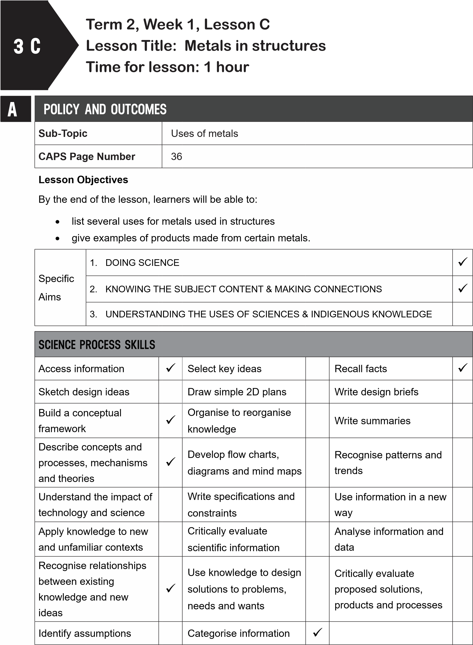
B
POSSIBLE RESOURCES
For this lesson, you will need:
IDEAL RESOURCES
IMPROVISED RESOURCES
Resource Page 18: Nelson Mandela Bridge:
made from steel
Resource Page 19: Golden Gate Bridge –
made from iron
Resource Page 20: Aluminium furniture
Resource Page 6: Steel is strong and
malleable
C | CLASSROOM MANAGEMENT
- Make sure that you are ready and prepared.
- Write the following question onto the chalkboard before the lesson starts:
Can you name three ways in which rusting can be prevented?
- Learners should enter the classroom and answer the question in their workbooks.
- Discuss the answer with the learners.
- Write the model answer onto the chalkboard.
Rust can be prevented by painting, coating with tin or applying a layer of grease.
D | ACCESSING INFORMATION
 | 1. Write the following onto the chalkboard (always try to do this before the lesson starts):
STRUCTURES MADE FROM METAL
- Iron is a strong metal but should be painted with anti-rust paint.
- Steel is strong and light.
- Bridges are made from iron or steel.
- Car bodies are often made from steel.
- Aluminium is strong and light.
- Some furniture is made from aluminium.
- Explain and discuss the following with the learners:
  - Show learners Resource Page 18: ‘Nelson Mandela Bridge: made from steel’.
  - The cables on this bridge are made from steel.
  - Steel is very strong and light.
  - Show learners Resource Page 19: ‘The Golden Gate Bridge: made from iron’.
  - This roadway and pylons are made from iron but they should be painted with anti-rust paint.
  - Iron is very strong but it rusts.
  - The cables are made from steel.
- Explain how metals are used in other structures to the learners as follows:
  - Show learners Resource Page 20: ‘Aluminium furniture’.
  - Aluminium is very strong and light.
  - It is ideal for making outdoor furniture, as it does not rust.
  - Show learners Resource Page 6: ‘Steel is strong and malleable’.
  - Steel is often used to make car bodies as it can be shaped and it does not rust.
- Give learners time to copy this information into their workbooks.
Checkpoint 1
Ask learners the following questions to check their understanding at this point:
- Why are some bridge made from iron?
- Why is some outdoor furniture made from aluminium?
Answers to the checkpoint questions are as follows:
- Iron is a very strong metal.
- Aluminium does not rust and it is strong and light.

E | CONCEPTUAL DEVELOPMENT
 | 1. Write the following on the chalkboard (always try to do this before the lesson starts):
TASK: IDENTIFY PROPERTIES AND USES OF METALS
1. Match each of the uses in Column A with the property in Column B.
Each product may have more than one property.
Each property can be used more than once.
Column A  Products made from metal | Column B  Properties of metals
1. outdoor furniture (aluminium) | a. strong
2. bridges (iron) | b. hard
3. cars (steel) | c. shiny
4. pot and pans (copper) | d. light
5. cable-stayed bridges (steel) | e. good conductor of heat
 | f. does not rust
 | g. malleable

- Explain this to the learners as follows:
  - Learners must match each product in Column A with the properties in Column B.
  - Each product may have more than one property.
  - Learners must draw a table in their workbooks.
  - Write the products in Column A.
  - Write down all the properties of the metal used in that product in Column B.
- Give learners time to complete this task in their workbooks.
- Model answer. Discuss the answers with the learners.
TASK: IDENTIFY PROPERTIES AND USES OF METALS
Column A  Products made from metal | Column B  Properties of metals
1. outdoor furniture (aluminium) | strong, light
2. bridges (iron) | strong
3. cars (steel) | shiny, strong, does not rust, malleable
4. pot and pans (copper) | good conductor of heat, does not rust
5. cable-stayed bridges (steel) | strong, light

Checkpoint 2
Ask the learners the following questions to check their understanding at this point:
- Why is aluminium a good metal to use for outdoor furniture?
- Why are some bridges made from iron?
Answers to the checkpoint questions are as follows:
a. It is a good metal to use as it does not rust and it is strong and light. b. Iron is a very strong metal.
- Ask learners if they have any questions and provide answers and explanations.
F | REFERENCE POINTS FOR FURTHER DEVELOPMENT
 | If you need additional information or activities on this topic, you can find these in your textbook on the following pages:
 | NAME OF TEXTBOOK | TOPIC | PAGE NUMBER
 | Study & Master | Uses of metals | 84-85
 | Viva | Uses of metals | 70-74
 | Platinum | Uses of metals | 80-81
 | Solutions for All | Uses of metals | 90
 | Day-by-Day | Uses of metals | 70-72
 | Oxford | Uses of metals | 60-61
 | Spot On | Uses of metals | 36
 | Top Class | Uses of metals | 55
 | Sasol Inzalo Bk A | Uses of metals | 164-171
G | ADDITIONAL ACTIVITIES/ READING
In addition, further reading, listening or viewing activities related to this sub-topic are available through the following web links:
- https://goo.gl/B9C2YN (3min 59sec) [Hunting for properties]
- https://goo.gl/hFztXs (47sec) [Uses of metals and non-metals]
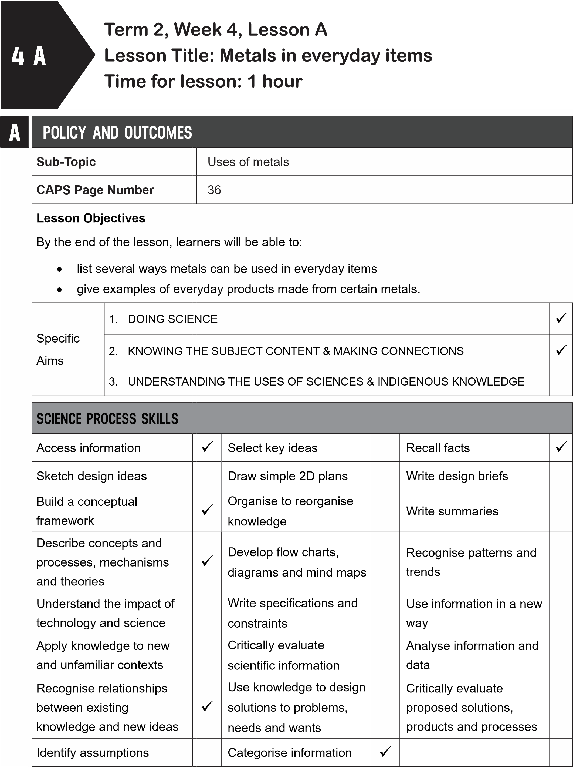
B | POSSIBLE RESOURCES
 | For this lesson, you will need:
 | IDEAL RESOURCES | IMPROVISED RESOURCES
Examples of objects with metal in them. E.g.
batteries, spoons, etc.
CLASSROOM MANAGEMENT
- Make sure that you are ready and prepared.
- Write the following question onto the chalkboard before the lesson starts:
Why is steel used to make car bodies?
- Learners should enter the classroom and answer the question in their workbooks.
D
C
- Discuss the answer with the learners.
- Write the model answer onto the chalkboard.
Steel is used as it is malleable and it does not rust.
ACCESSING INFORMATION
1. Write the following onto the chalkboard (always try to do this before the lesson starts):
EVERYDAY PRODUCTS MADE FROM METAL
- Many metal products can be found in the kitchen area of a house.
- A stove, sink, pots and pans, cutlery, kettle and taps are all made from metal.
- Stainless steel is used to make sinks, taps and door handles as it does not rust. It is also strong and shiny.
- Steel is used to make car bodies and bicycles.
- Steel is strong but it does rust.
- Water pipes are made from copper or a metal that does not rust.
- Aluminium is often used for window frames and cooking pots.
- Aluminium does not rust. It is malleable and a good conductor of heat.
- Iron and steel are used for machinery in factories.
- Machinery needs to be strong.
- Gold and silver are used for jewellery.
- Gold and silver are malleable and shiny.
- Explain this to the learners as follows:
  - There are many uses for metals in everyday life.
  - Metals are used in many products because of their properties.
  - Metals that conduct heat well are used to make pots and pans for cooking.
  - Copper and aluminium are used to make pots and pans.
  - Metals that are malleable and shiny are used to make jewellery.
  - Point out all the other metals in the classroom and their uses.
- Give learners time to copy this information into their workbooks.
Checkpoint 1
Ask the learners the following questions to check their understanding at this point:
- Why are gold and silver used for jewellery?
- Why are some water pipes made from copper?
Answers to the checkpoint questions are as follows:
- Gold and silver are malleable and shiny.
- Copper does not rust.
E | CONCEPTUAL DEVELOPMENT
 | 1. Write the following on the chalkboard (always try to do this before the lesson starts):
TASK: EVERYDAY USES OF METALS
- Write down the metal items you have used at home that contain metal.
- If you can, write down what type of metal was used to make this product and why this metal was used.
- Explain this to the learners as follows:
  - Get learners to write down in their workbooks the items they have used at home that contain metal.
  - They must identify the metal and say why this specific metal was used.
  - Let them share this information with a partner. This should take two minutes.
  - Ask a few learners to share what they have written down with the class.
- Write the following on the chalkboard (always try to do this before the lesson starts):
TASK: CHOOSE THE RIGHT METAL
Write down the metal that is used to make the products below. Choose one of the metals from the list (one of the metals is used twice): stainless steel, gold, steel, copper. a. a wedding ring
b. the body of a helicopter
  - a door handle
  - water pipes
  - a bridge like the Nelson Mandela Bridge
- A model answer:
TASK: CHOOSE THE RIGHT METAL

- a wedding ring: gold
- the body of a helicopter: steel
- a door handle: stainless steel
- water pipes: copper
- a bridge like the Nelson Mandela Bridge: steel
Checkpoint 2
Ask the learners the following questions to check their understanding at this point:
- What metals are used to make pots and pans?
- Why is aluminium a better metal than steel to make window frames?
Answers to the checkpoint questions are as follows:
- Copper and aluminium. They do not rust and they are strong metals.
- Aluminium is better as it does not rust, whereas steel does.
- Ask the learners if they have any questions and provide answers and explanations.

F | REFERENCE POINTS FOR FURTHER DEVELOPMENT
 | If you need additional information or activities on this topic, you can find these in your textbook on the following pages:
 | NAME OF TEXTBOOK | TOPIC | PAGE NUMBER
 | Study & Master | Uses of metals | 84-85
 | Viva | Uses of metals | 70-74
 | Platinum | Uses of metals | 80-81
 | Solutions for All | Uses of metals | 89-94
 | Day-by-Day | Uses of metals | 70-72
 | Oxford | Uses of metals | 61
 | Spot On | Uses of metals | 37
 | Top Class | Uses of metals | 55-56
 | Sasol Inzalo Bk A | Uses of metals | 164-171
G | ADDITIONAL ACTIVITIES/ READING
In addition, further reading, listening or viewing activities related to this sub-topic are available through the following web links:
- https://goo.gl/WEiec6 [Uses of metals]
- https://www.studyread.com/uses-of-metals [10 metal uses: Their role and importance in
daily life]

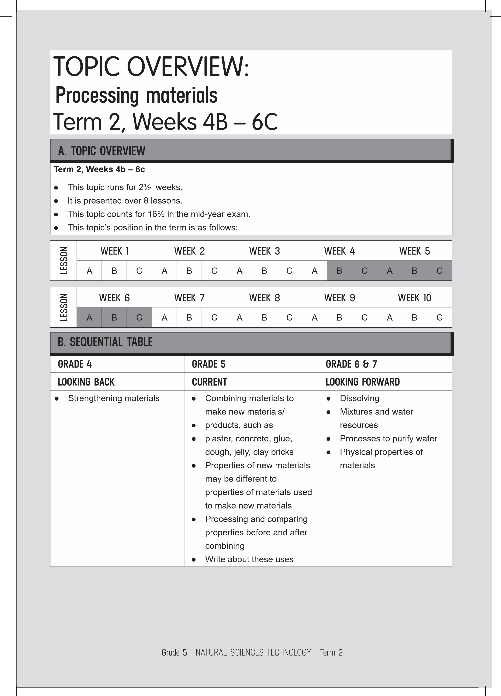
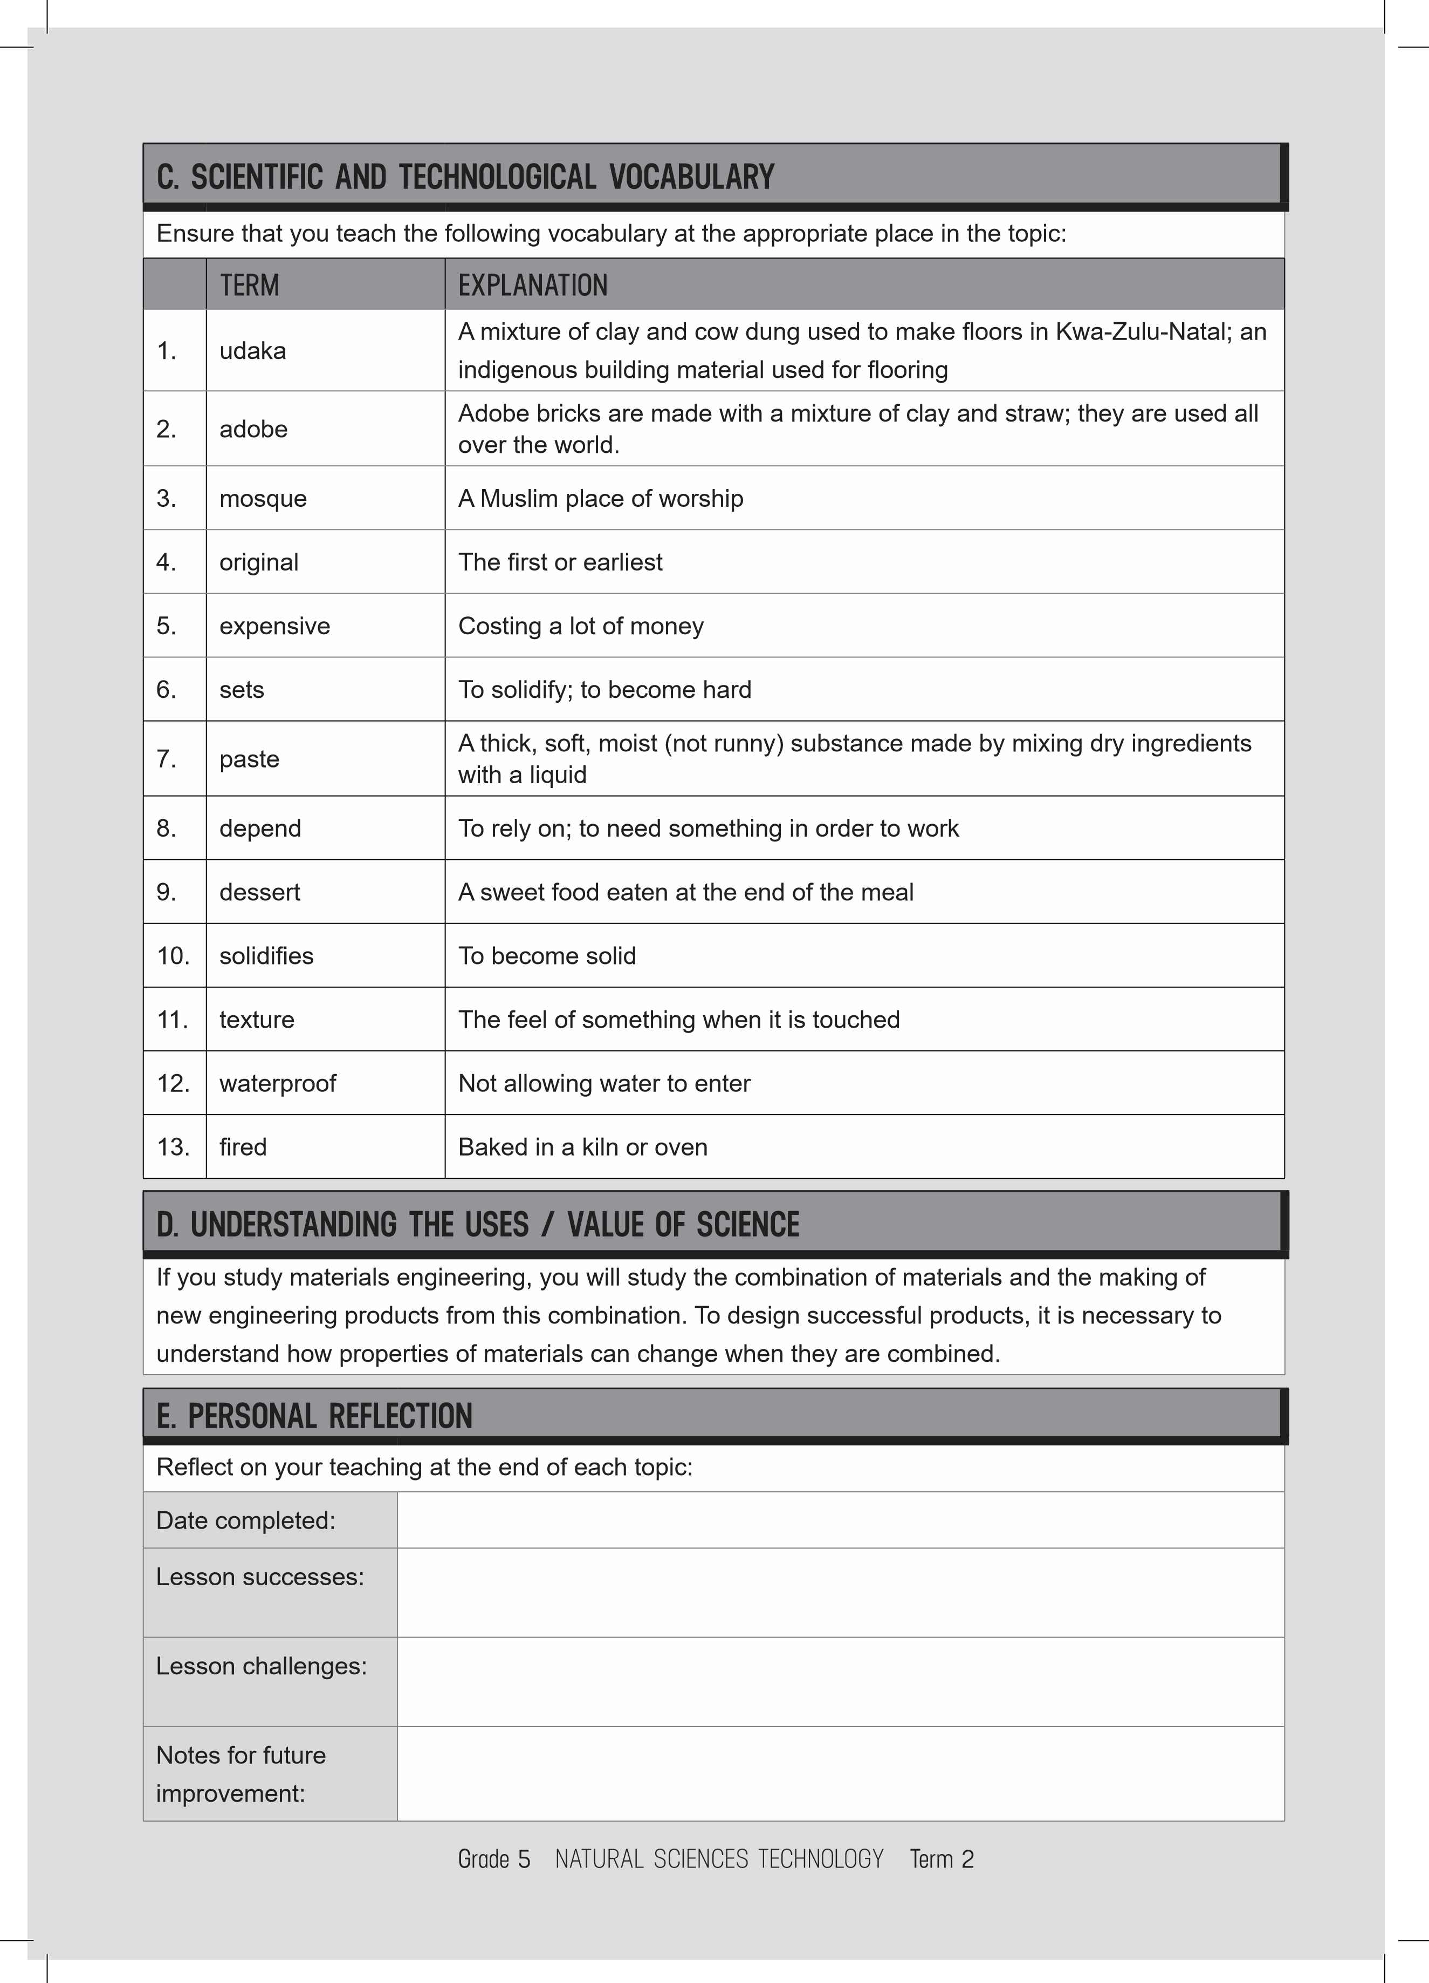
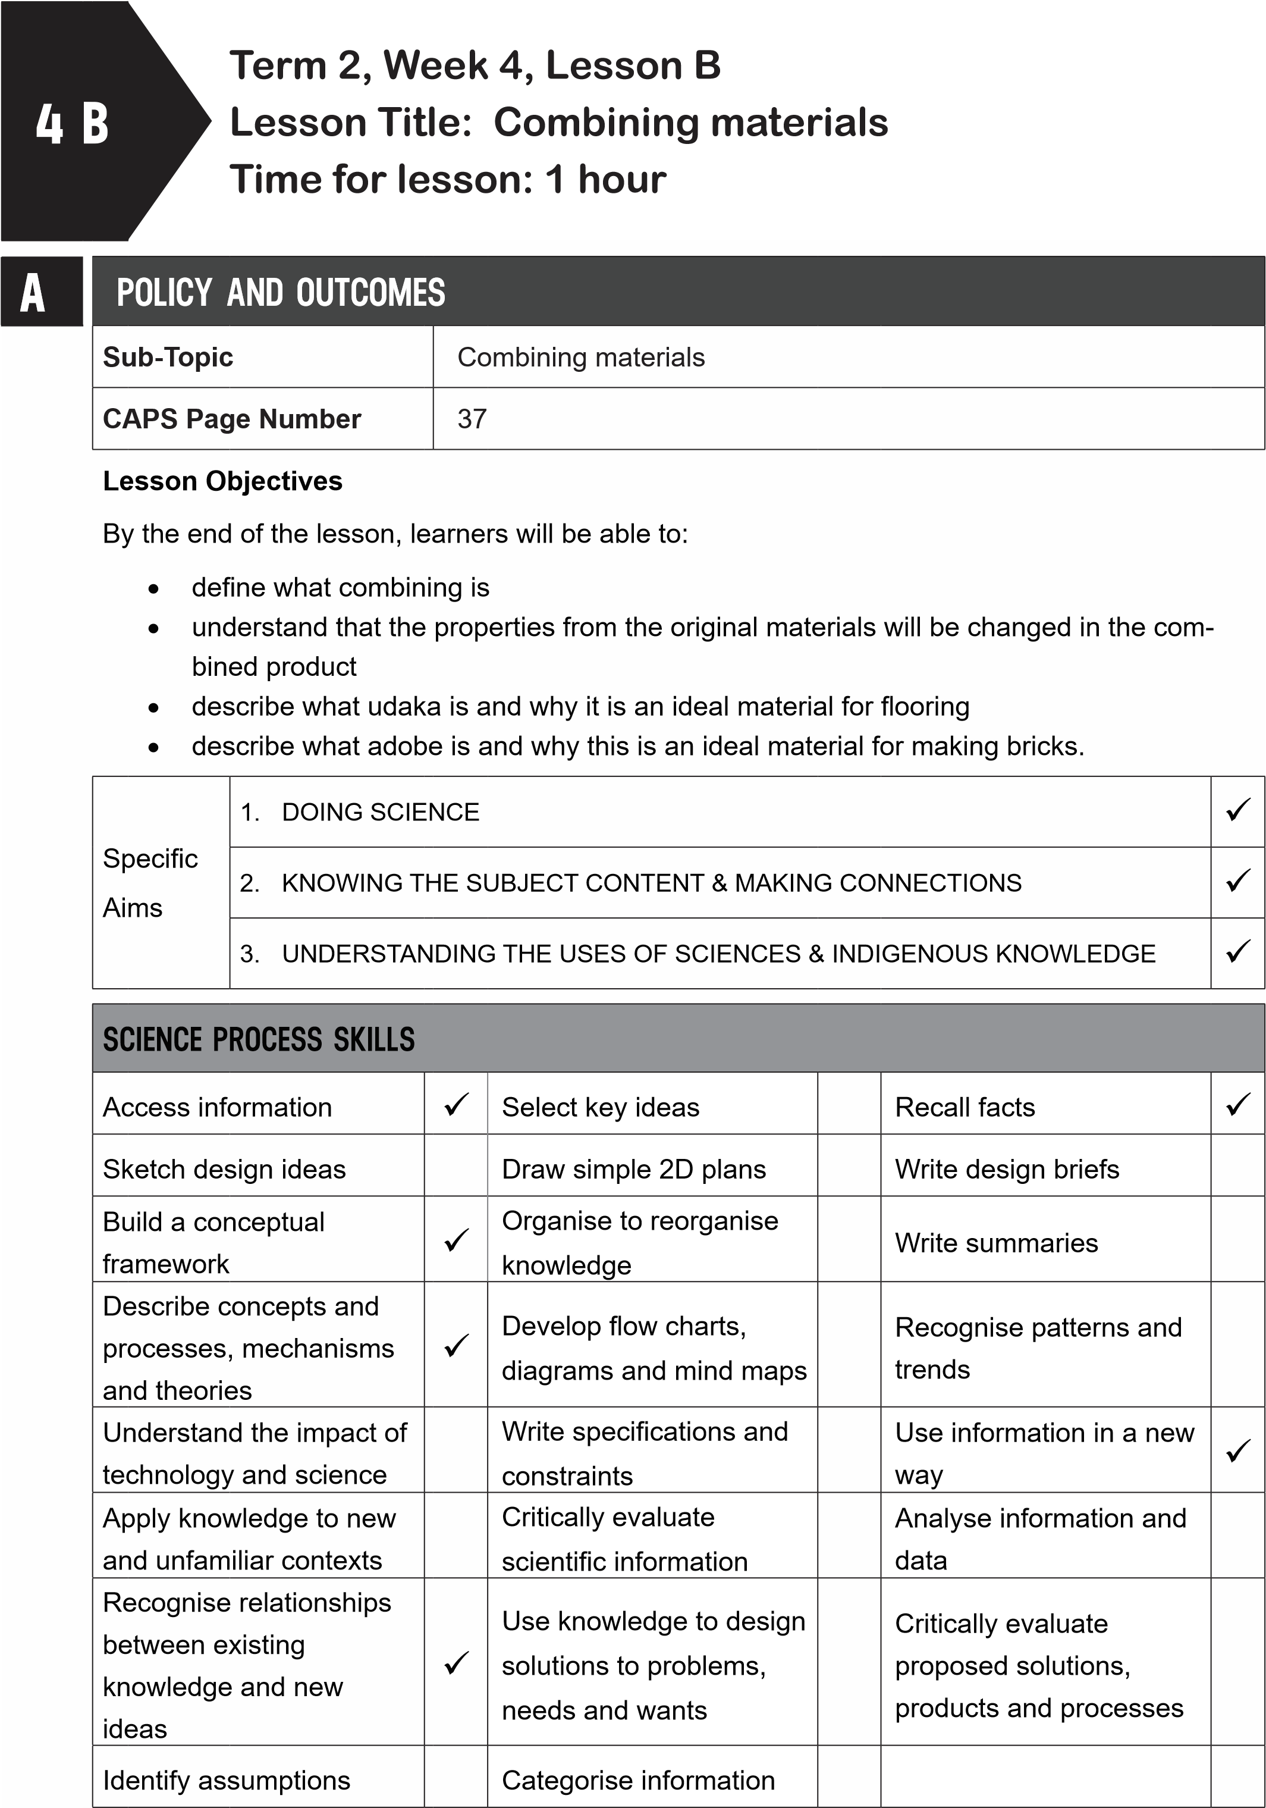

B
POSSIBLE RESOURCES
For this lesson, you will need:
IDEAL RESOURCES
IMPROVISED RESOURCES
Resource Page 21: The mosque at Djenne,
Mali
Resource Page 22: Making adobe bricks in
Peru, South America
C | CLASSROOM MANAGEMENT
- Make sure that you are ready and prepared.
- Write the following question onto the chalkboard before the lesson starts:
 | Can you name a metal that rusts?
- Learners should enter the classroom and answer the question in their workbooks.
- Discuss the answer with the learners.
- Write the model answer onto the chalkboard.
Iron (or steel) rusts.
D
ACCESSING INFORMATION
1. Write the following onto the chalkboard (always try to do this before the lesson starts):
COMBINING MATERIALS
- People sometimes need a material with certain properties.
- Manufacturers and engineers, among others, can make a new material by combining materials in different ways.
- This method produces a new type of material or a product.
- This new material or product can have different properties from the original materials.
- Bread is different from all the ingredients combined to make it.
- Explain this to the learners as follows:
  - Combining is one method of changing materials.
  - Other methods are heating, drying and cooling.
  - When materials are combined to make a new material or product, the properties of the new product may be different to the original materials.
  - Bread is made from flour, yeast, sugar, salt and oil.
  - Bread has different properties from the ingredients used to make it.
- Give learners time to copy this information into their workbooks.

Checkpoint 1
Ask learners the following questions to check their understanding at this point:
- Is the following statement true or false: ‘Combining is a method used to make new materials and products’?
- Is the following statement true or false: ‘The properties of the new material or product will be the same as the materials used to make it’?
Answers to the checkpoint questions are as follows:
- True.
- False: the new material or product may have different properties from the materials used to make it.
E | CONCEPTUAL DEVELOPMENT
 | 1. Write the following onto the chalkboard (always try to do this before the lesson starts):
INDIGENOUS BUILDING MATERIALS: UDAKA AND ADOBE
- In rural KwaZulu-Natal, houses are built using local materials.
- The floor of the home is often made of udaka.
- Udaka is a mixture of clay and cattle dung.
- The grass fibres in the cattle dung bind the clay.
- This makes a material that is ideal for floors.
- The cattle dung also keeps mosquitoes away.
- Using plant fibres to bind clay has been used by many cultures for many centuries.
- Adobe bricks are found in many structures and these bricks are still used today.
- The mosque in Djenne, Mali, is over 500 years old.
- It was made with adobe bricks.
- Adobe is a mixture of clay and straw that is then baked in the sun.
- Udaka and adobe are materials made by combining other materials.
2. Explain udaka to the learners as follows:
- Indigenous peoples use local materials to make their homes.
- Udaka makes an ideal combined material which can be used to make flooring.
- Udaka uses local materials and so is easy to make.
- It lasts for a long time.
- It is easy to use and is not expensive.
- It is also environmentally friendly.
- Udaka is an ideal combined material which can be used for flooring.
- Explain adobe bricks to the learners as follows:
  - Adobe bricks have been used all over the world for centuries.
  - Adobe is a combination of clay and straw mixed together.
  - When heated in the sun, it makes bricks for building houses.
  - Adobe bricks last for a long time.
  - It is not expensive and is environmentally friendly.
  - It uses local materials and lasts for a long time.
  - Show learners Resource Page 21: ‘The mosque at Djenne, Mali’.
  - This huge structure is made from adobe bricks and is over 500 years old.
  - Show learners Resource Page 22: ‘Making adobe bricks in Peru, South America’.
  - People all over the world make adobe bricks.
- Give learners time to copy the information into their workbooks.
Checkpoint 2
Ask the learners the following questions to check their understanding at this point:
- What materials are combined to make udaka for flooring?
- What materials are combined to make adobe bricks?
Answers to the checkpoint questions are as follows:
- Udaka is a combination of cow dung and clay.
- Adobe is a combination of clay and straw.
- Discuss and explain the information to the learners.
- Ask the learners if they have any questions and provide answers and explanations.

F | REFERENCE POINTS FOR FURTHER DEVELOPMENT
 | If you need additional information or activities on this topic, you can find these in your textbook on the following pages:
 | NAME OF TEXTBOOK | TOPIC | PAGE NUMBER
 | Study & Master | Processing materials | 87
 | Viva | Processing materials | 75-78
 | Platinum | Processing materials | 85
 | Solutions for All | Processing materials | 95-97
 | Day-by-Day | Processing materials | 77
 | Oxford | Processing materials | 62
 | Spot On | Processing materials | 38-39
 | Top Class | Processing materials | 57-58
 | Sasol Inzalo Bk A | Processing materials | 173-174
G | ADDITIONAL ACTIVITIES/ READING
In addition, further reading, listening or viewing activities related to this sub-topic are available through the following web links:
N/A
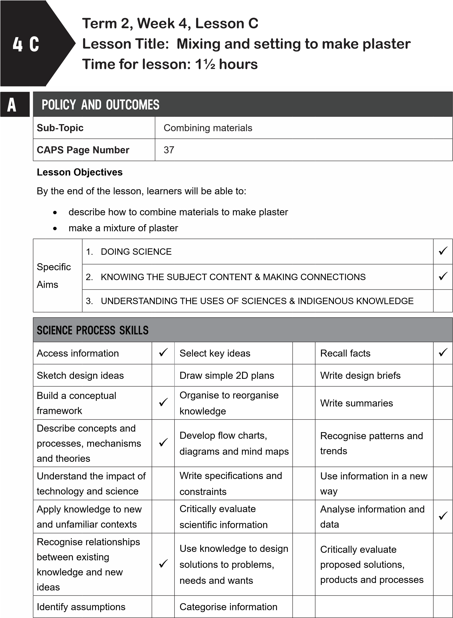
B | POSSIBLE RESOURCES
 | For this lesson, you will need:
 | IDEAL RESOURCES | IMPROVISED RESOURCES
 | paper cup, plastic spoon, 125 ml (1/2 cup), warm water, 62,5 ml (1/4 cup) plaster of Paris powder, newspaper | empty yoghurt tub stick polyfilla
 | Resource Page 23: Plaster of Paris
C | CLASSROOM MANAGEMENT
- Make sure that you are ready and prepared.
- Write the following question onto the chalkboard before the lesson starts:
 | Will a combined material have the same properties as the materials that were used to make it?
- Learners should enter the classroom and answer the question in their workbooks.
- Discuss the answer with the learners.
- Write the model answer onto the chalkboard.
No, it will not.
D |  | ACCESSING INFORMATION
- Write the following onto the chalkboard (always try to do this before the lesson starts):
MIXING AND SETTING: MAKING PLASTER
- Mixing a solid and a liquid and leaving it to set will give a material different properties from the original materials.
- A mixture sets when it is left to become hard.
- The properties of the new material will depend on how much of each type of material is in the mixture.
- Look carefully during the mixing process to get the mixture that is needed.
- Plaster is made by mixing a solid and a liquid.
- Plaster of Paris is made by mixing gypsum with water.
- Gypsum is mined from rocks.
- It is a white powdery substance that becomes a soft, malleable paste when mixed with water.
- When this mixture sets, it becomes hard and strong.
- Plaster of Paris is used as a mould to fix broken bones.
- To make ornaments, Plaster of Paris is placed in a mould and allowed to dry and become hard.
- Polyfilla is just like Plaster of Paris.
- It is used to fill up cracks in walls.
- Explain this to the learners as follows:
  - New materials are made when a mixture sets after it has been mixed.
  - The new material has different properties to the original materials.
  - Plaster of Paris is a soft, white powder.
  - When it is mixed with water and left to set, it becomes hard.
  - It is used to make casts to fix broken bones.
  - Show learners Resource Page 23: Plaster of Paris.
  - The photograph on the left shows what gypsum looks like.
  - Polyfilla is similar.
  - Polyfilla is used to fill in cracks in walls.
- Give learners time to copy this information into their workbooks.
Checkpoint 1
Ask learners the following questions to check their understanding at this point:
- What does ‘to set’ mean?
- Is the following statement true or false: The properties of the new mixture will depend on how much of each type of material is used in the mixture?
Answers to the checkpoint questions are as follows:
a. ‘To set’ means that when a solid and liquid have been mixed together and the mixture has been left for a while, the mixture becomes hard. b. True.
E | CONCEPTUAL DEVELOPMENT
- Write the following on the chalkboard (always try to do this before the lesson starts):
- Choose one of the activities. If you are unable to get plaster of Paris, then do the Polyfilla activity.
ACTIVITY: MIXING AND SETTING TO MAKE PLASTER
PLASTER OF PARIS
You will need: paper cup or empty yoghurt tub plastic spoon or a stick
125 ml (1/2 cup) warm water
62,5 ml (1/4 cup) plaster of Paris powder newspaper.
METHOD
- Observe and record the properties of each material.
- Lay newspaper over workspace.
- Put plaster of Paris in paper cup.
- Slowly add warm water stirring all the time with the plastic spoon.
- Add enough water until it is runny.
- Allow the mixture to set.
- Observe and record properties of the new material.
ACTIVITY: MIXING AND SETTING TO MAKE PLASTER
POLYFILLA
You will need: paper cup or yoghurt tub plastic spoon or stick
125 ml warm water
62.5 ml Polyfilla
METHOD
- Lay newspaper over workspace.
- Put Polyfilla in paper cup.
- Slowly add warm water stirring all the time with the plastic spoon.
- Add enough water until it is a paste.
- Allow the mixture to set.
Table for observations
Material | Properties
plaster of Paris/Polyfilla
water
new material

- Explain this to the learners as follows:
  - Mixing different materials and leaving the mixture to set gives the material different properties.
  - These properties are different to the properties of water and plaster of Paris or Polyfilla.
  - The new material cannot be separated back into the original materials.
  - This new material changes properties when it sets.
- A model answer:
Table for observations
Material | Properties
plaster of Paris/Polyfilla | white, powdery, a solid, soft
water | wet, liquid, can pour, fills the container it is placed in
new material | hard when set – malleable before it sets, solid, white

- Write the following on the chalkboard (always try to do this before the lesson starts):
TASK: QUESTION
How do you know that after the mixture has set, that there is a new material?
- Explain this to the learners as follows:
  - Write down the answer to the question in their workbooks.
  - Discuss their answers with a partner.
  - Ask some learners to discuss their answers. The new material will have different properties to the original properties.
  - Have a discussion on how new materials are formed when a solid and liquid are mixed and then set.
  - Ask learners what would happen if each material was not carefully measured to make the plaster? It could end up being too runny or too solid and not be suitable for its job
(making a cast for a broken bone, filling cracks in a wall)
Checkpoint 2
Ask the learners the following questions to check their understanding at this point:
- What are the properties of plaster of Paris/Polyfilla?
- What are the properties of the material when plaster of Paris/Polyfilla has been mixed with water?
Answers to the checkpoint questions are as follows:
- Plaster of Paris/Polyfilla is white, powdery, soft and a solid.
- The properties of the new material is that it is hard, solid and white.
- Ask the learners if they have any questions and provide answers and explanations.

F | REFERENCE POINTS FOR FURTHER DEVELOPMENT
 | If you need additional information or activities on this topic, you can find these in your textbook on the following pages:
 | NAME OF TEXTBOOK | TOPIC | PAGE NUMBER
 | Study & Master | Processing materials | 87-89
 | Viva | Processing materials | -
 | Platinum | Processing materials | 87-88
 | Solutions for All | Processing materials | 98-99
 | Day-by-Day | Processing materials | 78-79
 | Oxford | Processing materials | 63
 | Spot On | Processing materials | -
 | Top Class | Processing materials | 58-59
 | Sasol Inzalo Bk A | Processing materials | 165-166
G | ADDITIONAL ACTIVITIES/ READING
In addition, further reading, listening or viewing activities related to this sub-topic are available through the following web links:
- https://goo.gl/bk8TxF [Combining materials]
- http://scienceweb.asta.edu.au/years-f-2/unit3/lesson-two/yrf2-unit-3-lesson-2.html [Mixing things together]
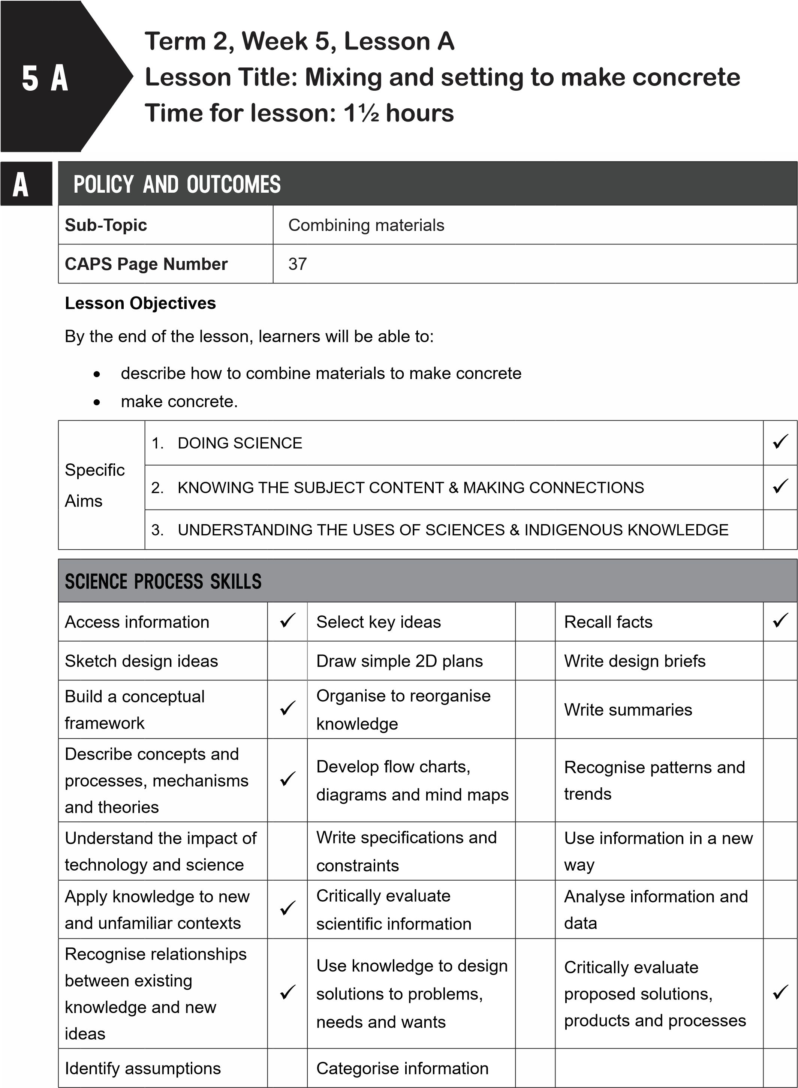
B | POSSIBLE RESOURCES
 | For this lesson, you will need:
 | IDEAL RESOURCES | IMPROVISED RESOURCES
 | Resource Page 24: Making concrete in a mixer
 | One cup cement, three cups of clean sand, three cups of gravel or small stones, water, an empty container, a strong stick, plastic gloves | An ice-cream or margarine tub
C | CLASSROOM MANAGEMENT
- Make sure that you are ready and prepared.
- Write the following question onto the chalkboard before the lesson starts:
 | Is the following statement true or false: Plaster is made from mixing a liquid with another liquid?
- Learners should enter the classroom and answer the question in their workbooks.
- Discuss the answer with the learners.
- Write the model answer onto the chalkboard.
False: Plaster is made from mixing a powdery solid with a liquid.
D
ACCESSING INFORMATION
1. Write the following onto the chalkboard (always try to do this before the lesson starts):
MIXING AND SETTING: MAKING CONCRETE
- Concrete is another material made from combining materials and leaving the mixture to set.
- Concrete is made from a mixture of sand, gravel, cement and water.
- The cement, gravel and sand are mixed in the ratio of 1:3:3.
- This means 1 part of cement to 3 parts of gravel to 3 parts of sand.
- After these materials are mixed, water is added.
- When water is added, it makes the cement stick the sand and gravel together.
- Concrete is very strong, hard, lasts a long time and is waterproof.
- Concrete is used in buildings, silos, water pipes and other structures.
- When combined with iron, it is used to make skyscrapers.
- Concrete was first used approximately 7500 years ago.
- Explain and discuss the following with the learners:
  - Concrete is a mixture of sand, gravel, cement and water.
  - It needs to be mixed in the ratio of 1 part of cement to 3 parts of gravel to 3 parts of sand.
  - Structures have purposes.
  - Two of these purposes are that they support something, or that they contain and protect something.
  - Structures can be found in the natural world and the human-made world.
  - Structures need to be strong enough to support something otherwise they will collapse.
  - Structures need to be stable which means they will not fall over easily.
- Give learners time to copy this information into their workbooks.
Checkpoint 1
Ask learners the following questions to check their understanding at this point:
- What four ingredients do you need to make concrete?
- Is concrete a modern material?
Answers to the checkpoint questions are as follows:
- You need cement, gravel, sand and water.
- No, concrete was used approximately 7500 years ago.
E | CONCEPTUAL DEVELOPMENT
 | 1. Write the following onto the chalkboard (always try to do this before the lesson starts):
ACTIVITY: MIXING AND SETTING CONCRETE – MAKE A BRICK
You will need:
one cup of cement three cups of clean sand three cups of gravel or small stones water an empty container (ice-cream or margarine tub) a strong stick plastic gloves.
METHOD
- Mix the cement, sand and gravel together in the container.
- Slowly add water to the mixture.
- Stir the mixture with the stick.
- Add enough water so that the mixture is wet but not watery.
- Using gloves, press the mixture down in the container.
  - Leave the brick to set.
  - When the mixture has set, turn the container upside down.
  - Tap out the brick.
- Explain this to the learners as follows:
  - This will be a teacher-led activity.
  - A few learners could assist with the activity.
  - If the brick is not strong and has cracks, ask the learners what could be done differently.
  - Sometimes stronger concrete can be made by adding less water.
  - Adding more water will make concrete that can flow easily into different shapes or moulds.
- Copy and complete the table:
TABLE TO COMPARE THE PROPERTIES
 | Materials used to make new material |  |  |  | New material
 | cement | stone | sand | water | concrete
Description
(hard, soft, smooth, rough, strong, weak, powdery, dry, wet)
- Which materials have the same properties as the concrete brick?
- Which materials had their properties changed during the process?
- Explain this to the learners as follows:
  - Fill in all the properties of each of the materials and the new material (concrete).
  - Answer the two questions in their workbooks.
  - Let learners compare their answers with a partner.
  - Ask a few learners to share their answers with the class.
- A model answer (answers may vary slightly):

TABLE TO COMPARE THE PROPERTIES
 | Materials used to make new material |  |  |  | New material
 | cement | stone | sand | water | concrete
Description  (hard, soft, smooth, rough, strong, weak, powdery, dry, wet) | soft, powdery, weak, dry | hard, rough, strong, dry | hard, rough, strong, dry | soft, smooth, wet | hard, rough, strong, dry
- The sand and the stone have the same properties as the concrete brick.
- The cement and water would have had their properties changed during the process.
Checkpoint 2
Ask the learners the following questions to check their understanding at this point:
- Which of the following ingredients changed their properties when mixed: cement, stone, sand, water?
- What can you do to make concrete stronger?
Answers to the checkpoint questions are as follows:
- Cement and water had their properties changed.
- To make concrete stronger, add less water.

F | REFERENCE POINTS FOR FURTHER DEVELOPMENT
 | If you need additional information or activities on this topic, you can find these in your textbook on the following pages:
 | NAME OF TEXTBOOK | TOPIC | PAGE NUMBER
 | Study & Master | Processing materials | 89-92
 | Viva | Processing materials | 77-82
 | Platinum | Processing materials | -
 | Solutions for All | Processing materials | 99
 | Day-by-Day | Processing materials | 79-80
 | Oxford | Processing materials | 63
 | Spot On | Processing materials | -
 | Top Class | Processing materials | -
 | Sasol Inzalo Bk A | Processing materials | 171-175
G | ADDITIONAL ACTIVITIES/ READING
In addition, further reading, listening or viewing activities related to this sub-topic are available through the following web links:
1. http://www.tomnewbyschool.co.za/wp-content/upload /2016/04/Grd-5-NS-Tech-T2-
2016-approved.pdf [Processing materials]
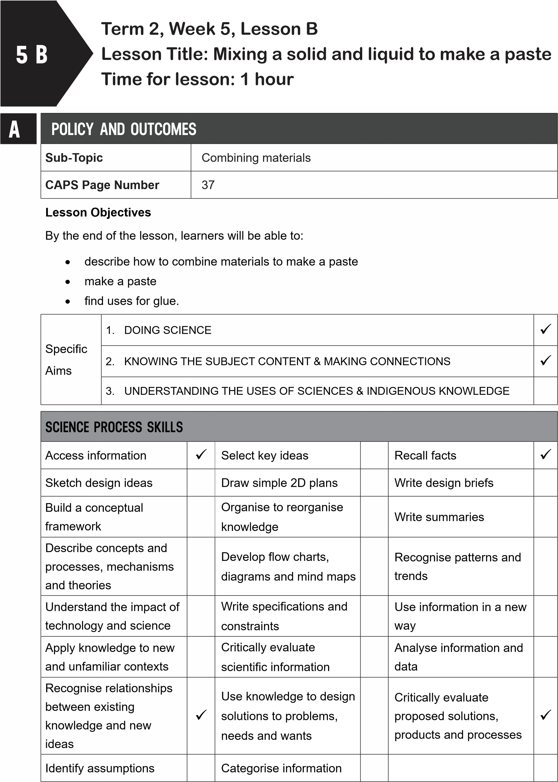
B | POSSIBLE RESOURCES
 | For this lesson, you will need:
 | IDEAL RESOURCES | IMPROVISED RESOURCES
 | One tablespoon of flour, one cup of water, a mixing bowl, a spoon, two pieces of paper, newspaper
CLASSROOM MANAGEMENT
- Make sure that you are ready and prepared.
- Write the following question onto the chalkboard before the lesson starts:
Can you list the four ingredients used to make concrete?
- Learners should enter the classroom and answer the question in their workbooks.
- Discuss the answer with the learners.
- Write the model answer onto the chalkboard.
Cement, sand, gravel and water are mixed to make concrete.
D
C
ACCESSING INFORMATION
1. Write the following onto the chalkboard (always try to do this before the lesson starts):
MIXING A SOLID AND A LIQUID TO MAKE A PASTE
- When we mix a little water with a powdery solid, we get a paste.
- A paste is a stiff mixture of a powdery solid and a liquid.
- When a little water is mixed with flour, it will become a sticky paste that can be used as glue.
- The properties of the paste will be different to the properties of the flour and the water. .
- Explain and discuss the following with the learners:
  - Mixing a powdery solid and a liquid will make a paste.
  - Toothpaste is a paste.
- Give learners time to copy this information into their workbooks.

Checkpoint 1
Ask the learners the following questions to check their understanding at this point: a. What makes a paste?
b. What two ingredients do you need to make a paste that can be used as glue?
Answers to the checkpoint questions are as follows:
- A powdery solid and a liquid make a paste.
- b. Flour and water can be made into a paste that can be used as glue.
E | CONCEPTUAL DEVELOPMENT
 | 1. Write the following onto the chalkboard (always try to do this before the lesson starts):
ACTIVITY: HOW TO MAKE GLUE
You will need: one tablespoon of flour one cup of water a mixing bowl a spoon
two pieces of paper newspaper.
METHOD
- Place the newspaper on your desk.
- Put the flour in the mixing bowl.
- Add a little bit of water – a teaspoonful.
- Mix the flour with the water.
- Keep adding teaspoonfuls of water until the mixture is a runny paste.
- Put a few drops of the paste onto one piece of paper.
- Place the other piece of paper over the first piece and press together.
- Leave to dry.
- Tidy up your workspace.
QUESTIONS
- Can you describe the properties of the original materials?
- Can you describe the properties of water?
- Can you describe the properties of the new material (glue)?
- Why is glue useful?
- Explain this to the learners as follows:
  - Learners will work in groups for this activity.
  - Gather all the materials together.
  - Add small drops of water at a time to the flour.
  - Do not make the mixture too runny.
- A model answer:
HOW TO MAKE GLUE
- Properties of flour: dry, soft, powdery, a solid
- Properties of water: wet, soft, a liquid
- Properties of new material: sticky, a paste, malleable
- Glue is useful as it can fix broken things and it can stick things together.
Checkpoint 2
Ask the learners the following questions to check their understanding at this point:
- What are the properties of the paste made from flour and water?
- What can this paste be used for?
Answers to the checkpoint questions are as follows:
- This paste is sticky and malleable.
- This paste can be used to glue things together.
- Ask the learners if they have any questions and provide answers and explanations.

F | REFERENCE POINTS FOR FURTHER DEVELOPMENT
 | If you need additional information or activities on this topic, you can find these in your textbook on the following pages:
 | NAME OF TEXTBOOK | TOPIC | PAGE NUMBER
 | Study & Master | Processing materials | 92-93
 | Viva | Processing materials | -
 | Platinum | Processing materials | 88
 | Solutions for All | Processing materials | 100-101
 | Day-by-Day | Processing materials | 78-79
 | Oxford | Processing materials | 65
 | Spot On | Processing materials | 40-41
 | Top Class | Processing materials | 59-69
 | Sasol Inzalo Bk A | Processing materials | -
G | ADDITIONAL ACTIVITIES/ READING
In addition, further reading, listening or viewing activities related to this sub-topic are available through the following web links:
- https://goo.gl/RZ7xfw [Home-made glue and paste recipes]
- https://goo.gl/if7p7W (2min 13sec) [How to make your own glue]
- https://goo.gl/KMxAXj ((52sec) [How do you make glue?]
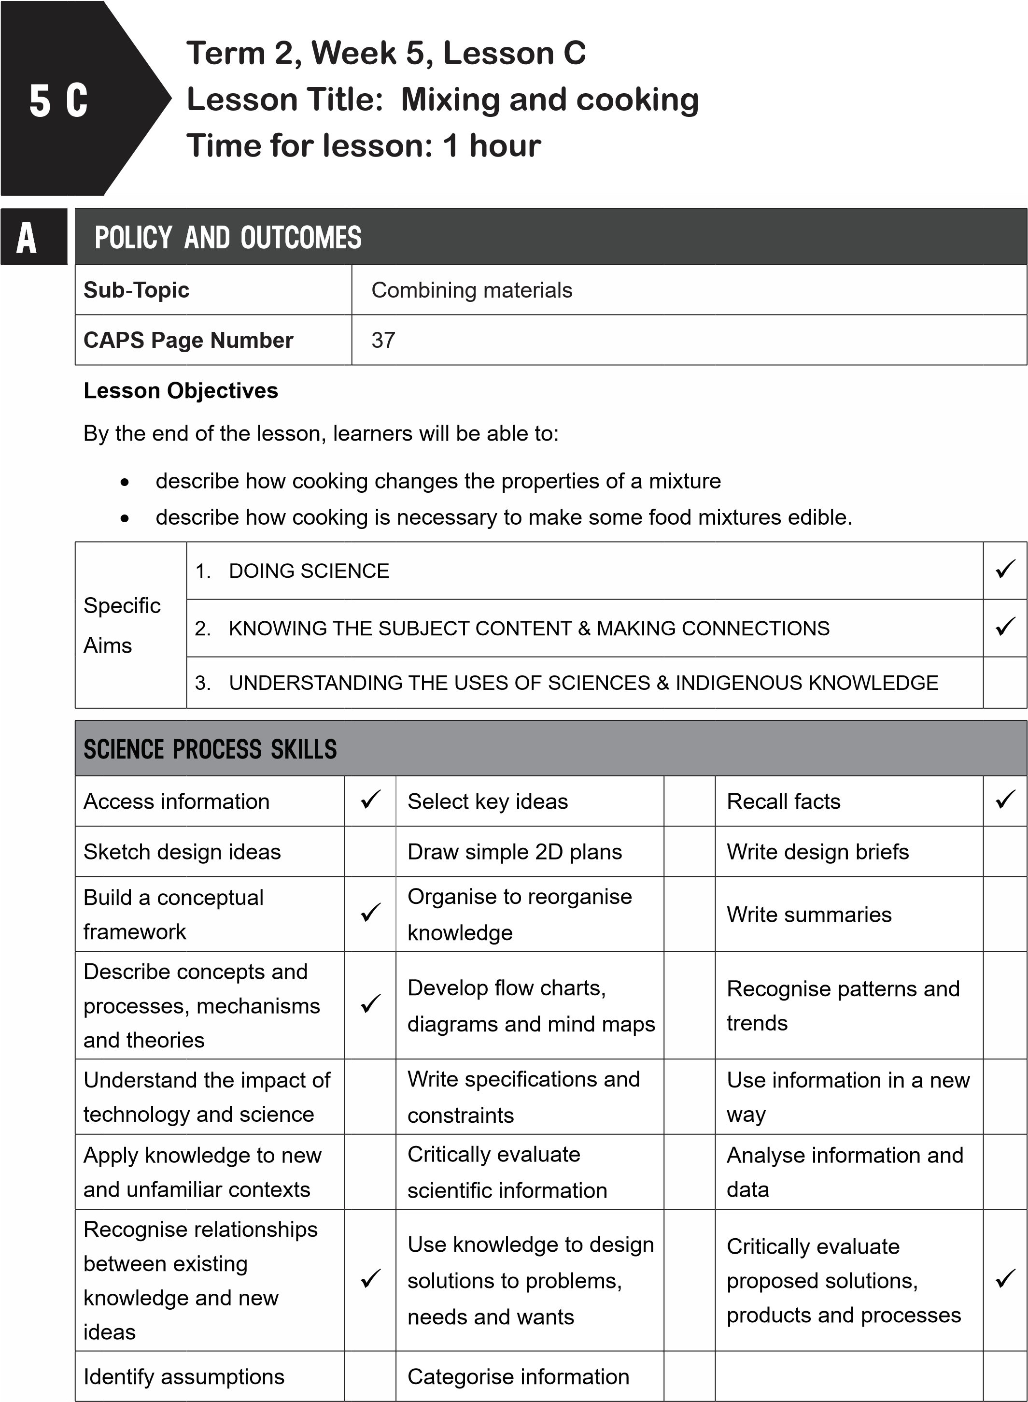
B | POSSIBLE RESOURCES
 | For this lesson, you will need:
 | IDEAL RESOURCES | IMPROVISED RESOURCES
 | Maize meal, salt, a teaspoon, water, a bowl, a pot, source of heat,
CLASSROOM MANAGEMENT
- Make sure that you are ready and prepared.
- Write the following question onto the chalkboard before the lesson starts:
What is a paste?
- Learners should enter the classroom and answer the question in their workbooks.
- Discuss the answer with the learners.
- Write the model answer onto the chalkboard.
D
A paste is a mixture of a powdery solid and a liquid.
C
ACCESSING INFORMATION
1. Write the following onto the chalkboard (always try to do this before the lesson starts):
MIXING AND COOKING
- Some mixtures need heat so that they can change into edible products.
- Cooking means heating.
- When an egg is cooked, the properties of the egg change.
- The runny egg yolk becomes firmer and lighter.
- The white of the egg solidifies and the clear colour turns white.
- The white of the egg becomes rubbery.
- Explain this to the learners as follows:
  - Some food is made edible when it is cooked.
  - When mielies ripen, their seeds become hard.
  - These seeds are ground and made into maize meal.
  - The maize meal is then cooked to make porridge.
  - Many foods are cooked to change their properties and to make them easier to digest.
- Give learners time to copy this information into their workbooks.
Checkpoint 1
Ask the learners the following questions to check their understanding at this point:
- What happens to egg white when it is cooked?
- Why do we cook food?
Answers to the checkpoint questions are as follows:
- The egg white turns white and becomes rubbery when cooked.
- Cooking food makes food more edible and easier to digest.
E | CONCEPTUAL DEVELOPMENT
- Write the following onto the chalkboard (always try to do this before on the chalkboard):
ACTIVITY: MIXING AND COOKING
You will need: maize meal
salt
a teaspoon water a bowl
METHOD
- Gather the solid items in the list.
- Taste the maize meal and the salt by putting a small amount in your hand.
- Write down in the table what each of these tastes like. Also write down the colour and the texture (what it feels like) of the maize meal and the salt.
Property | Mielie meal | Salt
Taste (sweet, salty, bitter, sour, no taste)
Colour
Texture (smooth, rough, fine, coarse, soft, hard)
- Write a few sentences in which you describe the properties of cooked maize meal.
- Which properties of the maize meal stayed the same through the cooking process?
- Explain this to the learners as follows:
  - Learners must copy and complete the table in their workbooks.
  - Learners will first taste the original solid materials used to make maize meal.
  - Cook the maize meal and allow the learners to taste and touch it.
  - Learners must then taste cooked maize meal.
  - Learners must compare the properties of the original materials with the new material.
- A model answer:
ACTIVITY: MIXING AND COOKING
Property | Mielie meal | Salt
Taste (sweet, salty, bitter, sour, no taste) | not much taste | salty
Colour | yellowy white | white
Texture (smooth, rough, fine, coarse, soft, hard) | slightly rough | coarse
- Write a few sentences in which you describe the properties of cooked maize meal.
- Which properties of the maize meal stayed the same through the cooking process?
Checkpoint 2
Ask the learners the following questions to check their understanding at this point:
- What does cooking mean?
- What does ‘texture’ mean?
Answers to the checkpoint questions are as follows:
- Cooking means that food is heated to change its properties and to make it more edible.
- Texture describes how a material feels when you touch it.
- Ask the learners if they have any questions and provide answers and explanations.

F | REFERENCE POINTS FOR FURTHER DEVELOPMENT
 | If you need additional information or activities on this topic, you can find these in your textbook on the following pages:
 | NAME OF TEXTBOOK | TOPIC | PAGE NUMBER
 | Study & Master | Processing materials | 93-95
 | Viva | Processing materials | -
 | Platinum | Processing materials | 89
 | Solutions for All | Processing materials | 104-106
 | Day-by-Day | Processing materials | 82
 | Oxford | Processing materials | 64
 | Spot On | Processing materials | -
 | Top Class | Processing materials | -
 | Sasol Inzalo BkA | Processing materials | 178-182
G | ADDITIONAL ACTIVITIES/ READING
In addition, further reading, listening or viewing activities related to this sub-topic are available through the following web links:
N/A
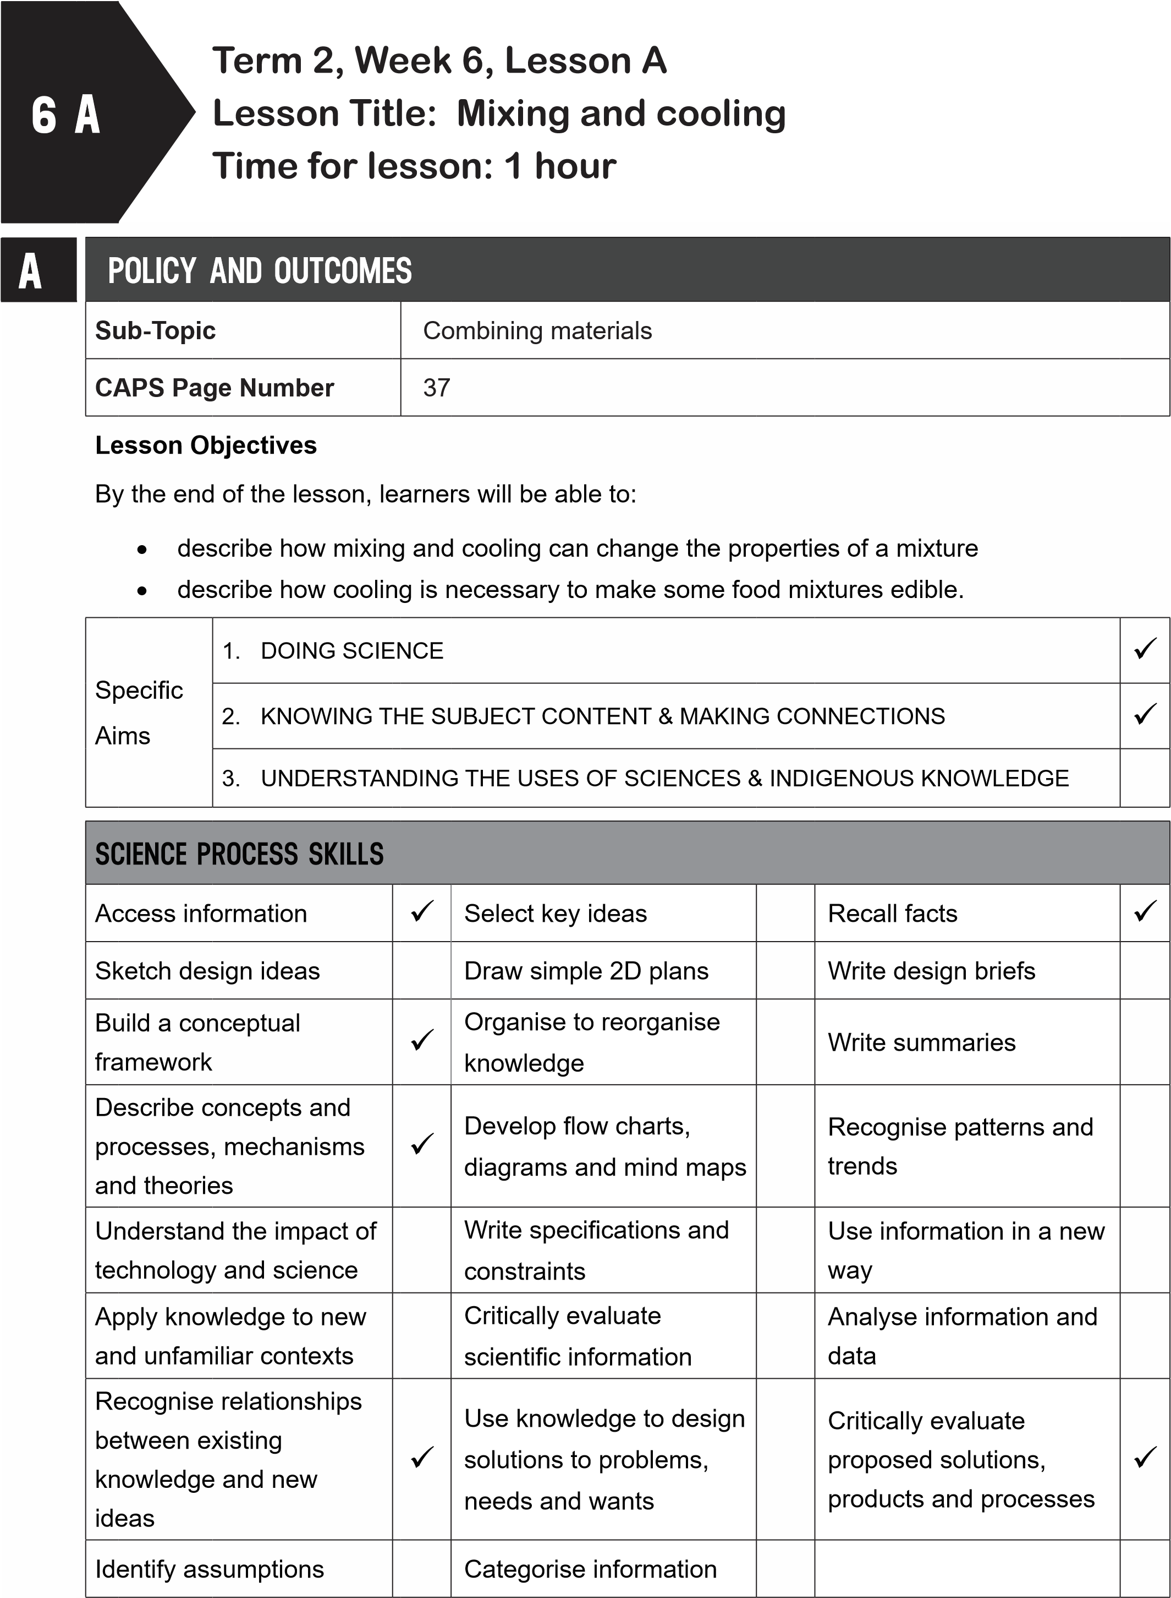
B | POSSIBLE RESOURCES
 | For this lesson, you will need:
 | IDEAL RESOURCES | IMPROVISED RESOURCES
 | A packet of jelly powder, one cup of boiling water, one cup of cold water, a mixing bowl, a spoon, a container to set the jelly
CLASSROOM MANAGEMENT
- Make sure that you are ready and prepared.
- Write the following question onto the chalkboard before the lesson starts:
What is cooking?
- Learners should enter the classroom and answer the question in their workbooks.
- Discuss the answer with the learners.
- Write the model answer onto the chalkboard.
Cooking is heating food to change its properties to make it more edible.
D
C
ACCESSING INFORMATION
1. Write the following onto the chalkboard (always try to do this before the lesson starts):
MIXING AND COOLING
- Cooling occurs when you remove the heat from something.
- Mixing and cooling are useful for cooking.
- Cooling changes the properties of the new material.
- When we need a food to set, it needs to cool.
- Many desserts are made this way.
- Explain and discuss the following with the learners:
  - Mixing and cooling are often used to make desserts.
  - Cream, milk and sugar can be mixed and cooled to make ice-cream.
  - The mixture needs to be put in the freezer.
- Give learners time to copy this information into their workbooks.

Checkpoint 1
Ask the learners the following questions to check their understanding at this point: a. What is cooling?
b. What type of food is often made with mixing and cooling?
Answers to the checkpoint questions are as follows:
- Cooling is removing the heat from something.
- Desserts are often made with mixing and cooling.
E | CONCEPTUAL DEVELOPMENT
1. Write the following onto the chalkboard (always try to do this before the lesson starts):
ACTIVITY: MIXING AND COOLING – MAKING JELLY
You will need:
a packet of jelly powder one cup of boiling water one cup of cold water a mixing bowl a spoon a container to set the jelly.
METHOD
- Put the jelly powder in the mixing bowl.
- Carefully add the boiling water.
- Stir well until all the jelly powder has dissolved.
- Add the cold water.
- Stir and pour the contents into the container.
- Leave to set in a fridge or cold place.
- This will take some time.
- Copy and complete the table below:
Compare properties of jelly powder and jelly
Property | jelly powder | jelly
Taste (sweet, salty, bitter, sour, no taste)
Colour
Texture (smooth, rough, fine, coarse, soft, hard)

9. Which properties stayed the same throughout the process?
- Explain this to the learners as follows:
  - This needs to be a teacher-led demonstration as there is boiling water involved.
  - Tell the learners to observe strict rules of safety when working with boiling water.
  - Make the jelly and leave it somewhere to set.
  - This will take a few hours.
  - Learners can copy the table into their workbooks and complete the table and Question 9 at a later stage.
- A model answer:
Compare properties of jelly powder and jelly
Property | jelly powder | jelly
Taste (sweet, salty, bitter, sour, no taste) | sweet | sweet
Colour | red | red
Texture (smooth, rough, fine, coarse, soft, hard) | coarse | smooth
9. The taste and the colour stayed the same throughout the process of mixing and cooling, but the texture changed completely. The texture went from being coarse and sugary to very smooth.
Checkpoint 2
Ask the learners the following questions to check their understanding at this point:
- When making jelly, which property changes during the process?
- What does ‘to set’ mean?
Answers to the checkpoint questions are as follows:
- The texture of the jelly powder and the jelly changes.
- ‘To set’ means that the mixture becomes solid.
- Ask the learners if they have any questions and provide answers and explanations.
F | REFERENCE POINTS FOR FURTHER DEVELOPMENT
If you need additional information or activities on this topic, you can find these in your textbook on the following pages:
NAME OF TEXTBOOK |  | TOPIC | PAGE NUMBER
Study & Master |  | Processing materials | 95-96
Viva |  | Processing materials | -
Platinum |  | Processing materials | 90
Solutions for All |  | Processing materials | 106-107
Day-by-Day |  | Processing materials | 85
Oxford |  | Processing materials | 64
Spot On |  | Processing materials | -
Top Class |  | Processing materials | -
Sasol Inzalo BkA |  | Processing materials | -
G | ADDITIONAL ACTIVITIES/ READING
In addition, further reading, listening or viewing activities related to this sub-topic are available through the following web links:
1. http://catsquared.com/further-processing-tools/ [Mixing, cooking and cooling]
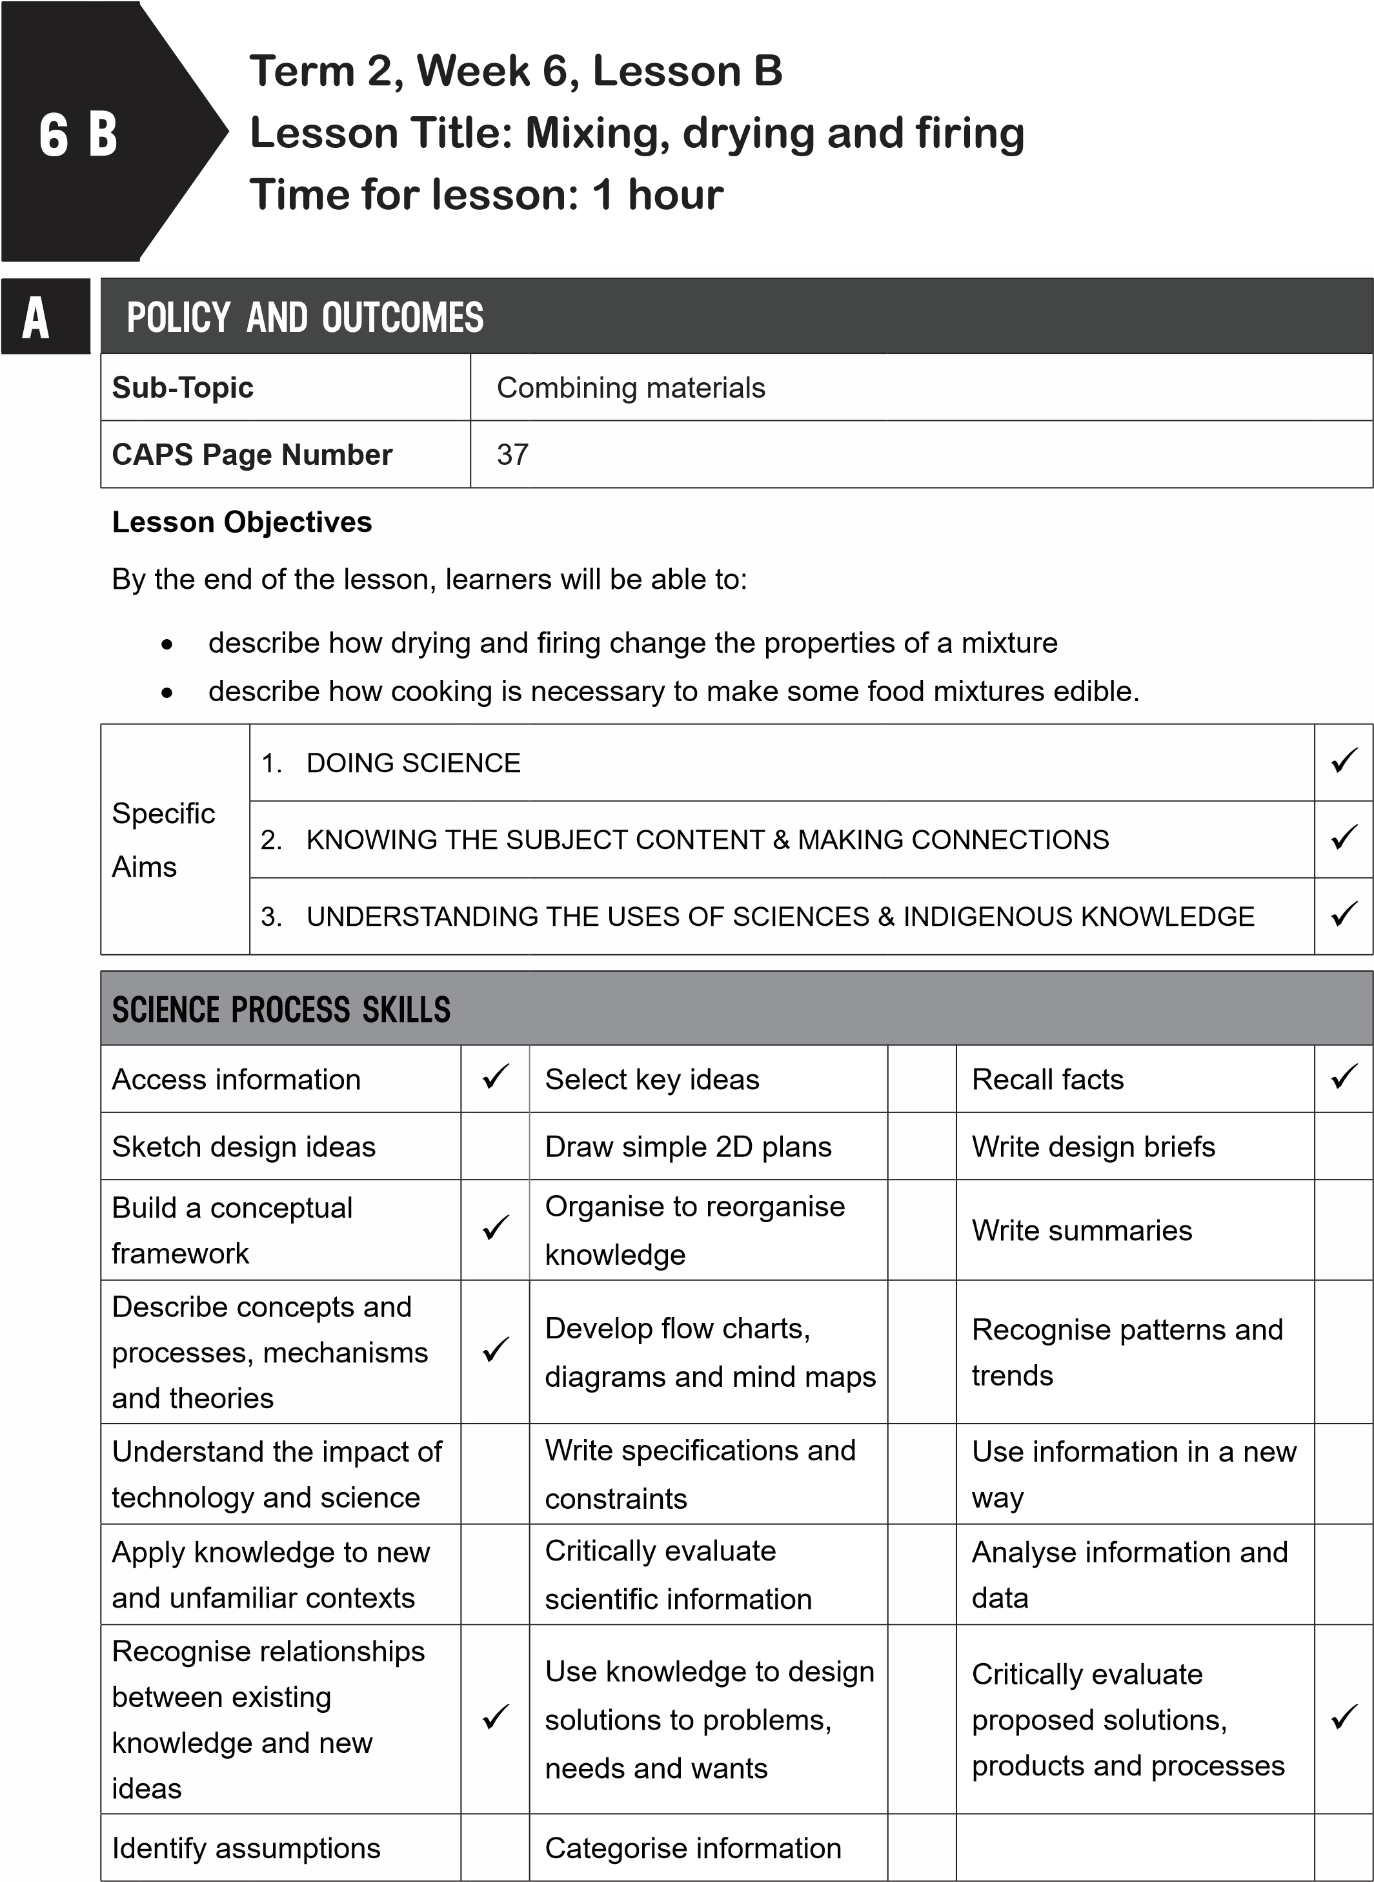
B | POSSIBLE RESOURCES
 | For this lesson, you will need:
 | IDEAL RESOURCES | IMPROVISED RESOURCES
Resource Page 21: The mosque at Djenne,
Mali
Resource Page 22: Making adobe bricks in
Peru, South America
 | Resource Page 25: Bricks | -
C | CLASSROOM MANAGEMENT
- Make sure that you are ready and prepared.
- Write the following question onto the chalkboard before the lesson starts:
 | What is cooling?
- Learners should enter the classroom and answer the question in their workbooks.
- Discuss the answer with the learners.
- Write the model answer onto the chalkboard.
Cooling is when you remove the heat from something.
D | ACCESSING INFORMATION
 | 1. Write the following onto the chalkboard (always try to do this before the lesson starts):
MIXING, DRYING AND FIRING
- Drying and firing are applied to materials like clay.
- Drying and firing are both ways of taking the water out of a mixture.
- This makes the mixture harder and stronger.
- Clay is made into bricks this way.
- Adobe bricks are made from a mixture of clay and straw.
- The straw makes the bricks stronger.
- The bricks are dried in the sun.
- In brick factories, bricks are put into a kiln.
- This is a big oven that bakes the bricks at a very high heat.
- This makes the bricks hard and waterproof.
- When clay fired, it changes the property of the clay.
- From being wet and malleable, the clay becomes hard, strong and waterproof.
- Explain the making of adobe bricks to the learners as follows:
  - Remind learners that in Lesson 4B, they learnt about adobe bricks.
  - These are clay and straw bricks that are dried in the sun.
  - Adobe bricks have been made for centuries by many cultures around the world.
  - Show learners Resource Page 22: ‘Making adobe bricks in Peru, South America’.
  - Show learners Resource Page 21: ‘The mosque at Djenne, Mali’.
  - This mosque was made from adobe bricks.
- Explain the making of fired bricks to the learners as follows:
  - Clay bricks can also be fired.
  - They are heated to a very high temperature.
  - This changes the property of the clay to make it hard and waterproof.
  - Show learners Resource Page 25: ‘Bricks’.
  - These bricks are made from clay and the put in a kiln.
  - The kiln bakes the bricks at a very high temperature.
- Give learners time to copy this information into their workbooks.
Checkpoint 1
Ask the learners the following questions to check their understanding at this point:
- What does drying and firing take out of a mixture?
- What material is mixed with clay to make adobe bricks?
Answers to the checkpoint questions are as follows:
- Drying and firing take the water out of a mixture.
- Straw is mixed with clay to make adobe bricks.
E | CONCEPTUAL DEVELOPMENT
 | 1. Write the following onto the chalkboard: (always try to do this before the lesson starts).
TASK: DRYING AND FIRING
Rewrite the following sentences by choosing the correct word from the list below:
clay, strong, cultures, adobe, straw, hard, kiln, waterproof.
- ____ bricks are dried in the sun.
- These bricks are made from a mixture of ____ and ____.
- The straw makes the bricks ____.
- Many ____ around the world build using these bricks.
- Clay bricks are fired in an oven called a ____.
- Firing bricks makes them ____ and ____.
- Explain this to the learners as follows:
  - Choose a correct word from the list to complete the sentences.
  - Learners must underline the word they have chosen.
  - Give learners time to complete this task in their workbooks.
- A model answer:
TASK: DRYING AND FIRING

- Adobe bricks are dried in the sun.
- These bricks are made from a mixture of clay and straw.
- The straw makes the bricks strong.
- Many cultures around the world build using these bricks.
- Clay bricks are fired in an oven called a kiln.
- Firing bricks makes them hard and waterproof.
Checkpoint 2
Ask the learners the following questions to check their understanding at this point:
- Can you name two ways in which clay has water removed to make bricks?
- What two properties do fired clay bricks have?
Answers to the checkpoint questions are as follows:
- Drying and firing are two ways in which water is removed from clay to make bricks.
- Fired clay bricks are hard and waterproof. .
- Ask the learners if they have any questions and provide answers and explanations.

F | REFERENCE POINTS FOR FURTHER DEVELOPMENT
 | If you need additional information or activities on this topic, you can find these in your textbook on the following pages:
 | NAME OF TEXTBOOK | TOPIC | PAGE NUMBER
 | Study & Master | Processing materials | 96-97
 | Viva | Processing materials | -
 | Platinum | Processing materials | 91
 | Solutions for All | Processing materials | 108
 | Day-by-Day | Processing materials | 84
 | Oxford | Processing materials | 64
 | Spot On | Processing materials | -
 | Top Class | Processing materials | 61-62
 | Sasol Inzalo BkA | Processing materials | -
G | ADDITIONAL ACTIVITIES/ READING
In addition, further reading, listening or viewing activities related to this sub-topic are available through the following web links:
- https://goo.gl/FFRb9E (5min 23sec) [Forming natural adobe and straw bricks]
- https://goo.gl/gxs9sE (3min 33sec) [My mud house]
- https://goo.gl/v9eqJD (6min 43sec) [Adobe brick maker]
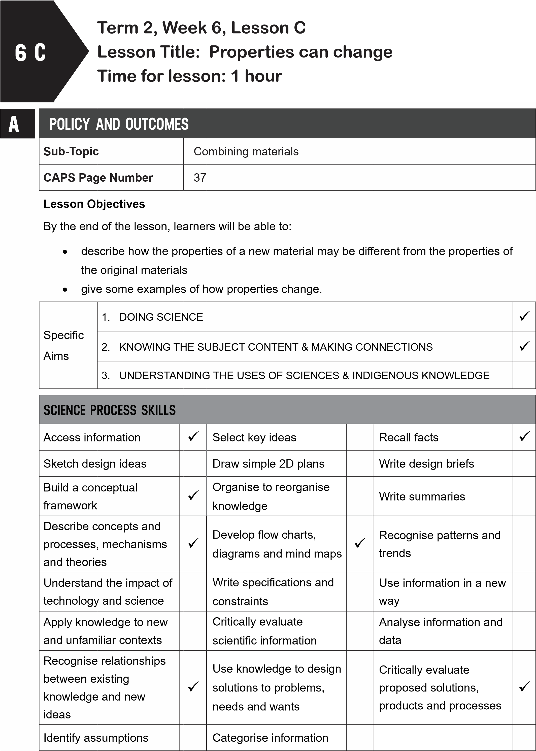
B
POSSIBLE RESOURCES
For this lesson, you will need:
IDEAL RESOURCES
IMPROVISED RESOURCES
Jelly and jelly powder
Cement powder and a piece of concrete
C | CLASSROOM MANAGEMENT
- Make sure that you are ready and prepared.
- Write the following question onto the chalkboard before the lesson starts:
 | How are adobe bricks dried?
- Learners should enter the classroom and answer the question in their workbooks.
D
- Discuss the answer with the learners.
- Write the model answer onto the chalkboard.
They are put in the sun to dry.
ACCESSING INFORMATION
1. Write the following onto the chalkboard (always try to do this before the lesson starts):
PROPERTIES OF NEW MATERIALS
- The properties of new materials may differ from the properties of the raw materials used to make the product.
- Plaster has different properties from the raw materials used to make it.
- Concrete is hard, rough, strong and dry.
- Concrete has different properties from the sand, cement, gravel and water used to make it.
- A paste is made from a powdery solid and a liquid.
- This new material has different properties from the solid and liquid used to make it.
- Cooking uses heat to make raw food more edible, because it changes the properties of the food.
- Jelly powder is mixed with hot water and then cooled.
- Jelly is different to jelly powder.
- Clay bricks are baked in a kiln or dried in the sun to become hard and waterproof.
- Bricks are hard and waterproof.
- Explain this to the learners as follows:
  - Learners have done many investigations on mixing and processing to make a new material from raw materials.
  - The properties of the new material may be different from the properties of the raw materials used to make it.
  - Read through the information on the chalkboard and make sure the learners understand it.
- Give learners time to copy this information into their workbooks.
Checkpoint 1
Ask the learners the following questions to check their understanding at this point:
- What is a paste made from?
- What two processes are used to make bricks?
Answers to the checkpoint questions are as follows:
- A paste is made from a powdery solid and a liquid.
- Bricks are dried or fired.
E | CONCEPTUAL DEVELOPMENT
1. Write the following onto the chalkboard (always try to do this before the lesson starts).
TASK: COMBINING AND PROCESSING MATERIALS
- Combining materials to make a new material can be shown by a flow diagram.
Plaster of Paris
+ water
mixed
set
Plaster of Paris
cast for a broken
arm
- The flow diagram shows which materials are mixed, the processes which take place and which new materials/ products are made.
- Draw flow diagrams for the following products:
  - concrete
  - jelly
  - adobe bricks.
2. Explain this to the learners as follows:
- Show learners how to read a flow diagram.
- Read the words and follow the arrows.
- Learners must draw flow diagrams for the three products: concrete, jelly, and adobe bricks. Give learners some time to complete this task.
.
3
A model answer:
TASK: COMBINING AND PROCESSING MATERIALS
a.
3
b.
3
3
c.
cement + sand +
gravel + water
mix
set
concrete
jelly powder + hot
water
mix
cooling
set
clay + straw +
water
mix
dried
adobe brick
jelly
Checkpoint 2
Ask the learners the following questions to check their understanding at this point:
- What properties does an adobe brick have?
- What is a property of cement?
Answers to the checkpoint questions are as follows:
- An adobe brick is hard and waterproof.
- Cement is a powdery solid.
- Ask the learners if they have any questions and provide answers and explanations.

F | REFERENCE POINTS FOR FURTHER DEVELOPMENT
 | If you need additional information or activities on this topic, you can find these in your textbook on the following pages:
 | NAME OF TEXTBOOK | TOPIC | PAGE NUMBER
 | Study & Master | Processing materials | 97
 | Viva | Processing materials | -
 | Platinum | Processing materials | 92-93
 | Solutions for All | Processing materials | 110
 | Day-by-Day | Processing materials | 85
 | Oxford | Processing materials | 66-67
 | Spot On | Processing materials | 41
 | Top Class | Processing materials | 62
 | Sasol Inzalo Bk A | Processing materials | 179-182
G | ADDITIONAL ACTIVITIES/ READING
In addition, further reading, listening or viewing activities related to this sub-topic are available through the following web links:
1. http://harriscounty.ga.schoolwebpages.com/education/components/scrapbook/default.
php?sectiondetailid=10713 [Physical and Chemical Changes]

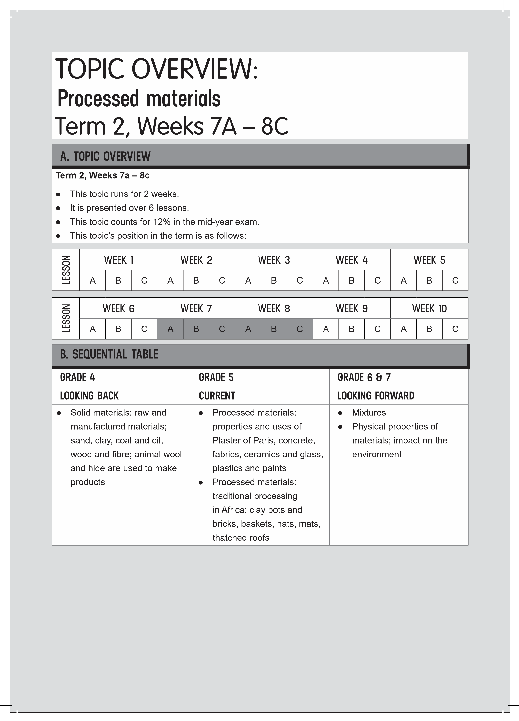
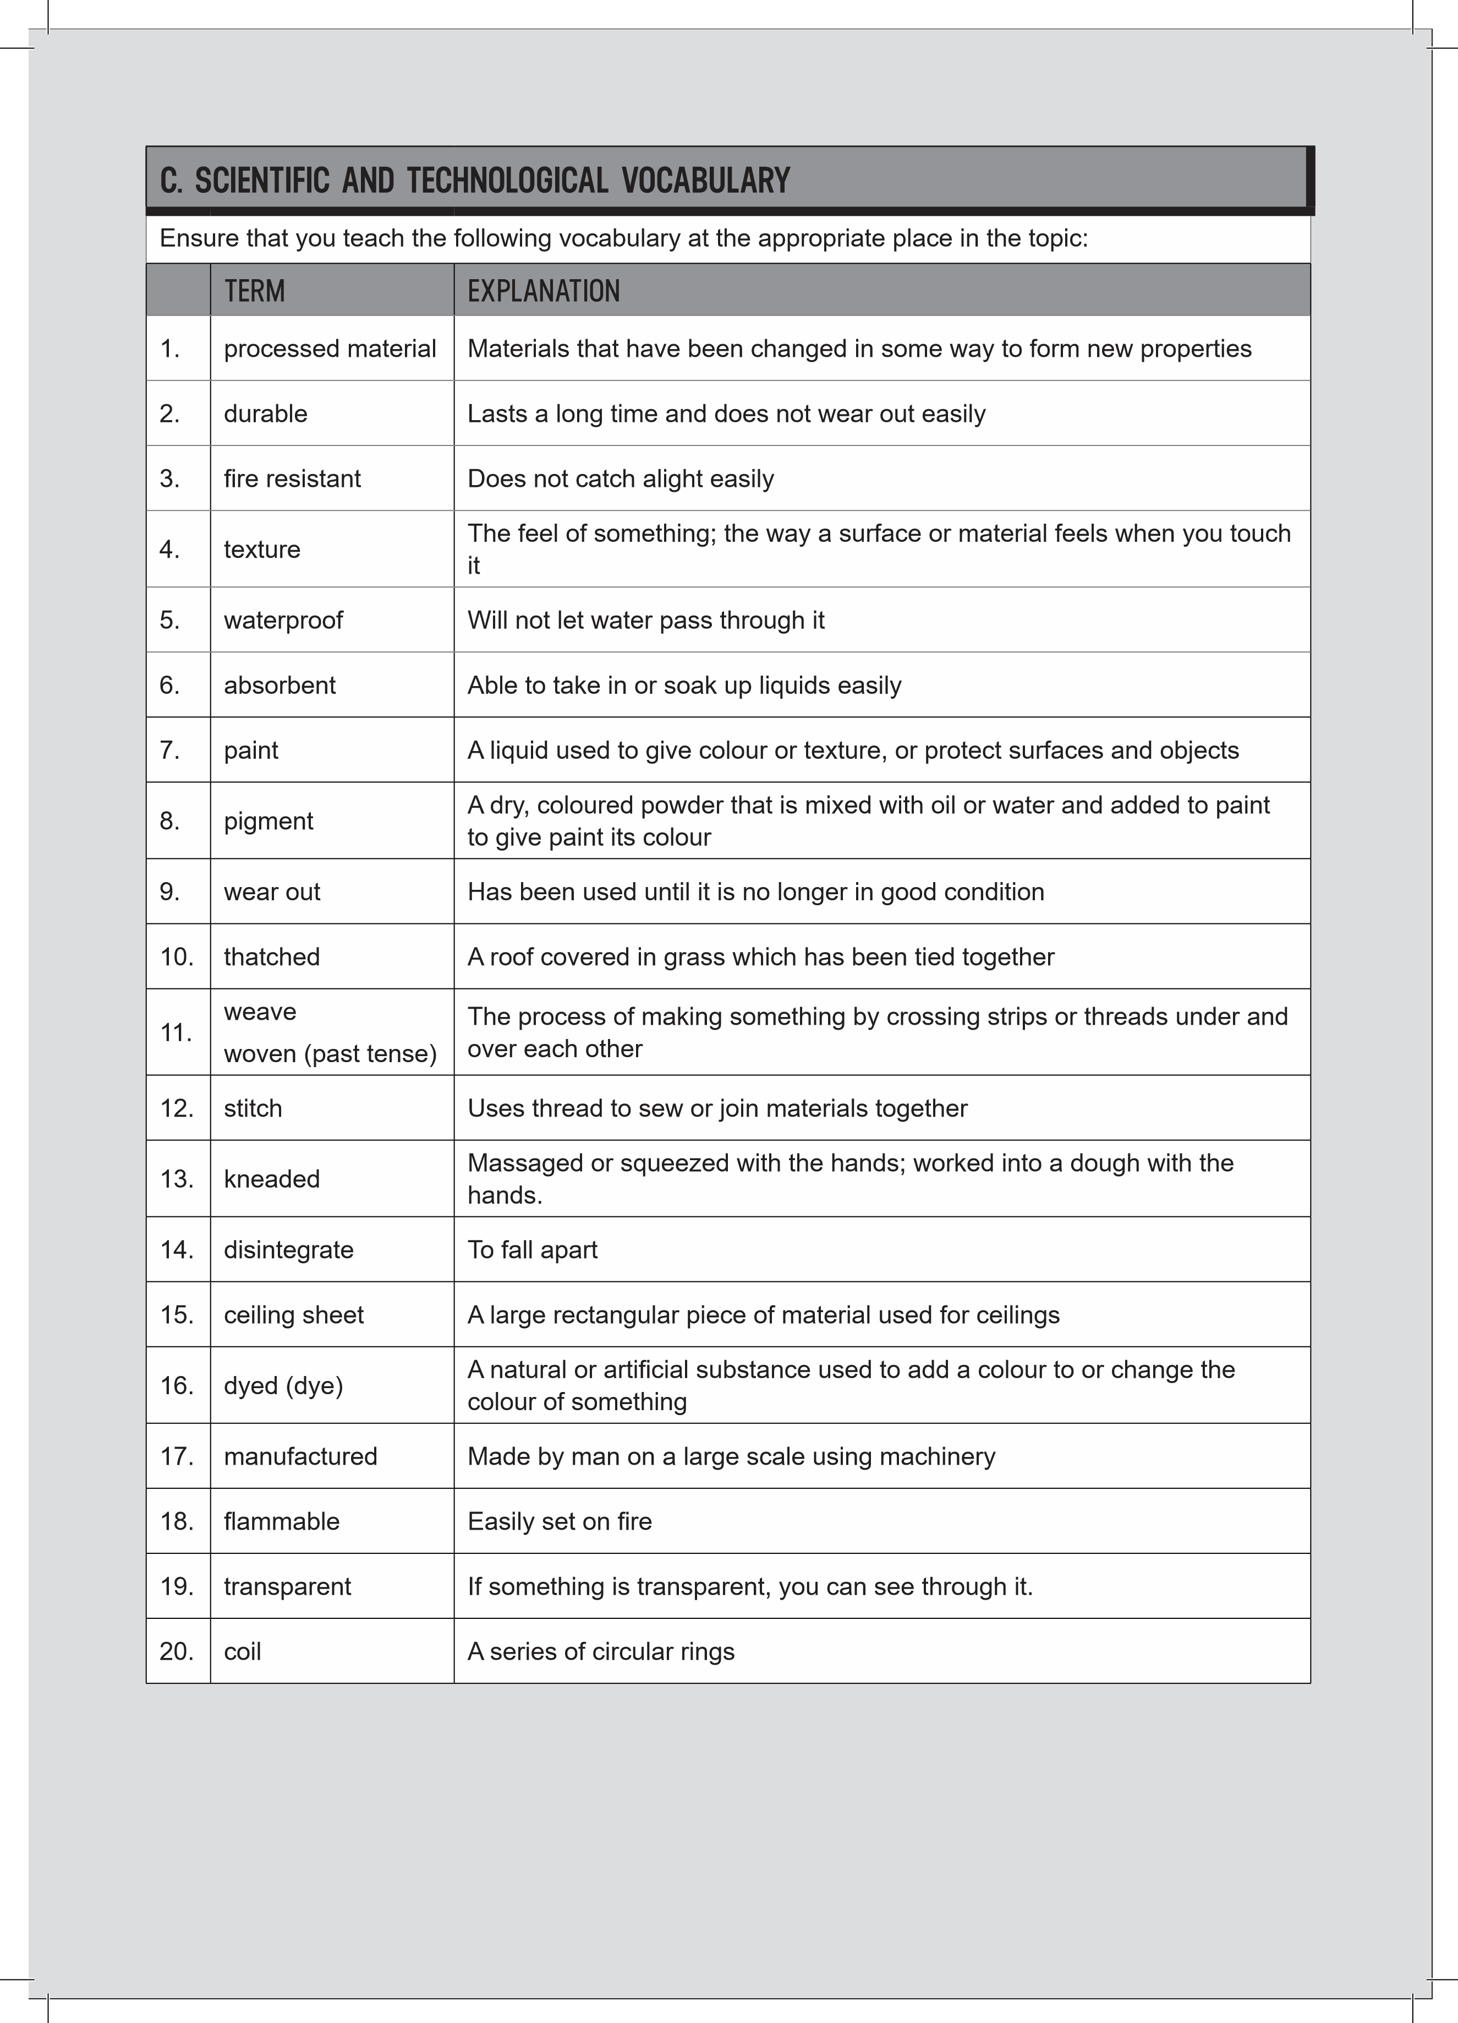

D. UNDERSTANDING THE USES / VALUE OF SCIENCE
We use many processed products in our daily lives. Understanding the materials and processes used to make these products will enable us to look after them better. It will also enable us to design and come up with ideas on how to improve existing products.
E. PERSONAL REFLECTION
Reflect on your teaching at the end of each topic:
Date completed:
Lesson successes:
Lesson challenges:
Notes for future improvement:

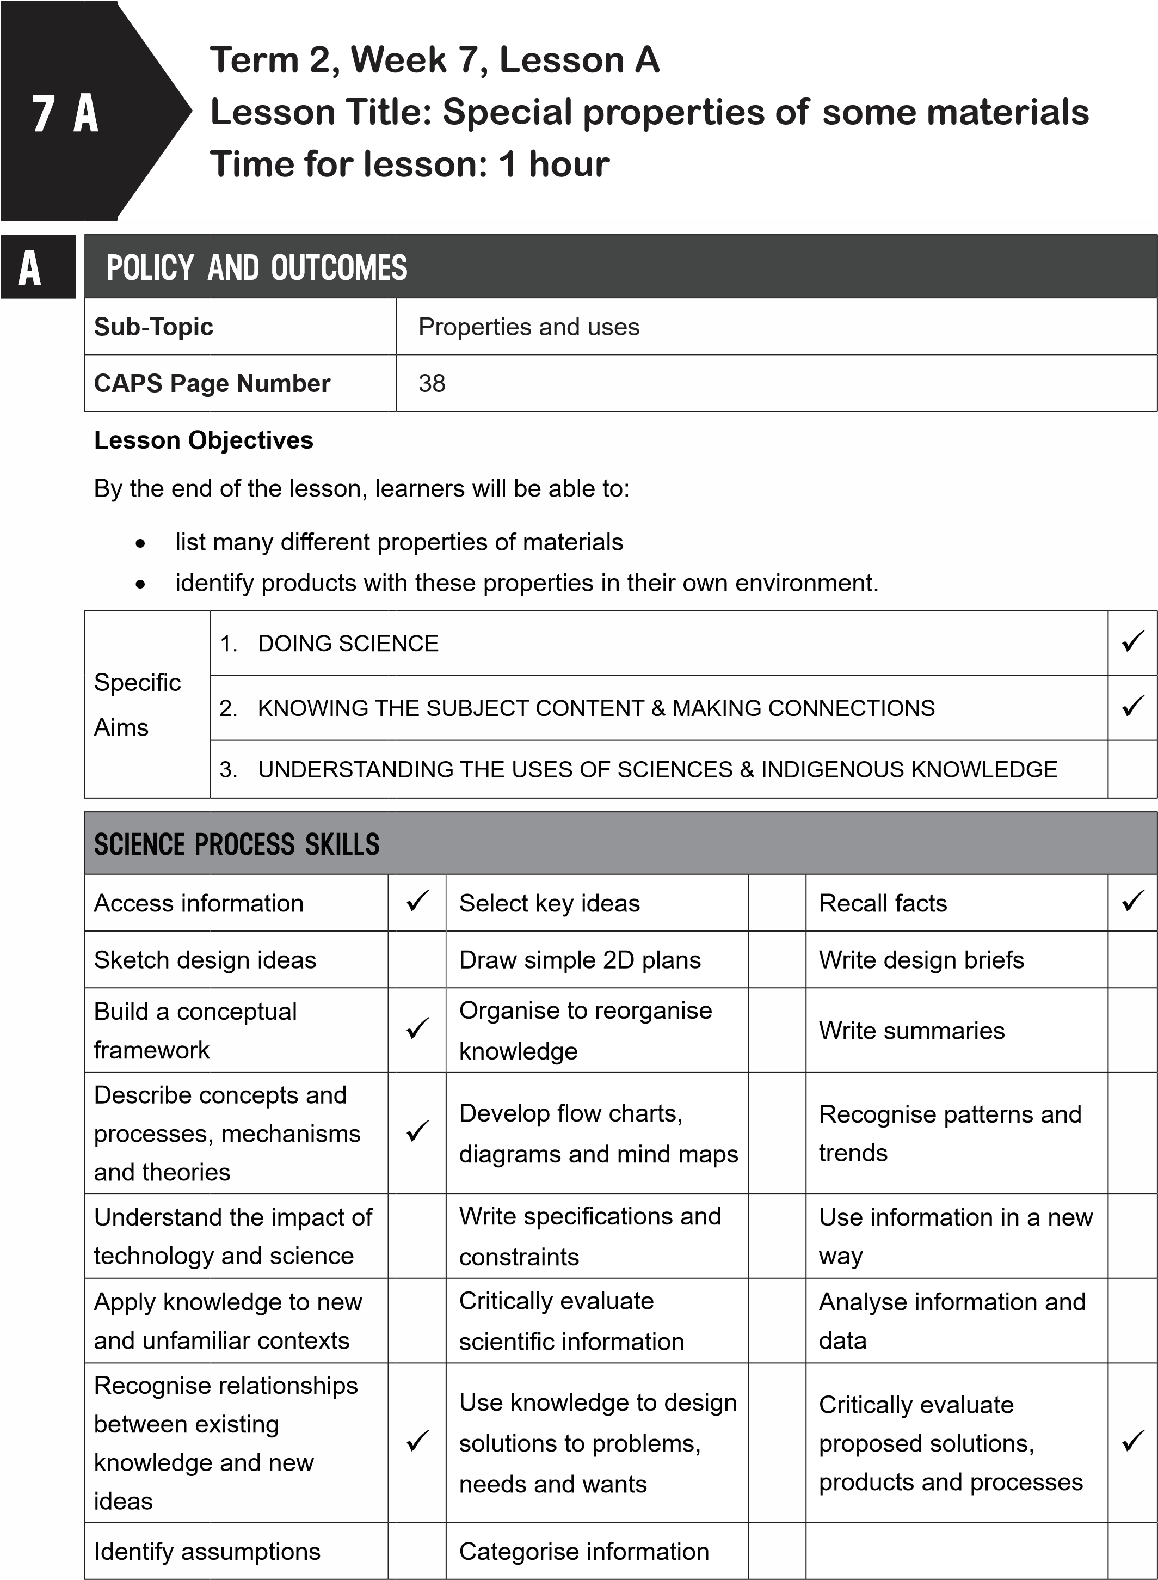
B
POSSIBLE RESOURCES
For this lesson, you will need:
IDEAL RESOURCES
IMPROVISED RESOURCES
Resource Page 26: Waterproof materials
Resource Page 27: Coloured fabric
C | CLASSROOM MANAGEMENT
- Make sure that you are ready and prepared.
- Write the following question onto the chalkboard before the lesson starts:
 | Do jelly and jelly powder have the same properties?
- Learners should enter the classroom and answer the question in their workbooks.
- Discuss the answer with the learners.
D
- Write the model answer onto the chalkboard.
No, they do not. Jelly powder is coarse while jelly is smooth.
ACCESSING INFORMATION
1. Write the following onto the chalkboard (always try to do this before the lesson starts):
SPECIAL PROPERTIES OF SOME PROCESSED MATERIALS
- Processed materials are materials that have been changed in some way.
- Processed materials are not natural materials.
- We use many processed materials every day.
- Some processed materials are useful because they have special properties.
- These materials can be strong, durable, waterproof, fire resistant, light or have interesting colours and textures.
- If a material is strong, it means it will not break or wear out easily.
- A durable material will last a long time.
- A waterproof material will not let water pass through it.
- A fire-resistant material is made so that it will not be easily damaged by fire.
- A material with a texture means that it will have a certain feel.
- Some materials need to be light.
- This means they will not weigh a lot.
- Explain this to the learners as follows:
  - Some processed materials need to have special properties.
  - New materials have special properties which enables them to be useful.
  - Read through all the meanings of the words used to describe the special properties of materials: strong, durable, waterproof, fire resistant, light, have colour or texture.
  - Show learners Resource Page 26: ‘Waterproof materials’.
  - The raincoat, umbrella and gumboots are made from waterproof materials.
  - Show learners Resource Page 27: ‘Coloured fabric’.
  - Fabric has many different textures and colours.
- Give learners time to copy this information into their workbooks.
Checkpoint 1
Ask the learners the following questions to check their understanding at this point:
- What does ‘durable’ mean?
- What does ‘waterproof’ mean?
Answers to the checkpoint questions are as follows:
- Durable means it will last a long time.
- Waterproof means that water will not pass through it.
E | CONCEPTUAL DEVELOPMENT
 | 1. Write the following on the chalkboard (always try to do this before the lesson starts):
TASK: PRODUCTS AND THEIR SPECIAL PROPERTIES
- Choose four products that you use at home or at school.
- Identify the material or materials used to make this product.
- Which properties of the material make this product useful?
- Fill this information in on the table below.
Table on properties of materials
Product | Use of object | Material that product is made from | Properties that make the product useful

- Explain this to the learners as follows:
  - Ask learners to copy the table into their workbooks.
  - Learners must each choose four products.
  - Complete the table.
  - Get some learners to share what they have written down on their tables.
- Give learners time to complete this task in their workbooks.
- A model answer (answers will very according to the products chosen)
Table on properties of materials
Product | Use of object | Material that product is made from | Properties that make the product useful
chair | to sit at a desk | wood  steel | both materials are durable and strong
school bag | to contain and protect school books and stationery | fabric | durable, light
jug | to hold water | glass | waterproof, durable
spoon | to eat | stainless steel | strong, durable, light, smooth texture

Checkpoint 2
Ask the learners the following questions to check their understanding at this point:
- What is meant by the ‘texture’ of a material?
- What does it mean if we say a material is ‘light’?
Answers to the checkpoint questions are as follows:
- The texture of a material means how it feels to the touch.
- It means the material will not weigh a lot.
- Ask the learners if they have any questions and provide answers and explanations.

F | REFERENCE POINTS FOR FURTHER DEVELOPMENT
 | If you need additional information or activities on this topic, you can find these in your textbook on the following pages:
 | NAME OF TEXTBOOK | TOPIC | PAGE NUMBER
 | Study & Master | Processed materials | 98-101
 | Viva | Processed materials | 86-88
 | Platinum | Processed materials | 95-96
 | Solutions for All | Processed materials | 114
 | Day-by-Day | Processed materials | 89-94
 | Oxford | Processed materials | 68
 | Spot On | Processed materials | 42-43
 | Top Class | Processed materials | 64-69
 | Sasol Inzalo Bk A | Processed materials | 188-191
G | ADDITIONAL ACTIVITIES/ READING
In addition, further reading, listening or viewing activities related to this sub-topic are available through the following web links:
- https://goo.gl/QTt8Y3 (2min 40sec) [Materials and their properties]
- https://goo.gl/wK89W1 (4min 33sec) [Properties of materials]
- https://goo.gl/oXXQFf (4min 26sec) [What’s my property?]
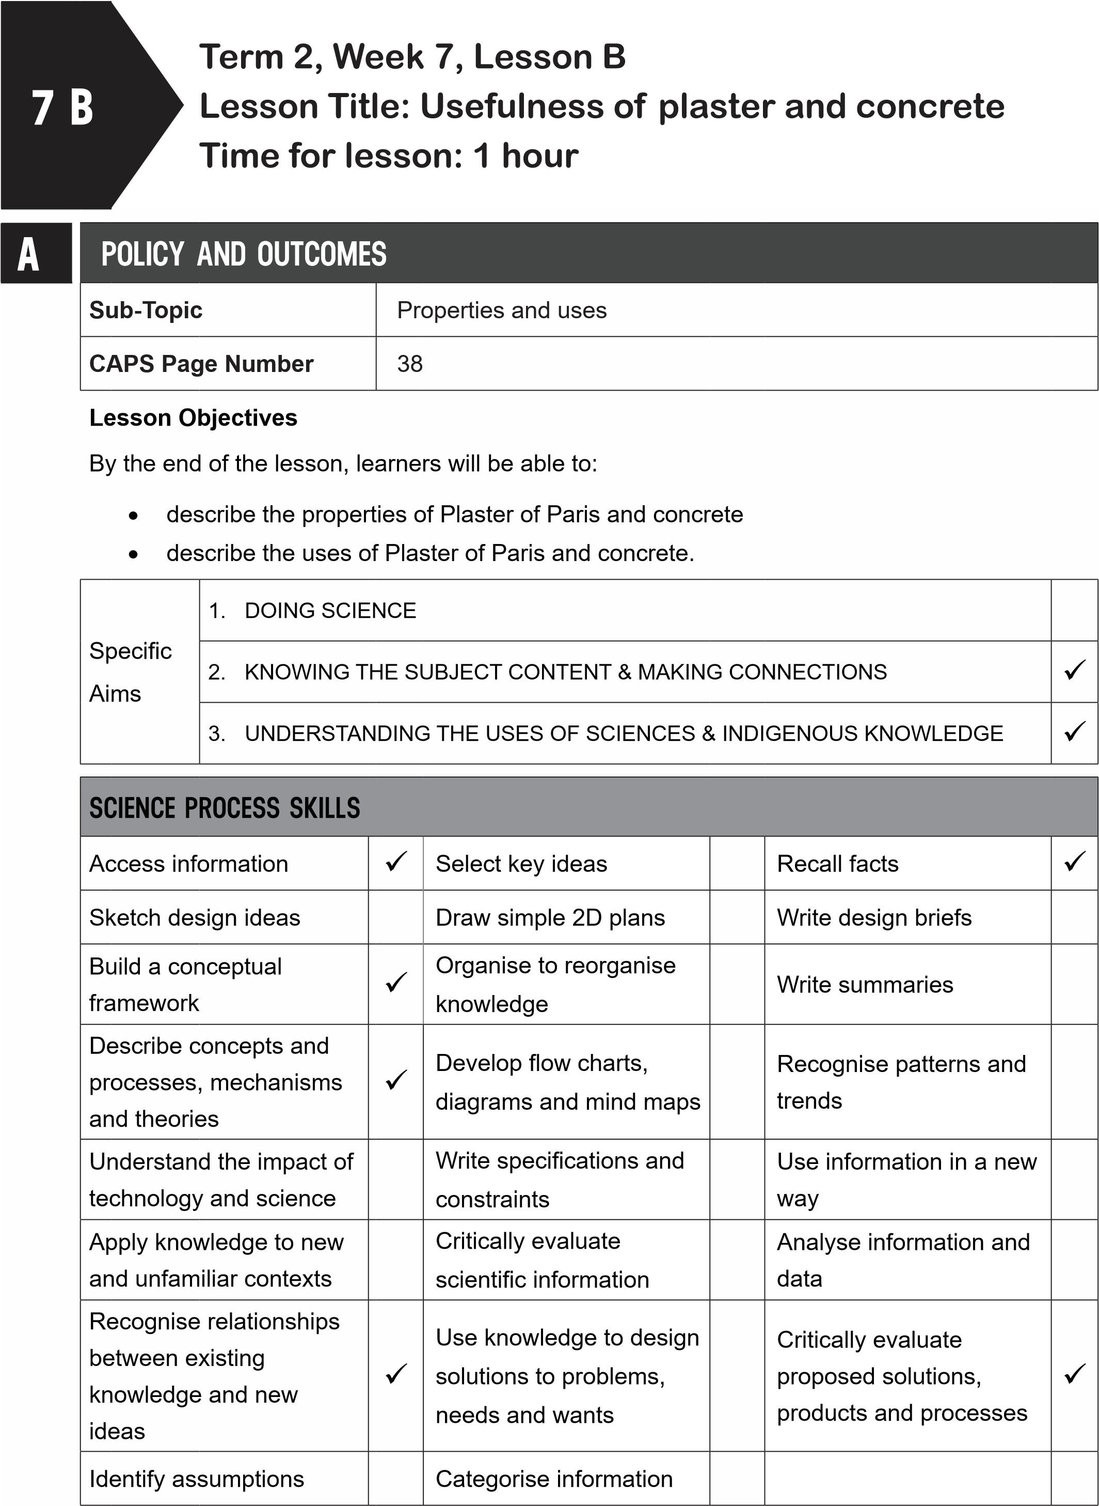
B | POSSIBLE RESOURCES
 | For this lesson, you will need:
 | IDEAL RESOURCES | IMPROVISED RESOURCES
 | Resource Page 23: Plaster of Paris
 | Resource Page 28: A concrete bridge
CLASSROOM MANAGEMENT
- Make sure that you are ready and prepared.
- Write the following question onto the chalkboard before the lesson starts:
What is ‘texture’?
- Learners should enter the classroom and answer the question in their workbooks.
D
C
- Discuss the answer with the learners.
- Write the model answer onto the chalkboard.
Texture is how a material feels to the touch.
ACCESSING INFORMATION
1. Write the following onto the chalkboard (always try to do this before the lesson starts):
USEFULNESS OF PLASTER AND CEMENT
- When Plaster of Paris is mixed with water, it becomes a malleable material that can be moulded into different shapes.
- This plaster sets and hardens very quickly.
- Plaster of Paris is fire-resistant and water-resistant.
- Water resistant means it will not allow water through and it will take some time to disintegrate in water.
- Ceiling sheets contain Plaster of Paris.
- Dentists makes casts of patient’s gum from this plaster.
- Bandages can be soaked in Plaster of Paris and then wound around a broken arm or leg to keep it still, so it can heal.
- It can be used to fill cracks in walls.
- Plaster of Paris can be used for works of art.
- Concrete is very strong, hard and durable.
- It is also fire-resistant and waterproof.
- Concrete is used in many buildings and bridges.
- Thick water pipes are made from concrete.
- Explain this to the learners as follows:
  - When mixed with water, Plaster of Paris becomes malleable.
  - This property makes it very useful for making casts for dentists and for broken arms and legs.
  - Show learners Resource Page 23: Plaster of Paris.
  - Point to the cast made around a broken leg.
  - This cast makes the leg not move so that it can heal.
  - Concrete is strong and durable.
  - These properties make it an excellent material for buildings and bridges.
  - Show learners Resource Page 28: A concrete bridge.
  - This bridge is strong, durable and waterproof.
- Give learners time to copy this information into their workbooks.
Checkpoint 1
Ask the learners the following questions to check their understanding at this point:
- Can you name two properties of Plaster of Paris?
- Can you give two uses for Plaster of Paris?
Answers to the checkpoint questions are as follows:
- Plaster of Paris is malleable before it sets and it is fire and water resistant (any two).
- Plaster of Paris is used to make casts for dentists and to fix broken arms and legs. It is used in ceiling sheets, it can fill cracks in walls and it is used to make works of art (any two).
E | CONCEPTUAL DEVELOPMENT
1. Draw the following onto the chalkboard (always try to do this before the lesson starts):
TASK: USES OF PLASTER OF PARIS AND CONCRETE
1. Copy and complete the table below:
Material | Where it is used | Properties | Reason why this property is useful
Plaster of Paris
Concrete

2. Explain the following to the learners:
- Using the information from the previous section, fill in the table.
- When the learners have completed the table, ask some learners to share their answers with the class. Discuss these answers.
- Give learners time to complete this task in their workbooks.
- A model answer:
TASK: USES OF PLASTER OF PARIS AND CONCRETE
Material | Where it is used | Properties | Reason why this property is useful
Plaster of Paris | In ceiling boards, in casts for a patient’s teeth at the dentist, to make a cast for a broken arm or leg, to fix cracks in walls, for artwork | malleable when wet and before it sets, fire-resistant, waterresistant, hard once set | being malleable means it fits around people’s teeth, arms and legs for casts; being hard protects the broken arms and legs
Concrete | Buildings, bridges, water pipes | strong, hard, durable, waterproof | It adds strength to buildings and bridges; makes buildings and bridges durable; being waterproof means it is useful for making water pipes.

Checkpoint 2
Ask the learners the following questions to check their understanding at this point:
- Can you name three properties of concrete?
- Can you give two uses for concrete?
Answers to the checkpoint questions are as follows:
- Concrete is hard, strong, durable, waterproof and fire-resistant (any three).
- Concrete is used in buildings and bridges, and for water pipes (any two). .
- Ask the learners if they have any questions and provide answers and explanations.

F | REFERENCE POINTS FOR FURTHER DEVELOPMENT
 | If you need additional information or activities on this topic, you can find these in your textbook on the following pages:
 | NAME OF TEXTBOOK | TOPIC | PAGE NUMBER
 | Study & Master | Processed materials | 98-101
 | Viva | Processed materials | 88-89
 | Platinum | Processed materials | 96-97
 | Solutions for All | Processed materials | 114-115
 | Day-by-Day | Processed materials | 89-94
 | Oxford | Processed materials | 68-69
 | Spot On | Processed materials | 42-43
 | Top Class | Processed materials | 64-69
 | Sasol Inzalo Bk A | Processed materials | 192-196
G | ADDITIONAL ACTIVITIES/ READING
In addition, further reading, listening or viewing activities related to this sub-topic are available through the following web links:
- https://goo.gl/HxT8xL [Construction materials - BBC Bitesize]
- https://goo.gl/j2gzFn [Processed materials]
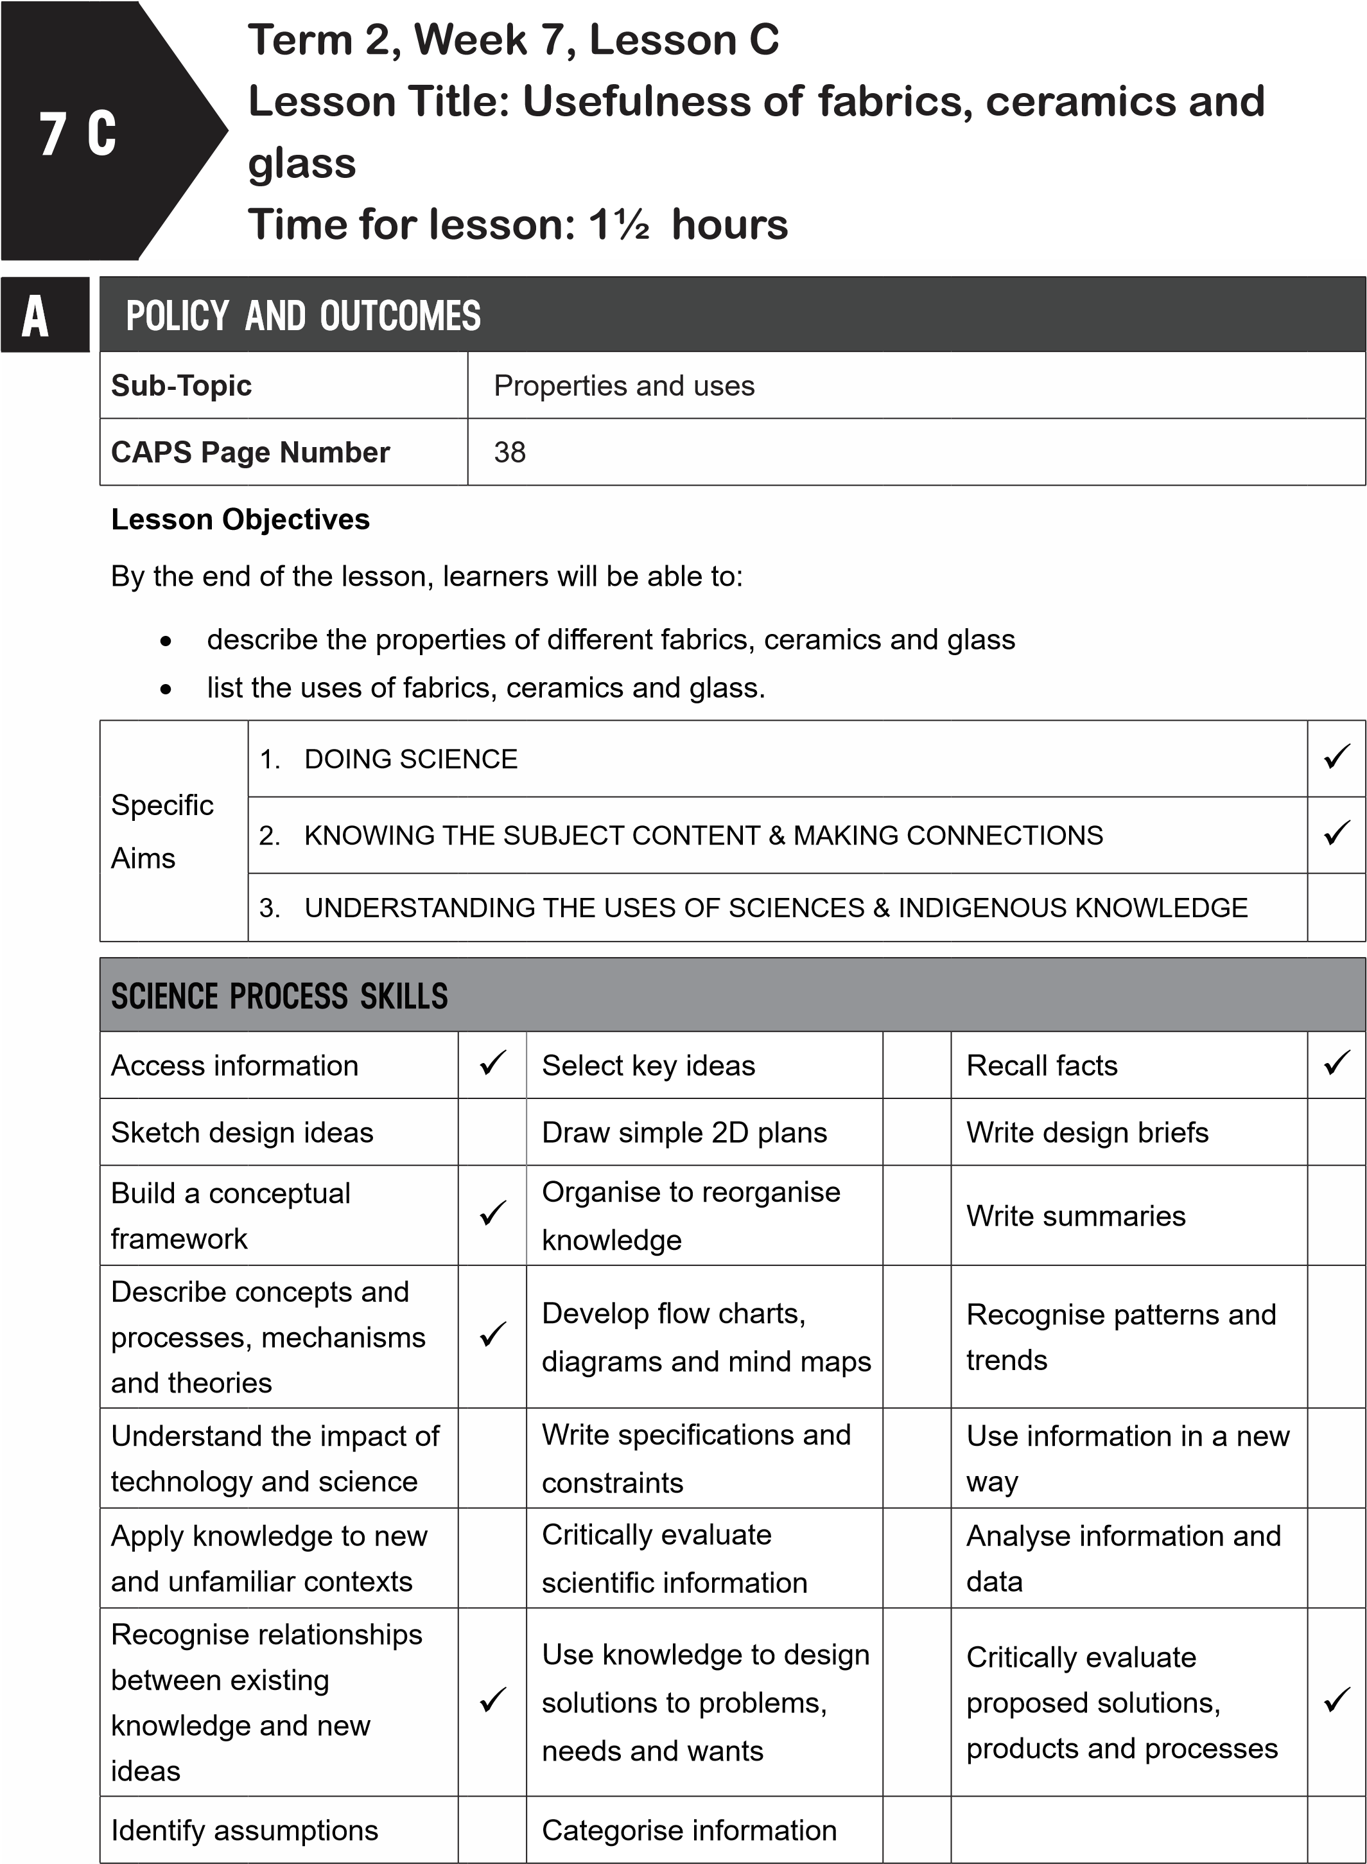
B
POSSIBLE RESOURCES
For this lesson, you will need:
IDEAL RESOURCES
IMPROVISED RESOURCES
Resource Page 10: Non-metals: Glass
Resource Page 26: Waterproof materials
Resource Page 27: Coloured fabric
Resource Page 29: Ceramic pots
C | CLASSROOM MANAGEMENT
- Make sure that you are ready and prepared.
- Write the following question onto the chalkboard before the lesson starts:
Can you give three properties of concrete?
- Learners should enter the classroom and answer the question in their workbooks.
- Discuss the answer with the learners.
- Write the model answer onto the chalkboard.
Concrete is hard, durable, strong, fire-resistant, waterproof (any three).
D | ACCESSING INFORMATION
 | 1. Write the following onto the chalkboard (always try to do this before the lesson starts):
USEFULNESS OF FABRICS
- Fabrics are used to make many kinds of products.
- Clothes, towels, curtains, tents, parachutes, stockings and many other products are made from fabric.
- Some fabrics, like towels, are absorbent.
- Fabrics can be dyed into many different colours.
- They also have many different textures depending on the fibres used to weave the fabric.
- Natural fabrics like wool, cotton and leather are fire-resistant.
- Manufactured fabrics, like nylon and polyester, are crease resistant, durable and often cheap.
- Some manufactured fabrics are highly flammable.
- Manufactured fabrics are man-made and not natural.
USEFULNESS OF CERAMICS
- Ceramics are products made with clay that has been fired in a kiln.
- Pots are made from ceramics.
- They are durable.
- Ceramics are hard but brittle.
- Once fired, ceramics are waterproof and fire-resistant.
- Some ceramic pots can be used in the oven.
- Ceramics can be painted to make them attractive.
USEFULNESS OF GLASS
- Glass is a mixture of sand, soda ash and lime.
- It is very useful as it is transparent.
- Glass is used to make window panes, jars, bottles and ornaments.
- Curved glass is used for spectacles and telescopes.
- Explain the usefulness of fabrics to the learners as follows:
  - There are many different types of fabrics.
  - Natural fabrics are made from fibres such as wool, cotton, silk and leather.
  - Show learners Resource Page 27:’ Coloured fabric’.
  - The cloth is made from cotton, a natural fibre.
  - Manufactured fabrics are man-made.
  - Show learners Resource Page 26: ‘Waterproof materials’.
  - Plastic raincoats and umbrellas are made from manufactured fabric.
  - Point out all the fabrics in the classroom, like school uniforms, the teacher’s jersey, curtains, etc.
- Give learners time to copy the information on the usefulness of fabrics into their workbooks.
- Explain the usefulness of ceramics and glass to the learners as follows:
  - Ceramics are clay products that have been fired in a kiln.
  - They have many useful properties: hard, durable, waterproof, fire-resistant.
  - They are brittle so they will break if they are dropped.
  - Show learners Resource Page 29: ‘Ceramic pots’.
  - These have been fired in a kiln.
  - Ceramics are hard but brittle. They are also waterproof and fire-resistant.
  - Glass is transparent, hard, durable and waterproof.
  - It is an ideal material for window panes.
  - Show learners Resource Page 10: ‘Non-metals: Glass’.
  - The glass in the window panes is transparent.
  - Point out the glass window panes in the school buildings.
- Give learners time to copy the information on the usefulness of ceramics and glass into their workbooks.
Checkpoint 1
Ask the learners the following questions to check their understanding at this point:
- What are the two main groups of fabrics?
- Can you name three natural fabrics?
Answers to the checkpoint questions are as follows:
- Fabrics can be natural or manufactured.
- Wool, cotton, leather and silk are natural fabrics (any three).
E | CONCEPTUAL DEVELOPMENT
1. Write the following onto the chalkboard (always try to do this before the lesson starts):
TASK: USES OF FABRICS, CERAMICS AND GLASS 1. Copy and complete the table below:
Material | Where it is used | Properties | Reason why this property is useful
Fabrics
Ceramics
Glass

- Explain this to the learners as follows:
  - Using the information from the previous section, fill in the table.
  - When the learners have completed the table, ask some learners to share their answers with the class. Discuss these answers.
  - Give learners time to complete this task in their workbooks.
- Model answers (answers may vary)
TASK: USES OF FABRIC, CERAMICS AND GLASS
Material | Where it is used | Properties | Reason why this property is useful
Fabrics | clothes, towels, parachutes, stockings, curtains, tents | absorbent, light (for example, as in silk) strong | for towels as used in drying, for clothes to keep cool, to make curtains, table-cloths, and clothing
Ceramics | pots | after firing, heatresistant, waterresistant | can go in the oven, used for cooking food

Glass | window panes | transparent, hard, durable | lets light in allowing people to see outside

Checkpoint 2
Ask the learners the following questions to check their understanding at this point:
- What is a manufactured fabric?
- What property of glass lets us see through it?
Answers to the checkpoint questions are as follows:
a. A manufactured fabric is not made from natural fibre, but is man-made. b. Glass is transparent.
- Ask the learners if they have any questions and provide answers and explanations.
F | REFERENCE POINTS FOR FURTHER DEVELOPMENT
 | If you need additional information or activities on this topic, you can find these in your textbook on the following pages:
 | NAME OF TEXTBOOK | TOPIC | PAGE NUMBER
 | Study & Master | Processed materials | 98-101
 | Viva | Processed materials | 99-100
 | Platinum | Processed materials | 98-99
 | Solutions for All | Processed materials | 116-118
 | Day-by-Day | Processed materials | 89-94
 | Oxford | Processed materials | 69-70
 | Spot On | Processed materials | 42-43
 | Top Class | Processed materials | 64-69
 | Sasol Inzalo Bk A | Processed materials | 192-196
G | ADDITIONAL ACTIVITIES/ READING
In addition, further reading, listening or viewing activities related to this sub-topic are available through the following web links:
- https://goo.gl/DWTKwX [Processed materials]
- http://slideplayer.com/slide/9127914/ [Processed materials]
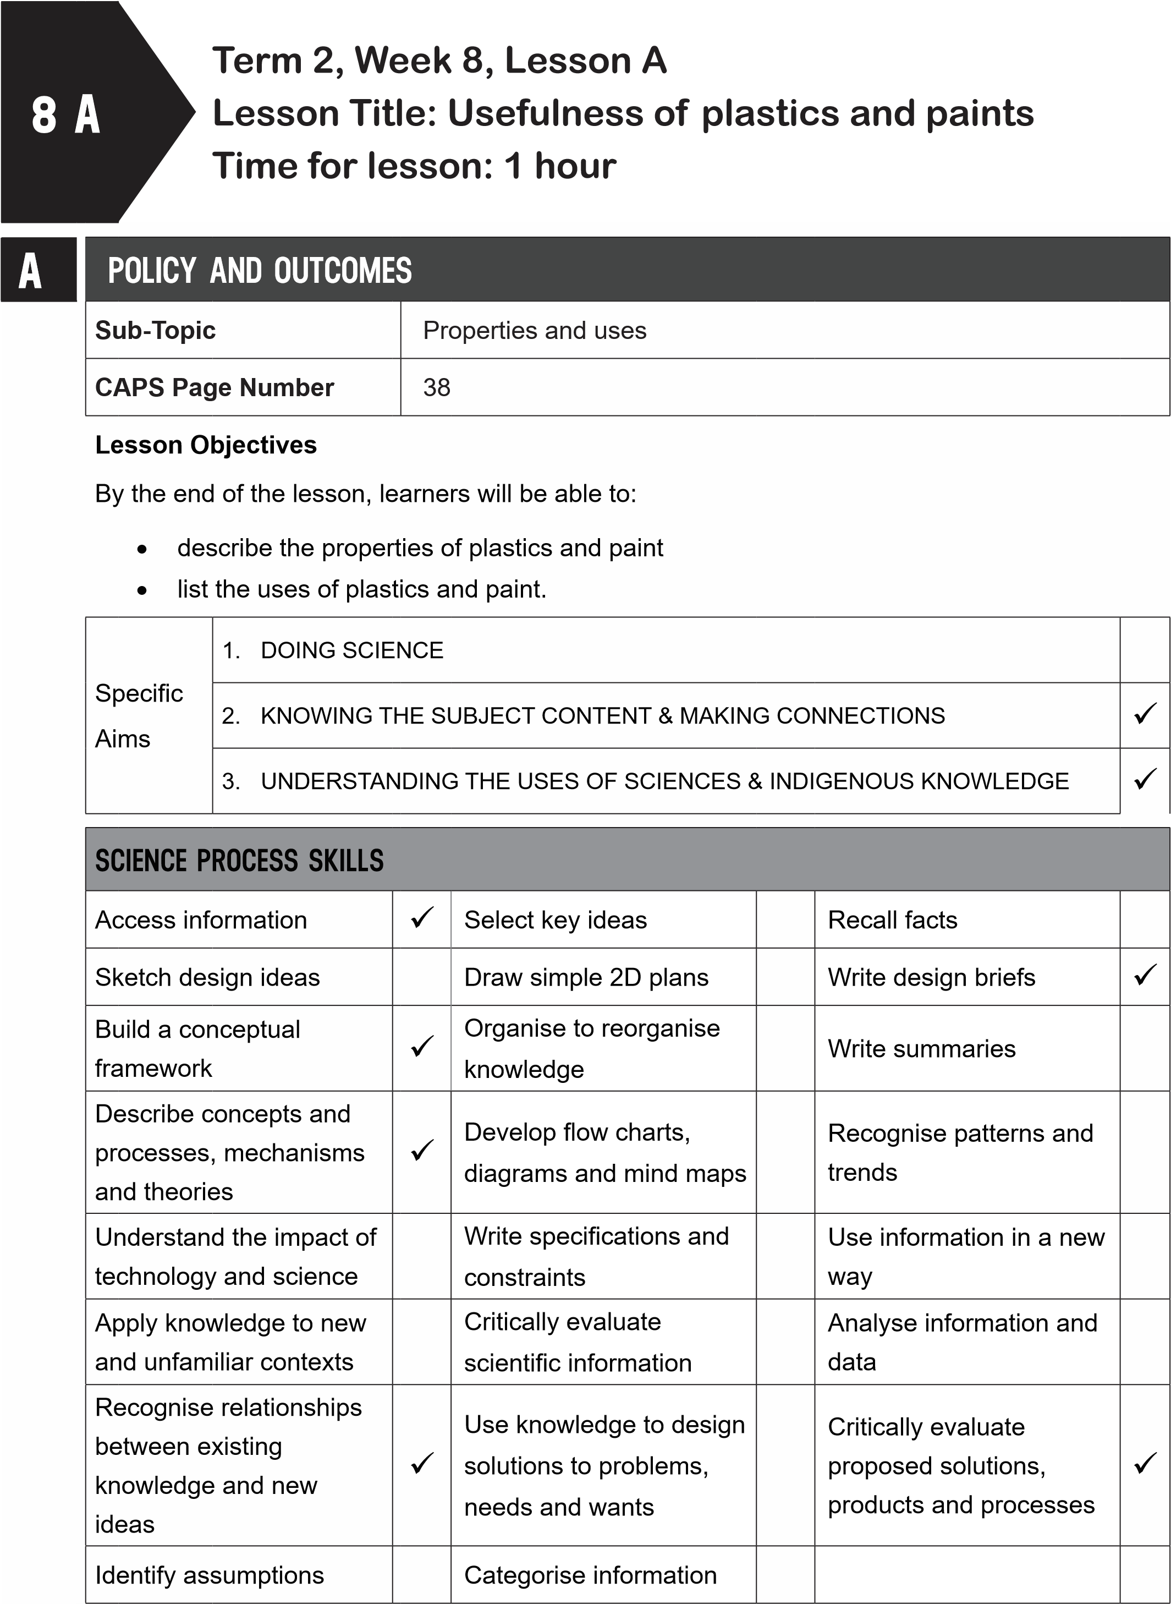
B
POSSIBLE RESOURCES
For this lesson, you will need:
IDEAL RESOURCES
IMPROVISED RESOURCES
Resource Page 8: Plastic bucket and electric
plug
Resource 30: A painted Ndebele hut
C | CLASSROOM MANAGEMENT
- Make sure that you are ready and prepared.
- Write the following question onto the chalkboard before the lesson starts:
 | What are ceramics?
- Learners should enter the classroom and answer the question in their workbooks.
- Discuss the answer with the learners.
D
- Write the model answer onto the chalkboard.
Ceramics are clay products that have been fired in a kiln.
ACCESSING INFORMATION
1. Write the following onto the chalkboard (always try to do this before the lesson starts):
USEFULNESS OF PLASTIC
- Plastics are very useful.
- Plastics are a manufactured material.
- They are easily shaped and coloured.
- They are light, strong, durable, waterproof and often cheap.
- Plastics are not heat or fire-resistant, so they will melt when heated.
- Plastic can be hard or soft, stiff or flexible.
- Plastic pipes are used for plumbing.
- Raincoats and umbrellas are made from plastic.
- Plastic is a poor conductor of electricity and so is used for electric plugs.
- Buckets, crates, bowls, toys, pens and brushes are made from plastic as it is light and durable.
- Shopping bags are made from plastic.
USEFULNESS OF PAINT
- Paint is a liquid coating applied to buildings, cars and other surfaces.
- It protects the surface.
- Paint adds texture and colour to the surface.
- Paint protects the surface.
- Explain the usefulness of plastics to the learners as follows:
  - Plastics are very useful and have many different properties.
  - Plastics come in many different forms.
  - Plastics are used for many different products from buckets and electric plugs to shopping bags.
  - Show learners Resource Page 8: ‘Non-metals: Plastic bucket and electric plug’.
  - Plastic is light and waterproof so it is an ideal material for a bucket.
  - Plastic is not a conductor of electricity so it can protect people from getting shocked by electrical wiring.
- Explain the usefulness of paint to the learners as follows:
  - Paint is a useful material.
  - It protects the surfaces it is painted on.
  - Show learners Resource Page 30: ‘A painted Ndebele hut’.
  - The paint protects the surface of the walls of the hut.
  - The paint makes the hut attractive.
- Give learners time to copy this information into their workbooks.
Checkpoint 1
Ask the learners the following questions to check their understanding at this point:
- Are plastics a natural or manufactured material?
- Is paint a solid, liquid or gas?
Answers to the checkpoint questions are as follows:
- Plastics are a manufactured material.
- Paint is a liquid.
E | CONCEPTUAL DEVELOPMENT
 | 1. Write the following on the chalkboard (always try to do this before the lesson starts):
TASK: USES OF PLASTICS AND PAINT
1. Copy and complete the table below:
Material | Where it is used | Properties | Reason why this property is useful
Plastics
Paint

- Explain this to the learners as follows:
  - Using the information from the previous section, fill in the table.
  - When the learners have completed the table, ask some learners to share their answers with the class. Discuss these answers.
- Give learners time to complete this task in their workbooks.
- Model answer (answers may vary)
TASK: USES OF PLASTICS AND PAINT
Material | Where it is used | Properties | Reason why this property is useful
Plastics | many uses: plastic pipes for plumbing, plastic covering on electric wires, plastic dishes, shopping bags, furniture | light  strong durable waterproof | for shopping bags, furniture, covering electrical wires, in plumbing
Paint | on surfaces such as buildings, cars, wooden furniture, road lines | adds texture adds colour protects | makes products more attractive, adds durability to products and buildings

Checkpoint 2
Ask the learners the following questions to check their understanding at this point:
- What property of plastic is useful when making umbrellas and raincoats?
- What property of plastic us useful when making shopping bags?
Answers to the checkpoint questions are as follows:
- Plastic is waterproof.
- Plastic is light.
- Ask the learners if they have any questions and provide answers and explanations.

F | REFERENCE POINTS FOR FURTHER DEVELOPMENT
 | If you need additional information or activities on this topic, you can find these in your textbook on the following pages:
 | NAME OF TEXTBOOK | TOPIC | PAGE NUMBER
 | Study & Master | Processed materials | 98-101
 | Viva | Processed materials | 89-94;101
 | Platinum | Processed materials | 100-101
 | Solutions for All | Processed materials | 118-120
 | Day-by-Day | Processed materials | 89-94
 | Oxford | Processed materials | 70-71
 | Spot On | Processed materials | 42-43
 | Top Class | Processed materials | 64-69
 | Sasol Inzalo Bk A | Processed materials | 192-196
G | ADDITIONAL ACTIVITIES/ READING
In addition, further reading, listening or viewing activities related to this sub-topic are available through the following web links:
1. https://www.thoughtco.com/uses-of-plastics-820359 [The usefulness of plastic in our lives]
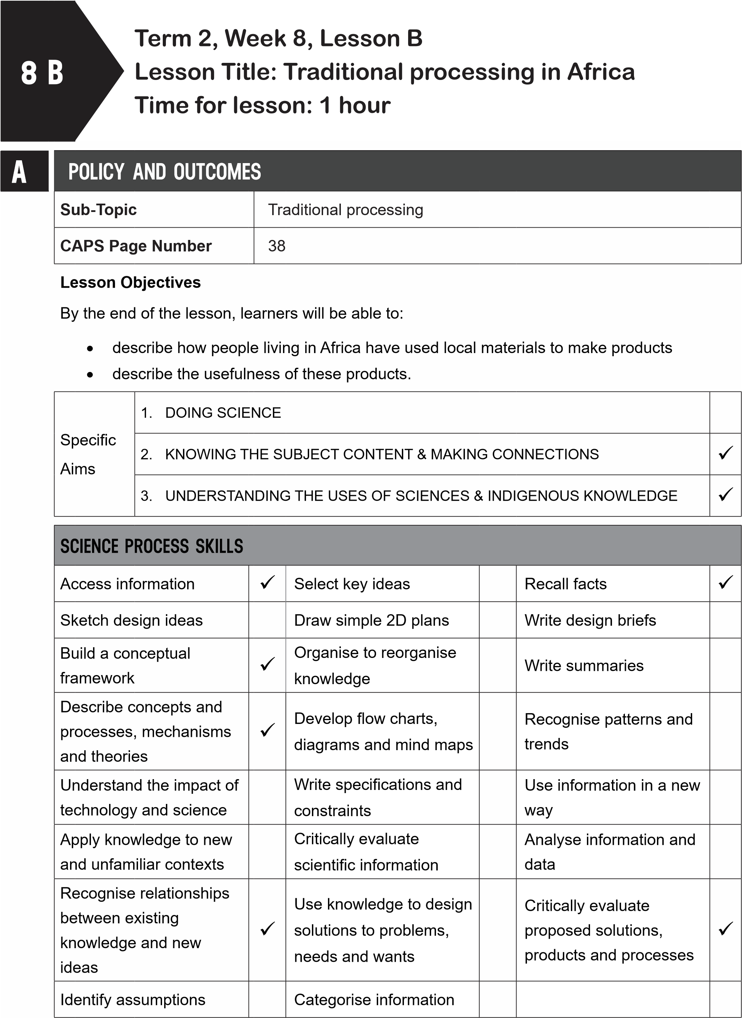
B
POSSIBLE RESOURCES
For this lesson, you will need:
IDEAL RESOURCES
IMPROVISED RESOURCES
Resource Page 31: Weaving baskets
Resource Page 32: A Basotho hat
Resource Page 33: Xhosa rondavels
Resource Page 34: The process of plaiting
Resource Page 29: Ceramic pots
C
CLASSROOM MANAGEMENT
1
.
Make sure that you are ready and prepared.
2
.
Write the following question onto the chalkboard before the lesson starts:
Is plastic a natural or manufactured material?
- Learners should enter the classroom and answer the question in their workbooks.
- Discuss the answer with the learners.
- Write the model answer onto the chalkboard.
Plastic is a manufactured material.
D | ACCESSING INFORMATION
- Write the following onto the chalkboard (always try to do this before the lesson starts):
TRADITIONAL PROCESSING
- In Africa, people have used local materials for centuries to make useful products.
- Baskets, hats, mats and thatched roofs are made from grasses and reeds.
- Baskets and mats are woven or plaited.
- Weaving is making something by crossing threads over and under each other.
- Baskets are used for storing grains, herbs and beer.
- Grasses and reeds can also be stitched together to make mats.
- Clay is another local material used to make useful products.
- It is used for building and for making pots.
- Clay bricks, known as adobe bricks, are made to build rondavels.
- Clay pots are fired to make them hard, durable and waterproof.
- Explain how grass and reeds are used to the learners as follows:
  - Traditional processing makes use of local materials.
  - Grass and reeds are used to make many products.
  - Show learners Resource Page 31: ‘Weaving baskets’.
  - Baskets are useful products in which to keep foodstuffs and other products.
  - Plaiting takes three different strands together and crosses them over in a certain way.
  - Show learners Resource Page 34: ‘Plaiting’.
  - Show learners Resource Page 32: ‘A Basotho hat’.
  - These traditional hats are made from grass.
  - Thatched roofs are made from grass sections that overlap one another.
  - These roofs are waterproof.
- Explain how clay is used to the learners as follows:
  - Show learners Resource Page 33: ‘Xhosa rondavels’.
  - These houses are made with thatched roofs, mud walls and udaka floors.
  - Show learners Resource Page 29: ‘Ceramic pots’.
  - These pots are made from clay and then fired.
- Give learners time to copy this information into their workbooks.
Checkpoint 1
Ask the learners the following questions to check their understanding at this point:
- How is a thatched roof made?
- What is weaving?
Answers to the checkpoint questions are as follows:
- A thatched roof is made from grass sewn and tied together.
- Weaving crosses threads over and under each other.
E | CONCEPTUAL DEVELOPMENT
 | 1. Write the following onto the chalkboard (always try to do this before the lesson starts):
TASK: WOVEN, STITICHED OR PLAITED
- Find three examples of products that have been woven, stitched or plaited.
- These products can be found in your school, your home or the community.
- Draw these objects and label the materials used.
- Include a heading.
- On your drawing, include the process (weaving, stitching or plaiting) that was used to make the product.
2. Explain this to you’re the learners as follows:
- Learners must draw the three products in their workbooks.
- Give the drawings a heading and label the materials and the process that was used to make the product.
- When learners have finished this task, ask some learners to share their drawings with the class. Discuss the material and the process involved in the making of each product.
- Give learners time to complete this task in their workbooks. 3. Model answers (answers will vary)
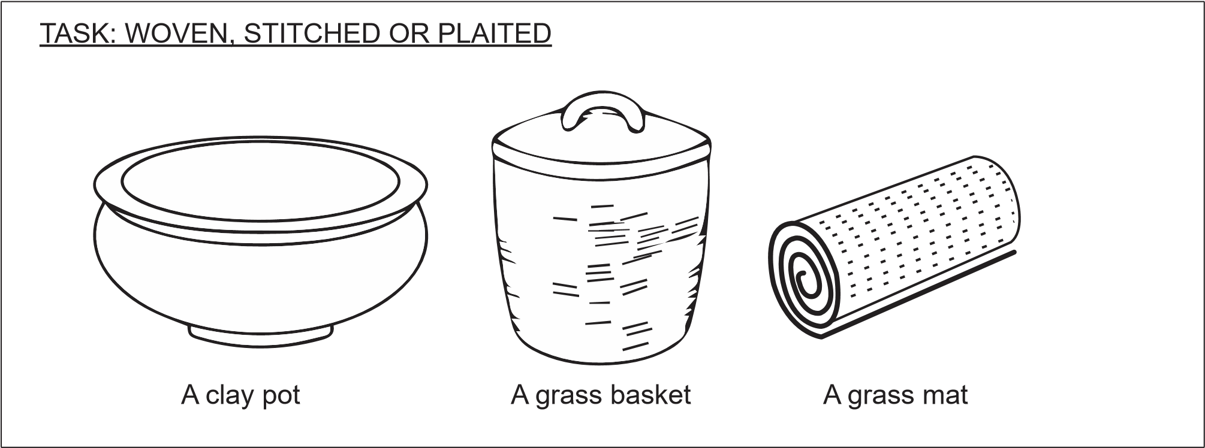
Checkpoint 2
Ask the learners the following questions to check their understanding at this point:
- Can you give three ways in which grass can be processed?
- What material are ceramic pots made from?
Answers to the checkpoint questions are as follows:
- Grass can be woven, stitched or plaited.
- Ceramic pots are made from clay.
4. Ask the learners if they have any questions and provide answers and explanations.

F | REFERENCE POINTS FOR FURTHER DEVELOPMENT
 | If you need additional information or activities on this topic, you can find these in your textbook on the following pages:
 | NAME OF TEXTBOOK | TOPIC | PAGE NUMBER
 | Study & Master | Processed materials | 101-104
 | Viva | Processed materials | 104-109
 | Platinum | Processed materials | 107-107
 | Solutions for All | Processed materials | 121-125
 | Day-by-Day | Processed materials | 97-98
 | Oxford | Processed materials | 72; 74
 | Spot On | Processed materials | 45
 | Top Class | Processed materials | 69-74
 | Sasol Inzalo Bk A | Processed materials | 196-215
G | ADDITIONAL ACTIVITIES/ READING
In addition, further reading, listening or viewing activities related to this sub-topic are available through the following web links:
- https://goo.gl/uz7s5t (3min 39sec) [Art for kids: How to weave a mat]
- https://goo.gl/rNsCGF (3min 46sec) [How to weave with a simple loom]
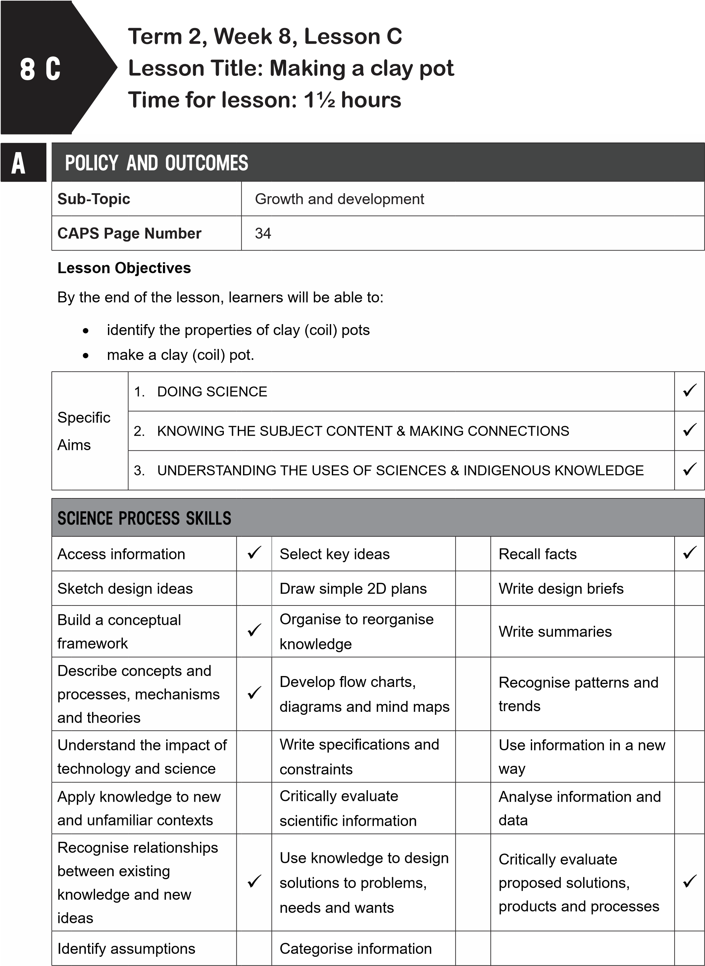
B | POSSIBLE RESOURCES
 | For this lesson, you will need:
 | IDEAL RESOURCES | IMPROVISED RESOURCES
 | Some clay (modelling clay, natural clay or play dough), a plastic sheet to work on, a stick | Plastic shopping bags could be used instead of plastic sheeting
CLASSROOM MANAGEMENT
- Make sure that you are ready and prepared.
- Write the following question onto the chalkboard before the lesson starts:
What material is used to thatch roofs?
- Learners should enter the classroom and answer the question in their workbooks.
- Discuss the answer with the learners.
- Write the model answer onto the chalkboard.
Thatching grass is used to thatch roofs.
D
C
ACCESSING INFORMATION
1. Write the following onto the chalkboard (always try to do this before the lesson starts):
AN IMPORTANT MATERIAL: CLAY
- Clay can be found along river banks.
- If the clay is dry, it is mixed with a bit of water and then kneaded.
- The clay is then covered to keep it damp.
- Sometimes other materials are added to the clay to make it stronger.
- This could be sand, grass or broken bits of clay pots.
- Explain and discuss the following with the learners:
a. Read through the information about clay with the learners.
- Give learners time to copy this information into their workbooks.

Checkpoint 1
Ask the learners the following questions to check their understanding at this point: a. Where can clay be found?
b. What can be added to clay to make it stronger?
Answers to the checkpoint questions are as follows:
- Clay can be found along river banks.
- Sand, grass or broken bits of clay pots can be added to make the clay stronger.
E | CONCEPTUAL DEVELOPMENT
 | 1. Write the following onto the chalkboard (always try to do this before the lesson starts):
ACTIVITY: MAKING A CLAY COIL POT
You will need: some clay (modelling clay, natural clay or play dough) a plastic sheet to work on a stick.
METHOD
- Knead the clay.
- Take a small piece of clay and flatten and shape it to form the bottom of the bowl.
- Take another piece of clay.
- Make a long sausage shape by rolling a piece of clay. When it is used to form a circle, it is called a coil.
- Use two hands and roll it backwards and forwards, moving your hands from the middle to the outside.

- Place the coil round the edge of the bottom of the bowl.
- Roll another coil.
- Place this coil on top of the first coil.
- Repeat this until your bowl is the height you would like it to be.
.
10
Smooth the inside and outside of the bowl with your hands or a spoon.
.
11
Decorate your bowl using a stick, spoon or any method you choose.
.
12
Leave your bowl to dry well.
- Explain this to learners as follows:
  - Make sure learners gather all they need before starting to make the bowl.
  - Learners must work on a plastic sheet or a plastic shopping bag.
  - Read through the instructions with the learners to make sure they understand the method.
  - Show learners Resource Page 35: ‘How to make a coil pot’.
  - This shows how to make coils from clay.
  - Show learners Resource Page 36: ‘How to make a coil pot’.
  - This shows how to place the coils on top of each other.
  - Show learners Resource Page 37: ‘How to make a pot’.
  - The illustration shows how to smooth the outside of the pot.
  - Learners must tidy their workspace when they have completed their clay coil pot.
Checkpoint 2
Ask the learners the following questions to check their understanding at this point: a. What is a coil?
b. Why must you work on a plastic sheet?
Answers to the checkpoint questions are as follows:
- A coil is a long sausage shaped object.
- A plastic sheet will keep the desk top clean and tidy.
- Ask the learners if they have any questions and provide answers and explanations.

F | REFERENCE POINTS FOR FURTHER DEVELOPMENT
 | If you need additional information or activities on this topic, you can find these in your textbook on the following pages:
 | NAME OF TEXTBOOK | TOPIC | PAGE NUMBER
 | Study & Master | Processed materials | 104
 | Viva | Processed materials | 106-108
 | Platinum | Processed materials | 104-105
 | Solutions for All | Processed materials | 125-127
 | Day-by-Day | Processed materials | 95-96
 | Oxford | Processed materials | 73
 | Spot On | Processed materials | 44
 | Top Class | Processed materials | 70
 | Sasol Inzalo Bk A | Processed materials | -
G | ADDITIONAL ACTIVITIES/ READING
In addition, further reading, listening or viewing activities related to this sub-topic are available through the following web links:
- https://goo.gl/FRrpdy (2min 41sec) [How to make clay pottery: how to make a coil pot]
- https://goo.gl/5bBVqB [How to make a coil pot]
Grade 5
NATURAL SCIENCES & TECHNOLOGY
TOPIC:

Processed materials
NATURAL
SCIENCES
&
TECHNOLOGY
ASSESSMENT
GRADE 5 TERM 2
Grade 5
NATURAL SCIENCES TECHNOLOGY
Term 2
Grade 5
NATURAL SCIENCES & TECHNOLOGY
In this section of the booklet, you will find your science assessments for this term.
There are two assessments included:
1
.
A Practical Activity
The activity completed is drawn from one of the lessons in the lesson plans. The rubric attached
in this pack will assist you with assessing the task completed by the learners. The task to be
assessed with the rubric is identified in the rubric.
2
.
A Final Examination
The final examination included will need to be copied onto the chalkboard for learners to complete.
There is also a memorandum included to assist you with marking the learners completed
examination scripts.
All of the assessments are aligned to CAPS requirements and the marks allocated for each
assessment are as stipulated in CAPS.
Grade 5
NATURAL SCIENCES TECHNOLOGY
Term 2

GRADE 5
 | Learners Marks | Possible Marks
Investigate |  | 5
Design and Make |  | 5
Evaluate |  | 5
Total: |  | 15
TERM 2
CAPS ASSESSMENT 3
TOTAL MARKS: 15
RUBRIC FOR PRACITICAL TASK LESSON: 4C
CRITERIA | EXCELLENT 5 MARKS | VERY GOOD  3 – 4 MARKS | ACHIEVED 2 MARKS | NOT  ACHIEVED  1 MARK
PREPARATION
- has read through list of what is needed
- gathers tools and materials necessary for mixing
MIXING
- follows method step-by-step
- sets up workspace
- accurately measures amounts of plaster of Paris/Polyfilla and water
- mixes carefully
- cleans workspace when finished
OBSERVES AND RECORDS
- copies table into workbook
- observes and record
properties of plaster of Paris/ Polyfilla and water before mixing
- observes and record
properties of plaster of Paris/ Polyfilla and water after mixing
- fills in table with observations

GRADE 5 RUBRIC
GRADE 5 TERM 2:
MID-YEAR EXAMINATION
MARKS: 45
QUESTION PAPER

NOTES TO THE TEACHER
• The mid-year examination will assess content and skills from Term 1 and Term 2. This examination is for 45 marks. The mid-year examination counts for 25% of the final year mark.
Prepare for the examination by doing the following:
- Write the following heading for the examination on the chalkboard: Natural Sciences and Technology.
- Write the examination questions on the chalkboard before the learners enter the classroom.
- Make sure that there is a piece of paper for each learner.
- Make sure that each learner has a pen, pencil and ruler.
- Learners must enter the classroom in silence.
- Tell the learners to write their names and the date at the top of the paper.
- Tell the learners when they must start.
- Learners are allowed an hour for the examination.
- Tell learners when the time is up.
- Collect all the papers.
- Dismiss the learners.

GRADE 5 ASSESSMENT
Grade 5 Mid-year Examination
Time: 60 minutes
Marks: 45
LIFE AND LIVING; STRUCTURES
PLANTS AND ANIMALS ON EARTH [5 MARKS]
1. Complete the following sentences from the list of possible words. Rewrite the sentence and underline the chosen words.
indigenous, classify, home, inter-dependence, food, shelter
- The plants that occur naturally in a place are called ____ .
- A habitat is a plant or animal’s ____ .
- ____ is when two or more things depend on each other.
- Animals depend on plants for ____ and ____ .
ANIMALS SKELETONS [4 MARKS]
- What do we call animals with no bones?
- What type of skeleton has a backbone? Exoskeleton, hydroskeleton or endoskeleton
- What type of skeleton does a crab have?
- Is a crab a vertebrate or an invertebrate?
SKELETONS AS STRUCTURES [4 MARKS]
- WWhich of the following are human-made frame structures: pylon, egg shell, plastic bottle, spider’s web, a window frame?
- What part of the skeleton are the ribs attached to?
- Is the skull of a vertebrate a shell or a frame structure?
FOOD CHAINS [4 MARKS]
- WWhat gas do plants make when they produce food?
- What do we call animals that eat meat and plants?
- Place these living things in the correct order as a food chain: owl, grasshopper, mouse, grass
LIFE CYCLES [3 MARKS]
12. Put the following in order for the life cycle of a plant:
seed, adult plant, fruiting plant, seed, seedling, flowering plant

GRADE 5 ASSESSMENT
MATTER AND MATERIALS; PROCESSING
METALS AND NON-METALS [6 MARKS]
13. Complete the following sentences from the list of possible words. Rewrite the sentence and underline the chosen words.
transparent, strong, hard, gold, malleable, brittle
- Metals are ____ which means they do not dent easily.
- Metals are ____ which means they do not break easily.
- Metals, like ____ , are used to make jewellery.
- Non-metals are ____ which means they will break easily.
- Non-metals are not ____ as they cannot be hammered into shapes.
- Glass is ____ and is used for windows.
USES OF METALS [6 MARKS]
Choose your answers from the following words: aluminium, steel, magnet, good conductors of heat, rusts, copper
- Why are pots and pans made of metal?
- What do we call a piece of metal that attracts other metal objects?
- When iron comes into contact with air or water, what happens to it?
- What metal is strong and light and used to make bridges and car bodies?
- What metal does not rust, is strong and light and used for outdoor furniture?
- What metal are water pipes made from as this metal does not rust?
PROCESSING MATERIALS [8 MARKS]
- What materials are combined to make udaka used for flooring in the Zulu culture?
- What do we call the bricks made from combining clay and straw?
- Which of the following is a plaster: clay, Polyfilla, udaka, adobe?
- What do we call the mixture that is made from cement, sand, gravel and water?
- Why do we mix and cook food? Give two reasons.
- From the list, choose two properties of bricks when they have been baked: malleable, hard, shiny, waterproof, ductile.
PROCESSED MATERIALS [5 MARKS]
waterproof, texture, light, strong, durable, plaster of Paris, concrete, weaving, mixing
Choose your answers from the list of words above:
- What property must the material used to make raincoats and umbrellas have?
- What two properties does concrete have that make it very useful?
- What material is used to make casts for broken arms as it is malleable?
- What process is used to make grass baskets and mats?

Grade 5 Mid-year Examination
Time: 60 minutes
Marks: 45
LIFE AND LIVING; STRUCTURES
PLANTS AND ANIMALS ON EARTH [5 MARKS]
1. Complete the following sentences from the list of possible words. Rewrite the sentence and underline the chosen words.
indigenous, classify, home, inter-dependence, food, shelter
- The plants that occur naturally in a place are called indigenous.
- A habitat is a plant or animal’s home.
- Inter-dependence is when two or more things depend on each other.
- Animals depend on plants for food and shelter .
ANIMALS SKELETONS [4 MARKS]
- What do we call animals with no bones? Invertebrates.
- What type of skeleton has a backbone? Exoskeleton, hydroskeleton or endoskeleton. An endoskeleton.
- What type of skeleton does a crab have? Exoskeleton.
- Is a crab a vertebrate or an invertebrate? Invertebrate.
SKELETONS AS STRUCTURES [4 MARKS]
- Which of the following are human-made frame structures: pylon, egg shell, plastic bottle, spider’s web, a window frame? Pylon, a window frame.
- What part of the skeleton are the ribs attached to? The backbone.
- Is the skull of a vertebrate a shell or a frame structure? A shell structure.
FOOD CHAINS [4 MARKS]
- What gas do plants make when they produce food? Oxygen.
- What do we call animals that eat meat and plants? Carnivores.
- Place these living things in the correct order as a food chain:
owl, grasshopper, mouse, grass grass, grasshopper, mouse, owl
LIFE CYCLES [3 MARKS]
12. Put the following in order for the life cycle of a plant:
seed, adult plant, fruiting plant, seed, seedling, flowering plant seed, seedling, adult plant, flowering plant, fruiting plant, seed

MATTER AND MATERIALS; PROCESSING
METALS AND NON-METALS [6 MARKS]
13. Complete the following sentences from the list of possible words. Rewrite the sentence and underline the chosen words.
transparent, strong, hard, gold, malleable, brittle
- Metals are hard which means they do not dent easily.
- Metals are strong which means they do not break easily.
- Metals, like gold, are used to make jewellery.
- Non-metals are brittle which means they will break easily.
- Non-metals are not malleable as they cannot be hammered into shapes.
- Glass is transparent and is used for windows.
USES OF METALS [6 MARKS]
Choose your answers from the following words: aluminium, steel, magnet, good conductors of heat, rusts, copper
- Why are pots and pans made of metal? They are good conductors of heat.
- What do we call a piece of metal that attracts other metal objects? Magnet. 16. When iron comes into contact with air or water, what happens to it? Rusts.
- What metal is strong and light and used to make bridges and car bodies? Steel.
- What metal does not rust, is strong and light and used for outdoor furniture? Aluminum
- What metal are water pipes made from as this metal does not rust? Copper.
PROCESSING MATERIALS [8 MARKS]
- What materials are combined to make udaka used for flooring in the Zulu culture? Soil, cow dung.
- What do we call the bricks made from combining clay and straw? Adobe.
- Which of the following is a plaster: clay, Polyfilla, udaka, adobe? Polyfilla.
- What do we call the mixture that is made from cement, sand, gravel and water? Concrete.
- Why do we mix and cook food? Give two reasons. We mix and cook food to make it edible, to make it easier to digest.
- From the list, choose two properties of bricks when they have been baked: malleable, hard, shiny, waterproof, ductile. Hard, waterproof.

PROCESSED MATERIALS [5 MARKS]
waterproof, texture, light, strong, durable, plaster of Paris, concrete, weaving, mixing
Choose your answers from the list of words above:
- What property must the material used to make raincoats and umbrellas have? They must be waterproof.
- What two properties does concrete have that make it very useful? Concrete is strong and durable.
- What material is used to make casts for broken arms as it is malleable? Plaster of Paris is used to make casts.
- What process is used to make grass baskets and mats? Weaving is used to make grass baskets and mats.

