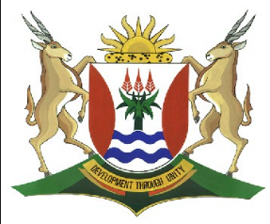
Province of the
EASTERN CAPE
EDUCATION

DIRECTORATE SENIOR CURRICULUM MANAGEMENT (SEN-FET)
HOME SCHOOLING SELF-STUDY WORKSHEET
SUBJECT | GEOGRAPHY | GRADE | 12 | DATE | 13/04/20
TOPIC | RURAL SETTLEMENT  ISSUES | TERM 2  CONTENT | (Please tick) | TERM 2 CONTENT
TIME ALLOCATION | 1HOUR | TIPS TO KEEP HEALTHY  1. WASH YOUR HANDS thoroughly with soap and water for at least 20 seconds. Alternatively, use hand sanitizer with an alcohol content of at least 60%.  2. PRACTICE SOCIAL DISTANCING – keep a distance of 1m away from other people.  3. PRACTISE GOOD RESPIRATORY HYGIENE: cough or sneeze into your elbow or tissue and dispose of the tissue immediately after use.  4. TRY NOT TO TOUCH YOUR FACE. The virus can be transferred from your hands to your nose, mouth and eyes. It can then enter your body and make you sick.  5. STAY AT HOME.
INSTRUCTIONS | See below.

Instructions:
- Please study the mind maps, diagrams and data below before answering the questions.
- The date stated in brackets is the year of the question paper.
- The questions have been taken from past question papers.
- Study your key concepts in your textbook.
- Practice and make sure you make yourself familiar with the mark allocation.
Additional mind maps will be loaded on the website next week.
Spend at least ONE hour with your Geography worksheet daily.

RURAL SETTLEMENT
SOCIAL JUSTICE ISSUES
POSSIBLE EXAM QUESTIONS ON RURAL SETTLEMENT ISSUES

- Please use the attached PowerPoints, Diagrams and Data to answer the following questions
QUESTION 1
1.1 |  | FIGURE 1.1 shows data on land restitution in the various provinces in South Africa. (Feb/March 2017)  Land cost Total awarded  Claims Hectares Beneficiaries (million Rand) (million Rand)  Eastern Cape 16 194 93 600 208 064 213 1 699  Free State 2 654 47 363 40 624 9 178  Gauteng 13 159 9 476 70 179 117 828  KwaZulu-Natal 14 742 610 996 409 323 3 463 5 969  Limpopo 3 067 487 935 215 936 2 360 3 193  Mpumalanga 2 688 389 395 223 524 3 650 4 360  Northern Cape 3 663 471 896 97 479 340 1 118  North West 3 707 364 729 169 823 1 130 1 878  Western Cape 15 526 3 132 116 297 23 1 124  Total 75 400 2 478 522 1 551 249 11 306 20 350  [Source: http://www.iea.org.uk/sites/default/files/publications/files/uldeconomicAffairs]
 |  | 1.1.1 |  | Define the term land restitution. (1x1) | (1)
 |  | 1.1.2 |  | Give the total number of land claims made to date. (1x1) | (1)
 |  | 1.1.3 |  | Which province has allocated the largest amount of land for land restitution thus far? (1x1) | (1)
 |  | 1.1.4 |  | Comment on the total land cost in relation to the total amount awarded for the land restitution process. (1x2) | (2)
 |  | 1.1.5 |  | Give TWO reasons for your answer to QUESTION 1.1.4 (2x2) | (2)
 |  | 1.1.6 |  | Explain the important role that land restitution plays in the social justice process in a democratic South Africa. (3x2) | (6)
 |  |  |  | Total | [13]
QUESTION 2
2.1 | Read through the case study (FIGURE 2.1) on a social justice issue (land reform) and answer the questions that follow. (September 2015)  FIGURE 2.1 : CASE STUDY – LAND REFORM  Patrick Mojapelo (59) has waited more than five years for the South African government to return 30 farms “stolen‟ from his community in the 1930‟s. “We have been claiming our land through the government‟s land restitution programme since 1995 and so far we haven‟t even got one farm. We keep meeting with Department of Land Affairs‟ officials and they make so many promises, but we still don‟t have a single farm,” said Mojapelo. Mojapelo joined protesters at the Union Buildings in Tshwane to make his point to the president. “The dispossession of black people of their land was a central part of the apartheid regime‟s systematic subjugation of the black majority, politically, economically, culturally and socially. In the absence of any meaningful land reform, the effects of this history of dispossession continue to keep people in poverty today. Despite this, there has been no fundamental change in land access and ownership in South Africa since 1994,” said Mojapelo, reading from a memorandum from protesters to the president.  [Source: Adapted from Focus]
 | 2.1.1 |  | State the aim of land reform in post-apartheid South Africa (1x1) |  | (1)
 | 2.1.2 |  | What is land restitution? (1x1) |  | (1)
 | 2.1.3 |  | Write down the reason why Patrick Majapelo is protesting. (1x1) |  | (1)
 | 2.1.4 |  | Explain THREE possible reasons why the Department of Land Affairs is unable to help Patrick. (3x2) |  | (6)
 | 2.1.5 |  | Suggest TWO ways how the Department of Land Affairs could deal specifically with Patrick’s restitution claim. (2x2) |  | (4)
 |  |  | Total |  | [13]

QUESTION 3

3.1 | FIGURE 3.1 shows various stakeholders discussing the issue of land redistribution. (June 2017)  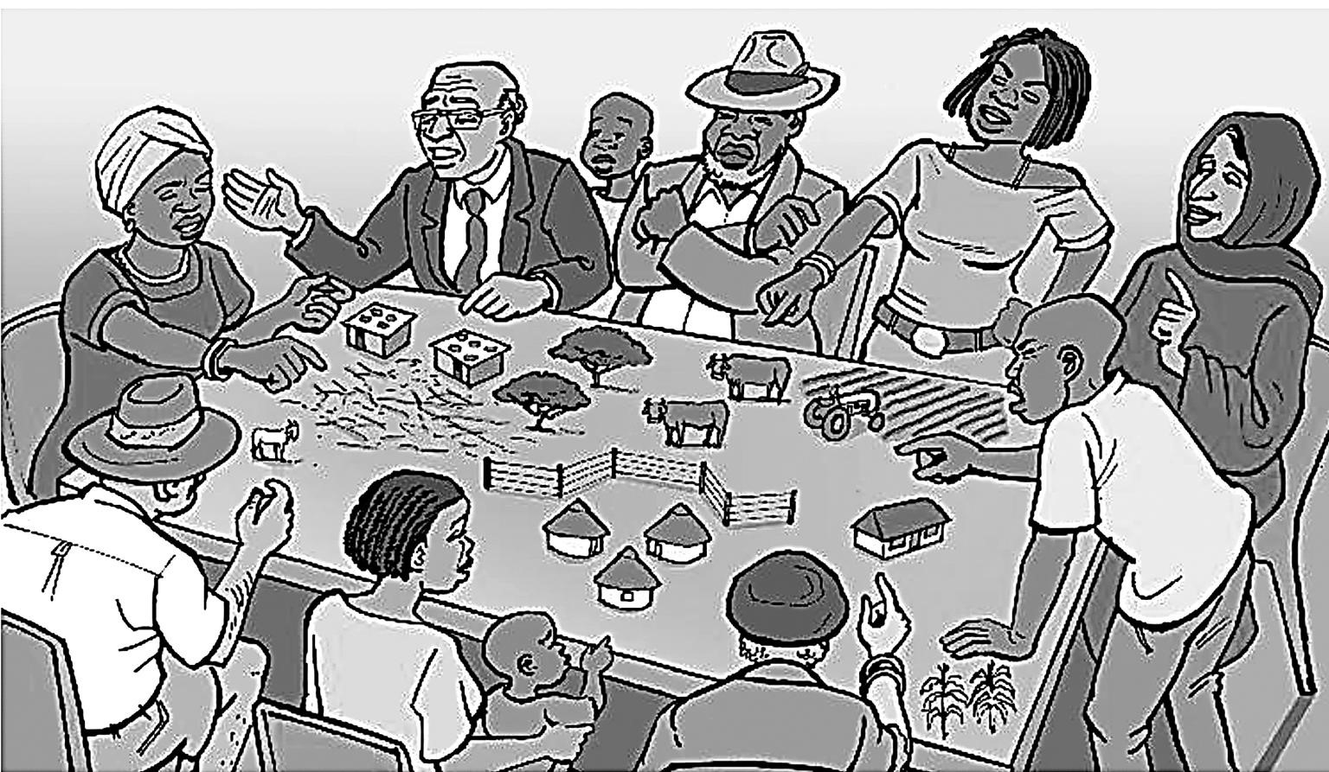
 | 3.1.1 | Define the term land redistribution (1x1) | (1)
 | 3.1.2 | Suggest a reason why the discussion is so intense in the sketch (1x1) | (1)
 | 3.1.3 | Discuss TWO goals/purposes that land redistribution hopes to achieve in post-apartheid South Africa. (2x2) | (4)
 | 3.1.4 | In paragraph of approximately EIGHT lines evaluate the challenges that authorities and stakeholders have been encountered in achieving these goals/purposes. (4x2) | (8)
 |  | Total | [14]

QUESTION 4
4.1 | Read the extract in FIGURE 4.1 based on a rural social justice issue. (June 2018)  WATER CRISIS HITS BEAUFORT WEST  One by one South Africa’s rural towns have succumbed as a catastrophic drought tightens its grip, turning vast areas into ground zero. Collapsed water infrastructure, theft and corruption have brought the future into the present with a bang.  With South Africa experiencing a water deficit of 38 billion cubic metres annually and needing an additional R30 billion a year to bridge the gap in water services infrastructure, the situation is a daily living nightmare for thousands of people.
 | 4.1.1 | Name the resource, from the passage, that rural people have no access to. (1x1) | (1)
 | 4.1.2 | Why is this resource (your answer to QUESTION 4.1.1.) considered to be a social justice issue? (1x1) | (1)
 | 4.1.3 | According to the article, what has contributed to the lack of this resource? (answer to QUESTION 4.1.1) (1x1) | (1)
 | 4.1.4 | What is meant by ‘... ground zero’ in the context of the article?  (1x2) | (2)
 | 4.1.5 | Why has it not been possible to provide water infrastructure to the rural community of Beaufort West? (2x2) | (4)
 | 4.1.6 | Evaluate the negative impact of the water crisis on employment in rural areas. (3x2) | (6)
 |  | Total | [15]

