DIRECTORATE SENIOR CURRICULUM MANAGEMENT (SEN-FET)
HOME SCHOOLING SELF-STUDY WORKSHEET
SUBJECT | Maritime Economics | GRADE | 10 | DATE | 1/4/20
TOPIC | Maritime World | TERM 1  REVISION | X | TERM 2 CONTENT
TIME ALLOCATION | 15min | TIPS TO KEEP HEALTHY  1. WASH YOUR HANDS thoroughly with soap and water for at least 20 seconds. Alternatively, use hand sanitizer with an alcohol content of at least 60%.  2. PRACTICE SOCIAL DISTANCING – keep a distance of 1m away from other people.  3. PRACTISE GOOD RESPIRATORY HYGIENE: cough or sneeze into your elbow or tissue and dispose of the tissue immediately after use.  4. TRY NOT TO TOUCH YOUR FACE. The virus can be transferred from your hands to your nose, mouth and eyes. It can then enter your body and make you sick.  5. STAY AT HOME.
INSTRUCTIONS | This worksheet is to be completed in your MRTE exercise/activity book.

Question 1
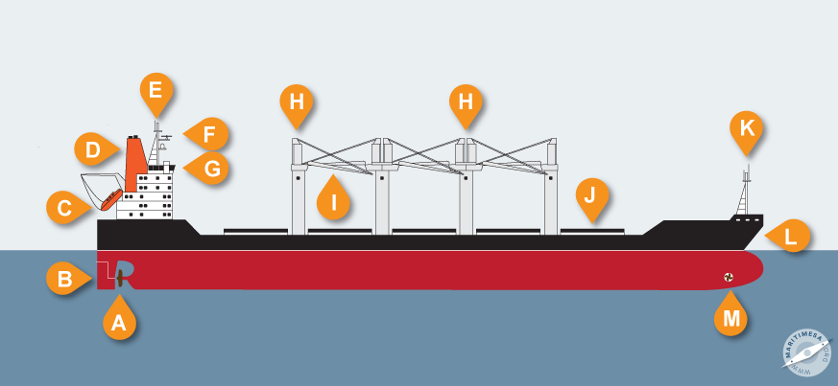
1. Label the parts of a ship from A – M (1x13)

