Province of the
EASTERN CAPE
EDUCATION

DIRECTORATE SENIOR CURRICULUM MANAGEMENT (SEN-FET)
HOME SCHOOLING SELF- STUDY WORKSHEET
SUBJECT | ECONOMICS | GRADE | 11 | DATE | 20/04/2020
TOPIC | MACROECONOMICS | TERM 1  REVISION | X | TERM 2 CONTENT
TIME ALLOCATION | 20 MINUTES MARKS: 40 | TIPS TO KEEP HEALTHY  1. WASH YOUR HANDS thoroughly with soap and water for at least 20 seconds. Alternatively, use hand sanitizer with an alcohol content of at least 60%.  2. PRACTICE SOCIAL DISTANCING – keep a distance of 1m away from other people.  3. PRACTISE GOOD RESPIRATORY HYGIENE: cough or sneeze into your elbow or tissue and dispose of the tissue immediately after use.  4. TRY NOT TO TOUCH YOUR FACE. The virus can be transferred from your hands to your nose, mouth and eyes. It can then enter your body and make you sick.  5. STAY AT HOME.
INSTRUCTIONS | INSTRUCTIONS AND INFORMATION  - Answer ALL questions in the ANSWER BOOK  - Number the answers correctly according to the numbering system used in this question paper.  - Write the question number above each answer.  - Leave 2–3 lines between subsections of questions  - Write neatly and legibly.

 | QUESTION 1
1.1
 | 1.1.1 | Name any TWO characteristics of natural resources (2x1) | (2)
 | 1.1.2 | Why is capital formation so important for the economy of South Africa? (2x1) | (2)
2.2 | Study the information given below and answer the questions that follow:
SOUTH AFRICANS ARE LEAVING THE COUNTRY IN ‘BIG NUMBERS’

South Africa is losing highly – skilled, tax – paying labour to foreign countries.
While the loss of a skilled worker can be damaging, the impact is multiplied when an entire family leaves the country as this could cause job losses to those providing services to the emigrating family such as domestic workers.

The loss of these skills can lead to a decline in tax revenues, a skills shortage, a negative impact on sentiment (which can be harmful to growth outcomes) and a loss in critical health and education services.
Source: Adapted from businesstech.co.za

 | 1.2.1 | Name the remuneration for labour. | (1)
 | 1.2.2 | What term is used refers to highly skilled workers leaving a country? | (1)
 | 1.2.3 | Briefly describe the term labour. | (2)
 | 1.2.4 | Explain why demand of labour is a derived demand | (2)
 | 1.2.5 | Suggest strategies the South African government can apply to try to retain highly skilled workers. | (4)
1.3 | Study the picture below and answer the questions that follow:
 | 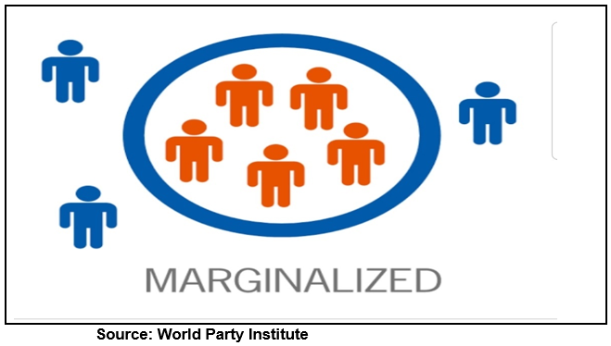
 | 1.3.1 | Give an example of economically marginalised people. | (1)
 | 1.3.2 | Which law has been introduced in South Africa to empower marginalised groups? | (1)
 | 1.3.3 | Briefly describe the term ‘economically marginalised group’ | (2)
 | 1.3.4 | What are the consequences of being economically marginalised? | (2)
 | 1.3.5 | How does the government use its procurement system to improve the situation of economically marginalised groups? | (4)
1.4 | Distinguish between renewable and non - renewable resources (4x2) |  | (8)
1.5 | Examine the positive effects of capital deepening (4x2) |  | (8)
 |  |  | [40]
 | TOTAL [40]

