Province of the
EASTERN CAPE
EDUCATION

DIRECTORATE SENIOR CURRICULUM MANAGEMENT (SEN-FET)
HOME SCHOOLING SELF- STUDY ANSWER SHEET
SUBJECT | ECONOMICS | GRADE | 11 | DATE | 16/04/2020
TOPIC | MACROECONOMICS | TERM 1  REVISION | X | TERM 2 CONTENT
TIME ALLOCATION | 40 MINUTES MARKS: 60 | TIPS TO KEEP HEALTHY  1. WASH YOUR HANDS thoroughly with soap and water for at least 20 seconds. Alternatively, use hand sanitizer with an alcohol content of at least 60%.  2. PRACTICE SOCIAL DISTANCING – keep a distance of 1m away from other people.  3. PRACTISE GOOD RESPIRATORY HYGIENE: cough or sneeze into your elbow or tissue and dispose of the tissue immediately after use.  4. TRY NOT TO TOUCH YOUR FACE. The virus can be transferred from your hands to your nose, mouth and eyes. It can then enter your body and make you sick.  5. STAY AT HOME.
INSTRUCTIONS | INSTRUCTIONS AND INFORMATION  - Answer ALL questions in the ANSWER BOOK  - Number the answers correctly according to the numbering system used in this question paper.  - Write the question number above each answer.  - Leave 2–3 lines between subsections of questions  - Write neatly and legibly.

QUESTION 1 MACROECONOMICS
1.1 | ONE term
 | 1.1.1 | Gross national product
 | 1.1.2 | Leakages
 | 1.1.3 | Production
 | 1.1.4 | Demand
 | 1.1.5 | Gross domestic expenditure
 | 1.1.6 | Double counting
 | 1.1.7 | Gross fixed capital formation
 | 1.1.8 | Intermediate/capital goods
 | 1.1.9 | Balance of payment
 | 1.1.10 | Open economy
 |  | (10 X 2) | [20]
 | QUESTION 2 MACROECONOMICS
2.1
 | 2.1.1 | Money capital  Real capital (2x1) | (2)
 | 2.1.2 | Economically marginalised group means the group of people that is seen as worse off compared to the rest of the population in terms of access to income and non-income | (2)
2.2 | Study the information below and answer the questions that follow.
Final consumption expenditure by government | 2015/16 % of the total | 2017/18 % of the total
Education | 17.7 | 19.4
Health | 8.9 | 11.4
Social protection | 6.3 | 14.9
Defence | 12.8 | 3.9
Public other and safety | 15.4 | 9.1
Interest | 12.4 | 8.8

 | 2.2.1 | Merit goods | (1)
 | 2.2.2 | Police forces | (1)
 | 2.2.3 | Consumption expenditure by government indicates how government uses its income from taxes to finances services | (2)
 | 2.2.4 | Functional classification is based on the nature of the service that is performed. | (2)
 | 2.2.5 | - Government spends more on education in both periods because education is the key to both economic growth and development.  - Investment on education gives people skills to be more efficient in producing goods and services.  This will lead to high level of production and employment. | (4)
2.3 | Difference between economic and free goods
 | Economic goods Free goods  They are scarce They are freely available from nature They are plentiful  People are willing to pay for them You do not pay for them  They belong to someone They do not belong to anyone  For example, minerals Max (4) For example, sand Max (4) |  | (8)
2.4 | Tabulate between capital(intermediate) and consumer goods  Capital (intermediate) goods Consumer goods  Includes all goods and services that are no directly consumed Includes all manufactured goods and services that are able to satisfy the consumer’s needs and wants  Help to manufacture other goods They have reached the final stage in the production process  These includes machines and tools that are used by producers in production process Have the characteristic of form utility  Are usually bought by manufacturers Are ready to be consumed  Max (4) Max (4) |  | (8)
2.5 | Graph of circular flow in a closed economy  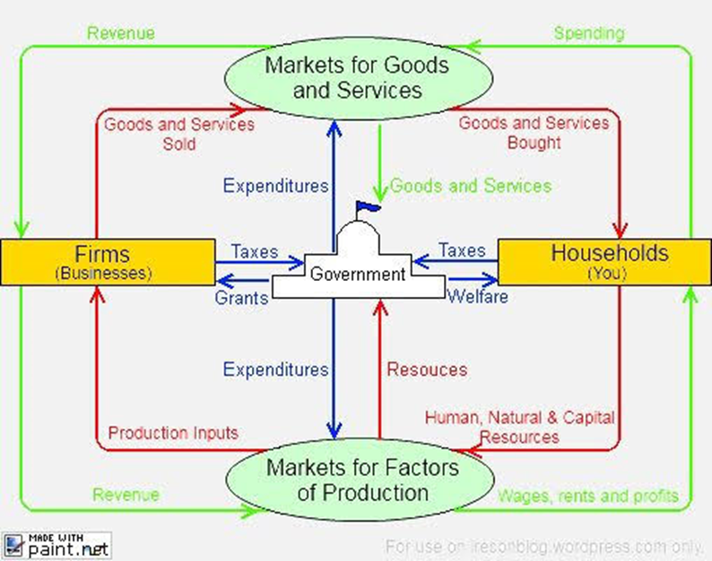 |  | (10)
 | Allocate 1 mark for identifying households, firm, government, factor & product markets. Correct arrows to & from participants Max (10)
 |  |  | 40
 | TOTAL [60]

