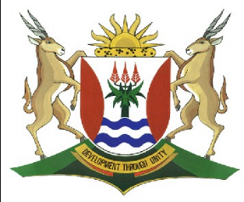
Province of the
EASTERN CAPE
EDUCATION

DIRECTORATE SENIOR CURRICULUM MANAGEMENT (SEN-FET)
HOME SCHOOLING SELF-STUDY WORKSHEET
SUBJECT | INFORMATION TECHNOLOGY THEORY | GRADE | 11 | DATE | 14 April to 17 April 2020
TOPIC | Database Management – Database software, Database types and, Database related careers . | TERM 1  REVISION | (Please tick) | TERM 2 CONTENT
TIME ALLOCATION | 1hr | TIPS TO KEEP HEALTHY  1. WASH YOUR HANDS thoroughly with soap and water for at least 20 seconds. Alternatively, use hand sanitizer with an alcohol content of at least 60%.  2. PRACTISE SOCIAL DISTANCING – keep a distance of 1m away from other people.  3. PRACTISE GOOD RESPIRATORY HYGIENE: cough or sneeze into your elbow or tissue and dispose of the tissue immediately after use.  4. TRY NOT TO TOUCH YOUR FACE. The virus can be transferred from your hands to your nose, mouth and eyes. It can then enter your body and make you sick.  5. STAY AT HOME.
INSTRUCTIONS | Resources used// Most of this week’s work is taken from the New DBE book  - Its gr8! @ grade12 theory, Study Opportunities  - Information Technology Theory Book Grade 12 , DBE  - Past Exam Papers  Answer all questions
1.1 What is a database?
1.2 Explain the purpose of a database.
1.3 List THREE things DBMS software allows you to do.
1.4 Briefly describe the following DBMS software:
a. Microsoft SQL Server
b. MySQL
c. BlackFish SQL
2.Compare the three types of databases.
 | DEFINITION | SIZE | ACCESSIBILITY
Desktop/personal database

Server/centralised database

Distributed database

3.1 What are the main roles of the following careers, that is, what do people in those careers do?
a. Database administrator
b. Database programmer
c. Database analyst
d. Database project manager
3.2 If you could choose one of these careers, which would it be? Give reasons for your answers.

