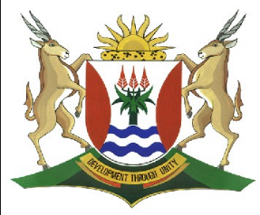
Province of the
EASTERN CAPE
EDUCATION

DIRECTORATE SENIOR CURRICULUM MANAGEMENT
(SEN-FET)
HOME SCHOOLING SELF-STUDY WORKSHEET ANSWER SHEET
SUBJECT | LIFE SCIENCES | GRADE | 12 | DATE | 02 April 2020
TOPIC | TYPES OF DOMINANCE | TERM 1  REVISION |  | TERM 2 CONTENT

LEARNER ACTIVITY: MONOHYBRID CROSSES
- In humans, the allele for blue (b) eyes is recessive to the allele for brown (B) eyes. A man, heterozygous for brown eyes marries a woman with blue eyes. Show how the possible genotypes, phenotypes and ratio of individuals with brown and blue eyes in the F1-generation may be obtained. (6)

- In rabbits the dominant allele (B) produces black fur and the recessive allele (b)
produces white fur. Study the table below showing the genotypes of four rabbits.

Rabbit | 1 | 2 | 3 | 4
Genotype | BB | Bb | Bb | bb

  - What are the phenotypes for rabbits 2 and 4 respectively (2)

________________________________________________________
________________________________________________________

  - State the genotypic ratio that is shown in the table above. (1)

_______________________________

  - If rabbits 1 and 4 were mated and had 12 offspring, how many of these would you expect to be black? (1)

_______________________________

  - Rabbit 2 was allowed to breed with rabbit 3. Use a genetic cross to show the possible phenotypes and genotypes of the F1 generation for fur colour. (6)

TOTAL = 16
TYPICAL EXAM QUESTIONS: DO Q 2.4 P2 NOV 2018;
Q 1.4 NOV 2017

LEARNER ACTIVITY: TYPES OF DOMINANCE
1. Study the diagrams below and answer the questions:

KEY: Black fish (B) x Grey fish (G) | Type of dominance  Description  Crossing
KEY: Red bird (A) x Blue bird (a) | Type of dominance  Description  Crossing

white  red  pink  Key: Red flower (R)x White flower (W) | Type of dominance  Description  Crossing
TOTAL 15

