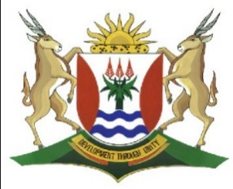
Province of the
EASTERN CAPE
EDUCATION

DIRECTORATE SENIOR CURRICULUM MANAGEMENT (SEN-FET)
HOME SCHOOLING SELF-STUDY MARKING GUIDELINES
SUBJECT | ACCOUNTING | GRADE | 10 | DATE | 12 May 2020
TOPIC | Term 2 Content

QUESTION 1
Information:
THANDEKA STORES
EXTRACT FROM PRE-ADJUSTMENT TRIAL BALANCE ON 31 DECEMBER 2019
 | Debit | Credit
Sales |  | 500 000
Cost of sales | 220 000
Debtors’ allowances | 15 000
Advertising | 30 000
Salaries and wages | 90 000
Bad debts | 1 500
Telephone | 2 100
Water and Electricity | 10 500
Discount received |  | 4 000

Required:
  - Show the closing entries of the following accounts in the General Ledger of Thandeka Stores for the year ended 31 December 2019:
    - Sales
    - Debtors Allowances
    - Water and electricity
    - Discount received
  - Prepare the Trading Account
  - Prepare the Profit and Loss account
  - Show the closing transfers in the General Journal

ACCOUNTING GRADE 10 FINAL ACCOUNTS ACTIVITY 2 – ANSWER SHEET
QUESTION 1
  - General Ledger of Thandeka Stores
Nominal Accounts Section
Sales

Debtors Allowances

Water and Electricity

Discount Received

1.2 GENERAL LEDGER OF THANDEKA STORES
TRADING ACCOUNT

1.3 PROFIT AND LOSS ACCOUNT

General Journal of Thandeka Stores – December 2019
Date |  | Details | Fol | Debit |  | Credit

[25]

