Province of the
EASTERN CAPE

DEPARTMENT OF EDUCATION

CONSUMER STUDIES GRADE 10 TERM 2 WEEK 1

FOOD SPOILAGE ACTIVITY

QUESTION 1
  - Define the following terms:
    - Food spoilage
(2)
    - Pathogenic micro-organisms
(1)
    - Oxidation
(2) (5)

1.2 Identify the microorganism that is responsible for the following food spoilage.
Food spoilage | Microorganism responsible
1.2.1
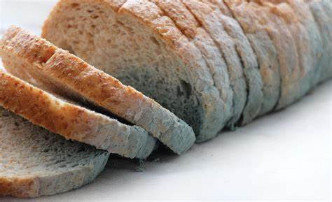
1.2.2
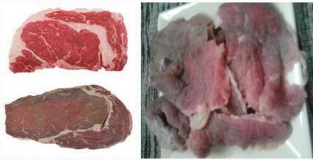
1.2.3
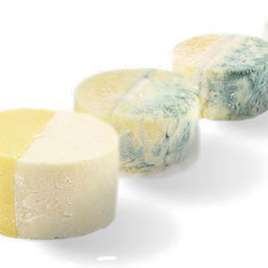
1.2.4
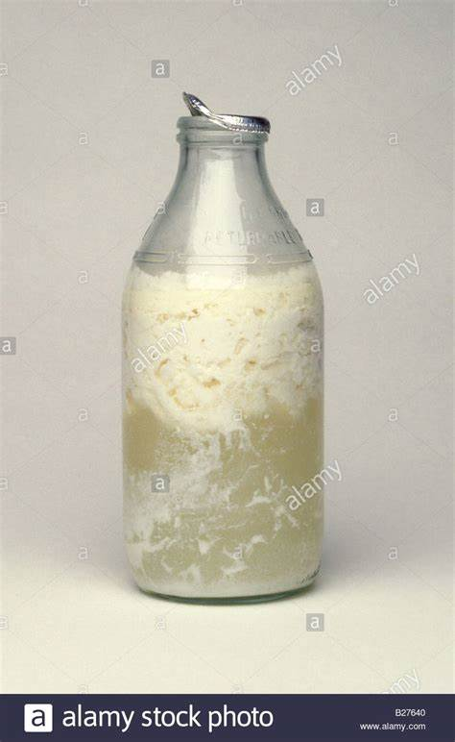
(4)
  - Match the example used in Column B with the method in Column A. Write only the correct letter next to the corresponding number.
COLUMN A  METHOD | COLUMN B  EXAMPLE
1.3.1 Oxidation | A.
1.3.2 Blanching | B.  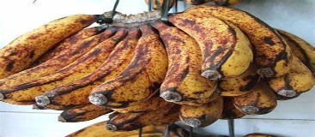
1.3.3 Fermentation | C.  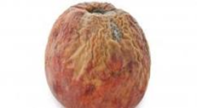
1.3.4 Loss of moisture | D.  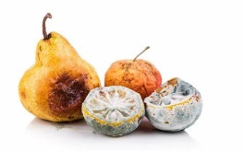
E.

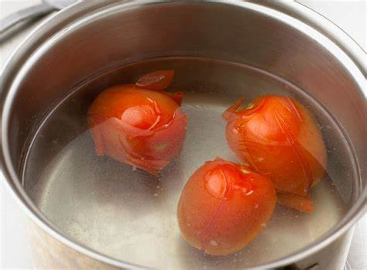
F.
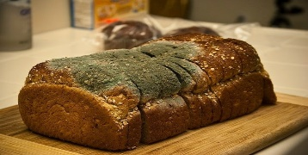
(4)
QUESTION 2
In a paragraph form discuss factors that influence the growth of microorganisms. (7)
[20]

