EASTERN CAPE

Province of the

DEPARTMENT OF EDUCATION

CONSUMER STUDIES GRADE 10 TERM 2 WEEK 3

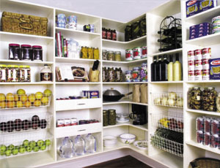
FOOD STORAGE
- Perishable foods:
- Foods that must be covered and stored in the refrigerator or in a freezer.
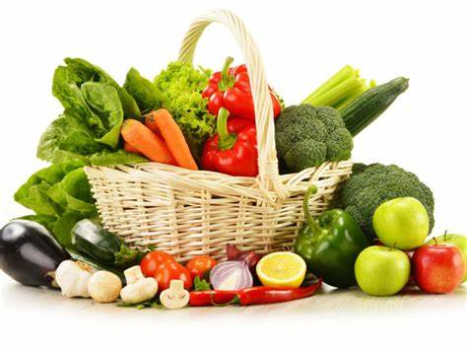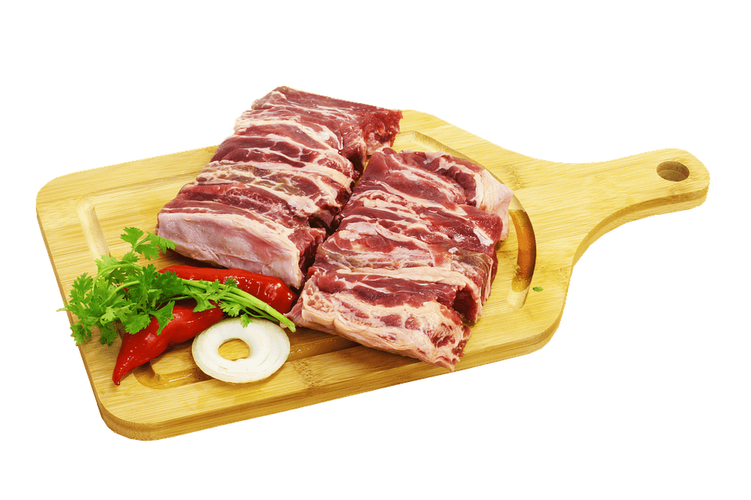
- Semi perishable foods:
- Foods that spoil within between four to ten days at room temperature.
- Eggs, butter, margarine and cheese can be
stored in the refrigerator for between two and six weeks.
- Bread can be covered and stored in a cool place for few days or frozen for a few months.
- Fruit and vegetables can be stored in a well ventilate cupboard or in the refrigerator.
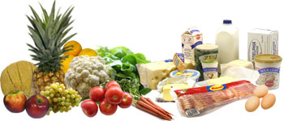

- Non- perishable foods:
- Non-perishable foods can last for longer than two weeks at room temperature.
- These foods can be stored in sealed containers in a cool, dry place for a few months.
- Canned foods, preserves and long-life milk can be stored for months until they are opened, then they must be stored in the refrigerator.

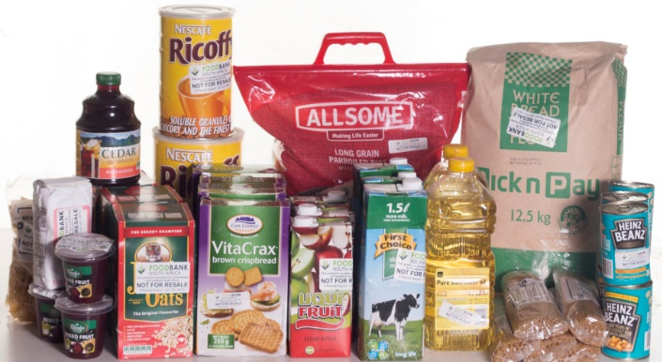

PROPER FOOD STORAGE IS IMPORTANT FOR THE FOLLOWING REASONS:
- Preserve the quality of food
- Nutritional value
- Appearance, texture and flavour
- Saves money since it prevents food spoilage and waste
- Prevents food- borne illness caused by micro-organisms

STORAGE AREAS
DRY STORAGE
- Areas should be dry, cool, dark and well ventilated.
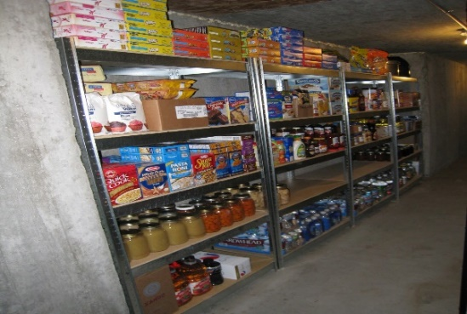 | 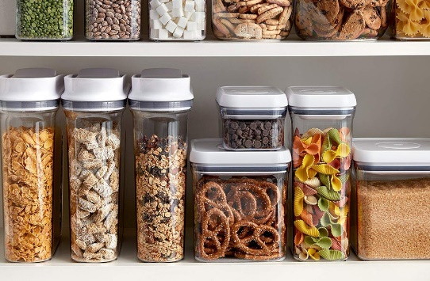

COLD STORAGE – REFRIGERATOR STORAGE
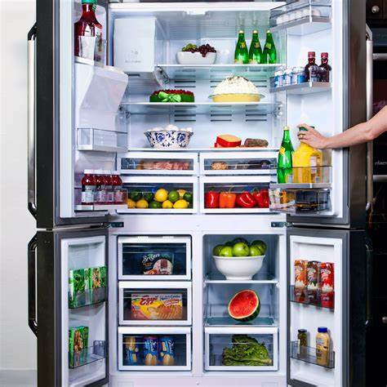
- Can be in the refrigerator or freezer.
- A refrigerator should operate between 2⁰C and 4⁰C

FREEZER STORAGE
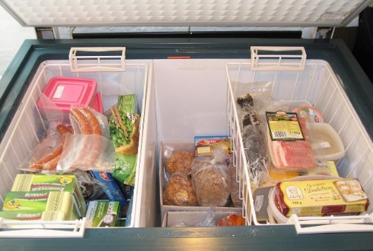

- A freezer should operate at -18⁰C

GUIDELINES FOR PROPER FOOD STORAGE
- Check the ‘best- before’ and ‘use- by ‘dates on labels.
- Follow the storage instructions on food labels.
- Do not store potentially hazardous food in the temperature danger zone.
- The ‘first in, first out ‘rule should be followed.
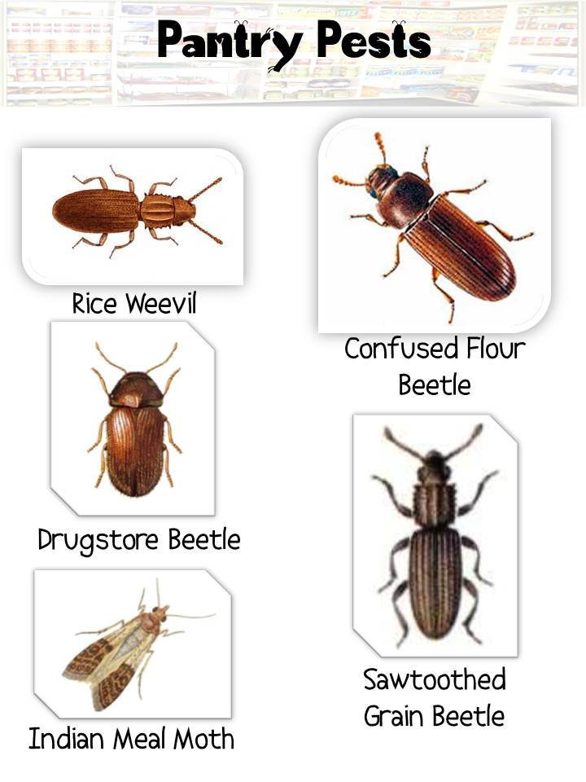
KITCHEN PESTS
- Kitchens are warm and have food and water
- They are natural place for pests to thrive
- Kitchen pests feed mostly on spices, dried fruit, cereal products and dog food
- Kitchen pests include cockroaches, flies, ants, rats and mice

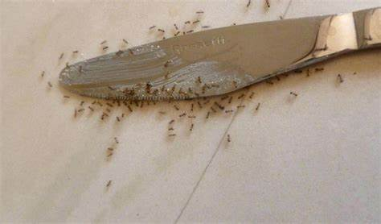
General guidelines to control pests
- Get rid of clutter
- Fix dripping taps
- Remove all rubbish from kitchen every day
- Waste bins seal properly
- Remove dirt and food from drains
- Make sure rubbish area is clean and without strong odours.
- Keep kitchen clean.
- Cover all food- Do not leave food out overnight.

WASTE CONTROL AND RECYCLING
- Waste is a growing issue for our society
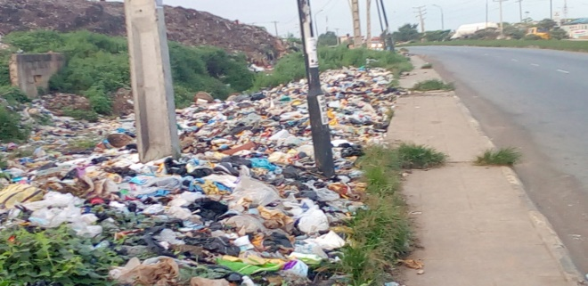

Problems caused by waste
- Waste is ugly - has negative impact on
tourism, as it spoils the landscape
- Pollutes the air, soil, rivers and
ground water
- Creates major health hazards
to people if it is not cleaned up
- It fills up landfill sites

Responsibility of waste control
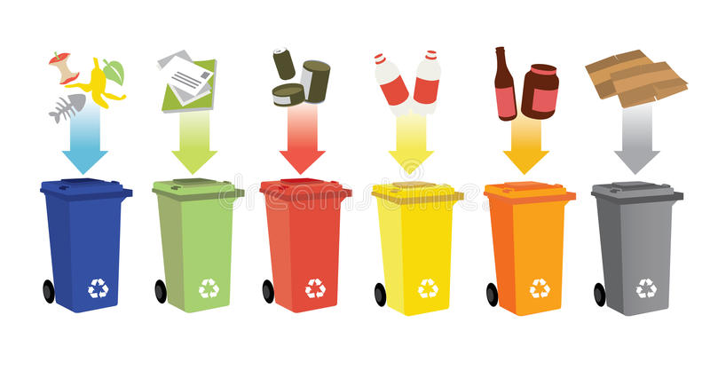
- Every person is responsible to reduce waste
- Municipality is responsible for the collection of waste in different areas

THREE Rs BEST WAY TO CONTROL WASTE
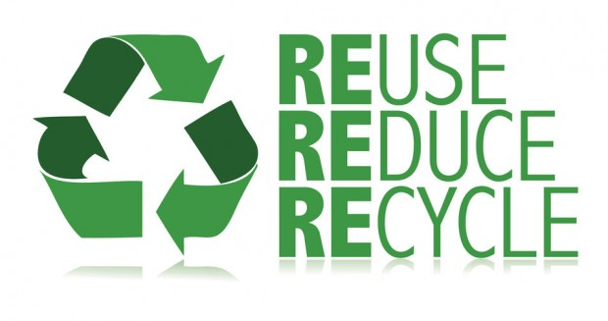
- Reduce
- Reuse
- Recycle

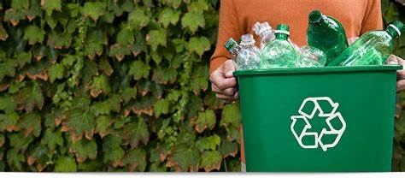

Benefits of recycling waste
- Reduces waste and save landfill space
- Create jobs
- Saves energy
- Reducing manufacturing costs - Reduce litter

Products that can be recycled | Products that cannot be recycled
- Glass bottles and jars  - Plastic products  - Metal containers (tin, aluminum, and steel cans)  - Paper (newspapers, magazines and mixed paper) | - Ceramics  - Car wind screens  - Laminated food containers (fruit juice and long-life milk boxes)  - Very dirty recyclable products  - Garden waste  - Bubble wrap  - Dead animals  - Takeaway coffee cups

TERMINOLOGY

TERM | EXPLANATION
- Sell by date | - Tells the store for how long to display the product for sale.
- Best for date | - Tells you for how long the product will retain its best flavour or quality.
- Use by date | - Tells you the latest recommendation date for using the product while it is still at its peak quality.
- Packaging date | - Is only for the use by the manufacture to track inventory, rotate stock or locate a product.

