EASTERN CAPE

Province of the

DEPARTMENT OF EDUCATION

CONSUMER STUDIES GRADE 10 TERM 2 WEEK 3
ACTIVITY

QUESTION 1
  - Define the following terms:
1.1.1 Perishable foods (2)
1.1.2 Non- perishable food (2)
1.2 Classify the following foods under perishable, semi perishable and non- perishable foods. Write only the correct letter under the relevant heading.
A  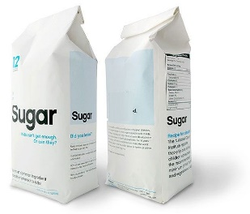 | B  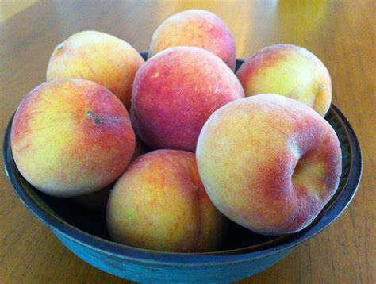 | C  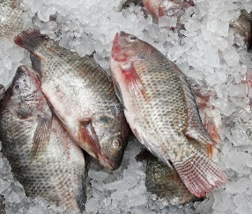 |  | D  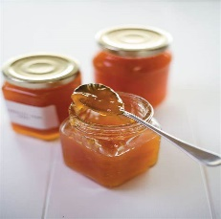
E  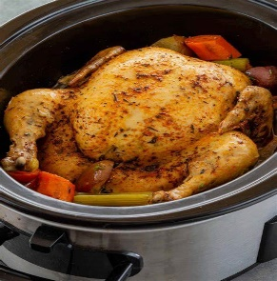 | F  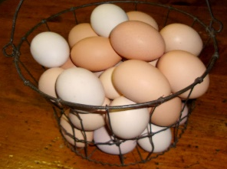 | G  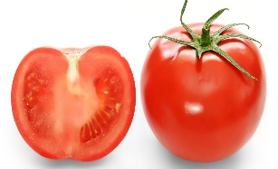 | H  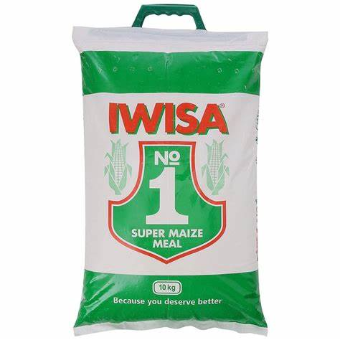
I  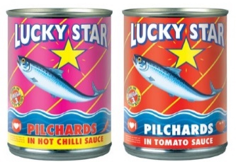 | J  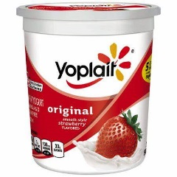

Tabulate your answer as follows:
PERISHABLE FOOD | SEMI PERISHABLE | NON-PERISHABLE
(10)

1.3 Study the logo below and answer the questions that follow.

1.3.1 Identify the logo used above (1)
1.3.2 In a paragraph form discuss the benefits of following the principles of the above logo. (5)
[20]

