Province of the
EASTERN CAPE
EDUCATION

DIRECTORATE SENIOR CURRICULUM MANAGEMENT (SEN-FET)
HOME SCHOOLING SELF- STUDY WORKSHEET
SUBJECT | ECONOMICS | GRADE | 10 | DATE | 22/04/2020
TOPIC | MACROECONOMICS | TERM 1  REVISION | X | TERM 2 CONTENT
TIME ALLOCATION | 30 MINUTES MARKS: 40 | TIPS TO KEEP HEALTHY  1. WASH YOUR HANDS thoroughly with soap and water for at least 20 seconds. Alternatively, use hand sanitizer with an alcohol content of at least 60%.  2. PRACTICE SOCIAL DISTANCING – keep a distance of 1m away from other people.  3. PRACTISE GOOD RESPIRATORY HYGIENE: cough or sneeze into your elbow or tissue and dispose of the tissue immediately after use.  4. TRY NOT TO TOUCH YOUR FACE. The virus can be transferred from your hands to your nose, mouth and eyes. It can then enter your body and make you sick.  5. STAY AT HOME.
INSTRUCTIONS | INSTRUCTIONS AND INFORMATION  - Answer ALL questions in the ANSWER BOOK  - Number the answers correctly according to the numbering system used in this question paper.  - Write the question number above each answer.  - Leave 2–3 lines between subsections of questions  - Write neatly and legibly.

 | QUESTION 1 MACROECONOMICS
1.1 | Answer the following questions:
 | 1.1.1 | List any two elements of economics (2x1) | (2)
 | 1.1.2 | Why specialisation important in a business? (2x1) | (2)
1.2 | Study the diagram below and answer the questions that follow:
 | 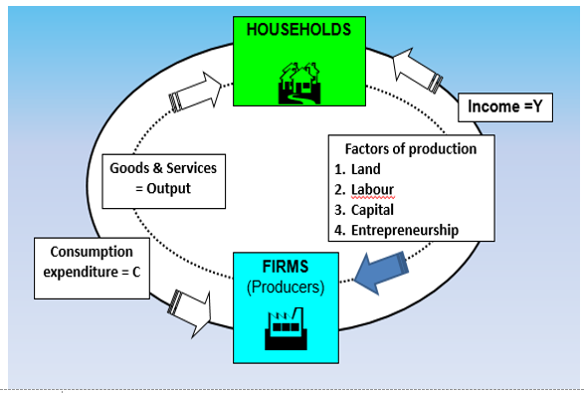
 | 1.2.1 | What type of economy is depicted in the diagram above? | (1)
 | 1.2.2 | What is the primary participant in the economy? | (1)
 | 1.2.3 | Differentiate between money flow and real flow | (4)
 | 1.2.4 | How can an injection benefit the South African economy? | (4)
1.3 | Study the information below and answer questions that follow:
 | 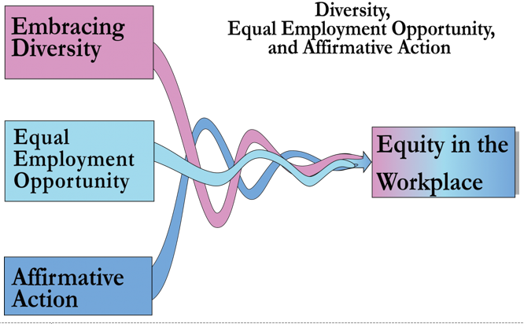
 | 1.3.1 | Mention two career opportunities in the field of economics | (2)
 | 1.3.2 | Distinguish between a positive and a normative statements (2x2) | (4)
 | 1.3.3 | Why equity in economics important in the workplace? | (4)
1.4 | Explain the use of economic models by economists. |  | (8)
1.5 | How is the South African government addressing the delivery of basic services to improve the standard of living |  | (8)
 |  |  | [40]

