Province of the
EASTERN CAPE
EDUCATION

DIRECTORATE SENIOR CURRICULUM MANAGEMENT (SEN-FET)
HOME SCHOOLING SELF-STUDY WORKSHEET
SUBJECT | INFORMATION TECHNOLOGY PRACTICAL | GRADE | 10 | DATE | 11 May to 15 May 2020
TOPIC | Revision – Flowcharts and Trace Tables | TERM 1  REVISION | (Please tick) | TERM 2 CONTENT
TIME ALLOCATION | 2hr | TIPS TO KEEP HEALTHY  1. WASH YOUR HANDS thoroughly with soap and water for at least 20 seconds. Alternatively, use hand sanitizer with an alcohol content of at least 60%.  2. PRACTISE SOCIAL DISTANCING – keep a distance of 1m away from other people.  3. PRACTISE GOOD RESPIRATORY HYGIENE: cough or sneeze into your elbow or tissue and dispose of the tissue immediately after use.  4. TRY NOT TO TOUCH YOUR FACE. The virus can be transferred from your hands to your nose, mouth and eyes. It can then enter your body and make you sick.  5. STAY AT HOME.
INSTRUCTIONS | Resources used// Most of this week’s work is taken from the New DBE practical book chapter 6  - Information Technology Practical Book Grade 10 , DBE  - Past Exam Papers  Answer all questions
Flowcharts
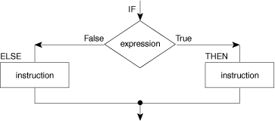

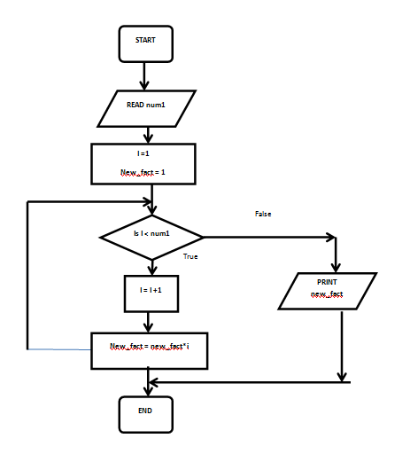

- A diagram of the sequence of movements or actions of people or things involved in a complex system or activity.
- A graphical representation of a computer program in relation to its sequence of functions (as distinct from the data it processes).

Trace Tables

A trace table is a tool used to track how the value of variables change in a program
after each line of code is executed. This tool is helpful for testing an algorithm
because it helps you to determine if an algorithm gives the correct result. If the
result is not correct, the trace table can help you to identify the logical error
responsible for the incorrect result.
To create a trace table:
● identify all the variables
● create a table with a column for each line number, a separate column for
each variable, and a column for the output
● follow the code line-by-line and write down the new value of the variable that
changed.

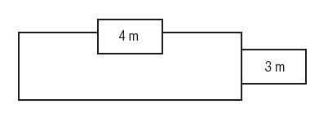
Activity 1 and 2
The formula for calculating the area of a rectangle is the length of the rectangle multiplied by the width of the rectangle. With this in mind:
- 1 Create an algorithm for calculating the area of a rectangular room.
- 2 a. The owner of the house pictured here wants to tile the doors of the lounge and bedroom 2. Create an algorithm for calculating the area that needs to be tiled.
b. Create an IPO chart for tiling the lounge and bedroom 2. Consider the following items when creating your algorithm and IPO chart.
  - The input of your algorithm.
  - The processing requirements and
  - steps of your algorithm.
  - The output of your algorithm.

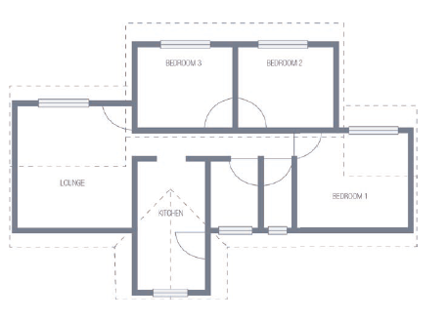

Flowcharts

