**  
 Province of the**

**EASTERN CAPE**

**EDUCATION**

**DIRECTORATE SENIOR CURRICULUM MANAGEMENT (SEN-FET)**

**HOME SCHOOLING SELF-STUDY WORKSHEET**

|  |  |  |  |  |  |
| --- | --- | --- | --- | --- | --- |
| **SUBJECT** | **GEOGRAPHY** | **GRADE** | **11** | **DATE** | **15 May 2020** |
| **TOPIC** | **GEOMORPHOLOGY** | **TERM 2**  **REVISION** | **√√** | **TERM 2 CONTENT** | **√√** |
| **TIME ALLOCATION** | **1HOUR** | **TIPS TO KEEP HEALTHY**  **1. WASH YOUR HANDS thoroughly with soap and water for at least 20 seconds. Alternatively, use hand sanitizer with an alcohol content of at least 60%.**  **2. PRACTICE SOCIAL DISTANCING – keep a distance of 1m away from other people.**  **3. PRACTISE GOOD RESPIRATORY HYGIENE: cough or sneeze into your elbow or tissue and dispose of the tissue immediately after use.**  **4. TRY NOT TO TOUCH YOUR FACE. The virus can be transferred from your hands to your nose, mouth and eyes. It can then enter your body and make you sick.**  **5. STAY AT HOME.** | | | |
| **INSTRUCTIONS** |  |

1. **Notes Topography Associated with horiziontally layered rocks**
2. **Worksheet on horizontally layered rocks**
3. **Please revise all concepts before going through your worksheet.**
4. **Revise at least 1 hour per day.**
5. **Please revise question papers from 2014 to 2019 on the ECEXAMS website**

**NB: Answer sheets will follow on Friday**

The impact of mass movements on people and the enviroment

Concept of mass movements

**MINDMAP – GRADE 11 GEOMORPHOLOGY**

**GEOMORPHOLOGY**

Characteristics associated with the development of hilly landscapes,basaltic Plateaus,canyon landscapes and karoo lansdscapes (mesas,buttes and conical Hills)

Strategies to minimize or prevent the effects of mass movement

**5. Mass Movements and Human Responses**

Kinds of mass movements: soil creep,soilflunstion,

landslides,rockfalls,mudflows and slumps

Concept of scarp retreat or back wasting

1. **Topography Associated with Horizontally layered rock**

**4. Slopes**

Utilization by People

Identification of batholiths,laccoliths,lopoliths,dykes and sills.

Overview if South Africa’s Topography

* Types of slopes
* Slope elements:crest,

cliff,talus and pediment.

* Characteristicsofthe slope element:crest,

cliff,talus and pedimenent.

* Slope development over time
* The concept of slope retreat

Characteristics and processes associated with the development of a scarp slope,dip slope.cuesta,homoclinal ridge,hogsback,cuesta basin and cuesta dome.

**3. Topography Associated with Massive igneous rocks**

**2. Topography Associated with Inclined/Tilted strata**

Characteistics and processes associated with the development of granite domes and tors

Utilization by People

Utilization by People

1. **Characteristics and processes associated with the development of Horizontally layered rock.**

**Hilly Landscapes**

|  |  |  |
| --- | --- | --- |
| Land  scape | Characteristics | Process |
| Hilly Areas (wet and Humid) | * slopes are rounded * results in gentle rolling (undulating) landscapes. * deep soils form on slopes | * chemical weathering dominant * the rocks decompose as a result of chemical reactions to the minerals in the rock. * Chemical weathering includes – hydrolysis, dissolution, oxidation, plants and bacteria. |
| Hilly Areas (Arid) | * landscape is more angular and rugged * soils are coarse and thin on the slopes | * mechanical weathering more active * mechanical weathering includes - ice wedging, exfoliation, sandblasting, biological factors and lightning strikes. |
| Basaltic Plateau | * flat and elevated above sea level * escarpment leads up onto the plateau * vertical joints formed in the basaltic layers due to shrinkage when cooling * uniform in their resistance to erosion resulting in the flat plateaus | * Lava flows from fissures to form horizontal layers over the eastern interior of South Africa as far as Zimbabwe. * The upper part of the Drakensberg are the remains of these lava flows. |
| Canyon Landscapes | * Forms deep, steep sided valleys with narrow valley floors * Most common in arid areas as mechanical weathering is more active * Examples: the Grand Canyon,USA; Fish river Canyon,Namibia. * The Blyde river Canyon is an example of a Canyon in a humid area. | * Develop over along periodof time * The river establishes its course on the surface sediments. * River erodes vertically as a results of rejuvenation * Hard layers of sedimentary rok form the vertical cliffs and the softer sedimentary rock form the gentler slopes. * Overall effect is a steep – sided valley with a river on the floor of the canyon. |
| Karoo landscapes (mesa,butte and Conical hill | * The landscape forms as a result pf erosion over millions of years. * The landscape is characterized by flat topped hills separated by wide flat plains * Dolerite,sills form the flattops of the hills as they are more resistant to erosion | * the intrusion of magma between horizontal layers of sandstone and shale. * cooled magma forms hard dolerite sills * further erosion of the flat plateau forms mesas,buttes,pointed buttes * a conical hill remains once the hard layer of dolerite has been removed. |

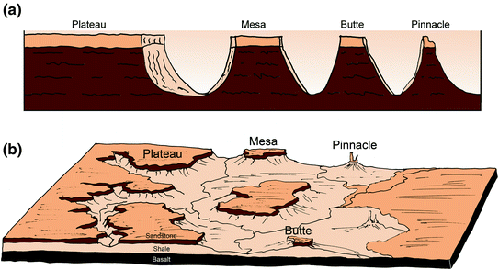

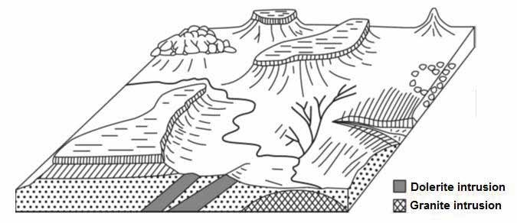

How buttes, mesas and

conical hills are formed

**HORIZONTAL LAYERS**

**Butte**

Mesa eroded to form a

small flat-

topped hill. Has

a hard top layer

**Mesa**

Rivers dissect plateau into

large blocks. Has a hard

top layer

**Conical hill**

Pointed hill after the hard

top of a butte has been

removed by erosion

:

:

:

**Tor**

Freestanding exposure

of bedrock formed by

differential weathering

usually in the form of

core stones

1. **Concept of scarp retreat or back wasting**

* A scarp is the cliff – like face or slope between the high area and the low flat land.
* Back wasting or **scarp retreat** refers to the change in position of the scarp as a result of erosion.
* This means that the cliff erodes backwards
* If the scarp is capped by a layer of hard resistant rock, the scarp will maintain its form (shape) as it retreats.
* Scarp retreat takes place along the edges of plateaus(escarpments),mesas and buttes.

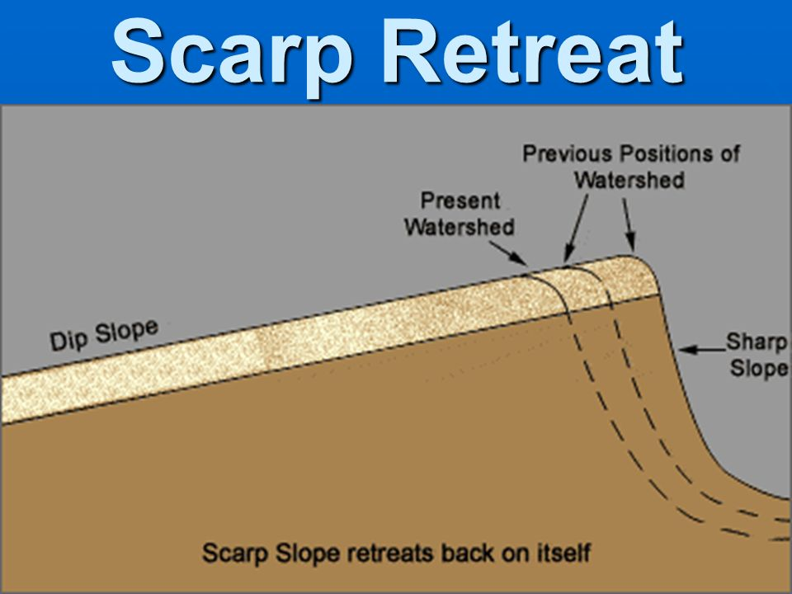

**Direction of retreat**

**Utilization of these landscapes by people**

Land utilization is determined by relief,soil and climates as well as social and economic needs

**Canyons**

* Steep sides and limited valley floor space makes it difficult to farm
* Water in the valley is not always accessible
* Form physical barriers ;too wide to build bridges across
* Tourist attraction because of their beauty

**Hilly landscapes – arid areas**

* slopes are more angular
* steep slopes limit cultivation
* large scale erosion is also common on the slopes because of the lack of vegetation
* more suitable for grazing

**Basaltic Plateau**

* Produce fertile soils rich in iron
* High rainfall and fertile soils produce good agricultural land
* High altitude plateaus can experience low winter temperatures which are not suitable for agricultural activities
* Access to high plateau is limite,mountain passes are costly to build and maintain

**Utilization of these landscapes by People**

**Karoo landcapes**

* Flat and therefore are easy to farm and to build transport routes
* Mostly found in the drier parts of South Africa,limiting Agriculture activities in the area
* Soils are thi and rainfall is limites
* Rainfall is mainly in the form of thunder showers which often lead to sheetwash runoff rather than the rain infiltrating the ground.
* Suitable for large scale sheep farming
* Also a major Tourist destination because of its beautiful scenery,plant life and fossils.

|  |  |  |  |  |
| --- | --- | --- | --- | --- |
| 1. **WORKSHEET ON HORIZONTAL LAYERED ROCK**   **Question 1.1**  FIGURE 1.1 shows TWO features of the Karoo landscape that is associated with horizontally layered rock. | | | | |
| 1.1. |  |  |  |  |
|  | 1.1.1 | Match the types of Karoo landscape (butte  And Mesa with the statements below:     1. Flat crest has a greater width than height      1. Flat crest has a greater height than width | (1 x1)  (1 x 1) | (1)  (1) |
|  |  |  |  |  |
|  | 1.1.2 | Why do both these landforms have steep concave slopes? | (1 x 1) | (1) |
|  |  |  |  |  |
|  | 1.1.3 | Describe the cap rock on these landscapes. | (1 x 2) | (2) |
|  |  |  |  |  |
|  | 1.1.4 | Explain the significance of cap rock on these landscapes. | (1 x 2) | (2) |
|  |  |  |  |  |
|  | 1.1.5 | In a paragraph of approximately EIGHT lines, explain how topography associated with horizontally layered rocks can be of  benefit and an obstacle to human activity. | (4 x 2) | **(8)** |
|  |  |  |  |  |
|  |  |  |  |  |
| **Figure 1.2** Refer to the structural landform, FIGURE 1.2 and answer the following  questions. | | | | |
|  | **1.2.1** | Identify the landforms **A**, **B** and **C** and name the process that is  responsible for the formation of these landforms. | (4 x 1) | (4) |
|  |  |  |  |  |
|  | **1.2.2** | Give ONE difference between landforms **B** and **C**. (2) | (2 x 1) | **(2)** |
|  |  |  |  |  |
|  | **1.2.3** | Explain why landform **E** is not suitable for human activities. | (2 x 2) | **(4)** |
|  |  |  |  |  |
|  | **1.2.4** | Write a short paragraph (not more than EIGHT lines) to describe the  human and economic importance of landform **D**. | (4x 2) | **(8)** |
|  |  |  |  |  |
|  |  |  |  |  |
| 1.2 FIGURE 1.2 shows slope retreat which is a theory of slope development. | | | | |
|  |  |  |  |  |
| **1.3** |  |  |  |  |
|  | 1.3.1 | Name the South African that formulated the theory of slope/parallel retreat. | (1 x 1) | (1) |
|  |  |  |  |  |
|  | **1.3.2** | Give evidence to suggest that the theory of slope/parallel retreat is shown in the sketch. | (2 x 1) | (2) |
|  |  |  |  |  |
|  | **1.3.3** | Discuss the role that a difference in climate can play in determining the different theories of slope development | (2 x 2) | (4) |
|  |  |  |  |  |
|  | **1.3.4** | Write a paragraph of approximately EIGHT lines to explain how the theory of slope decline differs from the theory of slope retreat. | (4 x 2) | (8) |
|  |  |  |  | **[48]** |
|  |  |  |  |  |
|  |  |  |  |  |