SUBJECT and GRADE | Civil Technology (Construction) Grade 12
TERM | TERM 2 (Week 5)
TOPIC | Foundations: (Specific)
AIMS OF THE LESSON | At the end of the lesson learners should be able to understand the different topics under: Pile foundations:  - Reasons for using pile foundations  - Advantages of using pile foundations Description and methods of installing:  - Precast concrete piles  - Steel tube caisson piles  - Driven in-situ piles  - Longitudinal and cross-sectional drawings through a pile and ground beam
RESOURCES | Paper based resources: | Digital resources:
 | In your textbook on page 124 – 129 of Chapter 9
INTRODUCTION | In Grade 11, you were introduced to Foundations:  Description, sketches and location of:  - Pad foundations  - Wide strip foundations  - Short bored (auger) pile foundations
CONCEPTS AND SKILLS | Key concepts/definitions: Foundations  Pile foundations:  - Reasons for using pile foundations  - Advantages of using pile foundations Description and methods of installing:  - Precast concrete piles  - Steel tube caisson piles  - Driven in-situ piles

Longitudinal and cross-sectional drawings through a pile and ground beam Pile foundations
A foundation is classified as a pile foundation when its depth is more than three times its breadth. It is a deep foundation and comprises long, slender components that are made of steel, reinforced concrete or, in rare cases, timber. Pile foundations are used where ground conditions are not suitable for normal foundations, i.e. when soil cannot support ordinary foundations. These foundations distribute the loads across stable ground, whether they are used underground or underwater. The type of soil and the weight of the structure play a role in the excavation, drilling and pouring of the piles. When stable soil lies deep below the natural ground level, holes for the foundation piles can be drilled and filled with reinforced concrete.
Alternatively, piles can be driven into the ground. A raft or floating foundation usually rests on the pile foundation system, thus providing stability.
Reasons for using pile foundations
- Ground conditions are not stable or solid enough to support ordinary, shallow foundations.
- Foundation piles distribute the load to more stable ground and can be used as underground or underwater supports.
- Piles provide stability when a raft or floating foundation is used.
- When structures are subjected to horizontal forces, pile foundations resist bending stress while still lending vertical support, e.g. multi-storey buildings.
- Where soils are prone to swelling and shrinking according to the moisture content, e.g. clay soil, shallow foundations cannot be used.
- When the superstructure is exposed to uplifting forces, e.g. offshore platforms, pile foundations are needed.
- Where soil erosion is possible, piles should be used to carry the load of the superstructure, e.g. for bridges and piers.
Advantages of using pile foundations
The use of pile foundations is viewed as a specialised design feature since extraordinary measures are applied in order to ensure a stable construction.
The advantages of using piling rather than common methods include the following:
- It can be used in poor soil.

- It can be used anywhere, even in water.
- The larger base ensures stability.
- It is relatively quick and easy to install if the equipment is available.
- If pre-fabricated piles are used, much time is saved.
- It resists tensile stress well.
- It is quick and less expensive to produce.
- It can be manufactured elsewhere and transported to the site.
- The installation can continue even when poor weather conditions hamper excavations.
- The length of the piles can easily be adjusted, depending on the circumstances.
- It offers good resistance against moving soil.
Methods of installing precast concrete piles
Precast concrete piles are used where weak subsoil layers cover the more stable layers of soil.
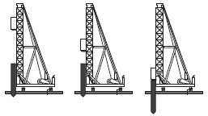
- Preformed concrete piles are driven into the ground by means of a mechanical drop hammer (pile hammer) until more stable layers of soil are reached.

Precast (preformed) piling
Types of soil where precast (preformed) piling can be use
- It can be used for soft soil.
- It can be used on unstable soil or ground.
- It can be used where the soil is loose.
- It can be used for non-cohesive soil.
- It can be used where there is soil movement.
- It can be used in constantly wet areas.

A drop hammer is used to drive precast concrete piles into the ground.
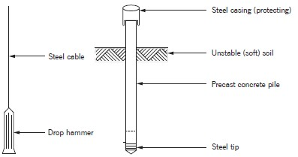
Steel tube caisson piles
This method entails driving the steel pipe casing through unstable soil or water until a stable ground formation is reached.
- The prefabricated casing is driven into the ground to the required depth.
- The casing is partially filled with dry concrete that has a low water content. This will form a plug.
- The pipe pile (caisson) is then driven in, using an internal drop hammer, until the pipe is filled to the top.
- Pipe pile casings do not need reinforcing since the steel casing is strong enough and acts as reinforcement.
- The steel casing will form part of the construction and is not removed
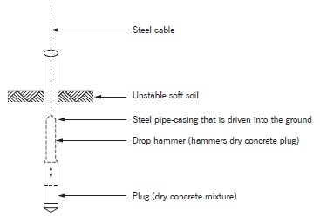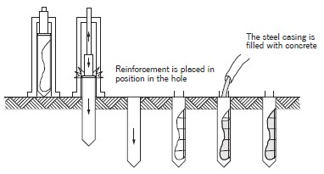
Steel tube caisson piles A steel tube caisson driven into the ground

Driven in-situ piles
In-situ piles are used instead of prefabricated piles in cases where the lengths of the piles differ.
- The method involves driving metal pipes that contain a dry concrete mix (gravel plug) into the ground.
- The pipe is held firmly in position while a drop hammer is used to drive the pre-filled dry concrete mix (gravel plug) out of the pipe to form an extended base (toe) at the bottom of the hole.
- Concrete is now poured into the pipe and compacted, using an internal drop hammer, until the pipe is filled to the top.
- The steel pipe is slowly extracted as the concrete is poured into the pipe.

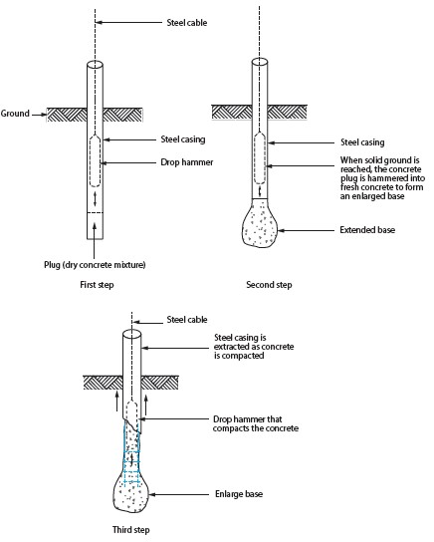

Steps to drive a pile into the ground in-situ

Building on a pile foundation
• Piles are driven into the ground and linked by means of reinforced concrete that is cast in trenches between the piles. The bottom of the trenches must be filled with a blinding layer consisting of well-burned ash or a layer of concrete sand, as illustrated below.
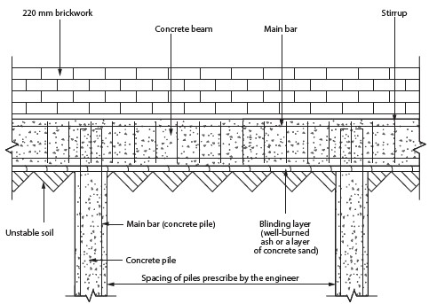
Longitudinal and cross-sectional view through a pile and ground beam

ACTIVITIES/  ASSESSMENT | Complete the activity on page 129 and 130 in your text book
CONSOLIDATION | - Learners should be able to know the reasons for using pile foundations as well as the advantages.  Learners should know the methods of installing:  - Precast concrete piles  - Steel tube caisson piles  - Driven in-situ piles  - Longitudinal and cross-sectional drawings through a pile and ground beam
VALUES | By engaging with this lesson, you should:  - Realise the importance of the correct installation of the different pile foundations.  - Know the value of pile foundations  - Acknowledge the bearing load of pile foundations in different soil types  - Appreciate the advantages of pile foundations

